Dreamcast
Hardware
Specification Outline

2013年3月26日 1:13 Sega Enterprises Development Department

Contents

1 Dreamcast Outline 3
1.1 Outline 3
1.2 System Specification 3
1.3 System Block 4
2 CPU:SH4 8
2.1 Features of SH4 8
2.2 SH4 Settings 8
2.3 Main Memory 9
2.3.1 Configuration of the memory 9
2.3.2 SDRAM control 10
2.4 Mapping of the system memory 10
2.5 Interface of CPU bus 11
2.6 Interrupt 11
2.7 PIO i/f 12
2.8 SCI i/f 12
3 Image drawing processor: HOLLY 13
3.1 HOLLY sub system 13
3.2 Chip specification 15
3.3 Pin list 15
3.4 Texture(Texture /Frame Buffer)memory 18
3.5 Internal configuration 19
3.5.1 System Bus 19
3.5.2 Core 19
3.6 Outline of drawing images 22
3.7 Internal configuration 20
3.7.1 PVR block 20
3.7.2 Tile Accelerator (TA)Block 20
3.7.3 System Bus Block 20
3.8 External interface specification 25
3.9 Data path 26
3.10 HOLLYのinterrupt処理 27
§4 Audio processor：AICA 30
4.1 AICA peripheral connection 30
4.2 Chip Specification 30
4.3 Pin specification 31
4.4 Main configuration and spec 32
4.5 Audio memory 33
4.6 RTC(Real Time Clock) 33
4.7 audio in/output 33
4.8 Image mode settings 33
4.9 MIDI interface 33
4.10 Interrupt 33
5 Boot ROM 34
5.1 Boot ROM configuration 34
5.2 Assigning the ROM 34
5.3 About the access cycle to the ROM 34
6 GD-ROM 35
6.1 Specification Outline 35
6.2 Interface 36
6.3 GD-ROM audio 36
7 Other 37
7.1 Control pad 37
7.2 Backup media 37
7.3 Modem 37
7.4 The setting method of the video output and the image mode 38
7.5 Dreamcast Clock Tree 38
7.5.1 PLL 39
7.6 Power supply 39
7.7 Reset Sequence 39

1 Outline of Dreamcast
This section is an outline of the Dreamcast system. For individual details please refer to the appropriate sections.
Additionally with regards to the details of the various sections that follow this section, please refer to other material.

Outline
A feature of Dreamcast is that it is a system with high quality graphics capability, thanks to its PVR2 core, and superb quality audio which has been produced at a low cost and has a retail price of under $200. Additionally by including a modem as a standard specification, it allows the easy development of network/internet business.

1.2 System Specification
These are the hardware specifications of the basic Dreamcast system.

- CPU: Hitachi SH4 200MHz , Super Scalar RISC Processor , 360MIPs, 1.4GFLOPs
- ASIC: Image drawing VL/NEC HOLLY 100MHz , Audio YAMAHA AICA
- Polygon performance : At peak 3 million polygons/sec ( triangle / quadrilateral ) , 1.5 million polygons/sec visible
- Polygon functions: shadow , tri-linear MIPMAP , edge anti-aliasing, fog, Ｚ buffering etc.
- 16MB Main memory(Can expand to a maximum of 32MB)
- 8MBTexture memory(Can expand to a maximum of 16MB)
- 2MB Boot ROM
- 128KB Flash memory
- 2MB audio memory(Can expand to a maximum of 8MB)
- Audio function: 64ch PCM / ADPCM / FM , 44.1KHz
- 4x～12x CAV-type GD-ROM drive(built-in 128KB buffer RAM)
- 4 Game ports (adapted for the optional light gun, storage device etc.)
- 4 port backup media (optional device)
- RTC(Real Time Clock) that has capability of battery backup
- 33.6kbps modem card
- Adapted for NTSC/PAL, VGA monitor image output

1.3 System Block

Refer to other page

Figure 1-1 Dreamcast Block Diagram

Figure 1-1 is the system block diagram. A simple explanation of each block is below.
CPU
The main CPU is a Hitachi SH4 with an internal performance of 1.8V / 200MHz and external performance of 3.3V / 100MHz. The frequency of the clock (where the operation is based) is 33.3MHz output from the external PLL. SH4 processes game sequence, AI, 3D operation and 3D image drawing commands. Also the PIO i/f, which allows external I/O access, is used in video mode selection. (Explained later)

Main memory
In order to take advantage of SH4 performance, the SDRAM (which is the main memory) is directly connected to SH4. The bus width is 64bit with a movement frequency of 100MHz and at burst, it has a maximum transfer quantity of 800MB/s (a theoretical value) Additionally, SH4 does not share the texture data/audio data and the main memory SDRAM. There is 16MB of base system space.
The access speed is -7ns or an equivalent speed.

HOLLY
This has a built-in PVR2 core and supports image drawing. In other words HOLLY, which is the core of the interface supports CPU i/f, texture memory i/f and/ or the peripheral devices G1/G2 bus i/f and the Maple i/f.
HOLLY uses SH4 and the SH4 DMA to read the display list created in the main memory to generate 3D graphics internally. When using texture mappings, the texture data is read from the texture memory.
From SH4, it is accessed via the multiplexed 64bit address/data interface mode.
From HOLLY, each RGB 8bit image data is accessed via the video DAC/ encoder.

Texture (texture/frame buffer) memory
As a base system it has an area of 8MB(which can be expanded to a maximum of 16MB)and HOLLY occupies 4 16M bit SDRAM(8 when expanded).The data bus width is 16bit×4 and 16/32/64 bit access is possible. The memory is accessed from HOLLY at 100MHz using -7ns or equivalent.

G1 bus
The GD-ROM drive, Boot ROM and flash memory are buses in parallel connection and the bus has a multiplexed EIDE-like i/f and Boot ROM i/f. Part of the Boot ROM address line, the 8 bit of code that contains the system data, is multiplexed. The data bus width is 16 bit at the time of GD-ROM access and 8 bit for Boot ROM and Flash memory access. It is also subject to type 1 interrupted entry from the GD-ROM.
GD-ROM access uses an ATAPI like protocol. For details of the protocol, refer to a separate document.
In order to prevent hardware reconstruction and Illegal copies, this bus is not external on commercially produced Dreamcast hardware. In the case of the SET5 set for software Development, the Crossproducts Company debugging adapter base is connected to this and thus allows software debugging. In that case, the downloading of data occurs through this bus.

G2 bus
The G2 bus is a multiplexed clock bus and supports the audio IC, AICA ,and supports the connection of optional devices like the card-in unit (modem) and the externally connected debugging tool.
The bus clock is 25MHz and the bus width is 16bit. It is subject to interruptions from AICA, the modem and external devices.
With commercially produced Dreamcast hardware, this bus is on the outside and has is used as an expansion bus.

4x-12xGD-ＲＯＭ
The drive reads using a CAV method and the data reading speed is 4x for normal space and 12x for high-density space. The drive has a 128KB buffer RAM and data is transferred through HOLLY. It delivers GD-DA (high-density digital audio) as opposed to AICA that is an audio IC.

Boot ROM
The system/boot ROM used by SH4 is connected to the G1 bus. There are 2MB of ROM space and a data bus width of 8 bit. The access time of the Dreamcast is set at 100ns.

Flash ROM
Information such as the Dreamcast system administration number is stored here.

Modem
It is a modem card featured as standard on the Dreamcast system as a card type unit and is connected to the G2 bus. The communication speed is 33.6Kbps and is equipped with a modular terminal.

AICA
AICA is a YAMAHA audio IC. It is a chip that has the primary objective of being in charge of the Dreamcast audio and reproduces 64ch PCM/ADPCM/FM stereo sound. Starting from the GD ROM it picks up audio signals or 33.8688MHz from the audio clock. Stereo sound generated within AICA becomes output from the external audio DAC/AMP.
As an internal configuration it is divided into an audio block and G2 bus i/f block and has a shared audio memory. The internal chip of the CPU uses an ARM7 core. A RTC (Real Time Clock) is also built-in. The audio block frequency is 22.5792MHz and the G2 bus i/f block frequency is 25MHz. As a peripheral i/f it supports audio memory i/f as well as MIDI i/f. The RTC has a 3V Lithium battery for backup purposes and a 32.768KHz x’tal.
Also, unlike video DAC/encoder, it allows video mode settings (switching) access.

Audio memory
AICA is connected to an audio memory occupying the 16M bit SDRAM (space is 2MB but can be expanded to a maximum of 8MB). The memory bus width is 16bit and access is at 67.7MHz.

External connection device
This is a device just like AICA and the modem that is located on the G2 bus and connected to a debugging tool etc.

Maple i/f
This is an original Sega peripheral interface supported by HOLLY that is a serial-type control pad interface. The Dreamcast console supports up to 4 ports. Additionally, this port supports the control pad (Light Gun) as well as connected backup media (which is explained later). The maximum port transferring rate is 2Mbps.

Backup media (B/U)
Backup media is optional support used for saving application data. It is connected through the Maple port and HUB (control pad) and a maximum of 4 can be connected.

MIDI i/f
This supports MIDI IN/OUT for the purpose of audio development.

Video output
Image information generated by HOLLY passes through the video DAC/encoder (Digital-Video-Encoder) and becomes output compatible with general NTSC/PAL monitors as well as a VGA. NTSC/PAL video signal output from a Video DAC/encoder and stereo sound output from AICA becomes output from the RCA connector. The cable connected to the RCA connector can be a multi-purpose commercial product. Opposed to the VGA monitor, analogue RGB/ synchronised signal etc will become output from the expansion VGA connector. The NTSC/PAL, VGA etc. video modes depend on the type of cable connected to the connector and that information is reflected in the SH4 I /O. This can be switched from SH4 to HOLLY using the AICA image register settings.

Audio output
Stereo sound generated by AICA passes through the audio DAC/AMP and video output generated by HOLLY and becomes output from the RCA connector and/or the expansion VGA connector.

PLL
This is for creating each clock in the system and has an attached 13.5MHz x’tal. The frequency of the output clock (or the output destination) is 33.3MHz(SH4) and 54MHz(HOLLY)

Other
The power unit has 100～120V AC, 50/60Hz input and supplies DC3.3V or DC5.0V to the system. The DC1.8V, DC2.4V for the SH4 interior / HOLLY internal power supply are created by a separate electrical power source IC.

----End of Outline----

2 CPU: SH4
The CPU used in the Dreamcast system is a SH4 (HITACHI) and with respect to 3D game programming it is mainly responsible for the processing of the game sequence, AI, physical calculations and 3D conversions. Below is an explanation of the SH4 settings and peripherals.

2.1 Features of SH4
Table 2-1 describes the main functions of SH4.

Core
Instruction core | 32bit RISC, 16bit Instruction
Pipe line | 5 stage
FPU | single/ double accuracy IEEE754
Clock | Internal 200 MHz, external 100 MHz, peripheral clock 50MHz
Performance | 360MIPS (core), 1.4GFLOP (matrix multiplication)
Super Scalar | 2
Cache | I$: 8KB, D$: 16KB (Both are direct mapping). There are index / RAM functions
Other | high-speed packet transfer through the store queue function is possible ( 32B)
Peripherals
calculation | Matrix multiplication, 1/√
DMAC | 4 channel, DDT mode
Memory i/f | SDRAM i/f, Multiplex i/f
MMU | Page Size: 1KB, 4KB, 64KB, 1MB
UBC | 2 Break Point
SCI | synchronised clock, synchronised pace
Timer | 3 Channel
RTC | Real Time Clock, Alarm, calendar
Process and package
Electrical power consumed | 1.8W
Voltage | External: 3.3 VDC, Internal1.8 VDC
Process | 0.25um, 2.4V / 3.3V
Package | 256 BGA
Die Size | 49mm²
Table 2-1 Features of SH4

2.2 SH4 Settings
With respect to the Dreamcast system, SH4 uses the settings described in table 2-2. (Note that it is slightly endian)
The operational mode, described in table 2-3, is dependent on the MD [7:0] pin and these pins can be used as other functions and is internally sampled when the reset is cancelled. The clock mode is the same except that after booting, the software can be used for further settings.

Category | Setting
External clock | 100 MHz (Cycle Time: 10ns)
Internal clock | 200 MHz (Cycle Time: 5ns)
Endian | Little Endian (Intel-style)
Table 2-2 Configuration of SH4

Mode pin | Setting | Operation
MD7 | 0 | SH4 is master mode operation
MD6 | 1 | area0 is MPX operation
MD5 | 1 | All the buses are little endian
MD4 | 0 | 64 bit bus width operation
MD3 | 0 | 64 bit bus width operation
MD2 | 1 | Clock mode
MD1 | 0 | Clock mode
MD0 | 1 | Clock mode
Table 2-3 SH4 operation mode settings

2.3 Main memory
The main memory of the system is directly connected to the CPU: SH4 and used as the SH4 program code and work memory. The supported memory size depends on the memory cost. The main memory specification is described in table 2-4. The basic configuration is an SDRAM with 16MB of space and two 64M bit (bus width 32bit).

Memory size | 16MB
Technology | 2 64Mbit SDRAM (4bank x 512k word x 32bit)
Total bus width | 64 bit
Burst sequence | Sequential
Number of internal banks | 4
Bus width of 1 chip | 32 bit
Frequency | 100MHz
BBW | 800MB/s
Table 2-4 The main memory base specification

2.3.1 The memory configuration
Table 2-5 is the configuration details and figure 2-1 is the memory configuration.

Space | Number | Each RAM | C_{LOAD} (Addr/Ctrl/Data) | Fig.
16MB …base | 2 | 4 x 512k x 32bit SDRAM (64Mbit) | 5 pF / 5 pF / 7 pF | 2-1
Table 2-5 The main memory configuration

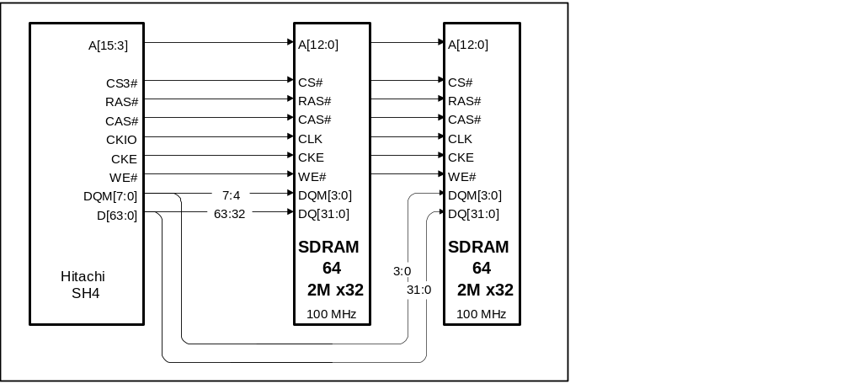
Figure 2-1 Configuration of 16MB SDRAM…Uses 2 64Mbit (4 x 512k x 32bit)

2.3.2 SDRAM Control
The BSC (Bus State Controller) in SH4 controls the SDRAM, all of the SDRAM control signals, refreshing and pre-charging.
The SDRAM needs to be set after the point when the power has just been switched on but before the SDRAM has yet to be accessed.
SH4 uses the software to generate the SDRAM configuration cycle. Writing in the SH4 register generates the configuration cycle.

The settings are cited below.
- The SDRAM burst length is set as 4. Only this setting is possible.
Also the CAS latency is set as 3.
The burst sequence is set as sequential access.
- The SH4 internal refresh counter is set as 2048 times per 32msec.
- SH4 is set as ラスdown mode.
This is to speed up access when using the same row address. (However in this mode, you are prohibited from having the WAIT function on for a long time.)

SH4 is the only SDRAM access master. Access from HOLLY to the SDRAM uses the SH4 DMA cycle. Due to SH4 DDT mode DMA, 1 external device can become the logical bus master.
With channel 0, an On Demand DMA (ODD) protocol is possible. Due to the ODD, the external device can program the SH4 DMAC channel0. From this HOLLY is able access the SDRAM efficiently.

2.4 System memory mapping
The external SH4 bus is a 64-bit data bus that allows a 26-bit address bus and 1 byte access. The internal address is 32 bit. Additionally SH4 has a multiplex data/address mode (MPX). It is directly connected to the SDRAM and uses CS3# for chip selection. CS3#area can be accessed in ラスdown mode.
The SH4 system memory map is divided into 7 areas. Each area is defined by an address and 7 decoded external chip selections become (CS#[6:0]) output.
Table 2-6 is the memory map and area configuration. For details on each function, refer to the relevant section.

Area | Physical Address | Type | Function | Size | Access | Note
0 (CS1) | $00000000 - $001FFFFF  $00200000 - $0021FFFF  $005F6800 - $005F69FF  $005F6C00 - $005F6CFF  $005F7000 - $005F70FF  $005F7400 - $005F74FF  $005F7800 - $005F78FF  $005F7C00 - $005F7CFF  $005F8000 - $005F9FFF  $00600000 - $006007FF  $00700000 - $00707FFF  $00710000 - $00710007  $00800000 - $009FFFFF  $01000000 - $01FFFFFF | MPX | Boot ROM  Flash Memory  System Control Reg.  Maple Control Reg.  GD-ROM  G1 Control Reg.  G2 Control Reg.  PVR Control Reg.  TA/PVR Core Reg.  MODEM  AICA sound Reg.  AICA RTC Reg.  AICA Memory  G2 External area | 2MB  128KB  512B  256B  256B  256B  256B  256B  8KB  2KB  32KB  8B  2MB  16MB | 1/2/4/32B  1/2/4/32B  4B  4B  1/2B  4B  4B  4B  4/32B  1B  4B  4B  4B  1/2/4/32B
1 (CS1) | $04000000 - $047FFFFF  $05000000 - $057FFFFF | MPX | Texture Mem.(64bit)  Texture Mem. (32bit) | 8MB  8MB | 2/4/32B  2/4/32B | (RD/WR)  (RD/WR)
2 (CS2) | $08000000 - $0BFFFFFF | - | Unassigned | 64MB | - | Reserve
3 (CS3) | $0C000000 - $0C7FFFFF | SDRAM | Work SDRAM | 16MB | 1/2/4/32B | Main Memory
4 (CS4) | $10000000 - $107FFFFF  $10800000 - $10FFFFFF  $11000000 - $117FFFFF | MPX | Polygon Converter  YUV Converter  Texture Mem. (WR) | 8Mbyte  8Mbyte  8Mbyte | 32B  32B  32B | TA FIFO  TA FIFO  (WR only)
5 (CS5) | $14000000 - $17FFFFFF | MPX | Ex. Device | 64MB | 1/2/4/32B
6 (CS6) | $18000000 - $1BFFFFFF | - | Unassigned | 64MB | 64MB | reserve
Table 2-6 memory mapping

2.5 CPU bus interface
SH4 uses 2 different bus protocols depending on the area of the CPU bus. Depending on which memory area is accessed, one of the 2 choices below is selected.

1) Direct operation to the SDRAM
2) MPX operation to HOLLY

The MPX interface is an interface for the multiplex address/data. With respect to areas 0,1,4 and 5 of SH4, MPX operation is possible.

- area 0 ＝ Boot ROM, GD-ROM, modem, HOLLY/AICA control register, external device area
- area 1 ＝ Texture memory access
- area 4 ＝ TA area within HOLLY (FIFO, YUV converter, texture memory access)
- area 5 ＝ external device area on the G2 bus.

With regards to direct operations involving the SDRAM, please refer to the previous section titled SDRAM control.

2.6 Interrupt
With regards to interruptions from the exterior of SH4, the following exist.

- NMI interrupt
- SH4 external interrupt(Level Trigger)

The debugging adapter controls JTAG interruptions.
(The debugging adapter is a software development tool that allows the reset of the Dreamcast system and JTAG interruptions etc.)
NMI is not used.
SH4 external interruptions (as a signal it is CIRL [2:1]) are controlled by HOLLY. Interruptions from HOLLY to SH4 are from HOLLY internally and from each device on the G1/G2 bus.

- HOLLY internally (PVR2 core, DMA part) interrupt…level trigger
- GD-ROM interruption (interruption from the G1 bus)
- AICA interruption (interruption from the G2 bus)
- MODEM interruption (interruption from the G2 bus)
- Reserve (interruption from external device connected to the G2 bus)

The outline of the connection is described in diagram 2-2 below.
If an interruption occurs from within HOLLY, GD-ROM, AICA, RESERVE etc., HOLLY will maintain the status in its internal register and record the interrupt signal as level ’L’. (It allows signal level changes of IRL#[2:1]. With regards to the other IRL#0,3 signals, it is connected to the ’H’ level) When the interrupt signal becomes level ‘L’, SH4 will read the HOLLY internal interruption register and jump to the appropriate vector routine interruption.

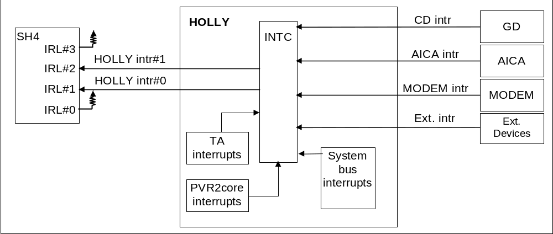
Figure 2-2 interruption outline

2.7 PIO i/f
The SH4 PIO interface is used in the reading of the Dreamcast system image mode settings. The allocation of each signal line of the PIO interface (PIO [9:0]) is described in figure 2-3 and table 2-7.

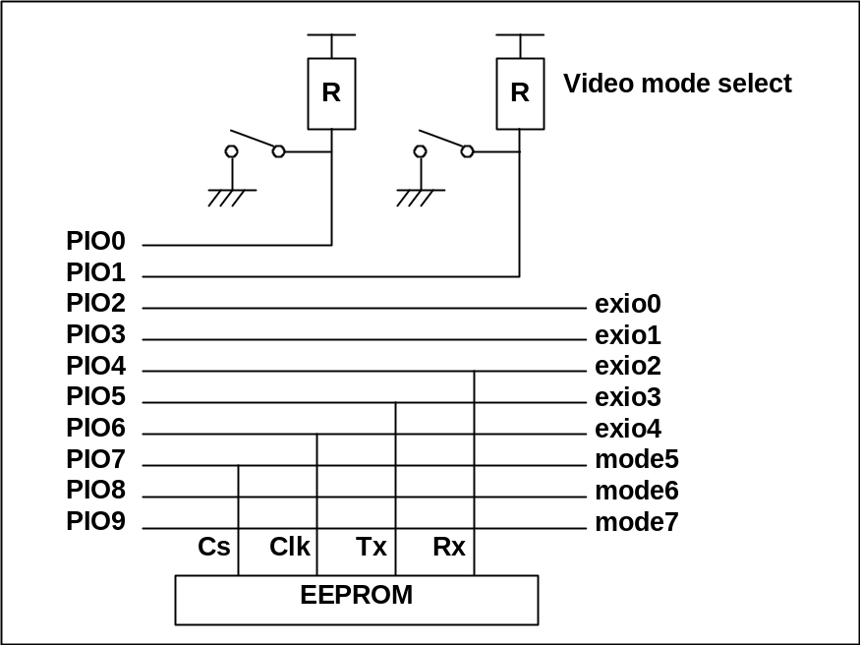
Figure 2-3 Allocation of PIO[9:0]

2.8 SCI i/f
SH4 has 2 serial interfaces (SCI) . With regard to the Dreamcast system, only one of these is a multi-purpose serial port in the console that is supported.

--End of CPU--

3 Draw image processor: HOLLY
The HOLLY chip is a product-version Dreamcast graphics processor with a built-in PowerVR2 core, which is part of the Power VR family and the next generation game console version after the PC PowerVR PCX2.
The internal part of HOLLY is divided into the system bus and core.
The system bus is an interface between the SH4 and Core, G1, G2, game pad and especially controls DMA movements.
The core is only used to draw images. From SH4 it is accessed through the system bus. Additionally with PCX2, flat parameter generation and tile parameter generation which was perofrmed by Pentium(R) has completely become converted to hardware and made faster.
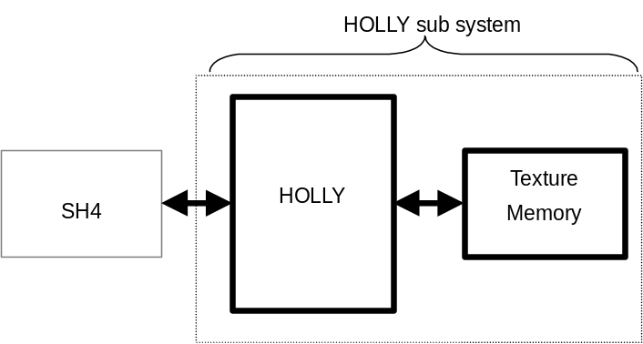

3.1 HOLLY subsystem
Figure 3-1 is the HOLLY sub system.
* With regards to an explanation about the pin, refer to the pin list .
Figure 3-1 Block diagram of the HOLLY sub system
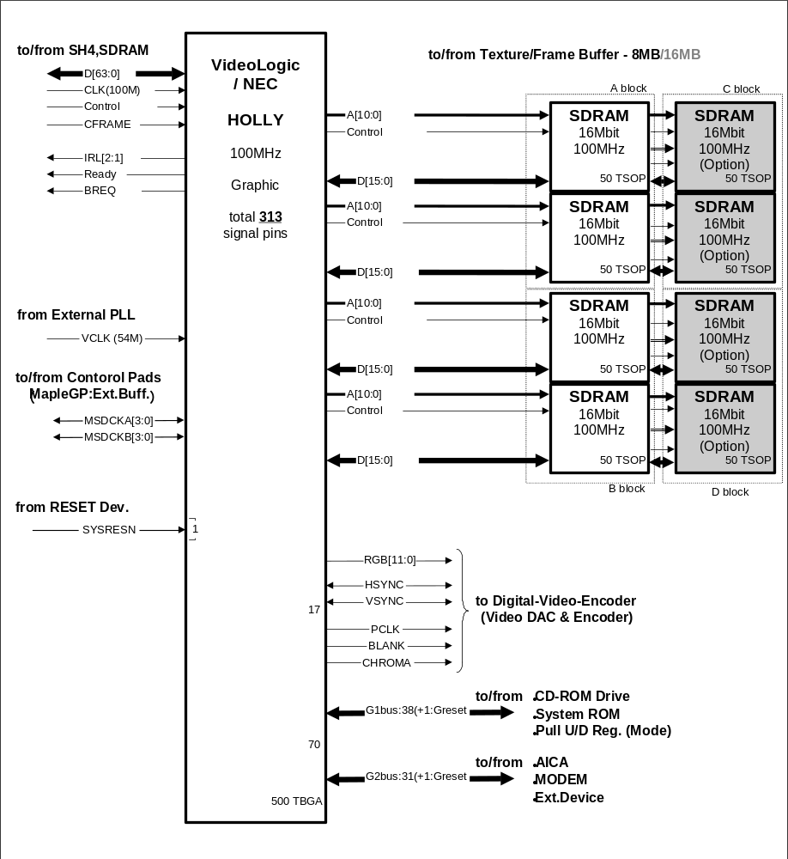

3.2 Chip specification
The main chip specifications for HOLLY are described below.

- Package 500pin Ｔ－BGA
- Process 0.2μm
- SH4 i/f clock 100MHz
- Draw image clock 100MHz
- Pixel clock 13.5MHz (Input 54Hz from the external PLL is internally 分周 before use.)
- Power supply DC2.4/3.3Ｖ(core 2.4V, all signal pins 3.3V. 5V pressure-withstanding pins are not supported)

3.3 List of pins
The pin list of the HOLLY chip is below.
If the first letter of the signal name is ’C’, it is a CPU bus related signal while ones starting with ‘L’ are texture memory related signals.
Additionally the texture memories of blocks C and D are only connected when the texture memory is at 16MB. Normally (at 8MB), nothing will be connected.
Pin name | i/o | Explanation
System-related signals
SYSRESN | input | Resets whole of HOLLY
VCLK | input | Displayed clock(13.5MHz) Not synchronised with the draw image clock
TESTN | input | The test pin of the chip  0:chip testing mode 1: normal operation
Pin name | i/o | Explanation
CPU related signal
CCKIO | input | The operational clock of the chip. Connects the CPU clock
CCs[5,4,1,0]N | input | Connects SH4 /CS n
CFRAMEN | input | Connects SH4 /FRAME
CRDWR | input | Connects the SH4 /RDWR 0:write 1:read
CIRL[2:1]N | output | Interrupts the CPU
CRDYN | output | CPU /READY
CDBREQN | output | CPU /Data Bus Request
CBAVLN | input | CPU /Bus Availability
CTRN | output | DMA-Transfer Request
CTDACKN | input | DMA-Transfer Data Acknowledge
CID[1:0] | input | DMA-Channel number
CAD[63:0] | In/output | CPU address/data multiplex bus
Pin name | i/o | Details
Texture memory related signals
SDACLK | Output | Blocks A and C (32 bit) texture memory clock  ** C is only used in 16MB expansion.
SDBCLK | Output | B and D (32bit) texture memory clock  ** D is only used in 16MB expansion.
SDACS0N | Output | Block A- chip selection
SDBCS0N | Output | Block B- chip selection
SDACS1N | output | Block C- chip selection (only used in 16MB expansion)
SDBCS1N | output | Block D- chip selection (only used in 16MB expansion)
SDARASN | output | Blocks A and C- RAS
SDBRASN | output | Blocks B and D- RAS
SDACASN | output | Blocks A and C- CAS
SDBCASN | output | Blocks B and D- CAS
SDA[1:0]DQM | output | Block A- DQM
SDB[1:0]DQM | output | Block B- DQM
SDAWEN | output | Blocks A and C- write
SDBWEN | output | Blocks B and D- write
SDA0A[10:0] | output | Blocks A and C- address0
SDA1A[10:0] | output | Blocks A and C- address1
SDB0A[10:0] | output | Blocks B and D - address0
SDB1A[10:0] | output | Blocks B and D- address1
SDAA11 | output | Blocks A and C- address
SDBA11 | output | Blocks B and D- address
SDA0D[15:0] | In/output | Blocks A and C- lowest data[15:0]
SDA1D[31:16] | In/output | Blocks A and C- highest data[31:16]
SDB0D[15:0] | In/output | Blocks B and D- lowest data[15:0]
SDB1D[31:16] | In/output | Blocks B and D- highest data[31:16]
Pin name | i/o | Explanation
Common Signals
GRESN | output | Reset for device
Pin name | i/o | Explanation
Ｇ1 bus related signals
G1D[7:0] | In/output | G1 data bus-lowest 8bit
G1RAD[15:8] | In/output | G1data bus- highest 8bit  Adapted to ROM address[7:0]
G1RAL[10:8] | Output | ROM address[10:8]
G1MRA[18:11] | In/output | Mode  ROM address[18:11]
G1RAH[20:19] | Output | ROM address[20:19]
G1CS[1:0]N | Output | GD-ROM chip selection
G1ROMCSN | Output | Boot ROM chip selection
G1FMCSN | output | Flash memory chip selection
G1RDN | output | Boot ROM read signal
G1WRN | output | Boot ROM light signal (for Flash ROM, normally not connected)
G1IORDY | input | GD-ROM IO ready
G1DREQ | input | GD-ROM DMA request
G1DACKN | output | GD-ROM DMA acknowledge
G1INTRQ | input | GD-ROM interrupt
Pin name | i/o | Explanation
Ｇ2 bus related signals
G2AD[15:0] | In/output | Address/data multiplex bus
G2BHN | output | Highest data(G2AD[15:8]) valid
G2BLN | output | Lowest data(G2AD[7:0]) valid
G2FRN | output | Frame signal
G2CLK | output | G2bus/clock
G2TRN | input | /TargetReady
G2DSN | In/output | /DeviceSelect
G2STN | Input | /Stop
G2RQAICN | Input | AICA /TransferRequest
G2RQEX0N | Input | External Device0 /TransferRequest
G2RQEX1N | Input | External Device1 /TransferRequest
G2RQDEVN | Input | Debugger /TransferRequest
G2MDMCSN | Output | Modem chip select
G2IRAICN | Input | AICA interruption
G2IRMDMN | Input | Modem interruption
G2IREXTN | Input | External device interrupt
Pin name | i/o | Explanation
Video related signal
HSYNC | In/output | Horizontally synchronised TV signal  Becomes slave (input) due to the register signals  Just after reset, it is slave mode
VSYNC | In/output | Vertically synchronised TV signals  Becomes slave (input) due to the register settings  Just after reset, it is slave mode
PCLK | Output | Pixel clock
BLANK | Output | Blanking signal 0:blanking
CHROMA | output | Chroma key fix signal 0: transparent pixel
RGB[11:0] | output | Highest or the lowest ‘bit’ of pixel data  1 pixel is 24 bit
Pin name | i/o | Explanation
Ｇ1 bus related signal
MSDCKA[3:0] | In/output | Game pad/ bus A side
MSDCKB[3:0] | In/output | Game pad/ bus B side
Table 3-1

3.4 Texture (Texture/Frame Buffer) Memory
HOLLY is connected to a 16Mbit SDRAM×4 memory 8MB(can expand up to 16MB) memory which is accessed at 100MHz and allows 16/32/64 bit data access. 1 byte access is not supported. 32 bit SDRAM does not allow specification.
Table 3-1 below describes details of the used memory in the Dreamcast base system.

Memory space | 8 MB(16Mbit×4)
Technology | 16 M bit SDRAM (2 x 256k x 16bit) x 4
Total bus width | 64bit(16/32 bit access possible but 8 bit is not)
Bus width of 1 chip | 16 bit
Frequency | 100 MHz
BBW | 800 MB/s
Figure 3-1 HOLLY texture/frame buffer memory specification

3.5 Internal configuration- Part1
The interior of HOLLY is divided into the following 2 parts.

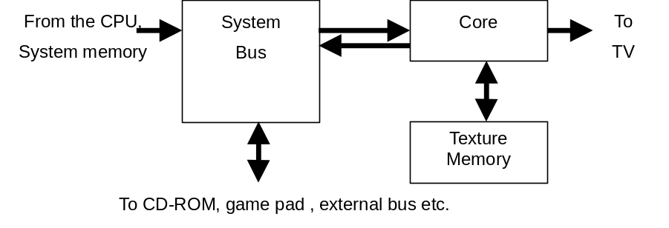

System Bus
Access from the CPU, with some exceptions, occurs through the system bus block.
The system bus is suitable for the DMA of the CPU. It is also suitable for single access of the CPU but due to its transfer capabilities, use from the DMA is recommended.

3.5.2 Core
The drawing of images occur through this block.
Access to the core block is through the system bus block. (Described earlier)
The types of access are described below.
- transfer of the polygon list (draw image)
- writing texture data
- reading texture RAM
- Reading and writing of the core register

Internal configuration- Part 2
The 3 blocks described below basically configure HOLLY.

PVR block
This is a rendering engine and includes the PVR 2 core as well as the texture memory arbiter.

Tile Accelerator(TA) block
This is a block that converts writing from the CPU or polygon data transferred from the main memory through the DMA, and uses the hardware to convert it into PowerVR format and includes YUV conversion, FPU etc.

System bus block
This is a block that transfers data from each block inside HOLLY to the internal bus. Transfer between the main memory and each device connected to HOLLY uses the SH4 DMA (DDT mode).
Below is an explanation of the bus configuration and each interface block.

The configuration is such that each interface block within the system bus block sandwiches the root bus , and access between each device is via the root bus. The root bus has a bus width of 32bit and an operational clock of 50MHz. The data transferring speed including arbitration is 123MHz (13clk/32B).
Each interface block connected to the root bus is described below.

- SH4 i/f
The HITACHI SH4 (internal 200MHz operation), which is the CPU, is an interface for accessing the root bus and connected to the 64 bit A/D (MPX) bus. It is accessed from areas CS0, CS1, CS5 where wait control is possible

- DDT i/f
This uses the SH4 DDT function to access the CPU main memory. The device on the root bus becomes the master bus and if you use DMA transferring to the main memory, DDT i/f becomes the target of each device from and is transferred to the main memory. Additionally it controls DMA access from the main memory .

- PVR i/f
This is the master/target device of the root bus and performs transfers between the PVR block and the TA block (access register). The data transfer is in units of 32B. There is also a DMA function.

- Maple i/f
This is a root bus master/ target device that transfers between the control pad etc. and maple device. The data is transferred in units of 32B. There is also a DMA function.

- G1 bus i/f
This is the master/ target device of the root bus and performs the transfer between the GD-ROM drive connected to the bus and the ROM/FLASH. The data is transferred in units of 32B. There is also a DMA function.

- G2 bus i/f
This is a master/ target device on the root bus and performs the transfer between the audio chip AICA, that is connected to the bus, the modem and the optional external device. The data is transferred in units of 32B. There is also a DMA function.

The ’ Bus Arbiter ‘ (connected to the root bus) performs the arbitration of the root bus and is set from SH4. It is connected to the SH4 i/f.

Outline of drawing images
HOLLY’s image drawing specifications are described below.

- Tile data generation by the hardware
- Removal of the backface polygon due to the hardware (select from register)

- draw image primitive: triangle (can strip) and quadrilateral (can not strip)
- Triangle strip (1～∞)
- Flat shading

- Texture colour：ARGB1555,565,4444
- On-chip palette: 2K byte
- YUV420,422
- Quantumise shrink texture: can shrink up to 1/4 ~1/8
- Rectangular texture, twiddle texture
- Cramp texture co-ordinates , flipping (mirroring)
- Chroma key fix

- Perspective texture mapping
- MIP map
- texture filtering：
- point sampling
– bilinear filtering
– trilinear filtering
– unisotropic filtering (Unisotropic)
- grow shading (RGBA specification /intensity specification can be selected)
- Specular Highlight
- Shadow (within shadow volume it displays separate texture)
- Simple reduce brightness shadow (1/4,1/2,3/4 simple shadow)
- 4x4 dithering
- rectangular clipping of pixel unit or tile unit
- colour cramp
- Fog：LUT method, linear/Exp.
- Fog colour settings are possible.
- Interpolation of the maxima α
- αblending: Open GL compatible
- automatic sorting of αpolygon possible
- Depth comparison: Open GL compatible
- Edge anti-aliasing
- BAMP mapping

- 16.7 million colours displayed
- Flicker filtering

- Internal 3D pixel format: 32BPP RGBA (16bit texture is expanded 24bit internally, then used.)
- CPU co-ordinate data format: 32bit , minimum number of fluctuations(IEEE754)
- Texture cache size: 128 entry

Etc.

Table 3-2 describes the NTSC/PAL modes suites to HOLLY.
With regard to the interlace mode, ‘single density’ displays the same image as the EVEN/ ODD field and ‘double density’ displays a different image to the EVEN/ODD field. Double density is better for the vertical resolution when viewing but the ’flicker’ phenomenon occurs. In this case, if you use the mode where you assign part of HOLLY’s texture memory as the frame buffer, flickers are reduced.

Resolution | Refresh rate and interlace mode | Reference
320x240 | 60 Hz non-interlace | NTSC low-res non-interlace
320x240 | 30 Hz interlace | NTSC low-res single density interlace
640x240 | 60 Hz non-interlace | NTSC high-res. Non-interlace
640x240 | 30 Hz interlace | NTSC high-res. single density interlace
640x480 | 30 Hz interlace | NTSC double density interlace (Flicker free possible)
320x240 | 50 Hz non-interlace | PAL low-res non-interlace
320x240 | 25 Hz interlace | PAL low-res single density interlace
640x240 | 50 Hz non-interlace | PAL high-res. non-interlace
640x240 | 25 Hz interlace | PAL high-res. single density interlace
640x480 | 25 Hz interlace | PAL double density interlace (Flicker free possible)

Table 3-2 NTSC/PAL resolution display

The texture memory stores the data below in the shared memory. Although it does not have the transfer capability of the system memory, the CPU can be used as a work area.
- texture data
- frame buffer

When displaying the interlace, depending on what colour is displayed, the flickering lustre may be annoying. This is called ‘flicker’ and the Dreamcast system supports the flicker filtering functions that are described below.

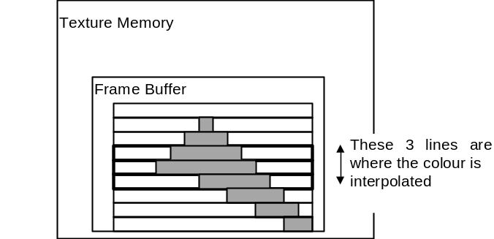
Diagram 3-2 Flicker filtering

Apart from the NTSC/PAL display mode, HOLLY uses settings from SH4 to display the VGA resolution that you can select from table 3-3. Additionally VGA monitor output from the Dreamcast console is not adapted for the A/ V connector but for another special connector.

Resolution | Refresh rate and interlace mode | Note
640x480 | 60Hz non interlace | VGA
Table 3-3 VGA Resolution

External interface specification
The interface specifications of HOLLY and each supported device are described below.

G1 bus
The G1 bus is connected to the GD-ROM drive and the ROM/ FLASH (space 2MB and bus width 8bit). Access to the GD-ROM uses an interface similar to EIDE (similar to ATA) but part of the bus signal line has multiplexed signal lines that are used for ROM/FLASH access. Additionally part of the address line to ROM/FLASH has multiplexed MODE signals which are incorporated in the system information. The bus operation is not synchronised and at the time of GD-ROM access the data bus width is 16 bit although at the time of ROM/FLASH access, it is 8 bit. The real transfer speed at the time of GD-ROM access is 10MB/s (2880ns/32B).

G2 bus
G2 bus is a bus like PCI that has an operational 25MHz clock and a bus width of 16 bit and is in parallel connection to the audio IC AICA, the modem and the optional external device. The real transfer speed is 40MB/s (19 clk/32B).

Maple
This is an original Sega peripheral interface that supports the connection of peripheral devices such as the control pad and backup media. Up to 4 ports can be connected. Data transmission occurs by the synchronised serial method. The maximum data transfer rate is 2Mbps and the real transfer speed of the port is 128KB/s. With regard to details on specifications, refer to Appendix. Maple i/f or other material.

Data path
The data path between HOLLY and each device is described below.

1) The following types of access are possible from SH4 to each block or device.

- write (only) from the (SH4) to the (TA block(data FIFO))
(Add ‘It goes through SH4i/f and ’ to the beginning of the next 4 lines.)
PVR i/f then reads/writes to the (texture memory), (PVR2 core) and (TA block (register))
Maple i/f then reads/writes to the (Maple Device)
G1 bus i/f then reads/writes to the (ROM/FLASH) and (GD-ROM drive)
G2 bus i/f then reads/writes to the (AICA (register/memory)), (MODEM) and (optional external device)

2) The main paths supporting DMA transfer access from each device other than SH4 are described below.

- write (only) from (main memory) to (TA block (data FIFO))
- read/write from (Maple device) to (main memory), (PVR2 core) and (each G2 device)
- read/write from (each G1 device) to (main memory), (PVR2 core) and (each G2 device)
- read/write from (each G2 device) to (main memory) and (PVR2 core)

For details on the G1/G2 bus cycle, timing etc and the bus specifications, refer to the material on each bus. Also, for details on the specifications of each device on the bus, refer to each relevant section. Regarding the locations of each G1/G2 device from SH4 (address: memory) map, refer to the section (CPU: SH4) titled memory map.

Interruption processing by HOLLY
HOLLY is the interrupt master for SH4 and is subject to interruption signals from each block or from each device connected to the interface and has a INTERRUPT CONTROLLER which generates interruptions to SH4. When interruptions are generated from each block, HOLLY will internally store the status of each interruption on the interrupt register and assign a change in level for SH4 IRL1, 2. Each type of interruption can be masked and the INTERRUPT CONTROLLER performs masks or clears.
As stated before, there are 2 types of interruptions- ones from the interior of HOLLY such as the PVR2 core block and ones from each device connected to the G1/G2 bus. With regards to the reasons for these interruptions, please read the descriptions for each block below. (For the processing of SH4 interruptions please refer to the section (CPU: SH4). It will be under Interruptions.)

Below are the interruptions for each interface block within the ’System Bus Block’.
* PVR i/f
- DMA End (Completion of DMA transfer: same for below )
- PVR Illegal address set
- DMA over run
* Maple i/f
- DMA End
- V Blank over
- DMA over run
- Write FIFO Overflow
- Illegal command
- Illegal addressing
* G1 bus i/f
- DMA End
- Illegal Address set
- DMA over run
- ROM/FLASH access at DMA
- From GD-ROM drive (Interruption from the GD-ROM)
* G2 bus i/f
- DMA(AICA)End
- DMA(Ex0)End
- DMA(Ex1)End
- DMA(Dev)End
- DMA(AICA)Illegal address set
- DMA(Ex0)Illegal Address set
- DMA(Ex1)Illegal Address ｓｅｔ
- DMA(Dev)Illegal Address ｓｅｔ
- DMA(AICA)over run
- DMA(Ex0)over run
- DMA(Ex1)over run
- DMA(Dev)over run
- Time out
- From AICA( Interruption from the sound chip AICA)
- From Modem ( interruption from the modem)
- From ExDEV( interruption from the optional external device)
* DDT i/f
- DMA(ch2) completed
- Sort DMA Command Error
* SH4 i/f
- Time out
- Accessing to inhibited area
* Bus Arbiter
- Root Bus Reset Time Out

Interruptions from the ’PVR core block’ are described below.
- V blank in (Once at the starting point)
- V blank out (1line before that display starts)
- H Blank In: each H, several H and/or select from the specified line of the register
- End of Render ISP
- End of Render TSP
- End of Render Video
- Hazard Processing (This occurs when you are using Strip Buffer and draw image does not occur on time.)
- ISP Out of Cache(Overflow of ISP Buffer )

Interruptions from the ’ Tile Accelerator Block ‘ are described below.
- End of Opaque (Transfer of Opaque Polygon complete)
- End of Translucent ( Transfer of Translucent Polygon complete)
- End of Opaque Modifier ( Transfer of Opaque Modifier Volume complete)
- End of Translucent Modifier ( Transfer of Translucent Modifier Volume complete)
- End of YUV Transfer ( Transfer of YUV422 data complete)
- ISP/TSP Parameter Overｆlow ISP or overflow of TSP parameter)
- Object Ｌｉｓｔ Overflow( Object List Pointer Overflow)
- FIFO Overflow (FIFO Overflow)
- Illegal Parameter ( Occurrence of abnormal data)

Audio processor：AICA
AICA which is a YAMAHA made audio IC, is a refined version of the audio IC SCSP used in the Sega Saturn. With respect to the Dreamcast system it generates 64ch PCM / ADPCM /stereo sound.

4.1 AICA peripheral connection
Figure 4-1 is a connection diagram of AICA peripherals.

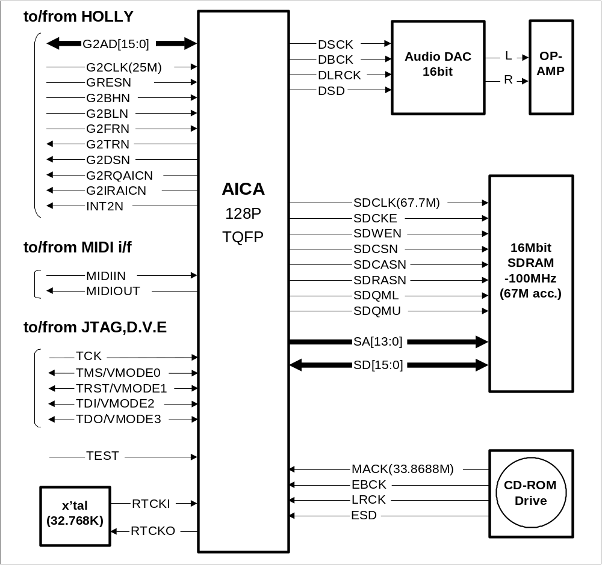
Figure 4-1 AICA peripheral connection diagram

4.2 Chip specification
The main chip specifications for AICA are described below.

- Package 128pin TQFP
- Process 0.35μm
- sound source clock 22.5792MHz
- system i/f clock 25.0MHz
- Power supply 3.3V

4.3 pin specification
Table 4-1 below contains the specifications of the signal pin.

PIN NAME | I/O | FREQ. | DESCRIPTION | I/F level
VDD3 |  |  | System’s 3.3V power supply
VRTC |  |  | Power supply pin to RTCpin
VSS |  |  | System’s GND pin
G2CLK | I | 25M | Clock signal used by the HOLLY I/F(G2 BUS) block | LVTTL
G2AD[15:0] | I/O | 25M | Address signal pin used by the HOLLY I/F(G2 BUS) | LVTTL
G2BHN | I | 25M | Signal pin used by the HOLLY I/F(G2BUS) and represents the ’High Enable’ of data or the bus mode | LVTTL
G2BLN | I | 25M | Signal pin used by the HOLLY I/F (G2BUS) and represents the ‘Low Enable’ of data or the bus mode. | LVTTL
G2FRN | I | 25M | With respect to the G2 BUS I/F, it is a signal pin that represents the start or completion of a cycle. | LVTTL
G2TRN | O | 25M | With respect to the G2 BUS I/F, it is used to control the cycle | LVTTL
G2DSN | O | 25M | With respect to the G2 BUS I/F, it is used to control the cycle | LVTTL
G2RQAICN | O | 25M | This is a signal pin used by the HOLLY I/F (G2 BUS) and is a DMA request signal. | LVTTL
GRESETN | I |  | This is a system reset signal from HOLLY(G2 BUS) | LVTTL
G2IRAICN | O |  | interrupt signal from AICA | LVTTL
MACK | I | 1024Fs | Sound block clock( Fs = 44.1KHz ) | LVTTL
ESD1 | I | 1024Fs | Digital Audio Data #1 from outside | LVTTL
EBCK1 | I | 1024Fs | Digital Audio Clock #1 from outside | LVTTL
LRCK1 | I | 1024Fs | Digital Audio LR Clock #1 from outside | LVTTL
ESD2 | I | 1024Fs | Digital Audio Data #2 from outside | LVTTL
EBCK2 | I | 1024Fs | Digital Audio Clock #2 from outside | LVTTL
LRCK2 | I | 1024Fs | Digital Audio LR Clock #2 from outside | LVTTL
DSCK | O | 256Fs | clock signal to external DAC | LVTTL
DSD | O | 44.1K | Digital Audio Data to external DAC | LVTTL
DBCK | O | 44.1K | Digital Audio Clock to external DAC | LVTTL
DLRCK | O | 44.1K | Digital Audio LR Clock to external DAC | LVTTL
MIDIIN | I |  | MIDI interface signal | LVTTL
MIDIOUT | O |  | MIDI interface signal | LVTTL
SD[15:0] | I/O | 67.8M | Wave Memory(external SDRAM)Data | LVTTL
SA[13:0] | O | 67.8M | Wave Memory Address output | LVTTL
SDQML | O | 67.8M | Control signal to Wave Memory | LVTTL
SDQMU | O | 67.8M | Control signal to Wave Memory | LVTTL
SDCLK | O | 67.8M | Clock signal to Wave Memory | LVTTL
SDCKE | O | 67.8M | Clock enable signal to Wave Memory | LVTTL
SDWEN | O | 67.8M | control signal(write) to wave memory | LVTTL
SDCSN | O | 67.8M | control signal(chip select) to wave memory | LVTTL
SDCASN | O | 67.8M | control signal(CAS) to wave memory | LVTTL
SDRASN | O | 67.8M | control signal(RAS) to wave memory | LVTTL
RTCKI | I | 32K | Clock pin for RTC | LVTTL
RTCKO | O | 32K | clock pin for RTC | LVTTL
TCK | I |  | Clock signal for JTAG I/F | LVTTL
VMODE0/TMS | I |  | Mode signal to DVE(VideoDAC.Encoder) / JTAG Mode Selection | LVTTL
VMODE1/TRST | I |  | mode signal to DVE / JTAG reset signal | LVTTL
VMODE2/TDI | I |  | mode signal to DVE / JTAG data input signal | LVTTL
VMODE3/TDO | O |  | mode signal to DVE / JTAG data output signal | LVTTL
TEST | I |  | mode signal to DVE and JTAG I/F switching signal | LVTTL
Table 4-1 AICA signal pin list

4.4 Main configuration and spec
Figure 4-2 is a block diagram of the interior of AICA.

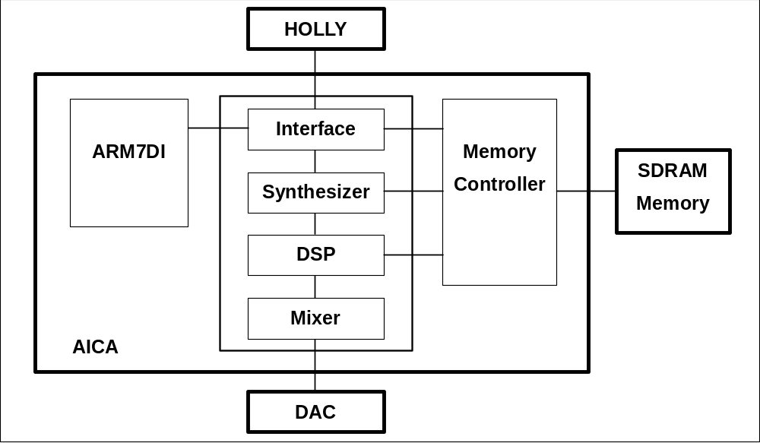
Figure 4-2 block diagram of the interior of AICA

The main block configuration of AICA is divided into the sound block (sound source part) and internal CPU and secondly the memory i/f block. The sound block is a block that includes the interface part, sound source part and the DSP part. The interface part is a block that is an interface of exchange with the Dreamcast system, through the internal CPU and the HOLLY G2 bus i/f, including SH4, RTC and MIDI. The internal CPU uses ARM7DI. The step of DSP is 128 step. The external memory uses the SDRAM (explained later). The sound block and the the internal CPU has a 22.5792MHz clock supplied from the GD-ROM drive and just like the memory i/f, it is 67.7376MHz from the GD-ROM drive clock. The HOLLY i/f is a 25 MHz clock supplied from the G2 bus.
With regard to external sound input, there are 2 types of audio signal input. With the Dreamcast system, there is 1 type of input from the GD-ROM drive GD-DA (LRCK, BCK, and SDATA). As stated before, the 33.8688 MHz clock supplied from the GD-ROM drive is converted to the sampling frequency 44.1KHz in the internal PLL, operational sound block clock as well as the memory i/f clock.
Apart from the memory i/f shared by each block (external SDRAM), AICA has 2, 3V Lithium batteries attached which allows the support of RTC (Real Time Clock) with backup and the MIDI i/f used for development. The internal CPU supports the JTAG i/f.

The specification of the sound source part is displayed in table 4-2 and represents the main sound source specs for AICA. The maximum number of simultaneous sounds is 64 sounds and each slot has an independent LFO. The ADPCM is a maximum of 1oct and the pitch can be changed. The PCM format is 8/16bit Liner, 4bit ADPCM.

PCM channel | 64ch | ADPCM and combined use
PCM format | 16bit / 8bit
ADPCM decoder | 64ch | PCM and combined use, 4bit ->16bit
Time fluctuation filter | 64ch | Features 64Ch 4 segment EG suitable for time fluctuation filter
Monaural MIX | Hard | Volume adjusted by using the master volume
Loop | Forward
Sampling frequency | 44.1KHz
Table 4-2 main sound source spec

4.5 Audio Memory
The (audio) memory that is externally connected to AICA is shared by the internal CPU and/or the sound source within the sound block, DSP and the external i/f. Table 4-2 shows the details used by the memory.

Memory space | 2MB (can be expanded to a maximum of 8MB)
Technology | 16Mbit SDRAM  (2 bank x 512kword x 16bit)
Number of memory chips used | 1
Bus Width of chip | 16 bit
Operational specification CLT | 2(fixed)
Operational specification BL | Full Page (fixed)
Frequency | 67.7376MHz
Table 4-2 AICA audio memory specification

4.6 RTC (Real Time Clock)
AICA has an internal chip with a RTC (Real Time Clock) operating at 2.0~3.5V. AICA has 3V lithium battery for the RTC that can be used for battery back up. The 32.768 kHz x’tal used as the clock source is also attached. The power consumed is less than 10μ A and the battery backup period is approximately 270 days. (Battery equivalent to ML3032 when recharging.)

4.7 Audio In/Output
Digital audio signals created by AICA can be mixed with the digital audio signal input from the GD-ROM drive 48Fs(=2.1168MHz) and the output passes through the external analogue DAC and/or the encoder and becomes output from the RCA connector and the expansion VGA connector. The external analogue DAC has 256Fs(=11.2896MHz) clock and/or 64Fs(=2.8224MHz) Digital Audio (DSD, DBCK, DLRCK) output.
(AICA has 2 types of Digital Audio input but the Dreamcast system only uses the one from the GD-ROM drive.)

4.8 Setting the image mode
AICA has a register that sets the various types of Dreamcast image (video) modes such as NTSC/PAL and VGA that are accessed from SH4. The content of that register reflects the image mode set by the draw image processor HOLLY from SH4. From AICA the image mode depending on the register value becomes mode signal(VMODE0～3) output from the D.V.E (Digital Video Encoder).
With regards to image mode settings please refer to 7.4 (video output and/or image mode setting method)

4.9 MIDI interface
The MIDI interface (MIDI IN/OUT) is supported for audio development.
MIDI interface becomes a 3.3V signal output to G2 i/f.

4.10 Interrupt
Interruptions are generated through the G2 bus and against HOLLY. Interruptions from the sound block are a type of interruption generated by AICA internally.
For details on interruptions refer to the sections (CPU: SH4) and (draw image processor HOLLY)

-- End of AICA --

Boot ROM
The Boot ROM is mapped to area0of SH4 and is accessed by the CPU. With respect to its location on the system, it is connected to the multiplexed G1 bus from the HOLLY ROM i/f. The G1 bus only has an 8 bit ROM interface when the SH4 Boot ROM is accessed.

Boot ROM configuration
The Boot ROM stores the data described below.
There are 2MB of ROM space. Table 5-1 contains estimates for the amounts of space used for data within the Boot ROM.

Details of the data | Necessary space
IPL | 0.25MB
Multi player (includes draw image/audio data) | 0.75MB
Kanji Font | 1MB
TOTAL | 2MB
Table 5-1 Details of the ROM data

Specifying a ROM
The ROM is a 16M bit (2MB) mask ROM with a 8 bit bus width and has an access time of 100~240ns.
The table below is the specified ROM details used by the Dreamcast system.

ROM type | Mask ROM
ROM size | 16Mbit
Bus width | 8 bit
Access time | 100ns～240ns
Table 5-2 Specifying ROM

About the access cycle to the ROM
As stated previously the Boot ROM is located on the G1bus. With regards to the bus cycle set-up or hold of an address, reading and writing is possible. The pulse width can be specified through the HOLLY register. Regarding the number of access cycles, 1 byte, 2 byte and 4-byte access is possible.

-- End of Boot ROM--

GD-ROM
The GD-ROM drive incorporated in the Dreamcast system is connected to the G1 bus which has HOLLY as the master and the GD-ROM data goes through HOLLY before it is read by the CPU. The reading of data is by the CAV method and the transferring of data is approximately 4 times the speed in the normal area and approximately 6~12 times the speed in the high-density area. It is stored in the drive’s 128KB corrected memory.
Opposed to the Audio IC AICA, it supplies the digital audio playback signal and the 33.8688MHz clock that is the audio clock source. Additionally there is a 33.8688MHz x’tal built into the drive.

Specification outline
The specification outline is below.

(Functions)
- adapted to GD-ROM (Giga Byte Disc: Sega original)
- Replay of CD-DA and GD-DA, stop ,pause ,both directions jump ,both directions scan replay
- Open and close door
- Compatible with various CD formats…CD-DA, CD-ROM XA, Photo CD, Video CD, CD Extra

(Performance)
- Digital Audio output 48Fs (Fs＝44.1 kHz)
- Read method CAV
- Correction memory space 128KB (buffering, DA shock proof and shared)
- data transfer speed
Single density area approx. 600KB/s (4x speed)
Double density area approx. 900 (6x speed)～1800 KB/s (12x speed)
From the buffer approx. 11.1 MB/s (PIO Mode3)
Approx. 13.3 MB/s (Multi word DMA Mode2)
- 1/3 stroke average access time
Less than 350ms (when first shipped)
- Full stroke average access time
Less than 600ms (when first shipped)
- Error rate
CD-ROM Mode1 less than 1×10^{－12}
CD-ROM Mode2 form1 less than 1×10^{－12}
CD-ROM Mode2 form2 less than 1×10^{－9}
CD-DA less than 1×10^{－9}
GD-ROM Mode1 less than 1×10^{－12}
GD-DA less than 1×10^{－9}
- Disc data space
General CD approx. 656MB(CD-ROM Mode1)
GD approx. 1020MB(GD-ROM Mode1)

(Power)
- 3.3V ± 5%
- 5.0V ± 5%
- 12.0V ± 10%

(Possible operational temperature)
0℃ ~ 55℃ 20％ ~ 85％RH

Interface
With regards to the Dreamcast console and the GD-ROM drive interface protocol, please refer to the separate document ’GD-ROM protocol SPI specification design’.

Digital audio
Audio signals from the GD-ROM (BCK, LRCK, SDATA) are clock synchronised 48Fs(Fs=44.1KHz) and input into the AICA external audio input pin then digitally mixed with audio generated from AICA internally before it becomes output.

-- End of GD-ROM --

Other
Options, peripheral devices and settings that have not been explained yet, are described below.

Control Pad
The Dreamcast system control pad is accessed through the HOLLY Maple i/f and supports up to 4 pads. Additionally this port is adapted for the use of the light gun as well as the backup media described later.
With regard to the Maple interface, please refer to separate documentation or the section (draw image processor: HOLLY), Appendix and the description of the Maple interface.

Backup media
This is used to backup (save etc) game data and is connected to the control pad sharing the HUB connected to the HOLLY Maple i/f. The Dreamcast console can directly support up to 4 media. With regard to details of the backup media please refer to other documents.

Modem
The communication speed is 33.6Kbps and the card has a LINE terminal. The compression of data, correcting of errors etc. is performed by SH4. With respect to details on the modem, please refer to separate documents.

Video output/ image mode settings method
As stated in the section (draw image processor: HOLLY), the Dreamcast system can use various video modes to display graphics. Since the Dreamcast console is compatible with various types of monitors, there are many types of connectors that are supported. Below are the various supported connectors and the signals from the connector.

- RCA connector : Audio signal( L,R ), composite video signal
- S image connector : S image signal( imageY+S signal , Chroma signal )
- Expansion VGA connector : Audio signal( L,R ),analogue RGB, composite,sync (H,V),mode signal, power
- (5V,12V)
( * Expansion connector is an optional connector for RF converter, RGB cable, and VGA cable)

The selection of the image display mode is through the insertion and removal of the monitor’s expansion VGA connector and that information is reflected in the SH4 PIO interface (PIO [1:0]). Setting occurs from SH4 to HOLLY or each image mode register of AICA. RGB signal and/or the image mode signal output is from each individual chip.
Table 7-1 shows the relationship between SH4: PIO and the image mode. Figure 7-1 shows the image mode setting method.

PIO1 | PIO0 | MODE
1 | 1 | TV(NTSC/PAL)
1 | 0 | VBS/Y+S/C
0 | 1 | RGB
0 | 0 | VGA
Table 7-1 SH4:PIO image mode settings

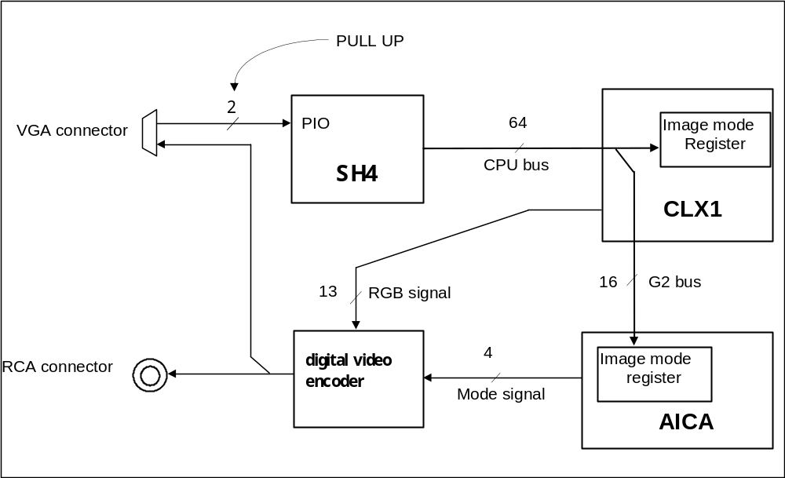
Figure7-1 image mode settings method

From HOLLY, the 24bit RGB image information (each RGB 8bit) is sent in units of 12 bit to the Digital-Video-Encoder (video DAC/encoder). The original 24 bit image data is divided into 12bit(RGB [11:0]) of MSB (RGB [11:0] = R [7:0], G [7:4]) and 12 bit of LSB (RGB [11:0] = G [3:0], B [7:0]). Then it is sent to the 54 Hz clock (which is double the 27Hz VGA pixel-clock) in a synchronised manner where it alternates between MSB and LSB. For details refer to a separate specification design document.
PLL
This is a main clock source device that does not include the system RTC and sound. Its 1 x’tal allows it to supply each clock. The clock supplies SH4 and HOLLY.
Each output from this PLL is unified regardless whether or not the video spec of the image mode is NTSC/PAL etc. Below is the list (units are <MHz>)

x’tal | To SH4 | To HOLLY/pixel
13.5 | 33.33333 | 54.0
Table 7-2 output clock list

Power Supply
The console has a built-in unit which has a domestic power supply of 100 ~120V AC which is directly inputted. Each of the 3.3 / 5.0 / 12.0V DC power supplies supply the main /GD-ROM power supply which includes the CPU, graphic chip, memory IC, peripheral IC etc. The 1.8V DC or 2.4V DC internal power supply from SH4/HOLLYis supplied from a separate power supply IC rather than 3.3V DC.

Reset Sequence
The reset sequence of Dreamcast is described below.

-- End of other--
Maple i/f
Supplementary explanation of the Maple i/f is below. With respect to the details of the Maple i/f specifications, please refer to separate material.

Maple i/f is an original Sega peripheral interface and is a serial interface that supports the connection of the control pad and backup media (B/U) etc. The Dreamcast console supports a maximum of 4 ports and devices can be connected to a maximum of 4 ports. With regards to the backup media, they are connected to the control pad that shares the HUB connected to the console’s Maple port.

 | (Port 0) | (Port 1) | (Port 2) | (Port 3)
Signal line | SDCKA0 | SDCKA1 | SDCKA2 | SDCKA3
Signal line | SDCKB0 | SDCKB1 | SDCKB2 | SDCKB3
power cable common to each port | VCC | VCC | VCC | VCC
power cable common to each port | GND | GND | GND | GND
Table C-1 Signal lines used by Maple i/f

Table C-1 is a list of signal lines used by the Maple i/f. The data transmission uses the synchronised serial method and talking in terms of 1 port, there are a total of 4 lines- the power cable (VCC, GND), SDCKA (both directions) data cable and SDCKB (both directions). The sending of data in both directions is 半2重 and the data transfer rate is a maximum of 2Mbps or a minimum of 250Kbps. Data transmission occurs in the units of frames (smallest unit) and the content of the frame starts from the START pattern which signifies the start of data transmission. A 1024 byte long (DATA) pattern, (parity) and (END) pattern configure it. (Parity) is horizontal and 8bit and is automatically added by the hardware when sending and deleted upon receiving.
The configuration of the controller consists of a 32 bit system register(SYSREG), sent data table Address Register(AREG), Status register(SREG), Assigned Parameter Clear Register(IREG), received data store address boundary setting Register(BREG) and a 32bit×8 word sent FIFO (TxD FIFO) from the received FIFO(RxD FIFO).

The basic operations are described below.
The peripheral controllers are synchronised to the V_BLANK signal (can be set to be postponed by the system register) and the sent data on the main memory which is described by the sent data table address register and is loaded to the sent FIFO (master operation)
Sent data is configured by the command+sent data store address+sent out data. Commands are to the peripheral controller, and set the length of command completion output port and sent out data. If there is no indication that the command is complete then as soon as the sent FIFO becomes empty, sent data in the main memory is loaded in 32 byte units by the sent FIFO. The sent data store address has a lead address for storing sent data. Sent data is data that is administered by the Maple protocol and is transferred to the peripheral devices in units of 4 bytes. Sent data from the peripheral device are in 4 byte units and is transferred to the main memory as soon as the sent FIFO becomes full. However, even if FIFO isn’t full, as soon as sending is complete it forces 32-byte transfer. (valid data＋invalid data)
If the peripheral device is not connected and time out, frame error etc. occurs, the 32bit value of 0xffffffff is written into the sent data store address that is appropriate for the command. (The lead data for the sent data store address is guaranteed except when the data is 0xffffffff because of the software protocol)
Once the string of operations has finished, the peripheral controller will stop operating and reflect the situation in the status register.

------------End-------------

