Conclusion About Our Design

By Kocin Sabareeswaran Bama

The application of our design was to write to the tag from external source (sensor) using a microcontroller and being able to read the data using a RF reader. Our system was able to write the data using I2C without any issue when run multiple times. Any data that needs to written to the tag via microcontroller was written given the serial busses were working properly. When the tag was interrogated by the reader, we had few restrictions. One, we get an error at the reader when tag was already being written with I2C. This was a major issue when we had a loop from Arduino that repeatedly wrote data to the tag. We can over come this issue by stopping the I2C communication when it was not necessary (i.e., when the desirable data was written). Secondly, our reader can read multiple blocks (each with 4 bytes) in only one sector at once. So, to get the data in the next sector we are required to repeat the read multiple blocks command with the starting block as the first block in the next sector. This can be resolved by having an iterative function for sending requests depending on the number of blocks

The fundamental part of the project is working well. We can read and write the data multiple times. This could further be utilized to write data from a sensor into the tag, where the tag requires power from a battery only when the I2C communication is in process and for RF mode the power is supplied by the reader. We can say our tag is BAP (Battery Assisted Passive).

Our system was meant to store user’s medical information (such as medication, blood group, allergies and etc.) and present time vital information, such as blood pressure, temperature and/or heart beat details. With a facility to lock each sector in the memory block we can configure our tag to password protect the data available for the world to view. This gives the user a freedom to choose who can read or write to the tag’s memory.

Our system can have a read distance of up to 150cm with right design for the antenna. The data rate from the reader to the tag is 1.65 Kbit/s or 26.48 Kbit/s Data Rate. We can choose between the data rate of our communication with the command used, for example command code 0x23 reads multiple blocks at 1.65Kbits/sec and command code 0xC3 reads multiple blocks at 26.48Kbits/sec. Data rate from tag to the reader, the device supports the one−subcarrier with 423.75 kHz (fc/32) frequency and two−subcarrier response with 423.75 kHz (fc/32) and 484.28 kHz (fc/28) frequencies. The one−subcarrier or two−subcarrier response format is selected by the RF Reader, here is a figure with data rate details.  
  
 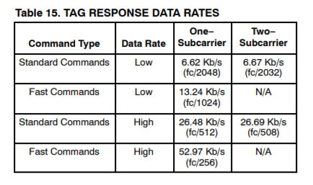

The I2C communication between the tag and the processor supports two frequencies Fast (400 kHz) and Fast−Plus (1 MHz). The tag supports 2,000,000 Program/Erase Cycles, has a 200-year data retention and can operate in temperature range -40oC to 150oC, making it more reliable and usable in vast variety of environments for long term.

The cost of our product includes approx. 20kr for the tag IC, 30 – 40 SEK for the processor, 10- 20 SEK for the sensor and 15 SEK other materials, which gives us a total price below 100kr. The cost of the product should be affordable as it is close to the average price of an individual’s meal in Sweden. The target audience would be elderly people or patients who wants to check their vital in their daily life and all they need is their phone that uses NFC. This can also be used in hospitals for doctors to check the patient details that is stored in the tag and sensor data without having to move the patient every time a data has to checked. Since the memory can be set to password protected the personal information of the patient is secure from anyone to read.

There are somethings in the product that could be improvised like the using less power for the microcontroller and sensor, getting accurate data from sensors, more user-friendly interface to interact with the tag. Also, since we intended to have this product in form of a patch or bracelet it is important for the product to be small and compact.

Although there is room for improvement, this product will be beneficial to the customers in need. It saves time and is convenient to use. It protects the patient’s privacy and is easy to read from your phone (if it supports NFC). It can be used in long term and in various environments.