SPOT – Assembly

Step 1:
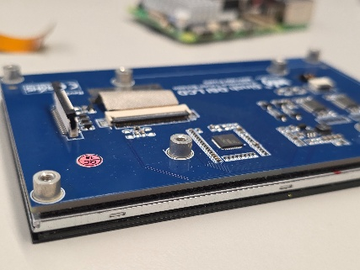
Unbox all the items and lay them out on a table. Then, make sure that all the spacers are removed from the backside of the screen. It should look like this:

Step 2:
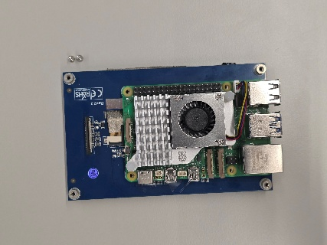
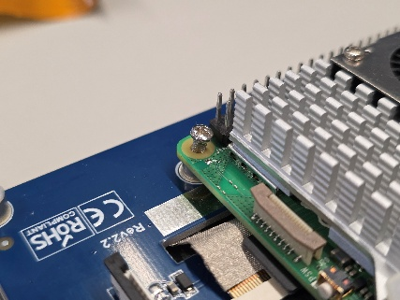
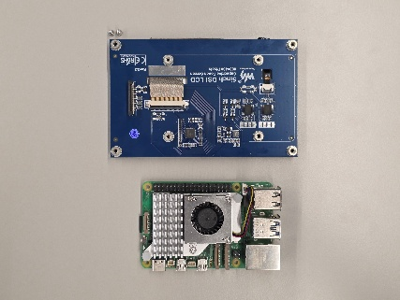
Install the Raspberry Pi 5 using the included screws.

Step 3:
Assemble the connector board using the plastic screws and spacers you ordered, then connect the ribbon-cables to the Pi Camera Module 3 and the screen.
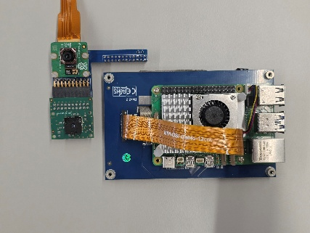
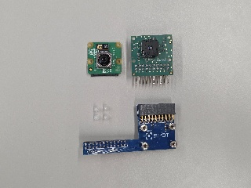

Step 4:
Attach the connector-pcb assembly to the Raspberry Pi 5. Make sure to use the outermost pins to avoid causing shortcuts.
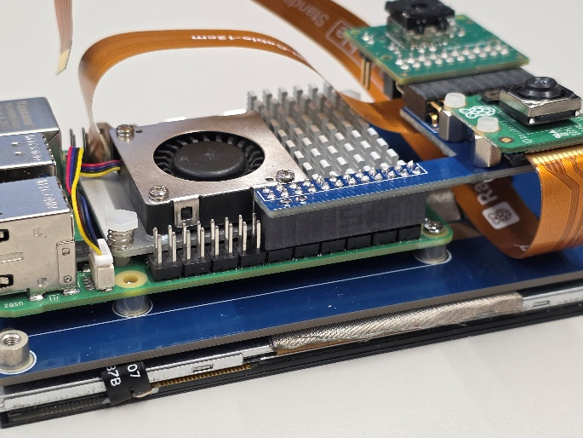

Step 5:
Connect the ribbon cables of the Pi Camera Module 3 and the screen to the Raspberry Pi 5. The screen’s cable should use the connector on the left.
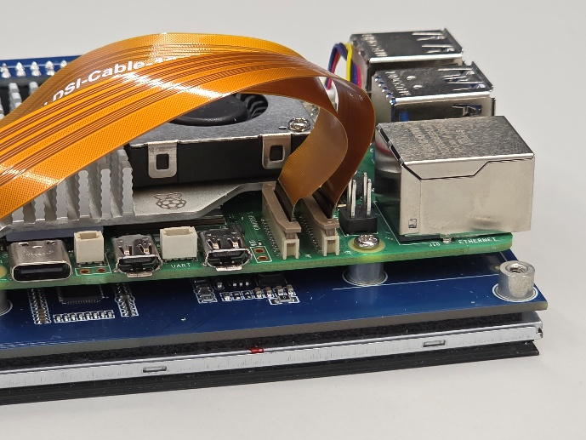
Screen

Step 6:
Mount the tall standoffs at the edges of the screen.
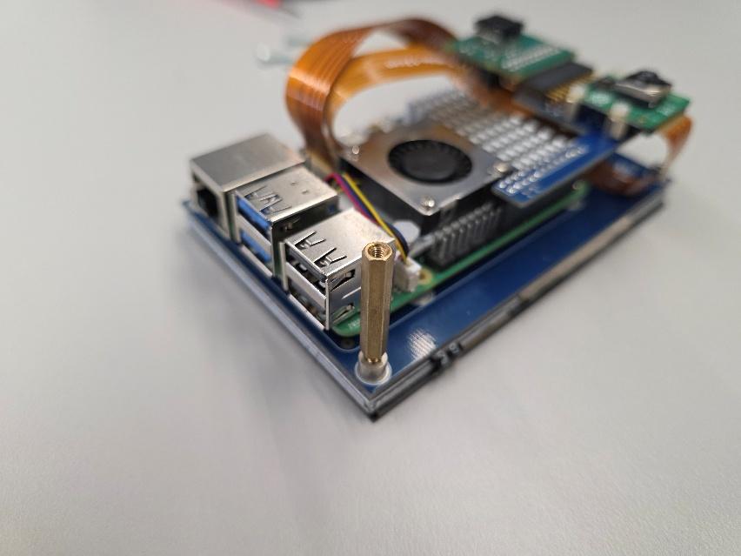

Step 7:
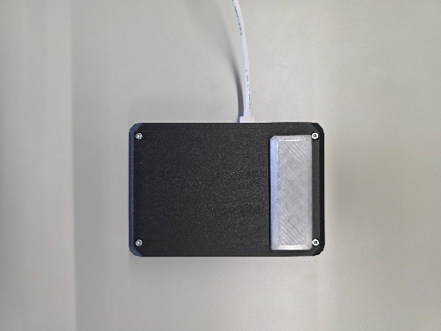
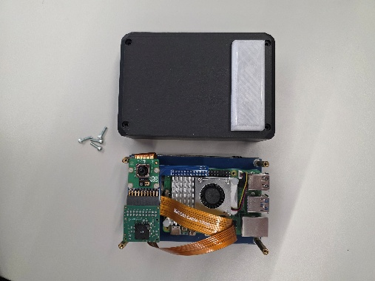
Install the assembly into the 3d-printed case using four M2.5*14mm screws. Note: You may have to use some force to push the assembly into the case, depending on your 3d-printer’s tolerances

