LABIRYNTH GAME
Albert Pyrgies
Sebastian Koczotowski

The game is a simple Labirynth game with one player, one level and manually created walls to move in between. The goal of the game is to get from predefined starting point to finish point 0.
The code uses functions to define walls and player movement.

Still uresolved are the following issues:

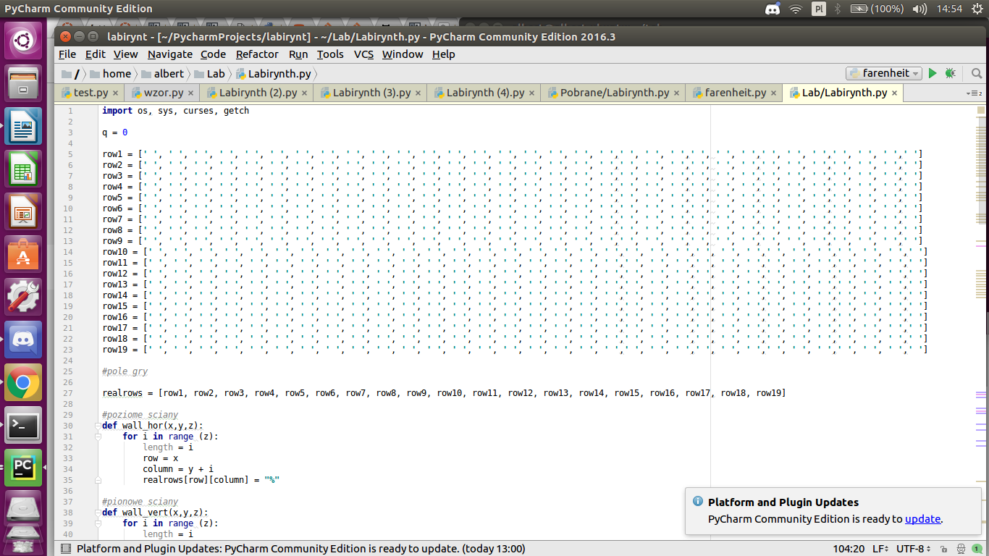

FEATURES:
- created a game matrix
- created labirynth
- set player position

PROBLEMS:
- player can move through walls
- player can move outside of board
- code is too big (matrix lists)

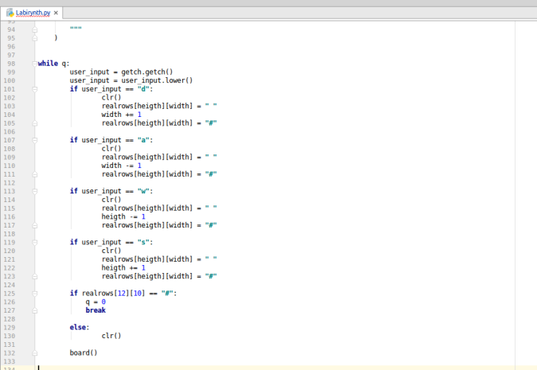

FEATURES:
- created gaming board and moving player
- added screen clearing to code (module import)
- enabled WSAD keys to serve as movement keys

PROBLEMS:
- global variables in functions
- duplicated functions
- imperfect while loop

SPECIFICATION ABOUT FURTHER DEVELOPMENT

1. MATRIX (shortening the code, shortening the lists)
2. WHILE LOOP (removing duplicate „if’s” and putting them in one function)
3. SPACE (removing spaces from string in print function)
4. PLAYER OUT OF RANGE (keeping player inside the defined board)
5. ICON/IMAGE (Adding fancy player icon)
6. CODE (remove global variables from functions)

BETA/EXTRA FEATURES (LOW PRIORITY):
1. Random level/board generator
2. Main menu / option selection

