PRODUCT RESEARCH • JULY 2026
Board Climbing Apps
and Route-Setting UX
Research, marking conventions, kickboard rules, data model guidance, and mockups for Board AF
A practical reference for turning one fixed home-board photograph into an understandable, safe-to-author problem library—without losing the special semantics of the kickboard.
● START ○ HANDS + FEET ◌ FOOT ONLY ◎ FINISH
Prepared for Board AF • Research snapshot: 18 July 2026

Executive summary
Board-climbing apps converge on a simple interaction: choose a board, select a problem, and highlight its holds. The hard part is not drawing rings; it is expressing the rules unambiguously. Standardized boards solve identification with a fixed layout and LEDs. Custom spray-wall apps solve it with a photograph and a saved hold map. Across both categories, the strongest products treat start, usable, foot-only, and finish as distinct semantics and keep the foot policy visible. [1–11]
PRIMARY RECOMMENDATION Model the kickboard as a board-level zone whose holds are foot-capable only. Then model each problem's foot policy separately. This prevents a kickboard hold from ever becoming a hand start or finish while still supporting either marked kicker feet or an open kicker.
- Rename the current HAND role to REGULAR or HANDS_AND_FEET; on the major LED systems, intermediate holds can normally be used by hands or feet, while foot-only is the restrictive role. [2, 5]
- Use role color plus a second cue: start = center dot/S, regular = solid ring, foot-only = dashed ring/F, finish = double ring/check. Color alone is too easy to lose against chalk, poor light, and color-vision differences.
- Make foot rules a required, visible problem property. Useful presets are Marked feet only, Open kickboard, Feet follow marked, Any feet, and Campus. MoonBoard and Crux both expose foot-policy variants rather than forcing users to guess. [3, 4, 7]
- For Board AF's present photograph, the lower separate panel is the kickboard. The mapped holds h37–h43 fall inside it; h01–h36 are on the main board. Existing sample problems that use h37, h40, or h43 as starts should be flagged for manual re-setting, not silently converted.
- Keep the offline-first model. Add zone-aware validation, undo, zoom/pan, draft/forerun state, and explicit rule text before adding accounts, leaderboards, or AI generation.

What this document contains
Section | Purpose
Market patterns | What leading LED-board and spray-wall apps do, and what Board AF should borrow.
Problem authoring | A step-by-step setting workflow, field definitions, and publishing checks.
Marking system | Recommended role names, colors, shapes, labels, and physical backup marking.
Kickboard | The board-zone model, feet-only behavior, migration consequences, and UI states.
Mockups + roadmap | Three mobile concepts, MVP priorities, and acceptance checks.

1. Market patterns
The products reviewed fall into two families. Standardized training boards—Kilter, MoonBoard, and Tension—know every hold in advance and can drive LEDs. Photo-based products—Crux, BoulderBot, Sprai, and AnyClimb—first map a custom wall, then save problems against the image. Board AF already has the core of the second model: a fixed photo, normalized coordinates, and an offline problem library.

Competitor pattern comparison
Product | Wall + authoring model | Useful lesson for Board AF
Kilter Board | Standardized LED board; search, create, light, log, and organize climbs. Green start, cyan middle, magenta finish, yellow foot-only. [1, 2] | A four-role semantic system is instantly readable. Keep lighting/marker roles independent of a problem's decorative accent color.
MoonBoard | Standardized grid; two-hand start, controlled top-row finish, and selectable foothold rules. Kickboard footholds are normally available unless the problem says otherwise. [3, 4] | Foot rules and finish rules belong in problem data. The kickboard is a distinct surface with a default policy.
Tension Board | Standardized LED board; green start, blue middle, red finish, magenta foot-only. TB2 deliberately removes the kickboard. [5, 6] | Do not assume every board has a kicker. Board geometry and zones must be configurable, not hard-coded into global route logic.
Crux | Photo-based setting; preserves mapped holds, supports circuits, drawing/annotations, grade voting, and five foot-rule presets. [7] | A rule-first editor, annotations, and reusable photo calibration are high-value custom-wall features.
BoulderBot | Photo wizard captures wall dimensions, angle, hold positions, and relative hold difficulty; manual and generated problems; offline operation. [8, 9] | Wall setup quality matters. Generation can inspire, but generated problems still need human adjustment and safety review.
Sprai | One-photo hold mapping for spray walls; setting, grading, beta video, sharing, sends, projects, and consensus. [10] | Optimize for thirty-second, chalky-hand interactions: large targets, few taps, and a board-first problem view.
AnyClimb | Custom wall plus projector; start, regular, and top roles with optional left/right hand or foot start assignments. [11] | Precise limb-specific starts are a useful advanced layer, but should not burden the MVP.
Board AF today | Fixed home-board photo, 43 normalized hold centers, start/hand/foot/finish roles, offline problem persistence, and a 44 dp target layer. [Local] | The foundation is strong. The main gap is separating physical hold capability, board zone, problem role, and feet rule.

Cross-product takeaways
- Identification is configuration. A wall photo is not enough. The app needs stable hold IDs and positions; custom-wall products save or detect the hold map once, then reuse it. [7–10]
- Route selection and route rules are separate. The chosen holds answer “where”; the feet policy, start/finish convention, angle, and restrictions answer “how.”
- LED colors are conventions, not a universal standard. Kilter and Tension both use green starts but differ on finish and foot-only colors. Semantic names and shapes should therefore be authoritative; color is a presentation layer. [2, 5]
- The fast path matters. Users often interact between climbs. Browsing and showing the selected line should remain immediate without detouring through account or analytics screens. [1, 10]
- Community features come after clarity. Grade consensus, videos, playlists, following, and leaderboards are useful, but none compensate for ambiguous feet or an invalid start.

2. How to make a board problem
A good route-setting workflow should support both an expert who already sees the line and a novice who needs prompts. The recommended default is rule-first, board-second: declare the feet behavior, mark start and finish, fill the movement, then forerun before publishing. A quick-set mode can collapse these steps into a role palette.
- Choose the intent. Name a target grade or leave it provisional. Add style tags such as compression, lock-off, coordination, tension, endurance, or technical feet. Decide whether the line is a warm-up, project, benchmark, or circuit component.
- Choose the feet rule. Default Board AF to Marked feet only. Offer Open kickboard and Feet follow marked as one-tap alternatives. Show the selected rule throughout setting and climbing.
- Mark the hand start. Allow one start hold (both hands matched) or two start holds (one hand on each). Start holds must be on the main board and must be hand-capable.
- Place the finish. Allow one finish hold (match and control) or two finish holds (control both). Board AF does not need MoonBoard's top-row restriction unless the board owner chooses it as a board rule.
- Build the movement. Select the regular holds that define the intended path. Treat regular holds as usable by hands and feet unless the chosen foot policy says otherwise.
- Add or expose feet. Under Marked feet only, explicitly select foot-only holds. Under Open kickboard, all kicker holds are implicitly available and do not need individual problem assignments.
- Forerun and adjust. Climb the problem, observe unintended shortcuts, awkward collisions, fall direction, and reach dependence. Test with differently sized climbers when possible; Tension's kickboard rationale highlights how low feet can advantage taller or shorter bodies differently. [6]
- Publish with context. Save name, provisional grade, angle, feet rule, setter, tags, and a short note. Keep the problem in Draft until it has been climbed successfully; then mark it Published or Benchmark if it earns that status.

Problem-quality checklist
- Start and finish are visually unmistakable, and the one-hold/two-hold convention is explained in the climb view.
- The feet rule is visible without opening an overflow menu; kicker behavior is stated in plain language.
- The intended line has been forerun and obvious unintended holds, wall edges, or off-limits surfaces are identified.
- The landing area, pads, hardware, and movement have been checked by a responsible human. An app or generator cannot certify climbing safety. [8]
- Grade is labeled “setter estimate” until enough sends or votes exist; consensus can be added later. Kilter and Crux both use climber feedback to refine grading. [1, 7]
- A beta note describes intent without becoming mandatory unless the setter explicitly marks a limb restriction.
TERMINOLOGY In bouldering, “problem” is the clearest primary term. Use “route” only as a familiar secondary label in onboarding or search. Rename the current HAND role to REGULAR or HANDS + FEET, and rename FOOT to FOOT ONLY.

3. How to mark problems
The marker system must remain readable over a textured photograph, at arm's length, and under imperfect lighting. Use color, shape, and a short label together. The role meaning should stay the same in the route setter, problem detail, board overlay, legend, and any future LED or projector output.
Semantic role | Climbing rule | Recommended Board AF marker
Start | One hold = both hands matched. Two holds = one hand on each. Main board only. | Moss/green ring, center dot, and “S”. Keep 44 dp touch target; visual glyph about 30–32 dp.
Regular | Usable by hands and feet unless a stricter feet rule is selected. | Sky/cyan solid ring. Do not label this “Hand” because it implies feet are forbidden.
Foot only | May be used by feet; hands are not allowed. | Gold/yellow dashed ring or diamond plus “F”. Slightly smaller glyph is acceptable; target stays 44 dp.
Finish | One hold = match and control. Two holds = control both. | Coral/magenta double ring plus check. Avoid relying on red/green distinction alone.
Unselected | Not part of the problem unless the feet rule opens it. | Neutral low-contrast outline in setter mode; hidden in climb mode. Outside holds may be subtly dimmed.

Digital marking behavior
- Tap to assign; tap again to remove. If a different role is active, tapping an assigned hold changes the role only after a clear preview or undo opportunity.
- Keep selection state persistent. The chosen role remains active for rapid setting, but the role bar is pinned close to the board and shows counts.
- Zoom without shrinking targets. The hold marker's screen target should remain at least 44 dp while its anchor follows the normalized board coordinate.
- Show rules above the fold. A banner such as “Marked feet only • 2 kicker feet” is more useful than a generic legend alone.
- Never encode route role in accent color. A problem's decorative swatch is for library identity; semantic marker colors must stay consistent across all problems.

Physical backup marking
For a wall without LEDs or when a phone is inconvenient, small tape tabs next to holds are a useful backup. Record the tape color, start, finish, move count, and foot restrictions in the problem entry; REI's home-wall guide recommends this basic approach. [12] Put tape beside the hold rather than over the gripping surface, keep it clear of bolts, and remove stale markings. A permanent “KICKBOARD — FEET ONLY” label on the lower panel can reinforce the board rule.

Accessibility rules
- Every role has a non-color cue: dot/S, solid ring, dash/F, or double ring/check.
- The legend uses the same glyphs shown on the board, not generic colored dots.
- Selected markers maintain strong light/dark contrast against the photo; add a dark halo beneath bright rings.
- Provide a high-contrast mode and, later, user-customizable colors while preserving role shapes.
- Screen readers announce hold ID, board zone, allowed use, and assigned role—for example, “h42, kickboard, foot only, selected.”

4. The kickboard is a different surface
A kickboard (or kicker) is the short lower panel below the main overhanging board. Some systems use it; others deliberately remove it. MoonBoard treats its kicker holds as footholds and exposes foot-policy variants. Tension Board 2 removed the kicker to deliver the full wall angle immediately, reduce low-foot height effects, create different footwork, and simplify the structure. [3, 4, 6] The product implication is simple: a kickboard is optional board geometry, not merely a low y-coordinate.
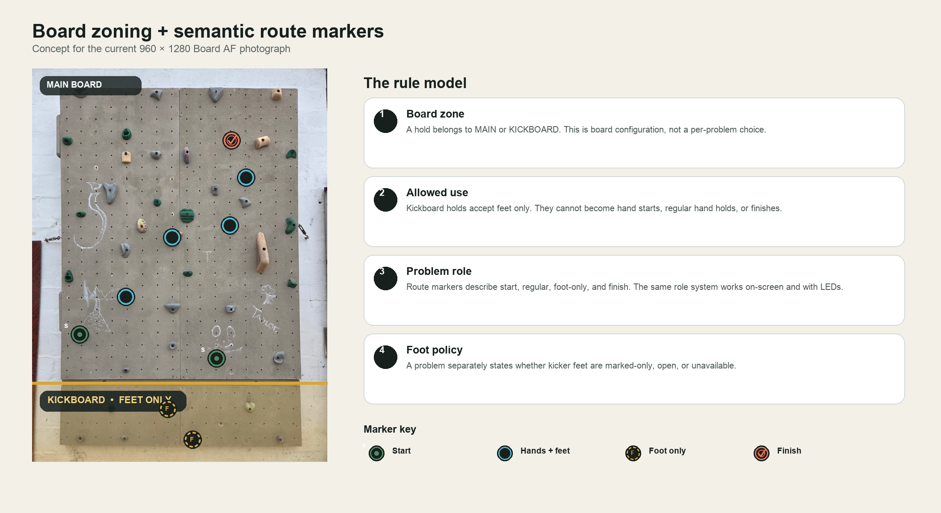
Figure 1. Proposed Board AF zone model. The kickboard band is configured once; problem roles are validated against it.

Board AF-specific finding
CURRENT BOARD PHOTOGRAPH The visible seam near 80% of image height separates the lower kickboard. The current normalized mapping places h37–h43 on this lower panel and h01–h36 on the main board. Treat that split as an initial configuration inferred from the photograph and verify it once in Board setup.
Current sample | Conflict | Migration action
Tidepool | h43 is assigned START but lies on the kickboard. | Flag as Needs review; choose a main-board start. Keep h43 only if converted to an explicit foot.
Moss line | h37 is assigned START but lies on the kickboard. | Flag as Needs review; preserve name/grade/note and ask the setter to reselect the start.
Chalk ghost | h40 is assigned START but lies on the kickboard. | Flag as Needs review; do not silently coerce the start to FOOT ONLY because the problem would lose its start.
Golden hour | No kickboard start conflict in the current data. | Validate normally; decide whether its existing main-board FOOT role should become FOOT ONLY or follow the chosen feet rule.

Recommended kickboard behavior
- Board setup stores a polygon or y-boundary for each zone. A simple horizontal boundary is sufficient for the current photo, but a polygon supports future multi-panel boards.
- Every hold has a physical capability: HAND_AND_FOOT or FOOT_ONLY. Zone defaults populate the capability, but an owner can correct an exceptional hold during setup.
- Selecting Start, Regular, or Finish while tapping a kickboard hold is blocked with a short explanation and haptic feedback. Offer “Mark as foot instead” as a safe shortcut.
- Open kickboard makes all kicker holds implicitly available to feet; Marked feet only requires individual selection; Campus makes all footholds unavailable.
- Climb view gives the kicker a subtle band or label only when needed. Do not flood every kicker hold with a marker when the rule is simply Open kickboard; the banner can carry that meaning.
- Board setups without a kicker omit the setting entirely. Tension Board 2 is evidence that “no kickboard” is a legitimate first-class layout. [6]

5. Data model and validation
The data model should separate four ideas that are currently compressed into HoldRole: where the hold is, what the physical hold permits, what role it plays in this problem, and which global feet rule applies. This separation prevents invalid states and makes future board types possible.
Entity / field | Recommended values | Why it exists
BoardZone | MAIN, KICKBOARD; later LEFT_PANEL, RIGHT_PANEL, ROOF | Physical geometry. Optional and configured per board.
HoldCapability | HAND_AND_FOOT, FOOT_ONLY | A property of the installed hold. Kicker defaults to FOOT_ONLY.
ProblemHoldRole | START, REGULAR, FOOT_ONLY, FINISH | A problem-specific semantic used for markers and validation.
FeetRule | MARKED_ONLY, OPEN_KICKBOARD, FEET_FOLLOW_MARKED, ANY_FEET, CAMPUS | A rule for which otherwise-unassigned holds feet may use.
StartRule | MATCH_ONE or SPLIT_TWO; later explicit LEFT/RIGHT | Explains one versus two start holds without ambiguous prose.
FinishRule | MATCH_ONE or CONTROL_TWO | Explains how the problem is completed.
PublicationState | DRAFT, NEEDS_REVIEW, PUBLISHED, BENCHMARK, ARCHIVED | Supports forerunning, migrations, and long-term library hygiene.

Save-time validation
- Start count. Require one or two START assignments. Each must be HAND_AND_FOOT and outside KICKBOARD.
- Finish count. Require one or two FINISH assignments. Each must be hand-capable and outside KICKBOARD.
- Role uniqueness. A hold receives only one explicit role in a problem. Changing role replaces the prior assignment.
- Feet compatibility. FOOT_ONLY assignments require a foot-capable hold. START, REGULAR, and FINISH require a hand-capable hold.
- Rule consistency. CAMPUS cannot contain FOOT_ONLY assignments. OPEN_KICKBOARD is invalid when the board has no kickboard.
- Migration safety. Invalid legacy problems become NEEDS_REVIEW and remain viewable. Never drop holds or rewrite roles silently.
- Climbability state. A problem can save as DRAFT with warnings, but PUBLISHED requires all hard validations and a confirmed successful forerun.

Suggested compact schema
BoardHold { id, point, zone, capability }
Problem { id, name, gradeEstimate, angle, feetRule, startRule, finishRule, state }
ProblemAssignment { holdId, role }
BoardZone { id, type, polygon, defaultCapability }

6. Mockups and interaction options
The three concepts below are complementary rather than mutually exclusive. Quick setter is the expert path, Rule-first is the onboarding path, and Climb view is the stable consumption path. All three use the same marker semantics and kickboard model.

Shared design principles
- Keep the board photograph dominant; controls should support the wall rather than compete with it.
- Place the feet rule in a persistent one-line banner so a climber never has to infer kickboard behavior.
- Keep primary actions and role selection in the lower thumb zone; reserve the top for identity and status.
- Reuse the same role names, colors, shapes, and one/two-hold conventions in every mode.
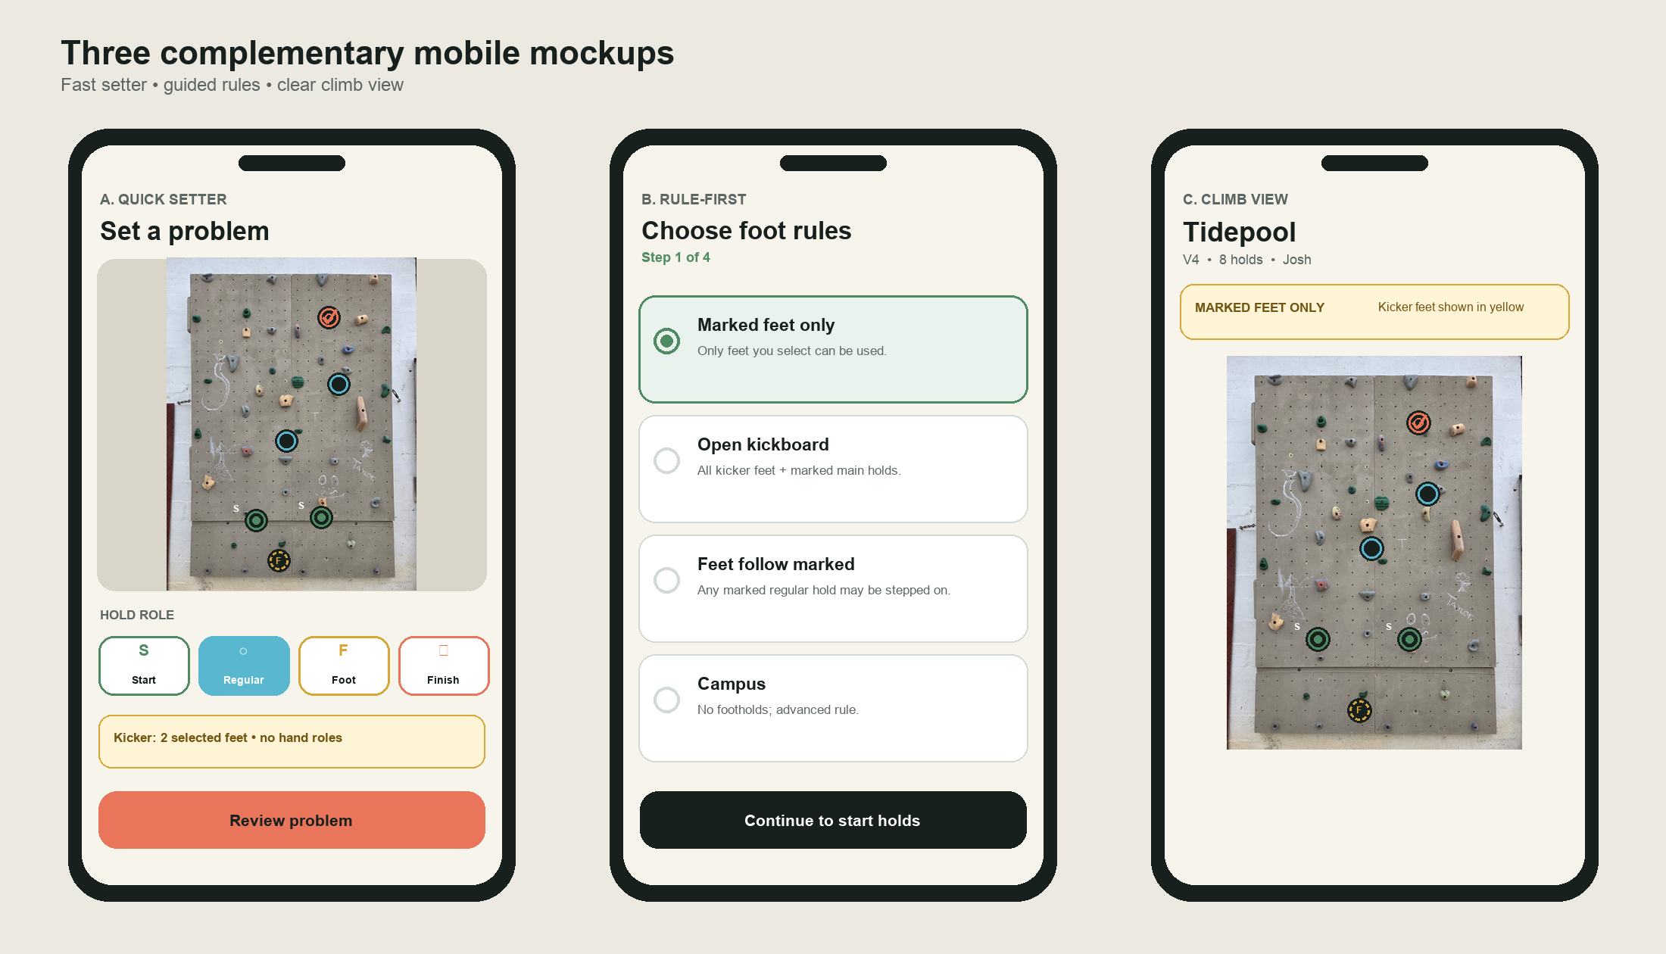
Figure 2. Low-fidelity concepts. The board remains the dominant visual; rules and actions sit close to the thumb zone.

A. Quick setter
- Best for repeat setters. Pin the four-role palette below the board and keep its current role active across taps.
- Show a kickboard status strip: “Open kicker” or “2 selected feet.” Tapping the strip opens the rule sheet.
- Provide Undo and Clear near the role counts; keep destructive Clear behind confirmation when the draft contains holds.
- Review problem opens metadata and validation without taking the setter away from the board prematurely.

B. Rule-first guided flow
Use for first-run onboarding or whenever no feet rule is chosen. Four short steps are enough: feet rule → start → finish → regular/feet. The current step filters which roles can be assigned, reducing invalid taps. Expert users can switch to Quick setter at any time.

C. Climb view
The problem title, grade, setter, and a one-line rule banner appear before the board. The route overlay uses semantic markers but does not expose editing targets. A long press or overflow action can reveal beta, edit, duplicate, archive, or report functions later.

Additional mockup directions worth testing
Concept | What changes | Test question
Board-first full screen | Photo occupies almost the entire screen; metadata collapses into a bottom sheet. | Can a climber understand the rules and start within five seconds?
Split tablet setter | Board remains left; persistent metadata, roles, and validation sit right. | Does the larger canvas make authoring faster without fragmenting attention?
Dim-out mode | Unselected holds and wall are darkened while selected markers remain vivid. | Does contrast improve without hiding hold shape or orientation?
Numbered circuit | Regular holds receive order numbers after selection. | Can users distinguish a strict circuit from a normal boulder where sequence is free?

7. Recommended Board AF roadmap

P0 — make the route model correct
- Add BoardZone and HoldCapability; configure h37–h43 as KICKBOARD + FOOT_ONLY after visual confirmation.
- Rename HAND to REGULAR/HANDS_AND_FEET and FOOT to FOOT_ONLY in model and interface copy.
- Add FeetRule and a one-line problem rule banner.
- Block invalid kickboard roles, add one/two start and finish validation, and migrate conflicting samples to NEEDS_REVIEW.
- Change semantic marker palette to Moss start, Sky regular, Gold foot-only, Coral finish; add role shapes and labels.

P1 — make setting fast and recoverable
- Undo/redo, persistent role selection, hold counts, draft autosave, duplicate problem, and discard confirmation.
- Pinch zoom and pan while preserving marker targets and normalized coordinates.
- Rule-first onboarding plus a Quick setter mode; Draft → Forerun → Publish state.
- Search/filter by grade, setter, sent/project, tags, and feet rule; keep all functions offline.

P2 — deepen training and sharing
- Beta videos, comments, shared walls, playlists/circuits, grade consensus, and benchmark curation.
- Optional left/right hand and foot start assignments for coaching or projector use.
- Hold-use heatmaps and underused-hold prompts. BoulderBot shows the value of hold metadata for generation and analytics. [8, 9]
- AI hold detection only when Board AF supports user-created boards. It adds little value to the current single pre-mapped wall.

Acceptance checklist for the next iteration
Area | Acceptance check
Board setup | Owner can see and adjust the kickboard boundary; each hold shows zone and capability.
Setter | Tapping a kicker with Start/Regular/Finish selected cannot create an invalid role and offers Foot only instead.
Rules | Feet rule is required, readable, and present in setter, detail, and climb states.
Markers | Every role remains identifiable in grayscale through shape/label; selected rings have a dark halo.
Validation | One/two starts and finishes work; incompatible combinations explain the exact fix.
Migration | Tidepool, Moss line, and Chalk ghost appear as Needs review with all legacy data preserved.
Geometry | Markers stay aligned at phone, tablet, and large widths; zoom/pan never changes stored coordinates.
Offline | Creating, editing, browsing, and viewing problems continue without an account or network.

Sources and research notes
Research snapshot: 18 July 2026. Official product/support documentation was preferred; official app-store listings were used where they supplied the clearest published role-color definitions. Product behavior changes over time, so implementation should rely on Board AF's own documented semantics rather than copying a color convention blindly.
1. Kilter Board — app overview and support
2. Kilter Board — app listing and LED roles
3. MoonBoard — start, finish, feet, and kickboard rules
4. MoonBoard — footholds and feet-rule variants
5. Tension Board 2 — app listing and LED roles
6. Tension Climbing — FAQ and no-kickboard rationale
7. Crux Climbing App — Setting Climbs documentation
8. BoulderBot — wall setup, caveats, and offline model
9. BoulderBot — generation, filters, logbook, and heatmaps
10. Sprai — official spray-wall product page
11. AnyClimb — wall setup, projection, and start roles
12. REI — home-wall feet rules and tape/log marking
Local evidence: README.md; BoardModels.kt; BoardSurface.kt; and app/src/main/res/drawable-nodpi/home_board.png.
Scope: Product and interaction research, not structural engineering or climbing-safety certification; competent human judgment remains required.

