AQUAMITRA: DIGITAL FISHERY POND MANAGEMENT & COMMUNITY SUPPORT SYSTEM

A Community Service Project Report

Submitted to the Faculty of Engineering of
JAWAHARLAL NEHRU TECHNOLOGICAL UNIVERSITY KAKINADA,
KAKINADA

In partial fulfillment of the requirements for the award of the Degree of

BACHELOR OF TECHNOLOGY
In
CSE (ARTIFICIAL INTELLIGENCE & MACHINE LEARNING)

By
Kunasani Kraanthi (24481A05J7)
Kanna Jagadish Babu (24481A05F4)
Kodali Durga Mahesh (24481A05G7)
Kodali Vijaya Babu (24481A05G8)

Under the Enviable and Esteemed Guidance of
Dr. M. Babu Rao, M.Tech., Ph.D.
Professor and Head, Department of CSE(AI&ML)



DEPARTMENT OF CSE (ARTIFICIAL INTELLIGENCE & MACHINE LEARNING)

SESHADRI RAO GUDLAVALLERU ENGINEERING COLLEGE
(An Autonomous Institute with Permanent Affiliation to JNTUK, Kakinada)
SESHADRIRAO KNOWLEDGE VILLAGE
GUDLAVALLERU – 521356
ANDHRA PRADESH
2026-27

Program Book
for

Community Service Project

Name of the College : Seshadri Rao Gudlavalleru Engineering College, Gudlavalleru

Name of the Department : CSE (AI & ML)

Name of the Faculty Guide : Dr. M. Babu Rao, M.Tech., Ph.D.

Duration of the CSP: From : 04-05-2026 To : 27-06-2026

Name of the Student: Kunasani Kraanthi, Kanna Jagadish Babu, Kodali Durga Mahesh, Kodali Vijaya Babu

Programme of Study Year of Study: B.Tech III Year

Register Numbers : 24481A05J7, 24481A05F4, 24481A05G7, 24481A05G8

Date of Submission : ……………………

Student’s Declaration

We, Kunasani Kraanthi, Kanna Jagadish Babu, Kodali Durga Mahesh and Kodali Vijaya Babu, Reg. Nos. 24481A05J7, 24481A05F4, 24481A05G7 and 24481A05G8 respectively, of the Department of CSE (Artificial Intelligence & Machine Learning) do hereby declare that we have completed the mandatory community service from 04-05-2026 to 27-06-2026 in …………………… (village / habitation) under the Faculty Guideship of Dr. M. Babu Rao, M.Tech., Ph.D. in College of Seshadri Rao Gudlavalleru Engineering College.

(Signature and Date)

Endorsements
Faculty Guide : Dr. M. Babu Rao, M.Tech., Ph.D.

Master of Trainer(S):

Head of the Department : Dr. M. Babu Rao, M.Tech., Ph.D., Professor and Head

Principal : Dr. B. Karuna Kumar, M.Tech., Ph.D.

Certificate from Official of the Community

This is to certify that Kunasani Kraanthi, Kanna Jagadish Babu, Kodali Durga Mahesh and Kodali Vijaya Babu
Reg. Nos. 24481A05J7, 24481A05F4, 24481A05G7 and 24481A05G8 of Seshadri Rao Gudlavalleru Engineering College underwent community service in …………………………… from 04-05-2026 to 27-06-2026.

The overall performance of the Community Service Volunteer during his/her community service is found to be (Satisfactory/Good).

(Authorized Signatory with Date and Seal)

ACKNOWLEDGEMENTS

The satisfaction that accompanies the successful completion of any task would be incomplete without the mention of people who made it possible and whose constant guidance and encouragements crown all the efforts with success.

We would like to express our deep sense of gratitude and sincere thanks to Dr. M. Babu Rao, M.Tech., Ph.D., Professor and Head, Department of CSE (Artificial Intelligence & Machine Learning) for his constant guidance, supervision and motivation in completing the project work.

We feel elated to express our floral gratitude and sincere thanks to Dr. M. Babu Rao, M.Tech., Ph.D., Head of the Department, CSE (Artificial Intelligence & Machine Learning) for his encouragement all the way during the analysis of the project. His annotations, insinuations and criticisms are the key behind the successful completion of the project work.

We would like to take this opportunity to thank our beloved principal Dr. B. Karuna Kumar, M.Tech. Ph.D. for providing a great support for us in completing our project and giving us the opportunity for doing project.

We are thankful to the community and officials from the community for giving the necessary information and very thankful to the faculty members for their motivation and knowledge rendered throughout our programme.

We wish to thank all our friends, who have helped us in various stages and for giving valuable suggestions throughout the project. We wish to thank all the community people who helped us to do the project in a successful way.

Kunasani Kraanthi (24481A05J7)
Kanna Jagadish Babu (24481A05F4)
Kodali Durga Mahesh (24481A05G7)
Kodali Vijaya Babu (24481A05G8)

CHAPTER 1: EXECUTIVE SUMMARY

The community service project aims to understand how fishery ponds, locally known as Chepala Cheruvulu, are managed in the community, to identify the difficulties faced by fish farmers in recording and monitoring pond information, and to apply computer science knowledge to propose a simple, low-cost digital tool, AquaMitra, that helps organise pond records and supports better management decisions.

Fishery ponds are an important source of food, employment and livelihood in many rural communities. Managing a pond is a continuing activity: the manager observes water conditions, notes the number and size of fish stocked, estimates the feed required, records fish deaths and unusual behaviour, spends on feed, labour and maintenance, and finally harvests and sells the fish. Each of these activities produces information, and the quality of later decisions depends on how well that information is kept.
The project presentation identifies that pond information is commonly kept through manual observation, personal experience, notebooks and scattered records. This makes it difficult to record water-quality parameters consistently, track fish growth, biomass and feeding, recognise unusual conditions in time, record mortality and events, and bring production, expense and sales information together. These problems are to be understood through the community interaction described in this report.
AquaMitra (Digital Fishery Pond Management & Community Support System) is proposed as a centralised digital platform built with Python and Streamlit with a database for pond records. Its main modules are water-quality monitoring (pH, temperature, dissolved oxygen, turbidity), fish-growth tracking, a feed calculator based on estimated biomass, rule-based early risk alerts, a mortality and event log, and expense and sales tracking, all brought together on a single dashboard.
The expected benefits are better record management, easier monitoring, clearer growth and feeding history, greater awareness of concerning conditions, improved visibility of production and finances, and easier access to information. These are expected benefits; no improvement in yield or income has been measured. The main limitations are dependence on accurate user entry, the absence of automatic sensing, the need for suitable alert limits from expert guidance, and the need for training. Future development may include IoT-based pH, temperature and dissolved-oxygen sensors, ESP32-based monitoring, weather integration, SMS notifications, a Telugu-language interface, a mobile-friendly application and predictive analytics.

Learning Objectives:
1. To understand the needs of the local community through direct interaction and observation.
2. To learn about fishery pond management practices and the challenges involved.
3. To apply computer science concepts to a real-world community problem.
4. To improve survey, communication, teamwork and problem-solving skills.
5. To understand digital record management and decision-support systems.

Learning Outcomes:
1. Understood how fishery ponds are managed and which records matter: water quality, stocking, growth, feed, mortality, expenses and sales.
2. Learnt to design a questionnaire, interact respectfully with community members and record information ethically.
3. Learnt to convert community problems into software requirements, modules, data tables and calculation logic.
4. Gained practical understanding of Python, Streamlit and relational data design for a decision-support tool.
5. Learnt to explain technical ideas simply to non-technical audiences through an awareness activity.
6. Developed teamwork, time management and professional documentation skills.
CHAPTER 2: OVERVIEW OF THE COMMUNITY

1. Introduction to the Village / Habitation
The community selected for this project is …………………………… village / habitation, ………………… mandal, ………………… district, Andhra Pradesh. The village has fishery ponds (Chepala Cheruvulu) managed by pond owners and fish farmers for livelihood. The details of the habitation given below are to be completed from the Gram Panchayat records and the team's own observations.
2. Geographic and Demographic Overview
Location and distance from the college: …………………… km. Approximate population and households: …………………… (source: Panchayat / Census records). Main occupations: …………………… . Water sources such as tanks, canals and wells: …………………… . Number of fishery ponds in the habitation: …………………… . Common fish species cultured: …………………… .
3. General Socio-Economic Conditions
The livelihood pattern, literacy, income groups and access to services of the habitation are to be described here using only information collected during the visit or published by official sources: …………………………………………………… .
4. Importance of Aquaculture and Fish Farming to Local Livelihoods
Freshwater fish farming in ponds and tanks is a recognised livelihood in many parts of India, including Andhra Pradesh. It provides food and income and supports related work such as fingerling supply, feed trading, transport and marketing. Pond-based farming often involves the whole family along with hired labour, so good information about the pond helps everyone connected to it. (This paragraph is general background and not a field observation.)
5. Roles of Stakeholders
(i) Pond owners and lessees own or lease the pond, decide on stocking, feed and harvest and bear the financial risk.
(ii) Fish farmers and pond managers carry out daily feeding, observation, water management and netting.
(iii) Workers help in feeding, guarding, harvesting and maintenance.
(iv) Suppliers provide fingerlings, feed, lime and equipment, and traders buy and sell the harvested fish.
(v) Fisheries extension officers and experts give technical advice, and local leaders help in community awareness.
6. Common Pond-Management Activities
Common activities include pond preparation (drying, liming and filling), stocking fingerlings, regular feeding, observing fish behaviour and water colour, periodic checks of water parameters, water exchange or aeration where available, sampling to judge fish size, reporting health problems, harvesting and selling. Each activity produces information that could be recorded.
7. Existing Approaches to Recording Pond Data
According to the project presentation, pond management relies on manual observation, experience, notebooks and scattered records. During the community visits the team noted how farmers keep their information, for example in notebooks, on calendars, by memory or in phone notes. Details of the practices observed in the habitation: …………………………… .
8. Possible Challenges in Monitoring and Record Keeping
(i) Water quality: pH, temperature, dissolved oxygen and turbidity may not be measured regularly, and test kits or meters may be unavailable or costly.
(ii) Fish growth and feeding: fish are rarely weighed on a schedule, and feed quantity is often decided by habit rather than by estimated biomass.
(iii) Mortality: deaths and unusual behaviour may be noticed but not recorded with date and pond.
(iv) Expenses and sales: costs, harvest and sales are spread over notebooks, bills and memory and are not linked to a pond or cycle.
9. Digital Literacy and Access Considerations
A community-facing tool is useful only if the intended users can reach and operate it. The team therefore considered who owns smartphones, who can read in Telugu and English, how reliable mobile data is near the ponds and who in the family would enter data. These findings drive the design choices of simple layout, Telugu labels and minimal typing.
10. Need for an Affordable, Accessible and Easy-to-Use Digital System
Commercial aquaculture software and sensor systems can be costly or complex for small pond owners. A system that runs on a modest device, needs no special hardware to begin with (manual entry) and presents information plainly could lower the entry barrier. Sensors and automation can be added later where they are affordable.
Need for the Project
AquaMitra may be useful to the community because it addresses a basic and common difficulty: keeping pond information in one organised, searchable place. It could help to replace scattered notes with a single dated record for every pond, make routine calculations of biomass, daily feed and totals consistent and quick, highlight entries that fall outside limits set by the farmer or an expert, show costs, sales and basic returns together, and provide a common format that can be shared with advisers or cooperatives.

CHAPTER 3: COMMUNITY SERVICE PART

Explanation
The community service was carried out over eight weeks of six working days each in …………………… (village / habitation) from 04-05-2026 to 27-06-2026 under the guidance of Dr. M. Babu Rao, M.Tech., Ph.D.. The work moved from understanding the community (Weeks 1 to 3), through requirements and design of the proposed AquaMitra tool (Weeks 4 to 6), to awareness, evaluation and documentation (Weeks 7 and 8). The theme and activities of each week are summarised below, followed by the weekly activity logs and weekly reports.
Week 1: Community Familiarisation and Problem Identification – Understood the purpose of the CSP, identified fishery pond stakeholders, learnt about pond-management practices and noted the challenges reported by the community.

Week 2: Community Interaction and Survey Preparation – Prepared a socio-economic and pond-management questionnaire, discussed water monitoring and record keeping with farmers and organised the information collected.

Week 3: Analysis of Community Problems – Categorised the challenges reported, analysed record-keeping needs for water quality, growth, feeding, mortality and finance, and prepared a problem statement.
Week 4: AquaMitra Requirements and Design – Defined the objectives and users of AquaMitra, organised its modules, designed the pond-management workflow and planned the dashboard and forms.

Week 5: Technical Mini-Project Development – Studied the Python and Streamlit approach, planned the pond-record data fields and designed water-quality, growth, feed and mortality records.
Week 6: Financial Tracking and Risk Awareness – Designed expense and sales records, described rule-based warning logic, discussed mortality recording and considered data validation.
Week 7: Review, Demonstration, and Community Awareness – Prepared educational material on organised pond records, explained the digital workflow, gathered feedback and listed usability improvements.

Week 8: Evaluation, Documentation, and Conclusions – Organised project records, reviewed requirements against the proposed solution, documented limitations and prepared recommendations and the final report.

ACTIVITY LOG FOR THE FIRST WEEK

DAY  & DATE | BRIEF DESCRIPTION OF THE DAILY ACTIVITY | LEARNING  OUTCOME | Person In-charge Signature
Day –1
04-05-2026
Monday
Day –2
05-05-2026
Tuesday
Day –3
06-05-2026
Wednesday
Day –4
07-05-2026
Thursday
Day –5
08-05-2026
Friday
Day –6
09-05-2026
Saturday

WEEKLY REPORT

WEEK – 1 (From 04-05-2026 to 09-05-2026)

The objective of the Activity Done:
To understand the purpose of the CSP, identify the stakeholders in fishery pond management, learn about local pond-management practices and record the challenges reported by community members.
Detailed Report:
The first week was devoted to understanding the purpose of the community service project and the context in which fishery ponds operate. The team studied the activities involved in managing a pond: stocking fingerlings, feeding, observing water condition, noting fish deaths, spending on inputs and finally harvesting and selling fish.
A list of stakeholders was prepared and a set of open-ended questions was drafted for conversations with pond owners and managers. The team interacted with community members, listened to how ponds are looked after and noted the difficulties they described.
The notes were summarised and compared with the problem areas identified in the project presentation: inconsistent water-quality records, difficulty in tracking growth and feeding, delayed recognition of concerning conditions and scattered financial records.
Community problem addressed: Lack of a clear picture of how pond information is currently handled.
Observations and findings: Pond information is mostly kept through experience, observation and notes rather than in a common format.
Skills gained: Stakeholder analysis, interview preparation, active listening and note-taking.
Relevance to AquaMitra: Sets the real-world requirements on which every module of AquaMitra depends.
Challenges: Scheduling visits and using simple, non-technical language with farmers.
Next steps: Prepare a structured questionnaire and plan the survey in Week 2.

ACTIVITY LOG FOR THE SECOND WEEK

DAY  & DATE | BRIEF DESCRIPTION OF THE DAILY ACTIVITY | LEARNING OUTCOME | Person In-charge Signature
Day –1
11-05-2026
Monday
Day –2
12-05-2026
Tuesday
Day –3
13-05-2026
Wednesday
Day –4
14-05-2026
Thursday
Day –5
15-05-2026
Friday
Day –6
16-05-2026
Saturday

WEEKLY REPORT

WEEK – 2 (From 11-05-2026 to 16-05-2026)

The objective of the Activity Done :
To prepare a socio-economic and pond-management questionnaire, discuss water monitoring and record keeping with farmers and organise the information collected.
Detailed Report:
Week 2 focused on preparing the community survey. The questionnaire, attached in Chapter 5, covers respondent details, pond and species information, water-quality checks, fish growth and feeding, mortality, expenses, sales and access to digital devices. A short statement explains that participation is voluntary.
The questionnaire was tried out and unclear questions were reworded. Conversations with pond owners and managers addressed how water quality is checked, how fish size is judged, how feed quantity is decided and how deaths are noted.
Responses were organised in a simple sheet so that they could later be counted and summarised. Preliminary requirements for a record-keeping tool were drafted from what was heard.
Community problem addressed: Absence of organised information about current record-keeping and digital access.
Observations and findings: Records are mainly informal; detailed survey tabulation will be attached with the survey sheets.
Skills gained: Questionnaire design, survey ethics, interviewing and data organisation.
Relevance to AquaMitra: Survey findings guide which features matter and how simple the interface must be.
Challenges: Respondent availability and explaining technical terms in Telugu.
Next steps: Categorise the reported challenges and analyse the problems in Week 3.

ACTIVITY LOG FOR THE THIRD WEEK

DAY  & DATE | BRIEF DESCRIPTION OF THE DAILY ACTIVITY | LEARNING OUTCOME | Person In-charge Signature
Day –1
18-05-2026
Monday
Day –2
19-05-2026
Tuesday
Day –3
20-05-2026
Wednesday
Day –4
21-05-2026
Thursday
Day –5
22-05-2026
Friday
Day –6
23-05-2026
Saturday

WEEKLY REPORT

WEEK – 3 (From 18-05-2026 to 23-05-2026)

The objective of the Activity Done:
To categorise the challenges reported by the community, analyse the record-keeping needs for water quality, growth, feeding, mortality and finance, and prepare a problem statement.
Detailed Report:
In Week 3 the information gathered was analysed. The challenges were sorted into six areas: water-quality monitoring, growth and feed tracking, early recognition of concerning conditions, mortality and event records, financial records and access to centralised information.
For each area the team described the information that would have to be recorded and the difficulty in recording it. The analysis kept a clear distinction between problems stated in the project presentation and problems confirmed in the community.
A problem statement was prepared: fish farmers lack a simple, centralised way to record and review pond information, which makes monitoring, feeding decisions and financial tracking harder.
Community problem addressed: Unstructured and scattered pond information.
Observations and findings: The six problem areas are consistent with what community members described.
Skills gained: Qualitative analysis, problem formulation and requirement thinking.
Relevance to AquaMitra: The problem statement defines the scope of AquaMitra.
Challenges: Reconciling incomplete or differing responses.
Next steps: Convert the problem statement into requirements and a design in Week 4.

ACTIVITY LOG FOR THE FOURTH WEEK

DAY  & DATE | BRIEF DESCRIPTION OF THE DAILY ACTIVITY | LEARNING OUTCOME | Person In-charge Signature
Day –1
25-05-2026
Monday
Day –2
26-05-2026
Tuesday
Day –3
27-05-2026
Wednesday
Day –4
28-05-2026
Thursday
Day –5
29-05-2026
Friday
Day –6
30-05-2026
Saturday

WEEKLY REPORT

WEEK – 4 (From 25-05-2026 to 30-05-2026)

The objective of the Activity Done:
To define the system objectives, identify the intended users, organise the proposed modules, design the pond-management workflow and plan the dashboard and forms.
Detailed Report:
Week 4 moved from analysis to design. Functional and non-functional requirements were written and the scope was fixed according to the six objectives of the presentation. User roles and their typical tasks were listed.
The workflow from data entry to dashboard was drawn: the user works through a Streamlit interface, Python code validates entries and performs calculations, and a database stores the records which the dashboard then displays as tables, charts and alerts.
Screens were sketched for the dashboard and for each entry form. Usability needs identified from the community interaction, such as simple language and a Telugu-friendly interface, were recorded as design goals.
Community problem addressed: No defined structure for a pond-management tool that suits the community.
Observations and findings: Simple forms and a single dashboard are preferred over complex software.
Skills gained: Requirements engineering, diagramming, UI sketching and usability thinking.
Relevance to AquaMitra: Produces the requirements, architecture and screens described in Chapter 5.
Challenges: Balancing features against simplicity.
Next steps: Plan the data fields and the technical mini-project in Week 5.

ACTIVITY LOG FOR THE FIFTH WEEK

DAY  & DATE | BRIEF DESCRIPTION OF THE DAILY ACTIVITY | LEARNING OUTCOME | Person In-charge Signature
Day –1
01-06-2026
Monday
Day –2
02-06-2026
Tuesday
Day –3
03-06-2026
Wednesday
Day –4
04-06-2026
Thursday
Day –5
05-06-2026
Friday
Day –6
06-06-2026
Saturday

WEEKLY REPORT

WEEK – 5 (From 01-06-2026 to 06-06-2026)

The objective of the Activity Done:
To introduce the proposed Python and Streamlit architecture, plan pond-record data fields, design water-quality and fish-growth records and document the feed-calculation logic.
Detailed Report:
Week 5 introduced the technical side of the mini-project. The team studied how Streamlit builds forms, tables and charts and prepared the data fields for ponds, stocking, water quality, growth, feeding and mortality.
The biomass and feed formulas were documented and checked with a hypothetical example: estimated biomass is the number of live fish multiplied by the average weight, and daily feed is the biomass multiplied by the feeding rate divided by 100. The feeding rate is supplied by the user or taken from expert guidance.
The design and status of each module is described in Chapter 5, Report of the mini-project.
Community problem addressed: No consistent data structure or calculation method for pond information.
Observations and findings: A small set of fields can cover the six problem areas.
Skills gained: Python, Streamlit basics, relational data design and formula checking.
Relevance to AquaMitra: Forms the technical core of AquaMitra.
Challenges: Time available and the learning curve of new tools.
Next steps: Design financial records and alert rules in Week 6.

ACTIVITY LOG FOR THE SIXTH WEEK

DAY  & DATE | BRIEF DESCRIPTION OF THE DAILY ACTIVITY | LEARNING OUTCOME | Person In-charge Signature
Day –1
08-06-2026
Monday
Day –2
09-06-2026
Tuesday
Day –3
10-06-2026
Wednesday
Day –4
11-06-2026
Thursday
Day –5
12-06-2026
Friday
Day –6
13-06-2026
Saturday

WEEKLY REPORT

WEEK – 6 (From 08-06-2026 to 13-06-2026)

The objective of the Activity Done:
To design expense and sales records, describe possible water-quality warning rules, discuss mortality and unusual-event recording and consider data validation and accuracy.
Detailed Report:
The sixth week dealt with finance and risk. Expense and sales records were designed so that costs and revenue can be totalled for each pond and cycle, giving a simple net-return figure. It is a simplified measure and does not replace full accounting.
Rule-based alert logic was described: when an entered water reading falls outside a range set by the user or an expert, or when recorded mortality exceeds a chosen limit, the dashboard shows a warning. No numeric limit is treated as universal because suitable values depend on species, stage and conditions.
Validation rules and limitations were documented so that the tool is not mistaken for a disease-diagnosis or prediction system.
Community problem addressed: Late recognition of concerning conditions and scattered financial records.
Observations and findings: Farmers need alerts as prompts to look closer, not as diagnoses.
Skills gained: Rule design, financial record structuring and validation.
Relevance to AquaMitra: Provides the risk-alert and expense/sales modules.
Challenges: Choosing suitable limits without expert input.
Next steps: Prepare the awareness activity and review in Week 7.

ACTIVITY LOG FOR THE SEVENTH WEEK

DAY  & DATE | BRIEF DESCRIPTION OF THE DAILY ACTIVITY | LEARNING OUTCOME | Person In-charge Signature
Day –1
15-06-2026
Monday
Day –2
16-06-2026
Tuesday
Day –3
17-06-2026
Wednesday
Day –4
18-06-2026
Thursday
Day –5
19-06-2026
Friday
Day –6
20-06-2026
Saturday

WEEKLY REPORT

WEEK – 7 (From 15-06-2026 to 20-06-2026)

The objective of the Activity Done:
To prepare educational material on organised pond records, explain the proposed digital workflow, gather feedback and identify usability improvements.
Detailed Report:
Week 7 centred on sharing the idea with the community and reviewing it. Educational material on organised pond records was prepared, and a short awareness session was planned with a feedback form of a few simple questions.
The session explained what to record, how often and why dates matter, how biomass and feed are estimated, how deaths and events are noted, and how a dashboard could bring this together. Feedback was collected through the form and informal discussion.
Usability improvements suggested by the feedback, such as simpler language and Telugu labels, were listed and carried into the recommendations.
Community problem addressed: Low awareness of the value of systematic record keeping.
Observations and findings: Attendance, reactions and suggestions are recorded in the awareness programme details.
Skills gained: Presentation, material preparation, facilitation and feedback analysis.
Relevance to AquaMitra: Tests the clarity and acceptability of the concept with possible users.
Challenges: Attendance timing and explaining digital ideas simply.
Next steps: Consolidate, evaluate and complete documentation in Week 8.

ACTIVITY LOG FOR THE EIGHT WEEK

DAY  & DATE | BRIEF DESCRIPTION OF THE DAILY ACTIVITY | LEARNING OUTCOME | Person In-charge Signature
Day –1
22-06-2026
Monday
Day –2
23-06-2026
Tuesday
Day –3
24-06-2026
Wednesday
Day –4
25-06-2026
Thursday
Day –5
26-06-2026
Friday
Day –6
27-06-2026
Saturday

WEEKLY REPORT

WEEK – 8 (From 22-06-2026 to 27-06-2026)

The objective of the Activity Done:
To organise project records, review the requirements against the proposed solution, document limitations, summarise learning outcomes and prepare recommendations.
Detailed Report:
The final week was used to bring the project together. Records were organised, the requirements were checked against the proposed solution and the limitations and assumptions were written down.
The team reflected on what was learnt: technical skills, communication with the community, teamwork and professional documentation. Recommendations were prepared for farmers, community leaders, the college and future developers.
The report was completed and reviewed with the faculty guide.
Community problem addressed: Need to consolidate findings and present them clearly.
Observations and findings: AquaMitra maps to all six problem areas but needs testing and expert-reviewed limits before use.
Skills gained: Technical writing, self-evaluation and project closure.
Relevance to AquaMitra: Completes the documentation of AquaMitra as a community solution.
Challenges: Collecting signatures and aligning with the college format.
Next steps: Submit the report and share the recommendations with the community.

CHAPTER 5: OUTCOMES DESCRIPTION

Details of the Socio-Economic Survey of the Village/Habitation. Attach the questionnaire prepared for the survey.

A socio-economic and pond-management survey was prepared for fish farmers and other stakeholders of the habitation. Participation was voluntary, personal details were optional and the information is used only for this college project. The questionnaire is attached below. Survey period: ……………… to ……………… ; method: face-to-face interview; number of respondents: ……………… ; language: Telugu / English. The responses are tabulated in the survey sheet attached with this report; no result is quoted here unless it appears in that sheet.
Questionnaire: AquaMitra – Fishery Pond Management and Record-Keeping Survey
Introductory statement: "We are students of Seshadri Rao Gudlavalleru Engineering College doing a Community Service Project on fishery pond management. We would like to ask a few questions about how you manage your pond and keep records. Taking part is voluntary, you may skip any question, and the information will be used only for our college project." Consent given: Yes / No
Section 1: General Information (optional items may be skipped)
1. Name (optional): ____________ 2. Age group: below 25 / 25–40 / 41–60 / above 60
3. Gender (optional): Male / Female / Other / Prefer not to say 4. Education: None / Primary / Secondary / Intermediate or Diploma / Graduate
5. Mobile number (optional): ____________ 6. Monthly household income (optional): below ₹10,000 / ₹10,000–25,000 / above ₹25,000 / prefer not to say
Section 2: Role and Pond Details
7. Your role: Pond owner / Lessee / Manager or caretaker / Worker / Trader or supplier / Other
8. Number of ponds managed: 1 / 2–3 / 4–5 / more than 5
9. Species cultured (tick all): Rohu / Catla / Mrigal / Pangasius / Tilapia / Other
10. Pond size (area and depth): ____________ 11. How do you decide the number of fingerlings to stock and where do you get them? ____________
Section 3: Water-Quality Monitoring
12. How do you check water quality? Visual (colour, smell) / Fish behaviour / Test kit / Digital meter / Expert or lab / Not checked
13. Do you measure pH? Regularly / Sometimes / Never 14. Temperature? Regularly / Sometimes / Never
15. Dissolved oxygen? Regularly / Sometimes / Never 16. Turbidity (clarity)? Regularly / Sometimes / Never
17. Do you write the readings down? Always / Sometimes / Never 18. Water-quality problems faced in the last year: ____________
Section 4: Growth, Feeding and Mortality
19. How do you monitor fish growth? Visual estimate / Periodic sampling and weighing / Not monitored
20. How often do you sample fish weight? Weekly / Fortnightly / Monthly / Rarely / Never
21. How do you decide daily feed? Fixed habit / Percentage of fish weight / Fish appetite / Adviser or supplier / Other
22. Do you record feed given each day? Yes / Sometimes / No 23. Unusual fish deaths in the last two cycles? Yes / No
24. How are deaths and unusual behaviour recorded? Notebook / Phone notes / Memory only / Not recorded
25. What action did you take when deaths or unusual behaviour were noticed? ____________
Section 5: Expenses, Sales and Production
26. How do you track expenses? Notebook / Bills only / Phone or computer / Memory only / Not tracked
27. Who maintains the accounts? Self / Family member / Accountant / No one
28. How do you record harvest and sales? Notebook / Trader's slip only / Phone or computer / Memory only
29. Can you tell the profit or loss of your last cycle? Yes, exactly / Roughly / No
Section 6: Digital Access and Interest
30. Smartphone: Own / Shared / None 31. Computer or tablet: Yes / No 32. Mobile internet near pond or home: Good / Weak / None
33. Comfort with mobile apps: Very comfortable / Somewhat / Need help / Not comfortable 34. Preferred language: Telugu / English / Both
35. Would you use a simple digital pond-management tool? Yes / Maybe / No
36. Most useful features (tick up to 3): Water records / Growth tracking / Feed calculator / Mortality log / Alerts / Expense and sales / Reports
37. What would stop you from using such a tool? Cost / Language / No phone or internet / No time / Not useful / Other
38. Any other suggestion: ____________
Recording and Analysis of Responses
Each questionnaire is given a serial number and entered in a spreadsheet with one row per respondent and one column per question. Closed questions are counted and expressed as percentages of those who answered, with the number of respondents stated; open answers are grouped into themes; names and phone numbers are kept apart from the analysis sheet. Limitations such as small sample size, language barriers and self-reported data are stated in the report.
Describe the problems you have identified in the community.

Problem 1: Inconsistent water-quality monitoring
- Water-quality parameters such as pH, temperature, dissolved oxygen and turbidity are not recorded consistently. Without dated readings it is hard to compare conditions over time or relate a fish-health event to water conditions. AquaMitra proposes a water-quality module that records, charts and reviews readings with timestamps.

Problem 2: Difficulty in tracking fish growth, biomass and feeding
- Growth, biomass and feed requirements are hard to track systematically, so feed may be over- or under-supplied. AquaMitra proposes stocking and sampling records, an estimated-biomass calculation and a simple feed calculator.
Problem 3: Delayed identification of potentially concerning conditions
- Unusual mortality, poor fish behaviour or water-quality issues may be noticed late. AquaMitra proposes rule-based alerts that prompt the user to look closer or seek expert advice; they are not diagnoses.

Problem 4: Inadequate or scattered mortality and pond-event records
- Deaths and observations are often not recorded with date and pond, so patterns cannot be examined. AquaMitra proposes a mortality and event log with date, pond, count, observations and follow-up action.

Problem 5: Scattered production, expense and sales information
- Stocking, feed cost, maintenance, harvest and sales are kept separately, making the profit or loss of a cycle hard to know. AquaMitra proposes expense, sales and production records for each pond and cycle.

Problem 6: Limited access to centralised pond-management information
There is no single place to view pond information, which is lost when a notebook is misplaced or a person leaves. AquaMitra proposes a unified dashboard combining pond, water, growth, feed, mortality, expense and sales information.

Short-term and long term action plan for possible solutions for the problems identified and that could be recommended to the concerned authorities for implementation.
The identified challenges in fishery pond record keeping and monitoring present an opportunity for transformative action. To address these issues effectively, a balanced short-term and long-term action plan has been devised, emphasizing creativity and sustainability

Short-Term Action Plan:
1. Standardised pond-record templates: a one-page sheet per pond (ID, area, species, stocking date) kept by the pond manager with help from the college team, to make records uniform and easy to digitise later.
2. Regular water-quality observations: noting pH, temperature, dissolved oxygen and clarity at a fixed time where tools exist, otherwise colour, smell and fish behaviour, to build a history of conditions.
3. Consistent stocking and growth records: noting the number of fish and average weight at stocking and each sampling date, as the basis for biomass and feed estimates.
4. Feed-quantity calculation sheets: a simple table to compute biomass × feeding rate / 100, with the rate taken from expert guidance, for more consistent feeding.
5. Mortality and event registers: a notebook with date, pond, count, observation and action, to give evidence when consulting experts.
6. Consolidated expense and sales registers: two ledgers with common categories, kept by the owner or a family member, to see cost and return for each cycle.
7. Basic awareness sessions on organised and digital record keeping, conducted by the college team with community leaders and the fisheries office.
Long-Term Action Plan:
1. Wider adoption of digital pond-management records through a tested AquaMitra application, training and a local support person.
2. Mobile-friendly access, so that records can be entered and viewed from a smartphone.
3. A Telugu-language interface, with labels reviewed by local users.
4. Integration of pH, temperature and dissolved-oxygen sensors, which needs suitable probes, calibration and maintenance, and has cost and reliability limits.
5. ESP32-based pond monitoring where it is technically and financially feasible, with weatherproof enclosures and testing.
6. Weather information integration and SMS or mobile notifications, which depend on a reliable data source and recurring costs.
7. Historical trend analysis and predictive analytics only after enough validated records are available and experts have reviewed the results.
8. Training and maintenance support, together with data backup, privacy and a plan for long-term sustainability by the college, local organisations and partners.

Description of the Community awareness programme/s conducted w.r.t the problems and their outcomes.

Purpose: to explain to fish farmers why scientific, organised pond records are valuable and to demonstrate how a simple digital tool such as AquaMitra could support them.
Objectives: introduce the value of regular records for water, growth, feeding, mortality and finance; show how a record sheet or the AquaMitra workflow is used; collect feedback on usefulness, language and ease of use.
Target audience: pond owners, managers, workers and family members who keep accounts, and community leaders of the habitation.
Topics explained: what to record and how often; water parameters in simple terms (with a reminder that suitable ranges depend on species and expert guidance); estimating biomass and daily feed; noting deaths and events; keeping expense and sales records; and how a dashboard brings these together.
Methods and material: a short talk in Telugu with local examples, printed record sheets, a handout on estimating daily feed and a walk-through of the proposed AquaMitra screens, followed by questions.
Feedback and outcomes: a short feedback form and oral comments were collected. Expected outcomes are greater awareness of record keeping and willingness to try the templates. Date: ……………… ; venue: ……………… ; attendance: ……………… ; photographs are attached in the Photos section.

Report of the mini-project work done in the related subject w.r.t the habitation/village.
1. Introduction
AquaMitra is a proposed digital decision-support system for fishery pond management and community support. It captures pond information in one place, performs routine calculations consistently and presents results plainly so that a farmer can review them. The presentation specifies Python and Streamlit with a database to store pond records.
2. Problem Definition
Fish farmers who manage ponds through observation, experience and scattered notes find it difficult to keep consistent water-quality records, track growth, biomass and feed, recognise unusual conditions in time, record mortality and events, and consolidate expense, sales and production data. No simple, affordable and centralised tool is available to them.
3. Aim and Objectives
Aim: to design a simple digital tool that helps fish-pond communities maintain organised records and make better-informed management decisions. Objectives: water-quality monitoring, fish-growth tracking, feeding support, early risk identification, mortality and event recording, and financial tracking.
4. Scope of the Mini-Project
In scope: pond registration, water-quality records, stocking and growth tracking, feed calculator, mortality log, rule-based alerts, expense and sales tracking, a dashboard with basic charts and an optional Telugu-friendly interface. Out of scope for now: sensor hardware, real-time data acquisition, weather integration, SMS notifications and machine-learning prediction, which are future work.
5. Existing Approach and Its Limitations
Pond information is kept through visual observation, notebooks, scattered notes and memory. These methods are subjective, hard to compare over time, easily lost, difficult to total or search, and do not link costs and sales to a pond or cycle.
6. Proposed AquaMitra System
The user opens the Streamlit interface, selects a pond and enters records through forms. Python code validates the entries, calculates biomass, feed and totals, applies alert rules and writes to the database. The dashboard reads from the database to show tables, charts, alerts and summaries.
7. Intended Users and Use Cases
Pond owner: reviews the dashboard, costs, sales and cycle summary. Pond manager or caretaker: enters daily observations, feed and mortality and views alerts. Helper or family member: enters data using simple forms. Adviser or extension officer: views the history to give advice.
8. Functional Requirements
FR-01 Register a pond with identifier, name, type, location, area and species.
FR-02 Record stocking details: date, number of fish, average weight, source.
FR-03 Record water-quality readings (pH, temperature, dissolved oxygen, turbidity) with date and time, and display history as tables and charts.
FR-04 Record sampling dates and average weight; compute estimated biomass.
FR-05 Compute daily feed from biomass and a user-supplied feeding rate.
FR-06 Record mortality count, date, pond, observations and follow-up action.
FR-07 Show rule-based alerts when entries fall outside user-configured limits.
FR-08 Record expenses by category and fish sales; compute total expenses, total revenue and basic net return.
FR-09 Provide a dashboard combining all records with date filters, and validate all inputs.
9. Non-Functional Requirements
Usability (simple words, minimal typing, Telugu labels where possible); reliability (records saved immediately and backed up); performance (quick loading for a few ponds on a modest device); security and privacy (access control and minimum personal data); maintainability (modular code and a documented schema); affordability (open-source tools and no special hardware for manual entry).
10. Hardware and Software Requirements
Client: smartphone, tablet or computer with a web browser and network access. Server or development machine: a computer able to run Python. Software: Python, Streamlit, a database system (the specific product is not fixed in the presentation) and supporting Python libraries for data handling and charts. Future, not required now: sensors, ESP32 microcontrollers, power and connectivity for IoT monitoring.
11. System Architecture
The architecture follows the presentation: User → Streamlit interface → Python application logic → Database → Dashboard, records and reports. The interface layer collects input and shows output; the logic layer validates, calculates and evaluates alert rules; the data layer stores records permanently.
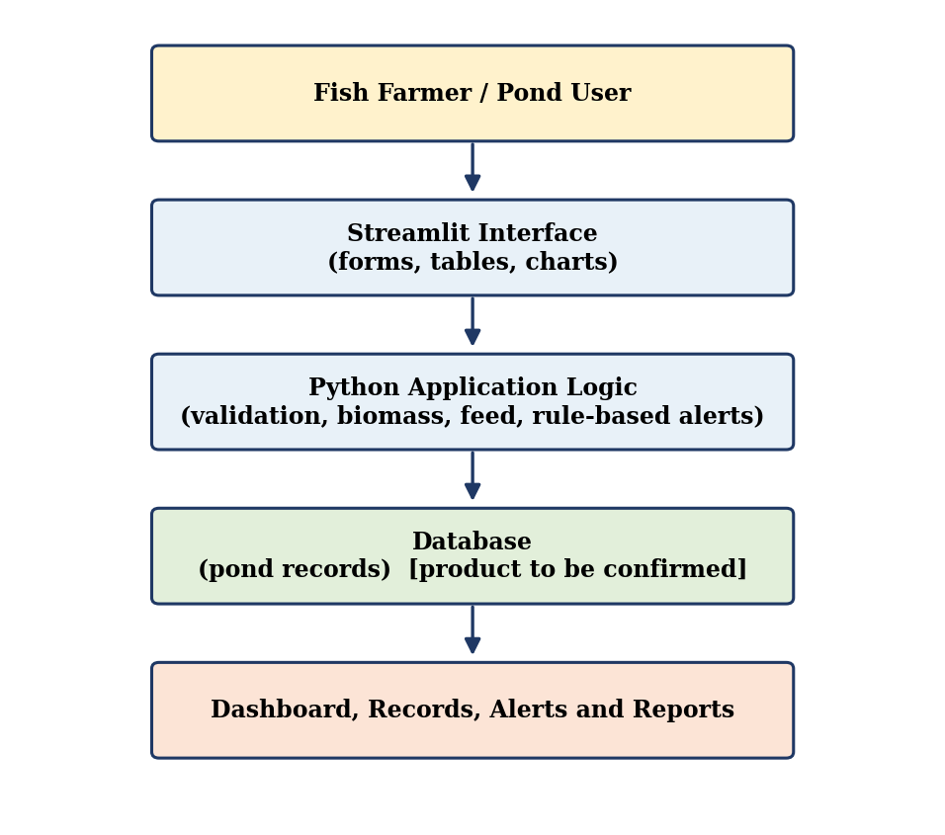
Figure 1: Proposed system architecture of AquaMitra
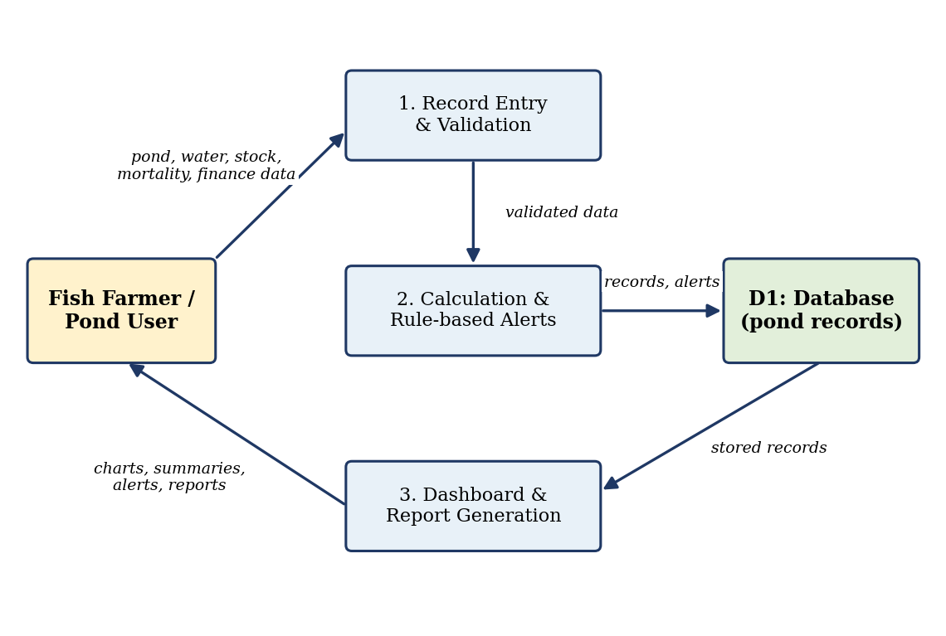
Figure 2: Basic data-flow diagram (proposed design)
12. Module-wise Design
Module 1 – Pond registration and management. A pond is registered once and then selected for every entry. Example fields: pond ID, name, type, location, area, depth, species, owner or manager and registration date. Stocking details (date, number of fish, average weight, source) are kept as separate records so that several cycles can be stored for one pond.
Module 2 – Water-quality monitoring. The user enters pH, water temperature, dissolved oxygen and turbidity with date, time, the method used (test kit, meter or visual estimate) and remarks. The application stores the readings, shows the latest values and plots history. Acceptable ranges can be configured per species or stage and readings outside them are flagged. Suitable ranges depend on the species, production stage, environment and reliable aquaculture guidance, so no threshold is presented as universal. Manual entry is different from automatic sensor-based monitoring: unless sensors are installed in future, the system knows only what the user enters.
Module 3 – Fish-growth tracking. At stocking and at each sampling date the number of live fish and the average weight are recorded. Estimated biomass (kg) = Number of live fish × Average fish weight (kg). This is an estimate and depends on an accurate fish count and a representative weight sample. Growth history is the series of average weights over time.
Module 4 – Feeding support. Daily feed requirement (kg) = Estimated biomass (kg) × Feeding rate (%) / 100. Hypothetical example for illustration only: for 2,000 live fish of average weight 0.25 kg, biomass = 2,000 × 0.25 = 500 kg; with an assumed feeding rate of 3 %, daily feed = 500 × 3 / 100 = 15 kg. The 3 % value only demonstrates the arithmetic. The appropriate rate depends on species, size, water temperature, health, feeding behaviour and aquaculture guidance; the calculator supports decisions and does not replace expert advice.
Module 5 – Mortality and event recording. The date, pond, number of dead fish, observations (such as unusual behaviour or recent weather) and follow-up action are recorded. Viewed over time, the counts and notes help the user and any expert see patterns that need investigation. The system does not diagnose disease.
Module 6 – Risk alerts. Alerts are simple rule-based checks, for example: if a recorded value is outside the configured range, or mortality in a chosen period exceeds a chosen number, a warning message is shown. These are rules written by people and are not machine-learning prediction; no predictive AI is claimed. Weather-based alerts need a weather data source and are future scope.
Module 7 – Expense, sales and production tracking. Expense records hold date, category (fingerlings, feed, labour, maintenance, other), amount and notes; sales records hold harvest quantity, price per kg and revenue. Total expenses = Sum of recorded expense entries. Total revenue = Sum of recorded sales revenue. Basic net return = Total revenue − Total expenses. This is a simplified measure and may exclude depreciation, financing cost and other business expenses.
Module 8 – Dashboard and reports. For a selected pond and date range the dashboard is proposed to combine pond details, latest and historical water readings, growth and biomass, feed calculations, mortality and events, alerts, and totals for expenses, sales and net return, with charts and date filters. These are proposed features.
13. Data Model and Database Design
The relational design below is a proposed schema. One pond has many stocking, water-quality, growth, feeding, mortality, expense and sales records (one-to-many). Each table has a primary key (PK) and child tables carry the pond identifier as a foreign key (FK). A users table is included only if login is adopted.
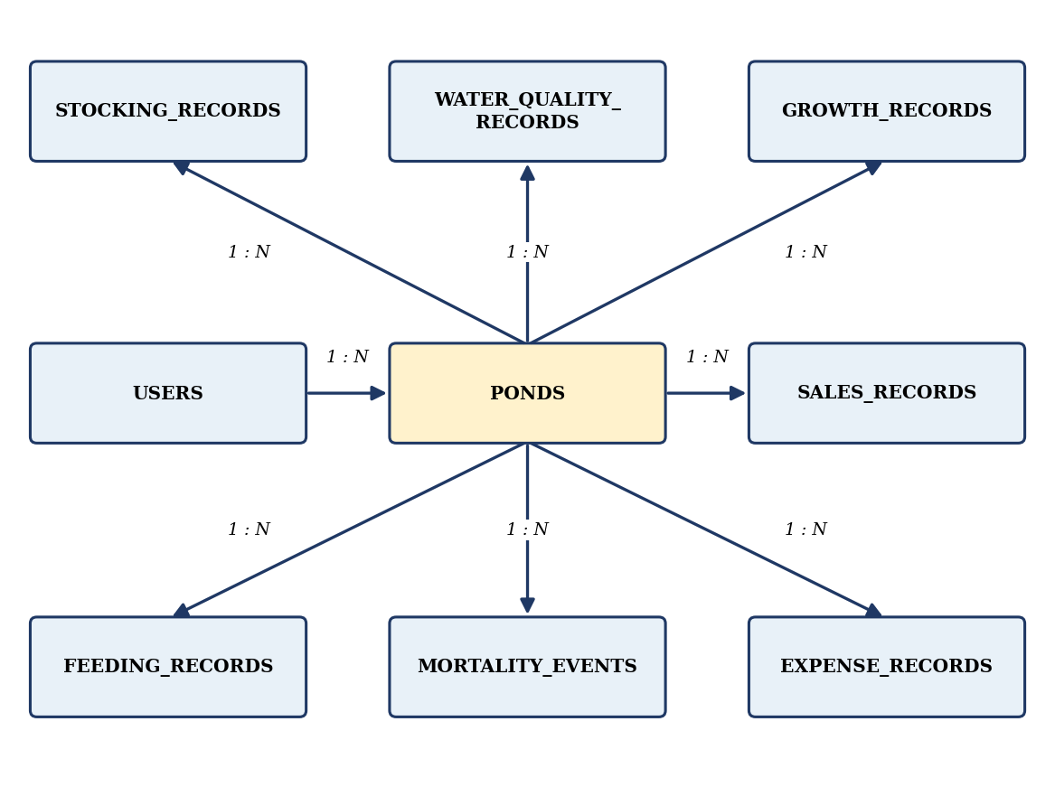
Figure 3: Illustrative entity-relationship diagram (proposed)
Table | Key fields | Other fields (examples)
users | user_id (PK) | name, role, contact
ponds | pond_id (PK), user_id (FK) | name, type, location, area, depth, species
stocking_records | stock_id (PK), pond_id (FK) | stock_date, number_of_fish, avg_weight_kg, source
water_quality_records | wq_id (PK), pond_id (FK) | recorded_at, ph, temperature, dissolved_oxygen, turbidity, method
growth_records | growth_id (PK), pond_id (FK) | sample_date, live_fish_count, avg_weight_kg, biomass_kg
feeding_records | feed_id (PK), pond_id (FK) | feed_date, feed_type, rate_percent, quantity_kg
mortality_events | event_id (PK), pond_id (FK) | event_date, dead_count, observations, follow_up
expense_records | expense_id (PK), pond_id (FK) | expense_date, category, amount, notes
sales_records | sale_id (PK), pond_id (FK) | sale_date, quantity_kg, price_per_kg, revenue

14. User-Interface Design
The interface is proposed as a Streamlit application with a sidebar to choose a pond and a page, entry forms for each module, a dashboard page with summary cards and charts, and an alerts panel. Guidelines: short labels in Telugu and English, units beside every number field, today as the default date, and a confirmation message after saving.
A prototype interface of AquaMitra, with English and Telugu language options, has been built; its screens are shown in Figures 4 to 10. They were captured in Demo Mode (offline demonstration) using sample data, so the ponds, quantities and amounts shown are sample values and not field records. The prototype also contains an AI companion labelled Demo AI; its suggestions are based on the sample data and are not validated advice.
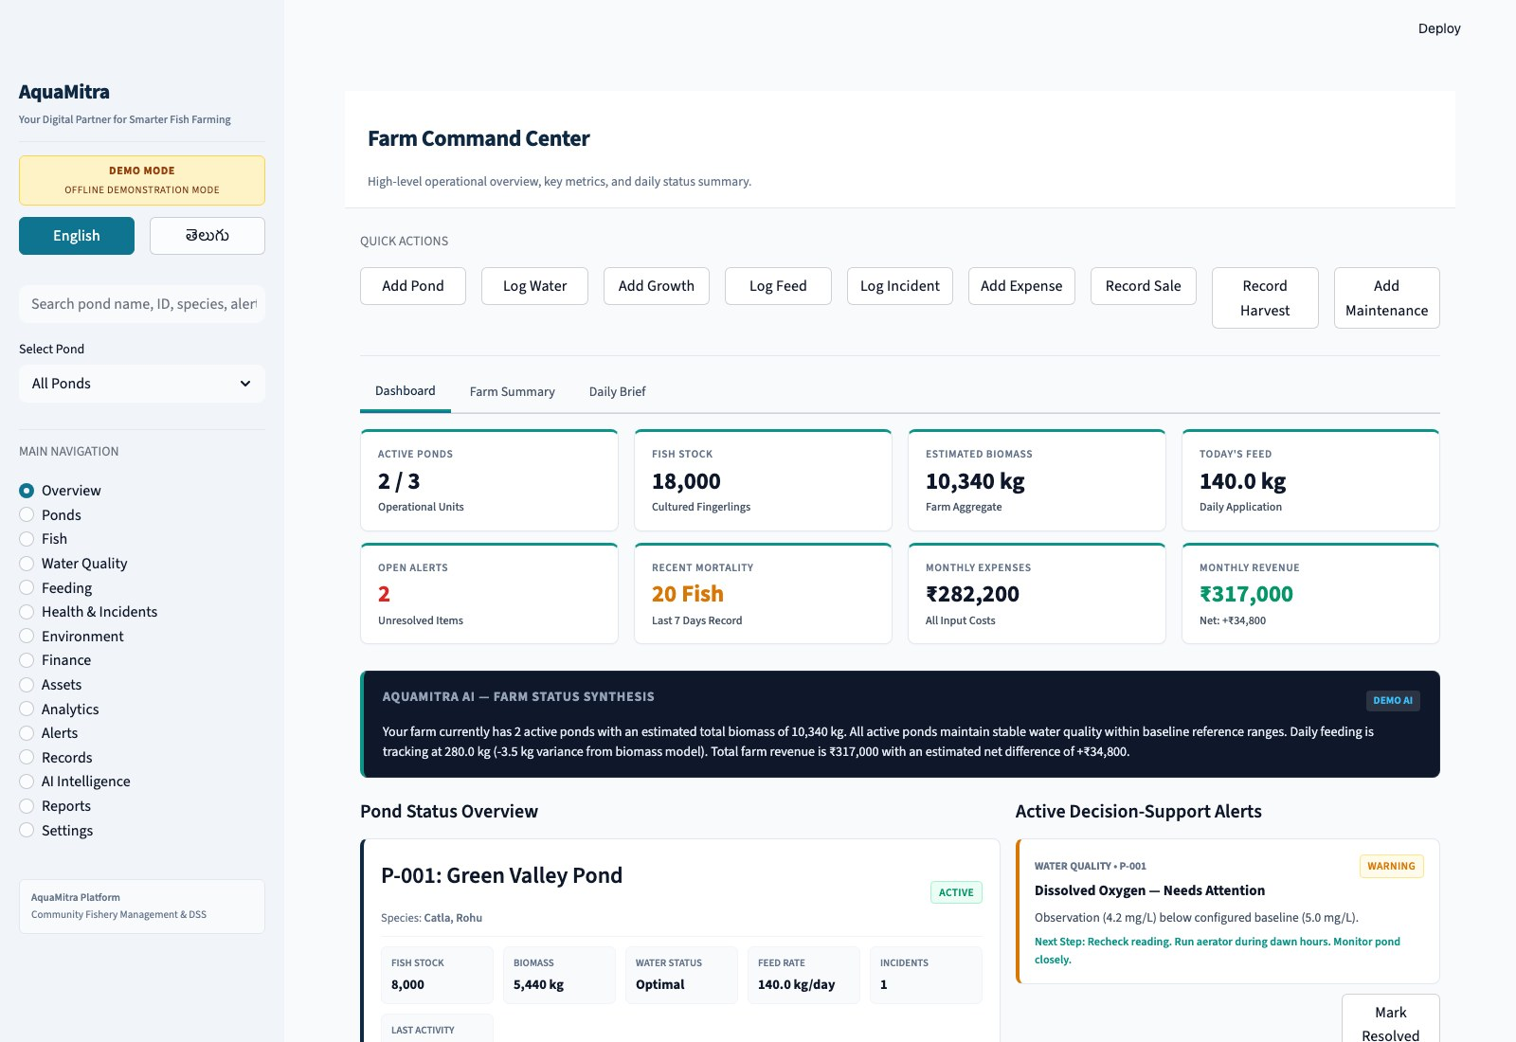
Figure 4: Farm Command Center (overview dashboard) of the AquaMitra prototype in Demo Mode with sample data
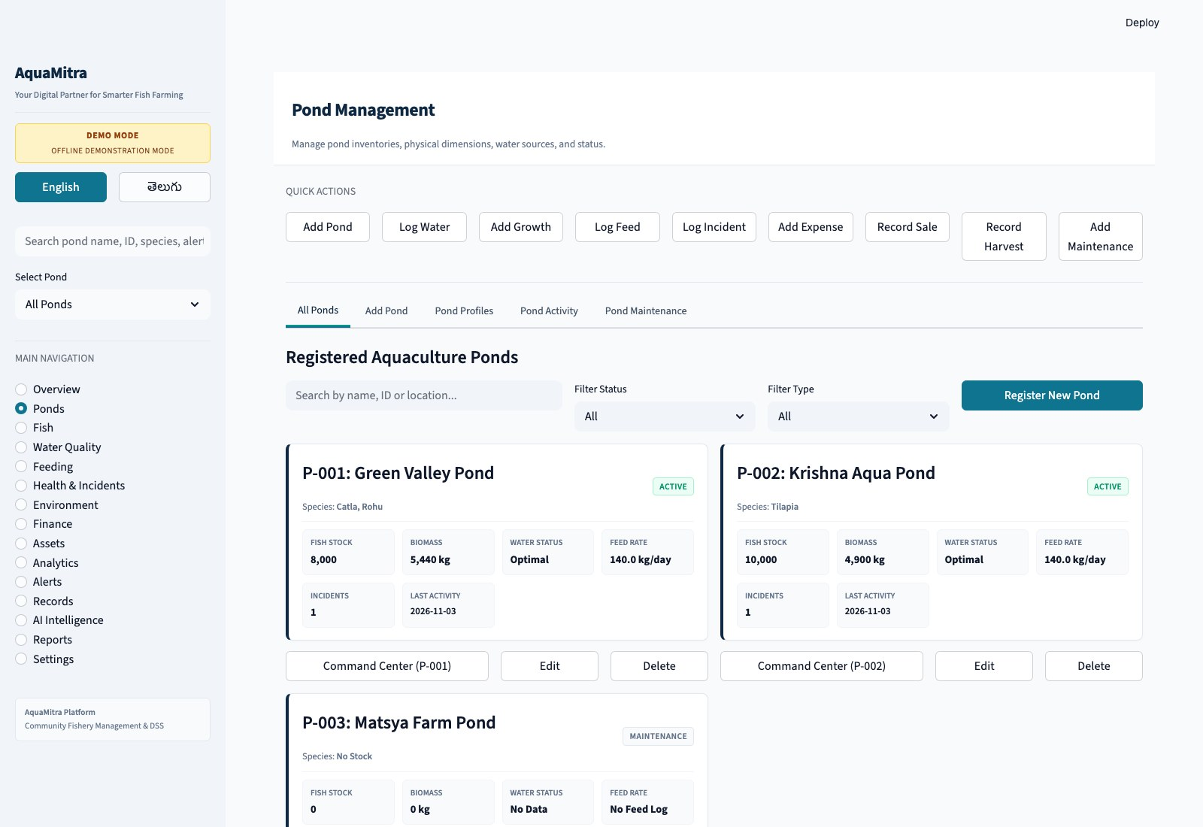
Figure 5: Pond management screen showing registered ponds and their status
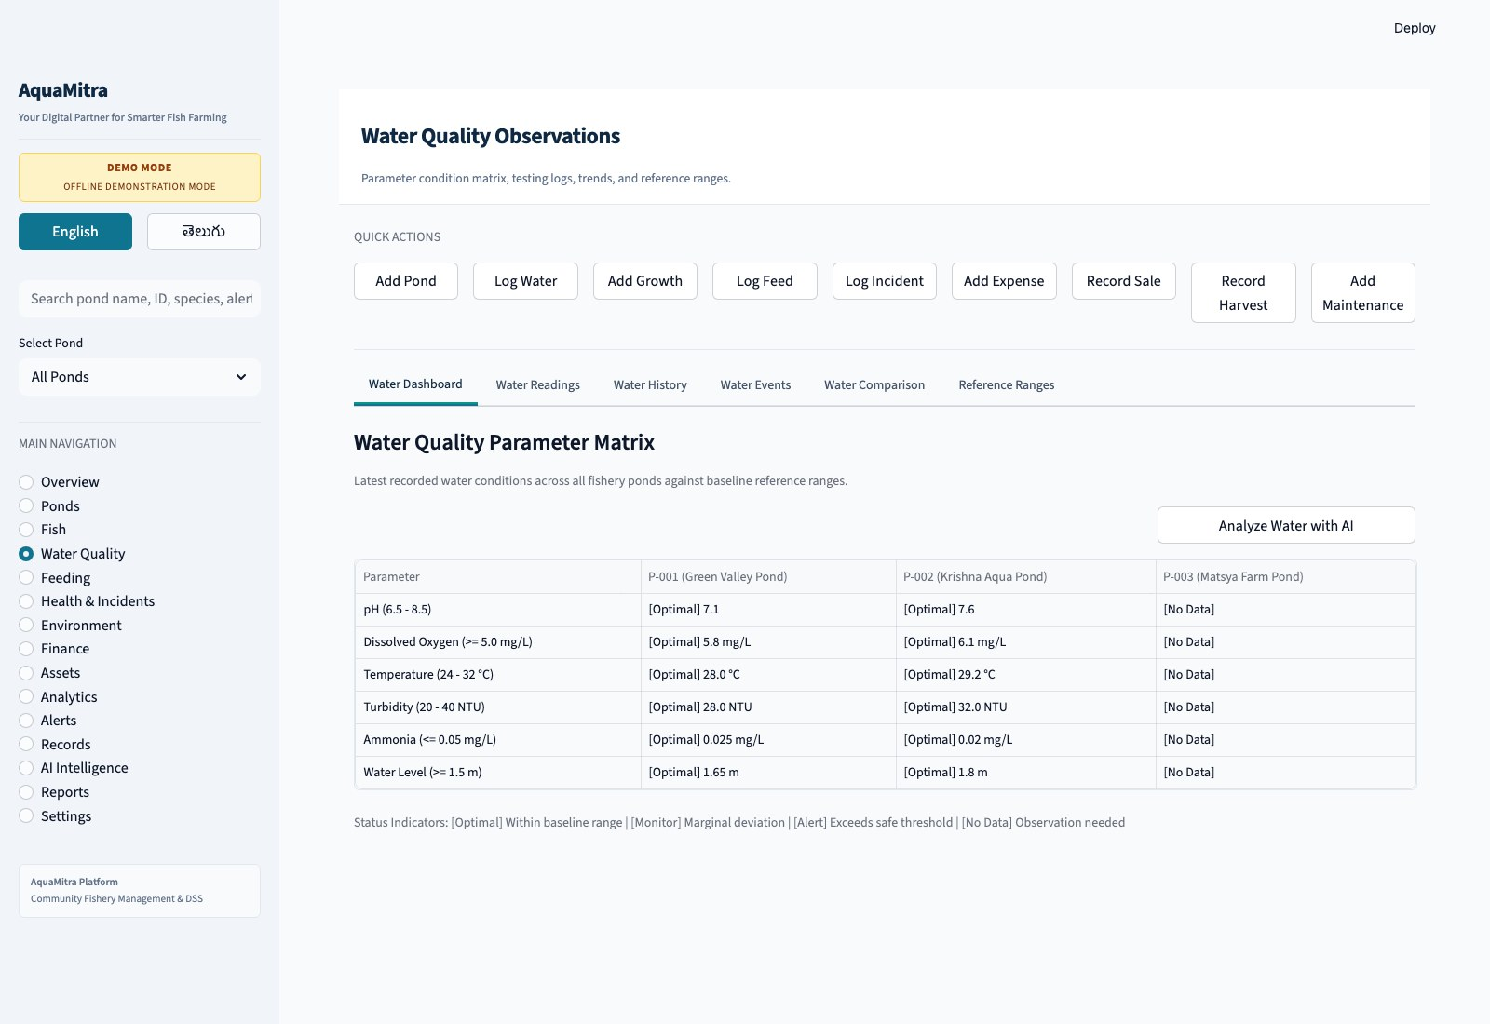
Figure 6: Water-quality parameter matrix with reference ranges
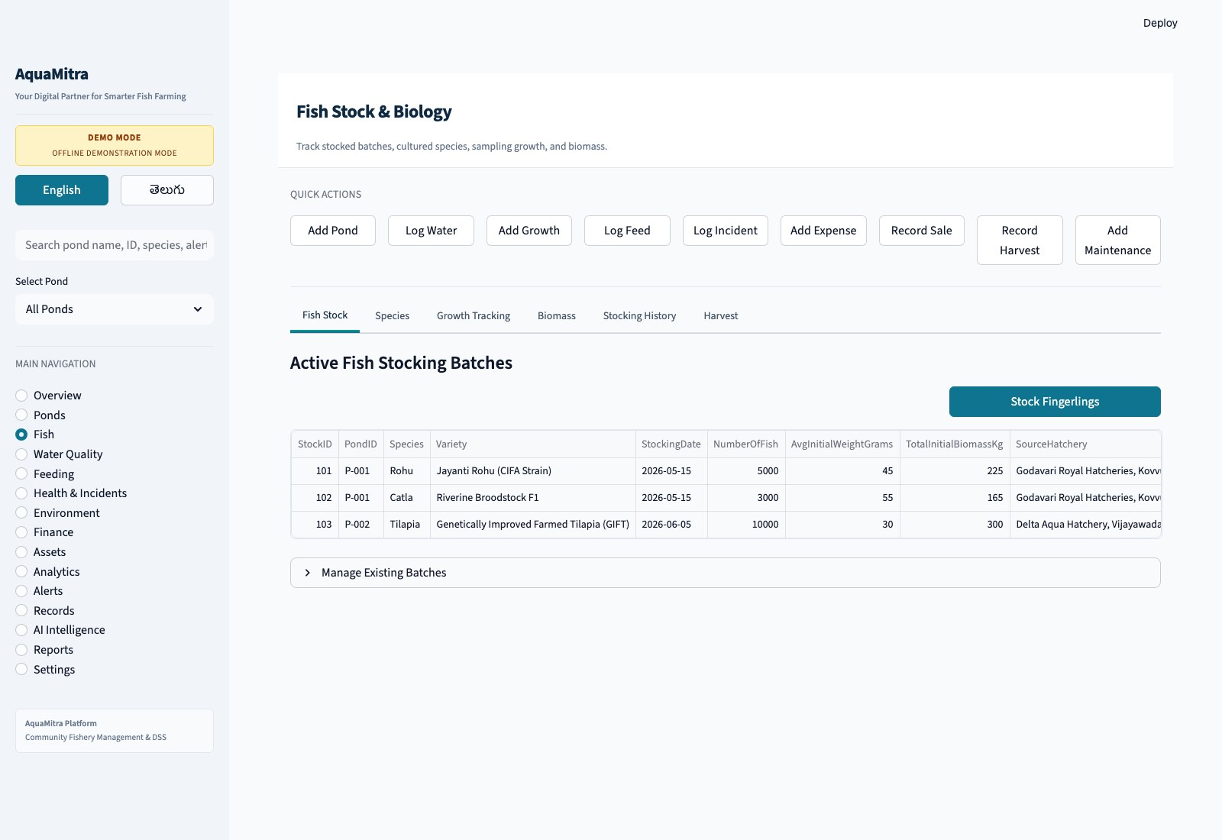
Figure 7: Fish stock and biology screen showing stocking batches
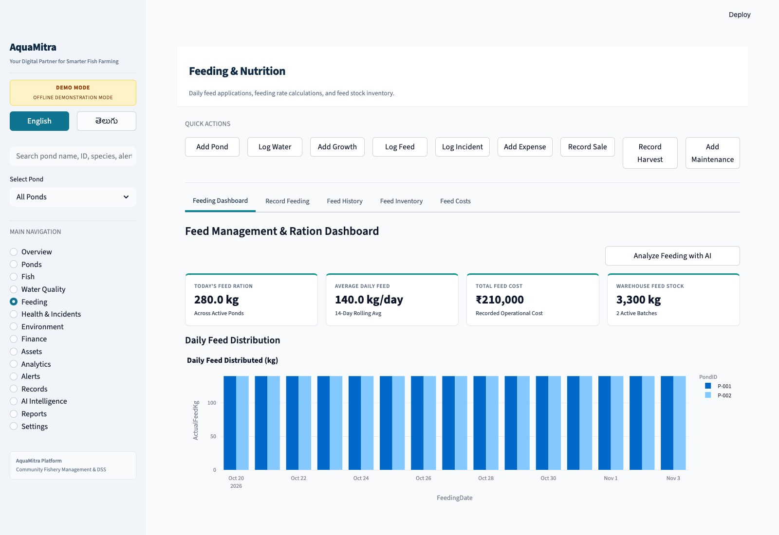
Figure 8: Feeding and nutrition dashboard with daily feed distribution
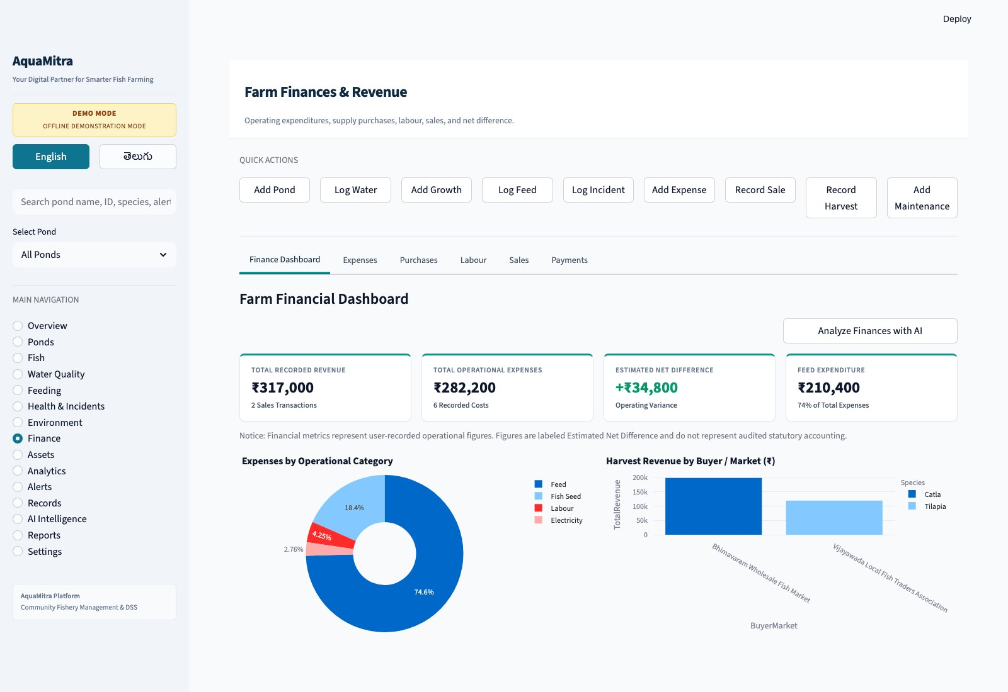
Figure 9: Farm finances and revenue dashboard
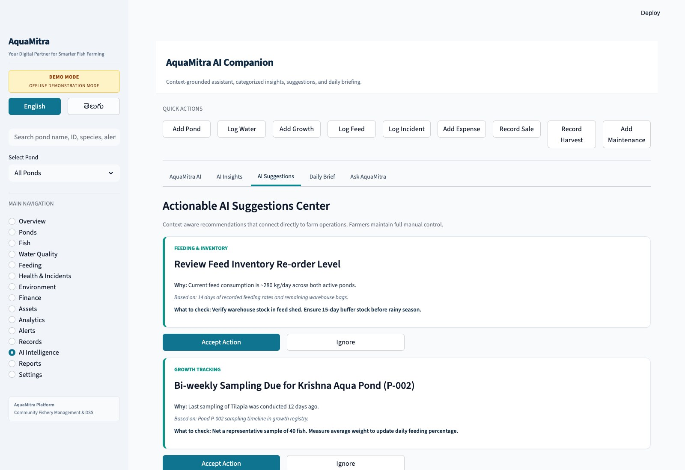
Figure 10: AI suggestions centre of the prototype (Demo AI, sample data)
15. Input Validation and Data Integrity
Required fields (pond, date) must be filled; numeric fields must be numbers within plausible bounds (for example pH between 0 and 14, and counts and weights not negative); units are fixed and displayed; duplicate entries are warned; and database keys prevent a record from referring to a pond that does not exist. Validation prevents impossible values but cannot guarantee that a plausible number is correct.
16. Risk-Identification Logic
Alert rules are checked when a record is saved and when the dashboard loads. Examples: (1) a reading below the lower or above the upper limit set for a pond; (2) mortality in a chosen period above a chosen number; (3) no water reading entered for more than a chosen number of days. Limits are set by the user or adviser. The message advises the user to re-check and consult an expert.
17. Testing Strategy
The proposed test cases are listed below. The Actual Result and Status columns are to be completed after running the tests on the working application; evidence such as screenshots should be attached.
ID | Objective | Input | Expected result | Actual | Status
TC-01 | Pond registration | Valid name, area, species | Pond saved and listed
TC-02 | Missing field | Empty pond name | Error; not saved
TC-03 | Valid water entry | pH 7.5, temp 28, DO 5, turbidity 20 (example) | Record saved with time
TC-04 | Invalid water entry | pH = 20 | Rejected with message
TC-05 | Biomass | 2,000 fish; 0.25 kg | 500 kg
TC-06 | Feed calculation | Biomass 500 kg; rate 3 % | 15 kg
TC-07 | Mortality entry | Date, pond, count 10, note | Saved and shown in log
TC-08 | Expense total | 1000, 500, 250 | 1750
TC-09 | Net return | Revenue 5000; expense 1750 | 3250
TC-10 | Incorrect input | Text in numeric field | Error; no crash
TC-11 | Record retrieval | Pond and date range | Correct records shown
TC-12 | Alert rule | Reading outside range | Warning displayed
TC-13 | Dashboard summary | Sample data | Totals match records

18. Security, Privacy and Backup Considerations
Editing should be limited to authorised users; only the personal data needed should be collected; regular backups of the database should be kept outside the device; and farmers should be told who can see their data.
19. Limitations
Results depend on accurate user entry; without sensors there is no automatic monitoring; thresholds need careful selection with expert guidance; connectivity and digital literacy may limit use; the database needs maintenance and backup; community training is needed; and there is no validated predictive analytics.
20. Future Enhancements
IoT-based pH, temperature and dissolved-oxygen sensors; ESP32-based pond monitoring; real-time sensor data; weather-API integration; SMS or mobile notifications; a Telugu-language interface; a mobile-friendly application; and predictive analytics from historical data. These are future scope and are not implemented.
21. Expected Community Benefits
Better organisation of information, easier access to records, visibility of historical trends, more consistent feed calculations, improved awareness of unusual conditions and more organised financial records. These are expected benefits; no reduction in mortality, gain in yield or increase in income has been measured or is claimed.
CHAPTER 6: RECOMMENDATIONS AND CONCLUSIONS OF THE MINI PROJECT

Recommendations and Conclusions:
The community service project studied how fishery ponds are managed in the community and how AquaMitra, a proposed Python and Streamlit based digital tool, can support organised record keeping. The conclusions and recommendations are given below.

Recommendations:
1. Fish farmers and pond managers: start dated records now using simple templates for water observations, stocking, feed, mortality, expenses and sales, and consult fisheries experts before acting on any alert.
2. Community leaders and local organisations: support awareness sessions, identify a local volunteer for training and encourage a common record format at cooperative level.
3. The college and future student teams: continue the project with a tested prototype, real pilot data and expert input, and keep documentation honest about status.
4. Developers and system maintainers: keep the design modular, document the schema, implement validation and backups, have alert limits reviewed by experts, and add prediction only after validation.
5. Potential implementation partners: the fisheries department, agricultural science centres, NGOs and cooperatives can provide expert review, pilot ponds and training.

Conclusions:
1. Community problem addressed: the difficulty fish farmers face in keeping organised records of water quality, growth, feeding, mortality, expenses and sales when they depend on manual observation and scattered notes.
2. Relevance of digital pond management: a simple centralised record makes information easier to store, find and review. Its actual value for the habitation must be confirmed by farmer feedback and a pilot use.
3. Mapping to the problems: water-quality records answer inconsistent monitoring; growth, biomass and feed modules answer tracking difficulty; rule-based alerts answer delayed identification; the mortality and event log answers scattered events; expense and sales records answer scattered finances; and the dashboard answers limited access to centralised information.
4. Educational value: the project allowed the team to apply programming, database and design knowledge to a real community need and to practise survey design, communication, teamwork and documentation.
5. Potential benefits to fish farmers: better record management, easier monitoring, clearer growth and feeding history, greater awareness of risks and better visibility of finances. No measured improvement is claimed.
6. Limitations: dependence on accurate user entry, no automatic sensing, the need for suitable alert limits, connectivity and digital-literacy constraints, backup needs, training needs and no validated predictive analytics.
7. Conditions for adoption: a tested and stable application, a Telugu-friendly design, user training, a local champion, expert-reviewed alert limits, a backup routine and clear data-privacy practice.
8. Future development: pilot with a few willing farmers, improve using their feedback, then consider mobile access, a Telugu interface and, where affordable, sensors and notifications. Sustainability needs a maintainer, funding and community ownership.
Conclusions 1, 3, 4 and 5 are supported by the project presentation; conclusions 2, 7 and 8 are recommendations for future implementation.

Student Self-Evaluation for the Community Service Project
Student: Kunasani Kraanthi Registration No: 24481A05J7 Period of CSP: 04-05-2026 to 27-06-2026

Student Name:
Registration No: Period of CSP: From:
To:
Date of Evaluation:

Name of the Person in-charge: Address with mobile number:

Please rate your performance in the following areas:

Rating Scale: 1 is lowest and 5 is highest rank

1) Oral communication | 1 | 2 | 3 | 4 | 5
2) Written communication | 1 | 2 | 3 | 4 | 5
3) Proactiveness | 1 | 2 | 3 | 4 | 5
4) Interaction ability with community | 1 | 2 | 3 | 4 | 5
5) Positive Attitude | 1 | 2 | 3 | 4 | 5
6) Self-confidence | 1 | 2 | 3 | 4 | 5
7) Ability to learn | 1 | 2 | 3 | 4 | 5
8) Work Plan and organization | 1 | 2 | 3 | 4 | 5
9) Professionalism | 1 | 2 | 3 | 4 | 5
10) Creativity | 1 | 2 | 3 | 4 | 5
11) Quality of work done | 1 | 2 | 3 | 4 | 5
12) Time Management | 1 | 2 | 3 | 4 | 5
13) Understanding the Community | 1 | 2 | 3 | 4 | 5
14) Achievement of Desired Outcomes | 1 | 2 | 3 | 4 | 5
15) OVERALL PERFORMANCE | 1 | 2 | 3 | 4 | 5

Date: Signature of the Student

Student Self-Evaluation for the Community Service Project
Student: Kanna Jagadish Babu Registration No: 24481A05F4 Period of CSP: 04-05-2026 to 27-06-2026

Student Name:
Registration No: Period of CSP: From:
To:
Date of Evaluation:

Name of the Person in-charge: Address with mobile number:

Please rate your performance in the following areas:

Rating Scale: 1 is lowest and 5 is highest rank

1) Oral communication | 1 | 2 | 3 | 4 | 5
2) Written communication | 1 | 2 | 3 | 4 | 5
3) Proactiveness | 1 | 2 | 3 | 4 | 5
4) Interaction ability with community | 1 | 2 | 3 | 4 | 5
5) Positive Attitude | 1 | 2 | 3 | 4 | 5
6) Self-confidence | 1 | 2 | 3 | 4 | 5
7) Ability to learn | 1 | 2 | 3 | 4 | 5
8) Work Plan and organization | 1 | 2 | 3 | 4 | 5
9) Professionalism | 1 | 2 | 3 | 4 | 5
10) Creativity | 1 | 2 | 3 | 4 | 5
11) Quality of work done | 1 | 2 | 3 | 4 | 5
12) Time Management | 1 | 2 | 3 | 4 | 5
13) Understanding the Community | 1 | 2 | 3 | 4 | 5
14) Achievement of Desired Outcomes | 1 | 2 | 3 | 4 | 5
15) OVERALL PERFORMANCE | 1 | 2 | 3 | 4 | 5

Date: Signature of the Student

Student Self-Evaluation for the Community Service Project
Student: Kodali Durga Mahesh Registration No: 24481A05G7 Period of CSP: 04-05-2026 to 27-06-2026

Student Name:
Registration No: Period of CSP: From:
To:
Date of Evaluation:

Name of the Person in-charge: Address with mobile number:

Please rate your performance in the following areas:

Rating Scale: 1 is lowest and 5 is highest rank

1) Oral communication | 1 | 2 | 3 | 4 | 5
2) Written communication | 1 | 2 | 3 | 4 | 5
3) Proactiveness | 1 | 2 | 3 | 4 | 5
4) Interaction ability with community | 1 | 2 | 3 | 4 | 5
5) Positive Attitude | 1 | 2 | 3 | 4 | 5
6) Self-confidence | 1 | 2 | 3 | 4 | 5
7) Ability to learn | 1 | 2 | 3 | 4 | 5
8) Work Plan and organization | 1 | 2 | 3 | 4 | 5
9) Professionalism | 1 | 2 | 3 | 4 | 5
10) Creativity | 1 | 2 | 3 | 4 | 5
11) Quality of work done | 1 | 2 | 3 | 4 | 5
12) Time Management | 1 | 2 | 3 | 4 | 5
13) Understanding the Community | 1 | 2 | 3 | 4 | 5
14) Achievement of Desired Outcomes | 1 | 2 | 3 | 4 | 5
15) OVERALL PERFORMANCE | 1 | 2 | 3 | 4 | 5

Date: Signature of the Student

Student Self-Evaluation for the Community Service Project
Student: Kodali Vijaya Babu Registration No: 24481A05G8 Period of CSP: 04-05-2026 to 27-06-2026

Student Name:
Registration No: Period of CSP: From:
To:
Date of Evaluation:

Name of the Person in-charge: Address with mobile number:

Please rate your performance in the following areas:

Rating Scale: 1 is lowest and 5 is highest rank

1) Oral communication | 1 | 2 | 3 | 4 | 5
2) Written communication | 1 | 2 | 3 | 4 | 5
3) Proactiveness | 1 | 2 | 3 | 4 | 5
4) Interaction ability with community | 1 | 2 | 3 | 4 | 5
5) Positive Attitude | 1 | 2 | 3 | 4 | 5
6) Self-confidence | 1 | 2 | 3 | 4 | 5
7) Ability to learn | 1 | 2 | 3 | 4 | 5
8) Work Plan and organization | 1 | 2 | 3 | 4 | 5
9) Professionalism | 1 | 2 | 3 | 4 | 5
10) Creativity | 1 | 2 | 3 | 4 | 5
11) Quality of work done | 1 | 2 | 3 | 4 | 5
12) Time Management | 1 | 2 | 3 | 4 | 5
13) Understanding the Community | 1 | 2 | 3 | 4 | 5
14) Achievement of Desired Outcomes | 1 | 2 | 3 | 4 | 5
15) OVERALL PERFORMANCE | 1 | 2 | 3 | 4 | 5

Date: Signature of the Student

Evaluation by the Person in-charge in the Community/Habitation
Student: Kunasani Kraanthi Registration No: 24481A05J7 Period of CSP: 04-05-2026 to 27-06-2026

Student Name: Registration No:
Period of CSP: From:
To:
Date of Evaluation:

Name of the Person in-charge: Address with mobile number:

Please rate the student’s performance in the following areas:

Please note that your evaluation shall be done independent of the Student’s self-evaluation Rating Scale: 1 is lowest and 5 is highest rank

1) Oral communication | 1 | 2 | 3 | 4 | 5
2) Written communication | 1 | 2 | 3 | 4 | 5
3) Proactiveness | 1 | 2 | 3 | 4 | 5
4) Interaction ability with community | 1 | 2 | 3 | 4 | 5
5) Positive Attitude | 1 | 2 | 3 | 4 | 5
6) Self-confidence | 1 | 2 | 3 | 4 | 5
7) Ability to learn | 1 | 2 | 3 | 4 | 5
8) Work Plan and organization | 1 | 2 | 3 | 4 | 5
9) Professionalism | 1 | 2 | 3 | 4 | 5
10) Creativity | 1 | 2 | 3 | 4 | 5
11) Quality of work done | 1 | 2 | 3 | 4 | 5
12) Time Management | 1 | 2 | 3 | 4 | 5
13) Understanding the Community | 1 | 2 | 3 | 4 | 5
14) Achievement of Desired Outcomes | 1 | 2 | 3 | 4 | 5
15) OVERALL PERFORMANCE | 1 | 2 | 3 | 4 | 5

Date: Signature of the Supervisor
Evaluation by the Person in-charge in the Community/Habitation
Student: Kanna Jagadish Babu Registration No: 24481A05F4 Period of CSP: 04-05-2026 to 27-06-2026

Student Name: Registration No:
Period of CSP: From:
To:
Date of Evaluation:

Name of the Person in-charge: Address with mobile number:

Please rate the student’s performance in the following areas:

Please note that your evaluation shall be done independent of the Student’s self-evaluation Rating Scale: 1 is lowest and 5 is highest rank

1) Oral communication | 1 | 2 | 3 | 4 | 5
2) Written communication | 1 | 2 | 3 | 4 | 5
3) Proactiveness | 1 | 2 | 3 | 4 | 5
4) Interaction ability with community | 1 | 2 | 3 | 4 | 5
5) Positive Attitude | 1 | 2 | 3 | 4 | 5
6) Self-confidence | 1 | 2 | 3 | 4 | 5
7) Ability to learn | 1 | 2 | 3 | 4 | 5
8) Work Plan and organization | 1 | 2 | 3 | 4 | 5
9) Professionalism | 1 | 2 | 3 | 4 | 5
10) Creativity | 1 | 2 | 3 | 4 | 5
11) Quality of work done | 1 | 2 | 3 | 4 | 5
12) Time Management | 1 | 2 | 3 | 4 | 5
13) Understanding the Community | 1 | 2 | 3 | 4 | 5
14) Achievement of Desired Outcomes | 1 | 2 | 3 | 4 | 5
15) OVERALL PERFORMANCE | 1 | 2 | 3 | 4 | 5

Date: Signature of the Supervisor
Evaluation by the Person in-charge in the Community/Habitation
Student: Kodali Durga Mahesh Registration No: 24481A05G7 Period of CSP: 04-05-2026 to 27-06-2026

Student Name: Registration No:
Period of CSP: From:
To:
Date of Evaluation:

Name of the Person in-charge: Address with mobile number:

Please rate the student’s performance in the following areas:

Please note that your evaluation shall be done independent of the Student’s self-evaluation Rating Scale: 1 is lowest and 5 is highest rank

1) Oral communication | 1 | 2 | 3 | 4 | 5
2) Written communication | 1 | 2 | 3 | 4 | 5
3) Proactiveness | 1 | 2 | 3 | 4 | 5
4) Interaction ability with community | 1 | 2 | 3 | 4 | 5
5) Positive Attitude | 1 | 2 | 3 | 4 | 5
6) Self-confidence | 1 | 2 | 3 | 4 | 5
7) Ability to learn | 1 | 2 | 3 | 4 | 5
8) Work Plan and organization | 1 | 2 | 3 | 4 | 5
9) Professionalism | 1 | 2 | 3 | 4 | 5
10) Creativity | 1 | 2 | 3 | 4 | 5
11) Quality of work done | 1 | 2 | 3 | 4 | 5
12) Time Management | 1 | 2 | 3 | 4 | 5
13) Understanding the Community | 1 | 2 | 3 | 4 | 5
14) Achievement of Desired Outcomes | 1 | 2 | 3 | 4 | 5
15) OVERALL PERFORMANCE | 1 | 2 | 3 | 4 | 5

Date: Signature of the Supervisor
Evaluation by the Person in-charge in the Community/Habitation
Student: Kodali Vijaya Babu Registration No: 24481A05G8 Period of CSP: 04-05-2026 to 27-06-2026

Student Name: Registration No:
Period of CSP: From:
To:
Date of Evaluation:

Name of the Person in-charge: Address with mobile number:

Please rate the student’s performance in the following areas:

Please note that your evaluation shall be done independent of the Student’s self-evaluation Rating Scale: 1 is lowest and 5 is highest rank

1) Oral communication | 1 | 2 | 3 | 4 | 5
2) Written communication | 1 | 2 | 3 | 4 | 5
3) Proactiveness | 1 | 2 | 3 | 4 | 5
4) Interaction ability with community | 1 | 2 | 3 | 4 | 5
5) Positive Attitude | 1 | 2 | 3 | 4 | 5
6) Self-confidence | 1 | 2 | 3 | 4 | 5
7) Ability to learn | 1 | 2 | 3 | 4 | 5
8) Work Plan and organization | 1 | 2 | 3 | 4 | 5
9) Professionalism | 1 | 2 | 3 | 4 | 5
10) Creativity | 1 | 2 | 3 | 4 | 5
11) Quality of work done | 1 | 2 | 3 | 4 | 5
12) Time Management | 1 | 2 | 3 | 4 | 5
13) Understanding the Community | 1 | 2 | 3 | 4 | 5
14) Achievement of Desired Outcomes | 1 | 2 | 3 | 4 | 5
15) OVERALL PERFORMANCE | 1 | 2 | 3 | 4 | 5

Date: Signature of the Supervisor

PHOTOS AND VIDEO LINKS
Photographs taken during the community visit are given below. Links to videos, if any, will be added after this section.
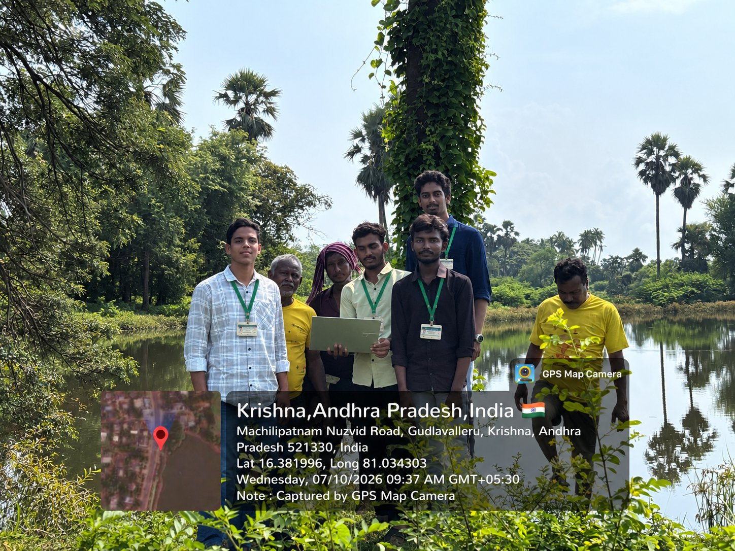
Photograph 1: Team members with community members at the pond site during the community visit, Gudlavalleru (GPS-stamped)
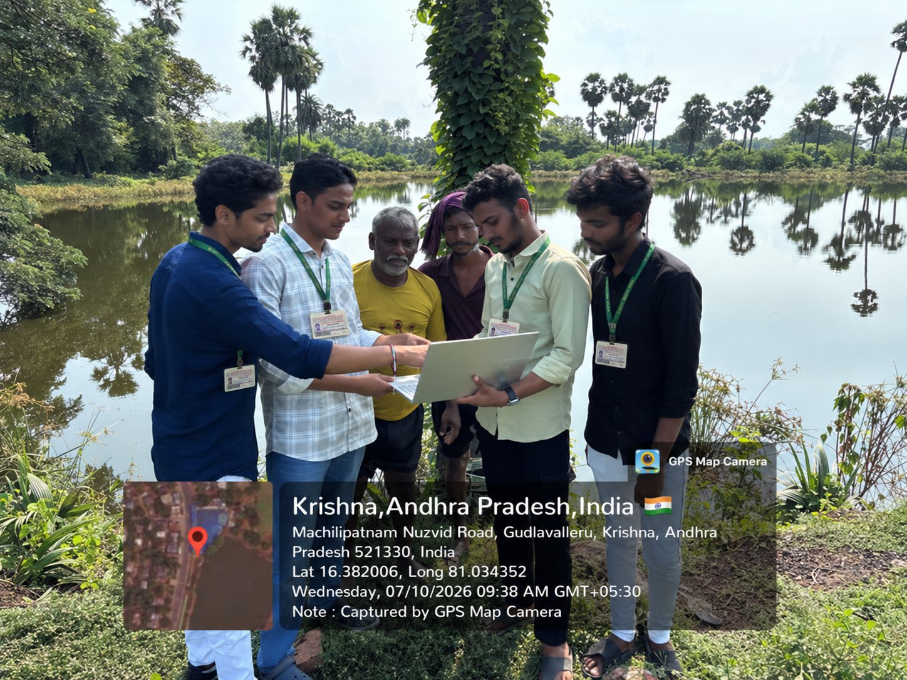
Photograph 2: Team showing the AquaMitra application on a laptop at the pond site
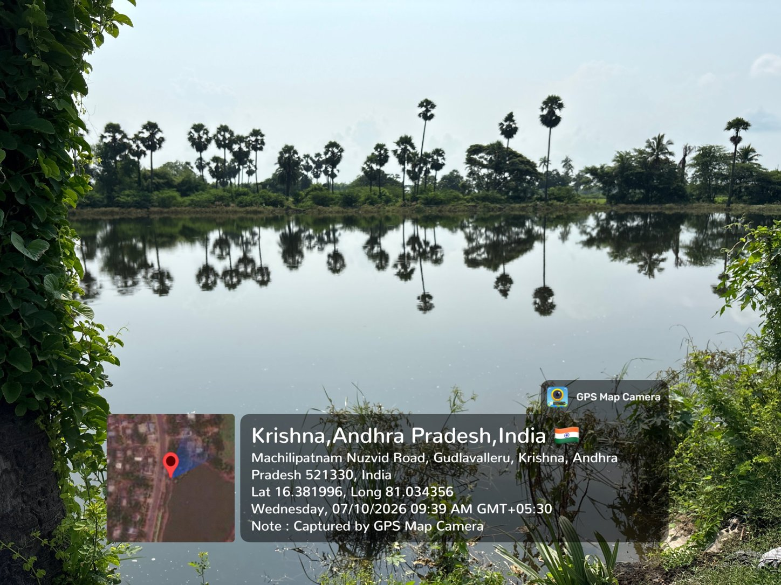
Photograph 3: View of the fishery pond visited
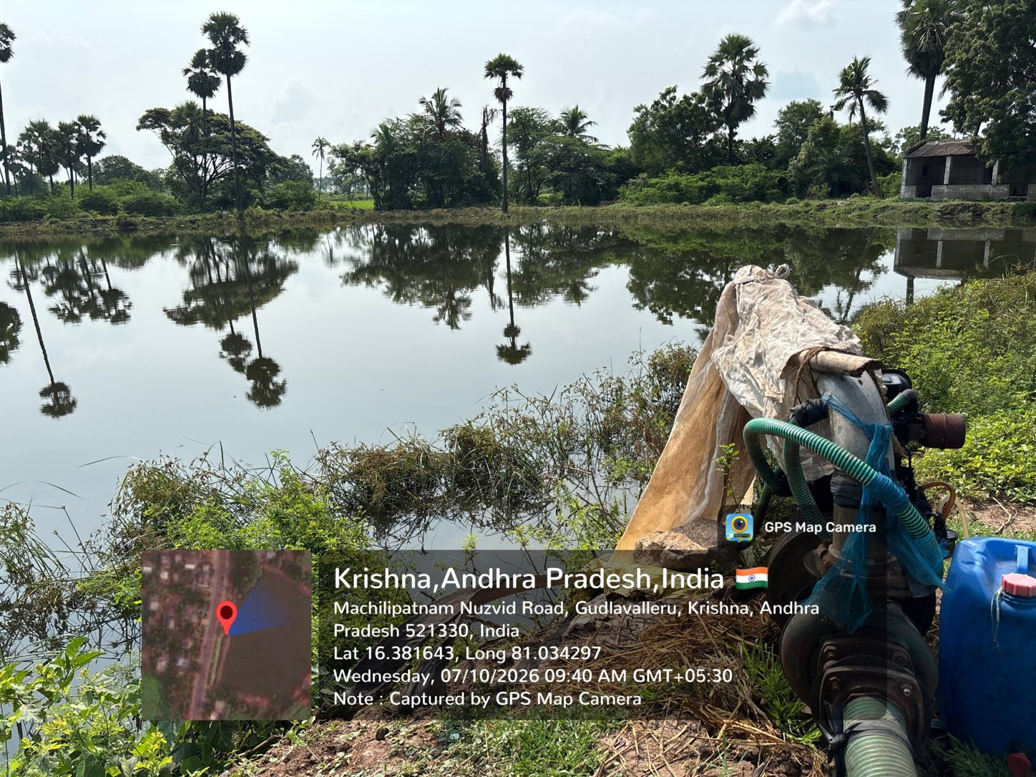
Photograph 4: Pond with a pump set at the pond edge

