Software Requirements Specification

for

GoSafe

An Online Cab Booking System

Version 1.0

Prepared by :- SHIVRAJ KESHAOWAR

NIIT UNIVERSITY

17/9/2016

Table of Contents

Table of Contents ii

Revision History ii

1. Introduction 1

1.1 Purpose 1

1.2 Document Conventions 1

1.3 Intended Audience and Reading Suggestions 1

1.4 Product Scope 1

1.5 References 2

2. Overall Description 2

2.1 Product Perspective 2

2.2 Product Functions 2

2.3 User Classes and Characteristics 3

2.4 Operating Environment 3

2.5 Design and Implementation Constraints 3

2.6 User Documentation 4

2.7 Assumptions and Dependencies 4

3. External Interface Requirements 4

3.1 User Interfaces 3

3.2 Hardware Interfaces 3

3.3 Software Interfaces 3

3.4 Communications Interfaces 5

4. System Features 5

4.1 Administrator 5

4.2 Mailing 6

4.3 Client……………………………………………………………………………………....6

5. Other Nonfunctional Requirements 8

5.1 Performance Requirements 8

5.2 Safety Requirements 8

5.3 Security Requirements 8

5.4 Software Quality Attributes 9

5.5 Business Rules 9

6. Other Requirements 9

Appendix A: Glossary 9

Appendix B: Analysis Models 10

**Use case Diagrams**

Appendix C: To Be Determined List 11

Revision History

|  |  |  |  |
| --- | --- | --- | --- |
| **Name** | **Date** | **Reason For Changes** | **Version** |
| Shivraj | 17/9/16 | Creating the SRS for the project | V 1.0 |
| Shivraj | 20/9/16 | For adding more information | V1.1 |
| Shivraj | 21/9/16 | Putting the final touch | V1.2 |

# Introduction

The Software Requirement Specification is designed to document and describe the agreement between the customer and developer regarding the specification of the software. Its primary purpose is to provide a clear and descriptive statement of user requirements. This document is broken into a number of sections used to logically separate the software requirements. The document can be easily understood by any user or client who can use computer or posses at-least some basic information about it.

## Purpose

Defining and describing the functions and specifications of the GoSafe system is the primary goal of this Software Requirement Specification (SRS) Document. This SRS illustrates, in clear terms, the systems primary uses and required functionality. The SRS is going to elaborate about our website and system to how they will work for the customers and the Owners. It also specifies the functional and non-functional requirements, Operating environments for user as well as for admin, business rules and our company.

## Document Conventions

* The main items which are integral part of this document are in **BOLD.**
* All the explanatory information is in plain text.
* The font for plain text is Arial and the font size is 12.
* The **bold** main items have

Font :- Times

Font size :- 18 – Designating main parts

14 – Designating sub parts to the above main parts.

## Intended Audience and Reading Suggestions

Our SRS document is free for all to view and give suggestions for further improvements of our web system. The rest of the SRS contains the full information of the Web system, use case diagrams and other requirement specifications.

## Product Scope

This project’s aim is to provide an online cab booking system which will have a unique cab sharing feature. The website will provide a valid and secure platform to for the sharing feature, such that only customers registered with our website will get to use it. All the data about our customers will be stored on our secure servers which will be maintained for good performance of the website.

## References

<http://www.guru99.com/traceability-matrix.html>

<http://1000projects.org>

<https://sourceforge.net>

# Overall Description

## Product Perspective

The Go-Safe website is completely new and will have some awesome features like sharing a cab with our fellow university students which will ultimately lead us to the goal of providing easier and cheaper cabs. We chose to make online cab system because online systems are much faster at performing certain tasks than those of humans. The sharing feature involves two modes, the first mode is that the client can share an already shared cab by just searching in the given menu while the second feature is that the client can make his/her cab available for sharing.

Our product perspective is roughly like as shown :-

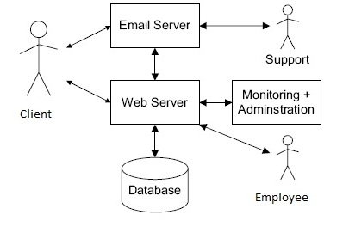

## Product Functions

The product basically contains following functions :-

1. The website will give different “Login page” for the Admin and Customer.
2. The admin will have a login password and has the power to update almost every detail/ information about cabs, employees, etc.
3. Customers get to use an online account to manage their activities on the website.
4. Customers can book a cab on any date from the list provided when they enter the required details.
5. Also they can see who is sharing a cab for the same destination if they opt for sharing the cab. Also, customers can share their booked cab if they want to.
6. The shared cabs can have less fares depending on the source, destination and the number of customers for it.
7. Customer will get automatic notification via e-mail as soon as they book a cab on our site.
8. After booking a cab they will have a 1 hour window to cancel the cab.
9. The client can give feedback after using our cab service for the first time which is going to help us improve on our part. Also, the reviews for the sharing feature will be displayed separately so that more and more people can take advantage of it and make our services popular making us grow further and reach more customers.

## User Classes and Characteristics

Our authorized employees and registered customers can use this website. There will be one employee who will act as Admin for the site and he will update all the data needed so that their will be no inconvenience to our precious clients.

Our clients can book a cab or book an already booked but shared by that client, which will allow them to share the fare for the journey. Also if client needs a cab on regular basis, he/she can do that. With the Unique Sharing feature of ours their travelling can become much cheaper. Here, the client who has raised his booked cab for sharing must accept the request of the other client in order to avail our sharing feature.

## Operating Environment

Since our website is an online platform it requires following items:-

**Client System**:- Computer (PC) running any windows, any Web browser

**Server system**:- WAMP Server, 000webhosting.com

**Network**:- TCP/IP, HTTP

**Database**:- HIDE SQL

**Software Tool**:- HTML, JavaScript, php, Sublime Text Editor

**Bootstrap**:- Bootstrap helps to make the website mobile friendly.

**Php document**:- It defines Functions for the website contents.

## Design and Implementation Constraints

The GoSafe website is totally on online platform so it doesn’t have many constraints except when our server are under maintainance or if we got any problem with server. Otherwise, there is one more constraint which is related to sharing feature of our site. The constraint is that the sharing of cabs should be done on same date and time and both clients should agree for it.

## User Documentation

We will provide user with FAQ’s for their batter understanding and usability of the site. Also, they can send their questions to us through our provided e-mail 24x7.The answers to their questions will be sent as soon as possible depending on which time of day is it.

## Assumptions and Dependencies

The following are the assumptions and dependencies for our website

1. Our website is totally based on our servers. If something goes wrong then site will be down until we take adaptive important measures.
2. Our service can cause malfunction in cases

* If the cab booked by client had any accident or something is wrong with the car
* The driver assigned to cab is not able to come to work.
* Also the company which is going to use our website for their don’t have any technical knowledgeable people. In this case we have provide external support from s to set-up the system successfully.

# External Interface Requirements

## User Interfaces

User interface has become very important in this modern age and evolving age. People are tending to use to websites, applications which are easier to use and understand. So, we are using HTML and CSS to design our user interface and it will be as easy to understand as possible, so that even the customer who is using it first time can easily navigate and use our services at fullest.

## Hardware Interfaces

As the website is online the only hardware interface we require is as follows :-

1. PC’s for the technical person who is going to manage all the information to be updated.
2. The client need to use any computer with internet connection to access our website.
3. On the server side, we need to use the hardware that is specified to use with the application with which our server is working.

## Software Interfaces

Server side software:-

1. A server software needed to be installed on the server hardware to run the website smoothly. Here, we are using WAMP server.
2. The server must be installed with database tools like HIDE SQL.
3. The client need to install a web browser through he/she can access the website.
4. The client network should support any network protocol like TCP/IP.
5. Normal server and client memory configurations are sufficient to run our website.

## Communications Interfaces

The communication protocols that are necessary for establishing secure internet are:-

1. TCP/IP protocol
2. HTTP protocol

These two protocols are a must for a better facilitation in both server and client part.

# System Features

All the important system features and their types are listed here :-

## Administrator :-

**4.1.1 Description and Priority**

The administrator is the going to be responsible for the smooth running of the website as he is the actual owner of the product and he should posses a good information of all the services he is providing. He is different from the he admin who will be responsible for the updation of data on the server, in short the Administrator is the superviser of all the activities going on the website and the system and he has the websites fate in his hand.

**4.1.2 Stimulus/Response Sequences**

The Administrator will have a personal secure login which will have more features to control the website and the data traffic. He will have a more advanced dashboard.

**4.1.3 Functional Requirements**

The Administrators dashboard will consist of links which can be accessed only by him/her and will provide many new features like inspection of the data traffic.

He will also be able to send mails directly through his account as it will be linked to his business – mail with the help of extensions. The “KEY password” will only be available to the administrator which can used to lock each and every connector to the webpage and in emergency situations. He can ban any client is he found about any misusage of the account or services.

Requirements for Administrator are :-

REQ-1: Perform weekly roster of Employees

REQ-2: Print reports daily, weekly, monthly and annually.

REQ-3: Check feedbacks.

REQ-4: Send newsletters.

REQ-5: Manage user-portfolio.

REQ-6: Changing the super password.

## Mailing :-

### Description and priority :-

The unique mailing system is one of the most important requirements for a software like this. An automated system will be set up so that it will send mails to the user as well as the administrator about all the activities such as conformation of booking a cab, password reset on request and for some other feature if the user opted for it.

### Stimulus/Response Sequences :-

* Mails will be sent to the user after a successful cab booking.
* Mail will be sent to the administrator after the user gives a feedback.
* Mails will be shared with respective customers who wanted a shared cab to alert them beforehand.
* A confirmation mail will be sent to the customer if the other customer accepted to use their shared cab.
* Mails will be sent for the password forgotten users on providing their valid and registered e-mail id with our website.

### Functional Requirements :-

The automatic mail generator is developed using PHP. It will generate all the necessary mails that will be required with the use of PHP on completing a ask that requires confirmation of such kind.

REQ-1: Temporary password will be mailed to the user in case the user forgot his original one.

REQ-2: Newsletters should go to the clients email addresses.

REQ-3: The client should get notifications through email about their cab booking while confirmed

REQ-4: Admin will get a mail if a customer will give a feedback.

REQ-5: Notification mail will be sent to the customer after getting any sharing request from any

Other customer.

## Client :-

### Description and Priority :-

This part of the SRS explains about the User Interface that customer is going to face. It has the customer login and logout functions, basically how will he login to our website and how he will get logged out is described here. Also the other features that a customer is going to face while he is logged in to the account on our system.

### Stimulus/ Response Sequences :-

* Customer has to register with us by sharing some authenticated details about him/her. By doing so he will become eligible for the usage all features of our website.
* The customer can choose a suitable username and desired password to login in our system. He will have to use the same every time whenever he is going to use our services.
* After the customer has logged into the system, for the purpose of booking a cab he has to provide date, time, location and destination for booking a cab.
* Then he will be shown available cabs on that route so that he can choose the desired one.
* The customer can cancel the cab in a span of an hour in some cases.
* The customer can opt for the sharing feature solely on his desire.
* After the customer confirms the cab on the website an auto-generated mail will be sent through our mailing system confirming the cab booking.
* After using the site the customer can logout from the system.

### Functional Requirements :-

Firstly, the customer have to register on the website then only he/she can login into our system through our website. There will be authentication for the customer, about the submission of correct or wrong details. If someone enters wrong login information in the login page then it will generate an error. When the customer provide valid login-id (username) and password then he can avail our services by providing valid information. After that he/she can book a cab by providing valid information from the desired place to the destination that he/she wants to go. Customer can also cancel the booking but only in the span of an hour because once the cab driver is enrooted to pick him/her up to the provided source destination the cab can’t be cancelled. After the successful booking of the cab the customer can logout of the system. The account will be secured with our encryption system.

REQ-1: Register and Login in our website

REQ-2: Authentication of the login.

REQ-3: Logout from the account through website.

REQ-4: Change password.

REQ-5: Resetting the password.

REQ-6: Date, Time and Location.

REQ-7: Selecting cab.

REQ-8: Cab booking.

REQ-9: Cab canceling.

# Other Nonfunctional Requirements

## Performance Requirements

Some performance requirements are as follows:-

1. The software should support use of multiple users at a time.
2. The database should be able to accommodate a minimum of 10,000 record of clients as on the primary basis.

## Safety Requirements

To protect our system from accidental or malicious access, modification or disclosure following safety measures will be done:-

1. Use cryptographic technique to encrypt the data primarily on our server.
2. Some areas of the must be restricted to communicate with other parts so that the safety should not be compromised.
3. Each user’s session log or history data set will be saved separately.
4. Check data integrity for critical variables

## Security Requirements

Some security requirements are as follows :-

1. The improved later version of the system will be integrated with more advanced encryption techniques.
2. Error tracking logs, misusage logs will be maintained so that if someone tries to invade integrity of user account or the source system , they can be stopped and prevented in future.
3. Communication should be restricted when a user is validating his account or license. This can achieved with “**https**” protocol.
4. If the user forget the account password then a dummy one time usable password will be sent upon a simple verification by providing registered mail with account via e-mail to the user and the user can again take any desired password to use the account further.

## Software Quality Attributes

The software quality and the service provided will be evaluated on the basis of the feedback which will be asked to every user after their each journey with us. Our management team will go through the serious issues faced by user’s and will take further actions needed to improve our website if it has any issue or the cab service.

## Business Rules

The role of our company is to maintain the database of the client company through our system i.e. updating available cab status, booked cab status, etc.We will achieve this by employing a person to update all this information for our client companies.

# Other Requirements

Some non-software based requirements needs to be considered:-

1. Maintaining the **service log** of each vehicle will be become an essential requirement in future.
2. Maintaining the car wise Accident details.
3. Maintaining the breakdowns and services of vehicles.
4. Also, maintaining the details of company, vehicles owned, records of employees, financial records are needed.

Appendix A: Glossary

**Vehicles/ car/ cabs** **:-** The actual vehicles that are officially owned by the client company who is

using our software

**Employee :-** The drivers of vehicles serving the user’s of the website (and the person who is going to update all the information about available cabs, if we hired such an employee.)

**HTTPS :-** Hypertext Transfer Protocol Secure

**TCP/IP :-** Transmission Control Protocol / Internet Protocol

**Client / Customer :-** The user of the website and our services

Appendix B: Analysis Models

Use Case Diagrams :-

Use case for Admin:-

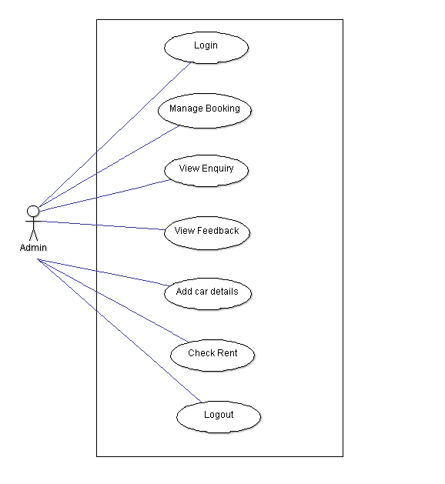

Use case for Customer :-

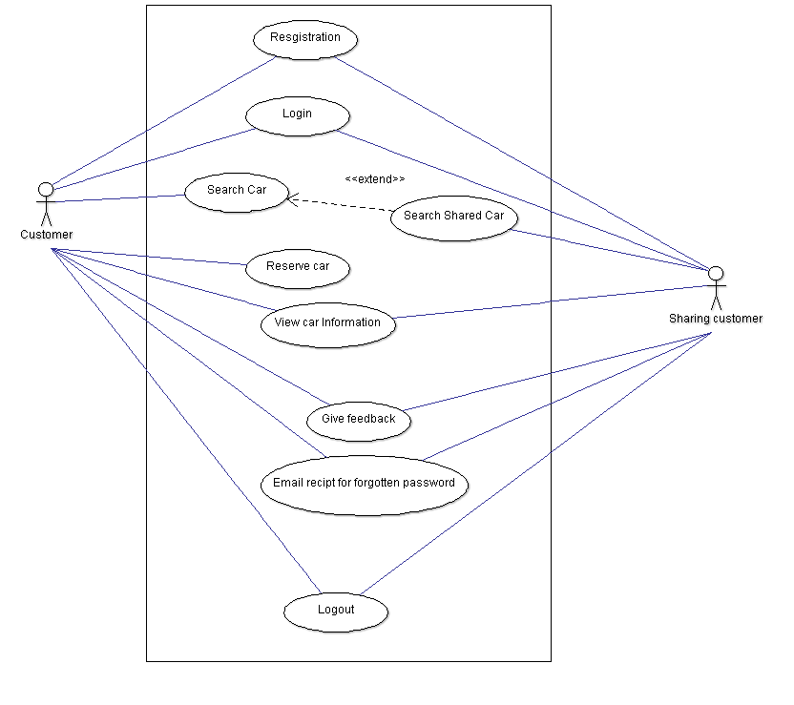

Appendix C: To Be Determined List

* This is going to be the new website with new sharing feature, so to reach to maximum customers as possible we will use advertisements on other websites as our first tool to popularize the website.
* The time we will reach a good amount of customers then we can try new ideas of promotions of the site to reach even more customers.