Software Requirements Specification

for

GO-Safe

Version 1.0

Prepared by

Karanam Rakesh

NU

17-09-2016

Table of Contents

Table of Contents ii

Revision History ii

1. Introduction 1

1.1 Purpose 1

1.2 Document Conventions 1

1.3 Intended Audience and Reading Suggestions 1

1.4 Product Scope 1

1.5 References 1

2. Overall Description 2

2.1 Product Perspective 2

2.2 Product Functions 2

2.3 User Classes and Characteristics 2

2.4 Operating Environment 2

2.5 Design and Implementation Constraints 2

2.6 User Documentation 2

2.7 Assumptions and Dependencies 3

3. External Interface Requirements 3

3.1 User Interfaces 3

3.2 Hardware Interfaces 3

3.3 Software Interfaces 3

3.4 Communications Interfaces 3

4. System Features 4

4.1 System Feature 1 4

4.2 System Feature 2 (and so on) 4

5. Other Nonfunctional Requirements 4

5.1 Performance Requirements 4

5.2 Safety Requirements 5

5.3 Security Requirements 5

5.4 Software Quality Attributes 5

5.5 Business Rules 5

6. Other Requirements 5

Appendix A: Glossary 5

Appendix B: Analysis Models 5

Appendix C: To Be Determined List 6

Revision History

|  |  |  |  |
| --- | --- | --- | --- |
| **Name** | **Date** | **Reason For Changes** | **Version** |
|  |  |  |  |
|  |  |  |  |

# Introduction

We are making a software GO-SAFE which is an online cab booking website that allows the users to book a cab and to get sharing from the other customers. This website allows the user to create a user account and it also allows the user to get the information of the available cabs and also can give feedback for the service. We are initially making the payment directly from customer to the driver. Cab sharing can be a most useful feature for the customers for those who don't want to spend that much amount for the distance he travelled.

**1.1 Purpose**

The purpose of this SRS document is to provide the complete overview of our software product. The document provides the target audience ,interface ,working and software requirements. It describes the product functionalities over customers .

**1.2 Document Conventions**

All the text is in Times New Roman, font size for main heading is 18, sub-main headings is of 12 and content is of 12. All the headings are written in **BOLD**  .

**1.3 Intended Audience and Reading Suggestions**

This SRS document is intended for marketing staff, testers ,documentation writers , project managers. The document can be read in a sequence that is given in the table of contents.

**1.4 Product Scope**

The scope of the product is Online Cab booking and sharing of cabs without calling the Cab services for the information and vacancy for any. This software provides the customer the available Cabs for him and it also gives the information for the cabs that are booked by other customers so that they can share the Cab with others. The main aim of the software is to provide the platform between the cab services and the customers .

**1.5 References**

***http://www.guru99.com/traceability-matrix.html***

***https://moodle.niituniversity.in/moodle/mod/resource/view.php?id=20307***

[**http://www.heidisql.com/download.php**](http://www.heidisql.com/download.php)

**http://argouml.en.softonic.com**

# Overall Description

**2.1 Productive Perspective**

This product is not a follow-on member of a product family .This is a new software that provides the platform between the cab services and customers which reduces a lot more work to customers for finding the cabs to travel.

**2.2 Product Functions**

This software performs the following functions

**∙**Online cab booking

**∙**Cab Sharing

**∙**Information of cab drivers

**∙**Reviewing the services after rides by the customers

**∙**User accounts for customers

**2.3 User Classes and Characteristics**

This product is mostly used by employees to travel from their rooms to the workplace. The people living in the rural areas can use this software because it is hard to find such cab services in rural areas. Students will also use this software to travel from hostels to the travel places. Sharing is the main function that attracts the students and employees.

**2.4 Operating Environment**

“GO-SAFE ” is website based so it works on the operating environment as follows

Database: Heidi SQL

Web Server: 000webhosting.com, WAMP server

Client on Internet: Operating System (any),Web Browser

Client on Intranet: Operating System (any) ,Web Browser ,Client software

Development End: HTML, php, JavaScript

Code Editor: Sublime Text Editor

Php documentation: For defining function.

Bootstrap: To make compatible for mobile browsers

**2.5 Design and Implementation Constraints**

The number of cabs available at the organization should be taken care because if the user did not find any available cabs at that time then he or she will not prefer this software for another time. Time will not be a issue in this software because the users can use this software whenever they needed. Simple interface will be used that can be easy to operate website for the users. Some webhost are used to link the databases to the software. No special techniques in the initial model. Basically English language that can be translated into any other Indian languages by using translator. HTML and CSS will be used for the basic building of the webpage.

**2.6 User Documentation**

Users are provided with the information in the online website itself .

**2.7 Assumptions and Dependencies**

There should be a better communication between the developer and the cab service that will be updated immediately for every change for example if some xyz cab is under repair but in the website it shows that the cab is ready to book.

Assuming that the cabs are in required number so that some cabs are can be booked at the organization also as well as for online booking .

Assuming the servers and internet are available for 24 hours so if the user wants to cancel the booking but if the server is down at that time so he or she cannot do the required action .

Completely depends on the web servers to maintain no ambiguity in the database.

Admin can do all the actions like add or delete a user.

Administrator is already created.

Vehicles are purchased and ready to use.

# External Interface Requirements

## User Interfaces

Our Software is a website so it is visible to the users with a uniform look and feel between all the web pages.

It provides the date ,time and place blocks to get information from the customer .

It provides login page for logging in to the website for the existing users and a sign up page for the new users.

**3.2 Hardware Interface**

**Server side hardware:**

* Hardware needed for the software to run without any glitches
* Hardware to communicate with the server may be a computer

**Client side hardware:**

* Hardware can be any operating system with working internet connection

**3.3 SOFTWARE INTERFACE:**

**Server side software:**

* Database tool: Heidi SQL
* Operating system: Windows
* Scripting tool: Sublime text editor,PHP
* Web server: WAMP server, 000webhosting.com

**Client side software:**

* Web browser: ANY
* Operating System: ANY

**3.4 Communication Protocol:**

Initially we are using some free hosts like WAMP as they will do the required security protocols to the servers. Later we may implement some better paid hosts.

**4. System Features**

**USE CASE DIAGRAM :**

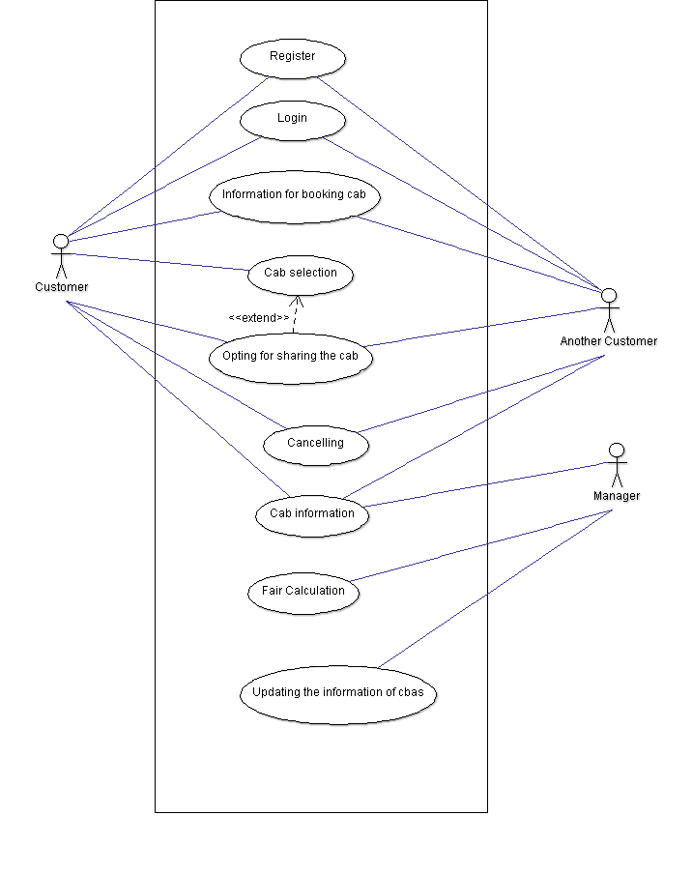

# 4.1 Administrator:

**4.1.1      Description and Priority**

              Administrator is the owner of the service and all the actions are done with permission of the administrator . But the administrator will not edit the details of the developers and users. He will only supervise the things that will be done on the web app.

1.1.2           Stimulus/Response Sequences

Administrator can only supervise to the developers in the way he wants to maintain the website. He checks the graphs of the company to take the required actions.

1.1.3           Functional Requirements

His dashboard consists of links to the further pages for inspection of data. He can also send mails directly from web app as it will have extensions already available on web browser stores. Key password will only be available to the administrator which can be locked for each and every connector to the web app and so does too in emergency situations. He has the authority to cut off clients for particular issues.

Requirements for Administrator are:

REQ-1:     Perform weekly roster of Employees

                  REQ-2:     Print reports annually, weekly, and daily

                  REQ-3:     Check feedbacks

                  REQ-4:     Send newsletters

                  REQ-5:     Manage user portfolio

                  REQ-6:     Changing the super password.

**4.2 Mailing**

4.1.1 Description and Priority

Mailing system is the one of the most important requirements for the software. An automated mail will be sent to the client as well as to the administrator with the information of the booking.

4.1.2 Stimulus/Response Sequences

∙Mail will be sent to the user after successful booking of a cab

∙Mail will be sent to the administrator after the user gives a feedback

∙Mail will be sent to customer1 after customer2 wants to share the cab

∙A mail will be sent to the user if he forgot the password or username.

4.1.3 Functional Requirements

Automatic mail generator is developed using PHP .An automatic mailing system will generate all the necessary mails that are required with the use of PHP on the click of a button specified by developers.

REQ-1: Temporary password will be mailed to the user incase the user forgets the password.

REQ-2: Newsletters should go the clients email addresses.

REQ-3: The client should get notification email of the booking while confirmed.

REQ-4: Admin will get a mail if any customer gives the feedback.

REQ-5 : Notification mail will be sent to the customer after joining of other customer for sharing

REQ- 6 :Cancellation mail will be sent to both the users and managers if the user cancelled the booking.

## 4.3     Client

## 4.1.1  Description and Priority

Here how the customer will login and log out of our system. What are the features the clients can get to experience from our system!! .

**4.1.2  Stimulus/Response Sequences**

·        Customer has to register otherwise he can’t access the features of the website.

·        After that the user has to login into our website with the particular username and password.

·        Then the customer has to give the date, time, and location for the cab to arrive.

·        Then select the cab from the available list of cabs from our website.

·        The client can cancel the cab in a span of hour in some cases.

·        The client can even go for sharing the cab if the client want.

·        After booking the MAIL will be sent.

·        Then the client can logout from it.

**4.1.3  Functional Requirements**

The customer can has first to register then only the customer can login into our website. There will be authentication for the client, whether the user is giving a correct details or not. The username and password will be sent to the customer’s email. When the login typed by the wrong username or password then there will be an error. After the customer login’s into the website then the customer can give the information of date and time and location from where the customer will travel. After that the customer can book the cab he wanted according to his specifications. The customer can cancel the booked cab only in a span of hour as the cab driver will enrooted to his location. After that MAILING will be done. Then the customer can logout from our website.

 ·        REQ-1:  Register and Login in our website

 ·        REQ-2:  Authentication of the login

 ·        REQ-3 : Logout from the website

·        REQ-4 : Change Password

·        REQ-5 : Resetting the password

·        REQ-6 : Date, time and location

·        REQ-7 : Selecting cab

·        REQ-8 : Cab booking

·        REQ-9 : Cab canceling

**5.Other Non Functional requirements**

**5.1 Performance Requirements:**

The performance requirements are that the server should keep updating the information of the cabs . The website can be accessible from any browser without any loading issues. The user interface should be easily understood by all types of customers.

**5.2 Safety Requirements :**

At initial state we are using some free hosts which are safely maintained by the Public hosts ,so at present there is no need to bother about license of the domain.

**5.3 Security Requirements :**

The login details of the user should be unique without any ambiguity so that if the user forgotten his details he should get the login details from making a request to the server with the necessary input.

**5.4 Software Quality Attributes :**

An online feedback form will be maintained to keep the software useful and to make the required changes. Developers will be working on the software if there are any feedback for the necessary action. An offline feedback may be maintained at the organization whether to maintain the software for the service or not.

**5.5 Business Rules :**

The initial version will not be containing online payment so the money can be given by the customer directly to the driver or the cab service. The software should firstly approved by the cab organization later by the customers. The changes can be done in the Software as requested by the organization. Sharing of the cabs will attract the most times.

**6. OTHER REQUIREMENTS:**

As this is the initial version we are just taking the database for the single organization so it is not for international level .Some references are taken from the known companies for the models .We are not implementing the GPS tracking .Cab sharing can be a attractive feature for the software.

**APPENDIX A : Glossary**

**Booking:** The client request to serve a cab at the requested date and time

**CSS :** Cascading Style Sheets

**HTML:** Hyper Text Markup Language

**SDLC :** Software Development Life Cycle

**SQL:** Structured Query Language

**PHP :** Personal Home Page

**APPENDIX B : Analysis Models**

Use case diagram according to user side

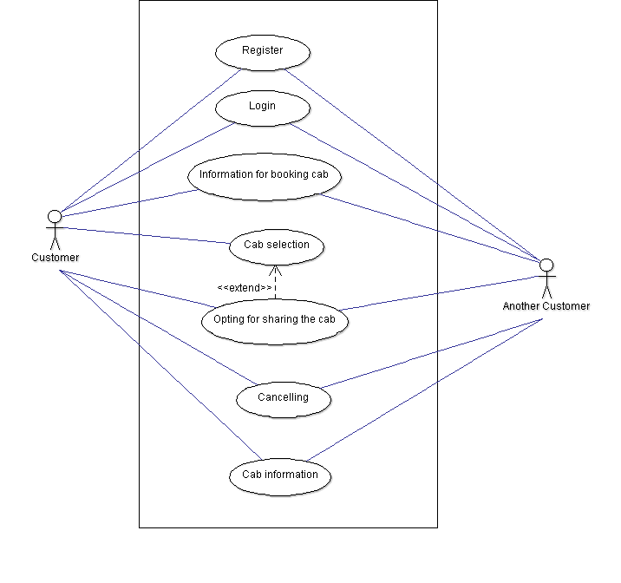

USE CASE from the Employers side

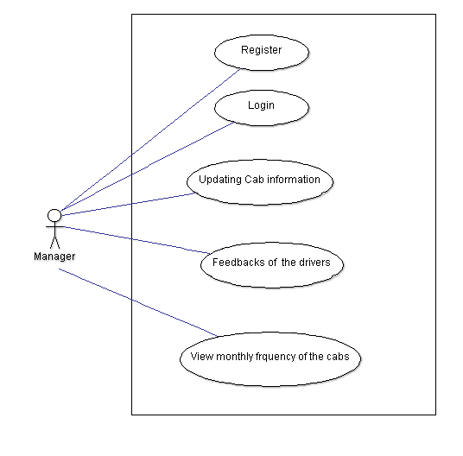

**APPENDIX C: To be Determined list**

We are planning to implement Online payment in the future updates.