2017-Apr-19

Tony Georgiou

Knysna SPAR

a cave in norway

02134564

bob@cool.beans

An audit has been carried out in the following store:

Knysna SPAR

Store audit date and time:

Date: 2017-Apr-13

The following is a report highlighting very important to critical issues found during the audit for your attention (including pictures).

Kindly note that a full report inclusive of pictures will follow in due course.

The centre lights and common areas are in poor condition, in addition to that the Retailer has since May of this year

complained about the leaking roof which has not been successfully repaired. This roof is extremely old and requires replacing.

In terms of our agreement of lease it is the landlord's responsibility to ensure the proper upkeep of the centre.

The overall rating achieved in each department audited, is recorded in the attached report. If any issues are raised they will be listed

below each department heading.

Yours Faithfully,

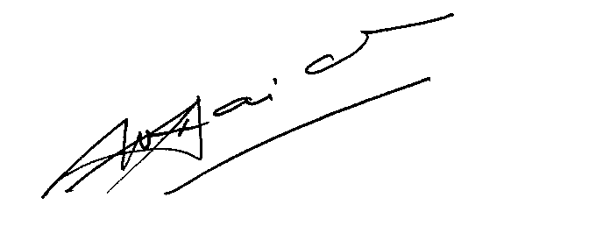

WENDY NAIDU (Ms.)

Group Property Portfolio Manager

|  |  |
| --- | --- |
| **Store Name** | Knysna SPAR |
| **Store Address** | a cave in norway |
|  |  |
| **Landlord** | Jane Doe |
| **Landlord Contact Details** | 929292 |
| **Landlord Address Details** | A cave in mexico |
| **Landlord Email Details** | jane@doe.com |
| **Audit Date** | 2017-Apr-13 |
| **Auditor Name** | Thor |

**Rating Key**

|  |  |  |  |
| --- | --- | --- | --- |
| **Very Bad** | 1 | Replacement Programme | Replacement Programme |
| **Bad** | 2 | Rehabilitation | Rehabilitation Programme |
| **Poor** | 3 | Repairs |
| **Fair** | 3.5 | To be monitored for further deterioration | Requires Constant Monitoring |
| **Good** | 4 | Condition-based Maintenance | Maintenance programme |
| **Very Good** | 5 | Preventative Maintenance |

**Area:** Ablution / Shower

**Section:** Ceilings

**Issue:** ventilation

**Actions to Take:** email landlord,schedule maintenance

**Issue Rating:** 3

**Photos of Issue**

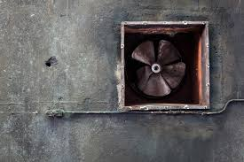

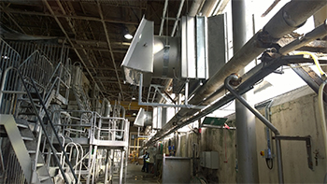

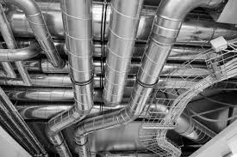

**Section:** Distribution Board

**Issue:** loose wires

**Actions to Take:** email landlord

**Issue Rating:** 3

**Photos of Issue**

No photos