Test Harness Architecture & Design

T. Archer, D. Howick, D. Pretola, M. Vats

4/10/2020

Table of Contents

Overview 3

Architectural Components 4

Test Executor 4

Requirements Mapping 4

Messaging Queues 4

Requirements Mapping 4

Test Harness 5

Requirements Mapping 5

Child Tester 5

Requirements Mapping 5

Test Drivers 6

Requirements Mapping 6

Logger 6

Requirements Mapping 6

Testing Requirements 6

Requirements Mapping 7

# Overview

The following figure shows and overview of the architecture.

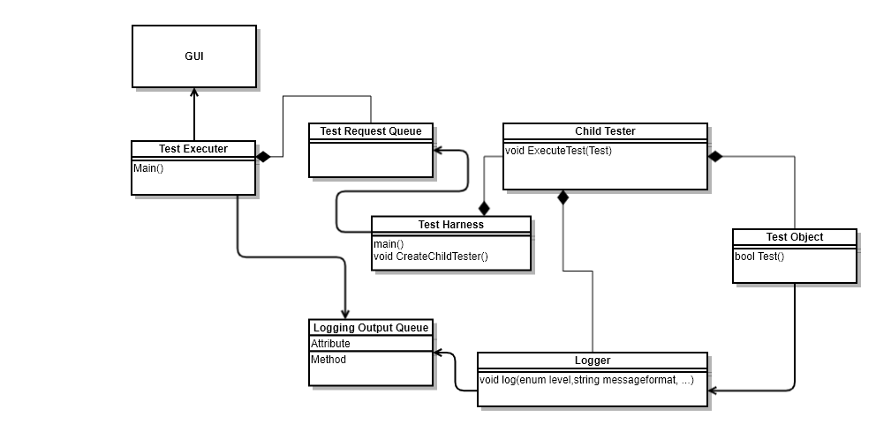

Components

* Test Executer
  + Command-Line Interface
  + Graphical User Interface
* Messaging Queues
  + Test Request Queue
  + Logging Output Queue
* Test Harness
  + Child Tester
  + Test Object
* Logger
* Test Drivers – Need to add to diagram

# Architectural Components

This section describes architectural components.

## Test Executor

The test executor will be the user interface of the Test Harness project. In earlier phases, this will be in the form of a Command-Line Interface application. In later phases, this will be a Graphical User Interface application. While the interaction of the application will differ, the functionality which allows choosing tests, messaging them to the Test Harness and displaying results should remain the same.

### Requirements Mapping

|  |  |  |  |
| --- | --- | --- | --- |
| Id | Requirement | Section | # |
| 001 | The test executive shall include a graphical user interface (GUI) allowing the operator to define tests to be executed by the Test Harness. | Test Executive Requirements | 1 |
| 002 | The test executive shall support building a Test Request by selecting library files from a repository using the GUI. | Test Executive Requirements | 2 |
| 003 | The test executive shall define methods for sending and processing messages. | Test Executive Requirements | 3 |
| 004 | The test executive shall provide facilities to transfer a Test Request to the Test Harness. (See Messaging Requirements for message details.) | Test Executive Requirements | 4 |
| 005 | The test executive shall support viewing the test status on the GUI. | Test Executive Requirements | 5 |
|  |  |  |  |

## Messaging Queues

Message queues will be used as the inter-process communication mechanism between application processes. Two queues will be used:

1. Test Request Queue
2. Logging Queue

The Test Request Queue will receive test requests messages from the Test Executor. These messages will be dequeued by the Test Harness in order to communicate which tests to run.

The Logging Queue will receive log messages from the Test Harness. The Test Executor will dequeue these messages and display the logging messages.

### Requirements Mapping

|  |  |  |  |
| --- | --- | --- | --- |
| Id | Requirement | Section | # |
| 101 | The test system shall implement a message-passing communication channel using sockets. This can be based on the Channel prototype found in the class Repository. | Messaging Requirements | 1 |
| 102 | The messaging system shall provide:  - Source and Destination addresses  - Message type  - Author  - Time-Date  -String body:  Expected to hold an XML string supplying information needed to execute a specific request. | Messaging Requirements | 2 |
| 103 | Each communication end point (FN #4) shall provide both a sender and a receiver (FN #5). | Messaging Requirements | 3 |
|  |  |  |  |

## Test Harness

This component is a application which is responsible for the execution of the tests. It primarily dequeues tests, loads the DLLs, calls the Child Tester to execute test (i.e. funcitons) within the DLL and enqueues results of the test.

### Requirements Mapping

|  |  |  |  |
| --- | --- | --- | --- |
| Id | Requirement | Section | # |
| 101 | The test system shall provide a Test Harness which accepts any callable object that requires no arguments (FN #2) and returns a boolean predicate to indicate success or failure. | Test Harness Requriements | 1 |
|  | The Test Harness shall accept a Test Request XML string defining one or more test elements by naming dynamic link libraries. | Test Harness Requriements | 5 |
|  | The Test Harness shall create, at startup, a number of child Tester processes. The child processes should post Ready messages to the Test Harness on startup. | Test Harness Requriements | 6 |
|  | The Test Harness shall define methods for processing Test Request messages and sending Test Status messages. | Test Harness Requriements | 7 |
|  | On receiving a Test Request, the Test Harness shall parse the request into individual tests and assign each test to a single child Tester | Test Harness Requriements | 8 |
|  | The Test Harness shall, on completion of processing of a Test Request, send a named, time-date stamped, test status message to the Client requesting the test. | Test Harness Requriements | 10 |
|  |  |  |  |

## Child Tester

This component executes a tests given a test function. After execution it provides results based on whether the function passed or failed.

### Requirements Mapping

|  |  |  |  |
| --- | --- | --- | --- |
| Id | Requirement | Section | # |
|  | The Test Harness shall invoke a passed callable object in the scope of a try block. | Test Harness Requriements | 3 |
|  | If exceptions are thrown during execution of the test, the catch block shall log test failure and the contents of the exception message. | Test Harness Requriements | 4 |
|  | Testers shall load the corresponding library, create an instance of the Test Driver, and log pass-fail status of each test, along with a time-date stamp. | Test Harness Requriements | 9 |
|  |  |  |  |
|  |  |  |  |
|  |  |  |  |

## Test Drivers

The test drivers are dynamic link libraries which have callable functions that will be used by the Test Harness for testing.

### Requirements Mapping

|  |  |  |  |
| --- | --- | --- | --- |
| Id | Requirement | Section | # |
| 201 | Test Drivers shall implement a common interface that declares a test method taking no arguments and returning a boolean value indicating test pass or failure. | Testing Requirements | 1 |
|  |  |  |  |
|  |  |  |  |

## Logger

The Logger component is responsible for logging test result output to the Logging Queue. It also supports various logging levels for less or more verbose output.

### Requirements Mapping

|  |  |  |  |
| --- | --- | --- | --- |
| Id | Requirement | Section | # |
| 001 | The Test Harness shall provide a multi-level logging mechanism, intended to show:  - Just pass-fail status  - Application specific messages for pass and fail, along with the result  - Detailed debugging output that includes level-two logging and a time-date stamp | Test Harness Requirements | 2 |

# Testing Requirements

These are requirements the project must satisfy to prove that the test harness can operate as required.

May need to develop testing use cases here.

## Requirements Mapping

|  |  |  |  |
| --- | --- | --- | --- |
| Id | Requirement | Section | # |
| 202 | The test system shall provide a test case where several TestRequests are sent in quick succession to demonstrate that the process pool executes TestRequests concurrently and that each will, on completion, post a Ready status message to the TestHarness and await the next TestRequest message. | Testing Requirements | 2 |
| 203 | The test system shall provide a sequence of tests demonstrating all the features of your TestHarness. | Testing Requirements | 3 |
|  |  |  |  |