check2

# Question 1

what is A in the following reaction ?

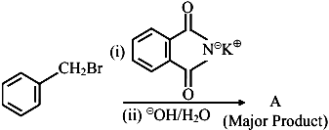

1. 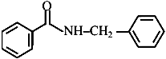
2. image
3. 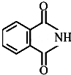
4. image

# Question 2

An organic compound "A" on treatment with benzene sulphonyl chloride gives compound \(B . B\) is soluble in dil. \(\mathrm{NaOH}\) solution.

Compound \(A\) is______________.

1. \(\mathrm{C}_6 \mathrm{H}_5-\mathrm{N}-\left(\mathrm{CH}_3\right)_2\)
2. \(\mathrm{C}_6 \mathrm{H}_5-\mathrm{NHCH}_2 \mathrm{CH}_3\)
3. \(\mathrm{C}_6 \mathrm{H}_5-\mathrm{CH}_2 \mathrm{NHCH}_3\)
4. \(\mathrm{C}_6 \mathrm{H}_5-\mathrm{CH}-\mathrm{NH}_2\)

# Question 3

The total number of reagents from those given below, that can convert nitrobenzene into aniline is _______________ (Integer answer)

|  |  |
| --- | --- |
| \(I . \mathrm{Sn}-\mathrm{HCI}\) | \(\mathrm{II} \cdot \mathrm{Sn}-\mathrm{NH}_4 \mathrm{OH}\) |
| \(I I I \cdot \mathrm{Fe}-\mathrm{HCl}\) | \(I V \cdot \mathrm{Zn}-\mathrm{HCI}\) |
| \(V \cdot \mathrm{H}_2-\mathrm{Pd}\) | \(V I \cdot \mathrm{H}_2-\) Raney nickel |

# Question 4

Match List I with List II.

|  |  |
| --- | --- |
| List-I | List-II |
| A. Benzenesulphonyl Chloride | I. Test for primary amines |
| B. Hoffmann bromamide reaction | II. Anti Saytzeff |
| C. Carbylamine reaction | III. Hinsberg reagent |
| D. Hoffmann orientation | IV. Known reaction of Isocyanates |

Choose the correct answer from the options given below:

1. A-IV, B-III, C-II, D-I
2. A-IV, B-II, C-I, D-II
3. A-III, B-IV, C-I, D-II
4. A-IV, B-III, C-I, D-II

# Question 5

Primary, secondary and tertiary amines can be separated using.

1. para-toluene sulphonyl chloride
2. chloroform and \(\mathrm{KOH}\)
3. benzene sulphonic acid
4. acetyl amide

# Question 6

Compound \(\mathrm{A}\) is converted to \(\mathrm{B}\) on reaction with \(\mathrm{CHCl}_3\) and \(\mathrm{KOH}\). The compound \(\mathrm{B}\) is toxic and can be decomposed by C. A, B and \(C\) respectively are :

1. primary amine, nitrile compound, conc. \(\mathrm{HCl}\)
2. secondary amine, isonitrile compound, conc. \(\mathrm{NaOH}\)
3. primary amine, isonitrile compound, conc. \(\mathrm{HCl}\)
4. secondary amine, nitrile compound, conc. \(\mathrm{NaOH}\)

# Question 7

The major product formed in the following reaction is.

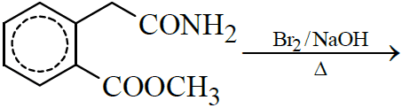

1. 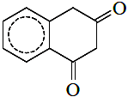
2. 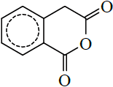
3. 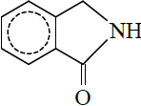
4. 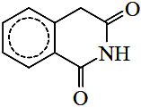

# Question 8

Choose the correct colour of the product for the following reaction.

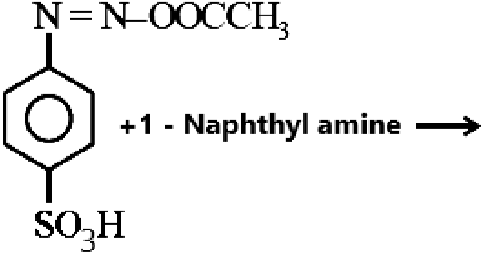

1. Yellow
2. White
3. Red
4. Blue

# Question 9

The correct order in aqueous medium of basic strength in case of methyl substituted amines is :

1. \(\mathrm{Me}_2 \mathrm{NH}>\mathrm{MeNH}_2>\mathrm{Me}_3 \mathrm{~N}>\mathrm{NH}_3\)
2. \(\mathrm{Me}_2 \mathrm{NH}>\mathrm{Me}_3 \mathrm{~N}>\mathrm{MeNH}_2>\mathrm{NH}_3\)
3. \(\mathrm{NH}_3>\mathrm{Me}_3 \mathrm{~N}>\mathrm{MeNH}_2>\mathrm{Me}_2 \mathrm{NH}\)
4. \(\mathrm{Me}_3 \mathrm{~N}>\mathrm{Me}_2 \mathrm{NH}>\mathrm{MeNH}_2>\mathrm{NH}_3\)

# Question 10

Number of isomeric aromatic amines with molecular formula \(\mathrm{C}_8 \mathrm{H}_{11} \mathrm{~N}\), which can be synthesized by Gabriel Phthalimide synthesis is ___________.  [6-Apr-2023]

# Question 11

Given below are two statements :

Statement I : In Hofmann degradation reaction, the migration of only an alkyl group takes place from carbonyl carbon of the amide to the nitrogen atom.

Statement II : The group is migrated in Hofmann degradation reaction to electron deficient atom.

In the light of the above statements, choose the most appropriate answer from the options given below:

1. Both Statement I and Statement II are correct.
2. Both Statement I and Statement II are incorrect.
3. Statement I is correct but Statement II is incorrect.
4. Statement I is incorrect but Statement II is correct.

# Question 12

Given below are two statements :

Statement I : Aniline is less basic than acetamide.

Statement II : In aniline, the lone pair of electrons on nitrogen atom is delocalised over benzene ring due to resonance and hence less available to a proton.

Choose the most appropriate option ;

1. Statement I is true but statement II is false.
2. Statement I is false but statement II is true.
3. Both statement I and statement II are true.
4. Both statement I and statement II are false.

# Question 13

The total number of electrons around the nitrogen atom in amines are,

# Question 14

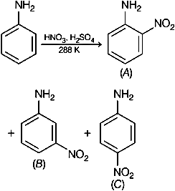  
Consider the given reaction, percentage yield of,

1. \((C)>(A)>(B)\)
2. \((B)>(C)>(A)\)
3. \((A)>(C)>(B)\)
4. \((C)>(B)>(A)\)

# Question 15

The product A formed in the following reaction is:

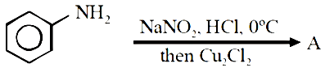

1. 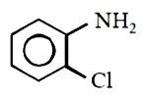
2. 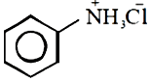
3. 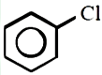
4. 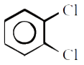

# Question 16

The products A and B formed in the following reaction scheme are respectively

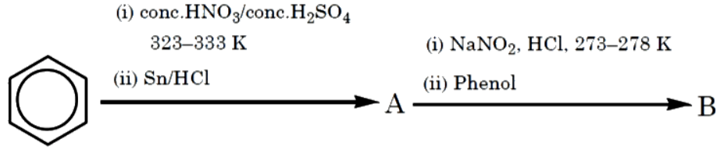

1. 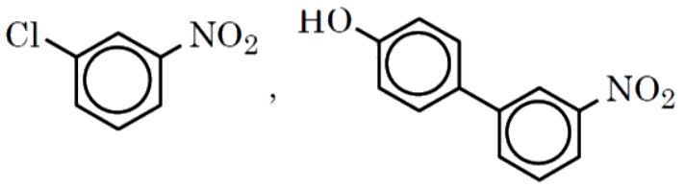
2. 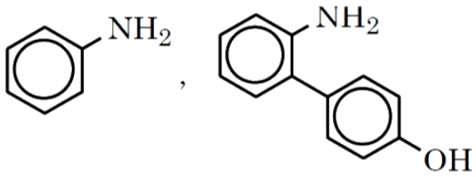
3. 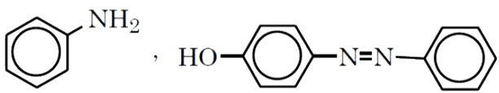
4. 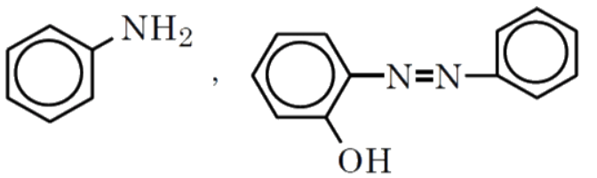

# Question 17

Number of compounds which give reaction with Hinsbergs reagent is _______.

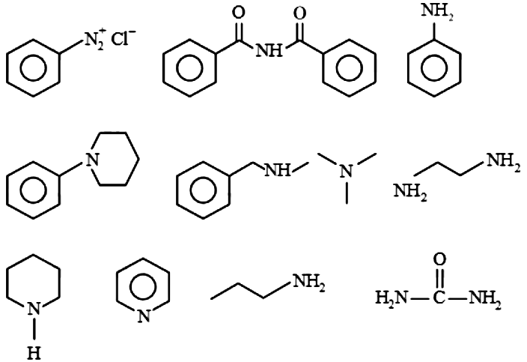

# Question 18

Given below are two statements :

Statement I: Aniline reacts with con. \(\mathrm{H}_2 \mathrm{SO}_4\) followed by heating at \(453-473 \mathrm{~K}\) gives p-aminobenzene sulphonic acid, which gives blood red colour in the Lassaignes test.  
Statement II: In Friedel - Crafts alkylation and acylation reactions, aniline forms salt with the \(\mathrm{AlCl}_3\) catalyst.  
Due to this, nitrogen of aniline aquires a positive charge and acts as deactivating group.  
In the light of the above statements, choose the correct answer from the options given below :

1. Statement I is false but statement II is true
2. Both statement I and statement II are false
3. Statement I is true but statement II is false
4. Both statement I and statement II are true

# Question 19

Which one of the products of the following reactions does not react with Hinsberg reagent to form sulphonamide? [25 Jul 2021]

1. 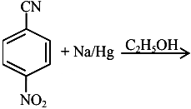
2. 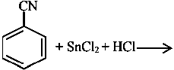
3. 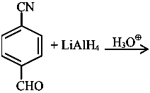
4. 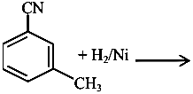

# Question 20

The total number of reagents from those given below, that can convert nitrobenzene into aniline is _______________ (Integer answer)

|  |  |
| --- | --- |
| \(I . \mathrm{Sn}-\mathrm{HCI}\) | \(\mathrm{II} \cdot \mathrm{Sn}-\mathrm{NH}_4 \mathrm{OH}\) |
| \(I I I \cdot \mathrm{Fe}-\mathrm{HCl}\) | \(I V \cdot \mathrm{Zn}-\mathrm{HCI}\) |
| \(V \cdot \mathrm{H}_2-\mathrm{Pd}\) | \(V I \cdot \mathrm{H}_2-\) Raney nickel |

# Question 21

Match List I with List II.

|  |  |
| --- | --- |
| List-I | List-II |
| A. Benzenesulphonyl Chloride | I. Test for primary amines |
| B. Hoffmann bromamide reaction | II. Anti Saytzeff |
| C. Carbylamine reaction | III. Hinsberg reagent |
| D. Hoffmann orientation | IV. Known reaction of Isocyanates |

Choose the correct answer from the options given below:

1. A-IV, B-III, C-II, D-I
2. A-IV, B-II, C-I, D-II
3. A-III, B-IV, C-I, D-II
4. A-IV, B-III, C-I, D-II

# Question 22

Compound \(\mathrm{A}\) is converted to \(\mathrm{B}\) on reaction with \(\mathrm{CHCl}_3\) and \(\mathrm{KOH}\). The compound \(\mathrm{B}\) is toxic and can be decomposed by C. A, B and \(C\) respectively are :

1. primary amine, nitrile compound, conc. \(\mathrm{HCl}\)
2. secondary amine, isonitrile compound, conc. \(\mathrm{NaOH}\)
3. primary amine, isonitrile compound, conc. \(\mathrm{HCl}\)
4. secondary amine, nitrile compound, conc. \(\mathrm{NaOH}\)

# Question 23

The major product formed in the following reaction is.



1. 
2. 
3. 
4. 

# Question 24

Consider the following sequence of reaction :

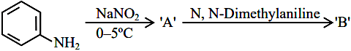  
The product \(\mathrm{B}\) is :

1. image
2. 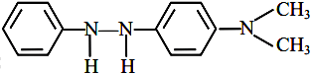
3. 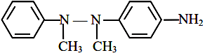
4. image

# Question 25

A compound with molecular mass 180 is acylated with \(\mathrm{CH}_3 \mathrm{COCl}\) to get a compound with molecular mass 390 . The number of amino groups present per molecule of the former compound is:

# Question 26

The decreasing order of basicity of the following amines is:

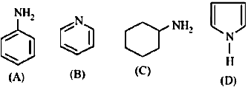

1. \((A)>(C)>(D)>(B)\)
2. \((C)>(A)>(B)>(D)\)
3. \((B)>(C)>(D)>(A)\)
4. \((C)>(B)>(A)>(D)\)

# Question 27

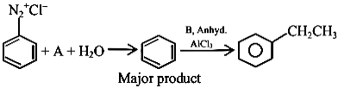  
In the chemical reactions given above \(A\) and \(B\) respectively are:

1. \(\mathrm{H}_3 \mathrm{PO}_2\) and \(\mathrm{CH}_3 \mathrm{CH}_2 \mathrm{Cl}\)
2. \(\mathrm{CH}_3 \mathrm{CH}_2 \mathrm{OH}\) and \(\mathrm{H}_3 \mathrm{PO}_2\)
3. \(\mathrm{H}_3 \mathrm{O}_2\) and \(\mathrm{CH}_3 \mathrm{CH}_2 \mathrm{OH}\)
4. \(\mathrm{CH}_3 \mathrm{CH}_2 \mathrm{Cl}\) and \(\mathrm{H}_3 \mathrm{PO}_2\)

# Question 28

The total number of electrons around the nitrogen atom in amines are,

# Question 29

The number of primary amines of formula \(\mathrm{C}_4 \mathrm{H}_{11} \mathrm{~N}\) is ?

# Question 30

The products A and B formed in the following reaction scheme are respectively



1. 
2. 
3. 
4. 

# Question 31

Number of compounds which give reaction with Hinsbergs reagent is _______.



# Question 32

Given below are two statements :

Statement I: Aniline reacts with con. \(\mathrm{H}_2 \mathrm{SO}_4\) followed by heating at \(453-473 \mathrm{~K}\) gives p-aminobenzene sulphonic acid, which gives blood red colour in the Lassaignes test.  
Statement II: In Friedel - Crafts alkylation and acylation reactions, aniline forms salt with the \(\mathrm{AlCl}_3\) catalyst.  
Due to this, nitrogen of aniline aquires a positive charge and acts as deactivating group.  
In the light of the above statements, choose the correct answer from the options given below :

1. Statement I is false but statement II is true
2. Both statement I and statement II are false
3. Statement I is true but statement II is false
4. Both statement I and statement II are true

# Question 33

The number of nitrogen atoms in a semicarbazone molecule of acetone is_____________.

# Question 34

Match List I with List II.

|  |  |
| --- | --- |
| List-I | List-II |
| A. Benzenesulphonyl Chloride | I. Test for primary amines |
| B. Hoffmann bromamide reaction | II. Anti Saytzeff |
| C. Carbylamine reaction | III. Hinsberg reagent |
| D. Hoffmann orientation | IV. Known reaction of Isocyanates |

Choose the correct answer from the options given below:

1. A-IV, B-III, C-II, D-I
2. A-IV, B-II, C-I, D-II
3. A-III, B-IV, C-I, D-II
4. A-IV, B-III, C-I, D-II

# Question 35

The major product formed in the following reaction is.



1. 
2. 
3. 
4. 

# Question 36

Choose the correct colour of the product for the following reaction.



1. Yellow
2. White
3. Red
4. Blue

# Question 37

Number of isomeric aromatic amines with molecular formula \(\mathrm{C}_8 \mathrm{H}_{11} \mathrm{~N}\), which can be synthesized by Gabriel Phthalimide synthesis is ___________.  [6-Apr-2023]

# Question 38

During halogen test, sodium fusion extract is boiled with concentrated \(\mathrm{HNO}_3\) to

1. remove unreacted sodium
2. decompose cyanide or sulphide of sodium
3. extract halogen from organic compound
4. maintain the \(\mathrm{pH}\) of extract.

# Question 39

A compound with molecular mass 180 is acylated with \(\mathrm{CH}_3 \mathrm{COCl}\) to get a compound with molecular mass 390 . The number of amino groups present per molecule of the former compound is:

# Question 40

The most appropriate reagent for conversion of \(\mathrm{C}_2 \mathrm{H}_5 \mathrm{CN}\) into \(\mathrm{CH}_3 \mathrm{CH}_2 \mathrm{CH}_2 \mathrm{NH}_2\) is:

1. \(\mathrm{NaBH}_4\)
2. \(\mathrm{CaH}_2\)
3. LiAl H\(_4\)
4. \(\mathrm{Na}(\mathrm{CN}) \mathrm{BH}_3\)

# Question 41

The decreasing order of basicity of the following amines is:



1. \((A)>(C)>(D)>(B)\)
2. \((C)>(A)>(B)>(D)\)
3. \((B)>(C)>(D)>(A)\)
4. \((C)>(B)>(A)>(D)\)

# Question 42

  
Consider the given reaction, percentage yield of,

1. \((C)>(A)>(B)\)
2. \((B)>(C)>(A)\)
3. \((A)>(C)>(B)\)
4. \((C)>(B)>(A)\)

# Question 43

The product A formed in the following reaction is:



1. 
2. 
3. 
4. 

# Question 44

In the reaction of hypobromite with amide, the carbonyl carbon is lost as

1. \(\mathrm{CO}_3{ }^{2-}\)
2. \(\mathrm{HCO}_3{ }^{-}\)
3. \(\mathrm{CO}_2\)
4. \(\mathrm{CO}\)

# Question 45

The number of nitrogen atoms in a semicarbazone molecule of acetone is_____________.

# Question 46

The correct order in aqueous medium of basic strength in case of methyl substituted amines is :

1. \(\mathrm{Me}_2 \mathrm{NH}>\mathrm{MeNH}_2>\mathrm{Me}_3 \mathrm{~N}>\mathrm{NH}_3\)
2. \(\mathrm{Me}_2 \mathrm{NH}>\mathrm{Me}_3 \mathrm{~N}>\mathrm{MeNH}_2>\mathrm{NH}_3\)
3. \(\mathrm{NH}_3>\mathrm{Me}_3 \mathrm{~N}>\mathrm{MeNH}_2>\mathrm{Me}_2 \mathrm{NH}\)
4. \(\mathrm{Me}_3 \mathrm{~N}>\mathrm{Me}_2 \mathrm{NH}>\mathrm{MeNH}_2>\mathrm{NH}_3\)

# Question 47

Number of isomeric aromatic amines with molecular formula \(\mathrm{C}_8 \mathrm{H}_{11} \mathrm{~N}\), which can be synthesized by Gabriel Phthalimide synthesis is ___________.  [6-Apr-2023]

# Question 48

During halogen test, sodium fusion extract is boiled with concentrated \(\mathrm{HNO}_3\) to

1. remove unreacted sodium
2. decompose cyanide or sulphide of sodium
3. extract halogen from organic compound
4. maintain the \(\mathrm{pH}\) of extract.

# Question 49

Given below are two statements :

Statement I : Aniline is less basic than acetamide.

Statement II : In aniline, the lone pair of electrons on nitrogen atom is delocalised over benzene ring due to resonance and hence less available to a proton.

Choose the most appropriate option ;

1. Statement I is true but statement II is false.
2. Statement I is false but statement II is true.
3. Both statement I and statement II are true.
4. Both statement I and statement II are false.

# Question 50

The decreasing order of basicity of the following amines is:



1. \((A)>(C)>(D)>(B)\)
2. \((C)>(A)>(B)>(D)\)
3. \((B)>(C)>(D)>(A)\)
4. \((C)>(B)>(A)>(D)\)

# Question 51

  
In the chemical reactions given above \(A\) and \(B\) respectively are:

1. \(\mathrm{H}_3 \mathrm{PO}_2\) and \(\mathrm{CH}_3 \mathrm{CH}_2 \mathrm{Cl}\)
2. \(\mathrm{CH}_3 \mathrm{CH}_2 \mathrm{OH}\) and \(\mathrm{H}_3 \mathrm{PO}_2\)
3. \(\mathrm{H}_3 \mathrm{O}_2\) and \(\mathrm{CH}_3 \mathrm{CH}_2 \mathrm{OH}\)
4. \(\mathrm{CH}_3 \mathrm{CH}_2 \mathrm{Cl}\) and \(\mathrm{H}_3 \mathrm{PO}_2\)

# Question 52

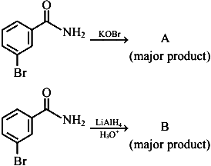  
In the above reactions, product \(A\) and product \(B\) respectively are:

1. 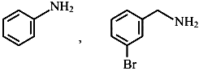
2. 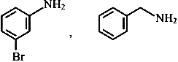
3. image
4. 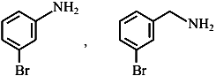

# Question 53

  
Consider the given reaction, percentage yield of,

1. \((C)>(A)>(B)\)
2. \((B)>(C)>(A)\)
3. \((A)>(C)>(B)\)
4. \((C)>(B)>(A)\)

# Question 54

what is A in the following reaction ?



1. 
2. image
3. 
4. image

# Question 55

Which one of the products of the following reactions does not react with Hinsberg reagent to form sulphonamide? [25 Jul 2021]

1. 
2. 
3. 
4. 

# Question 56

Match List I with List II.

|  |  |
| --- | --- |
| List-I | List-II |
| A. Benzenesulphonyl Chloride | I. Test for primary amines |
| B. Hoffmann bromamide reaction | II. Anti Saytzeff |
| C. Carbylamine reaction | III. Hinsberg reagent |
| D. Hoffmann orientation | IV. Known reaction of Isocyanates |

Choose the correct answer from the options given below:

1. A-IV, B-III, C-II, D-I
2. A-IV, B-II, C-I, D-II
3. A-III, B-IV, C-I, D-II
4. A-IV, B-III, C-I, D-II

# Question 57

The major product formed in the following reaction is.



1. 
2. 
3. 
4. 

# Question 58

Given below are two statements :

Statement I : In Hofmann degradation reaction, the migration of only an alkyl group takes place from carbonyl carbon of the amide to the nitrogen atom.

Statement II : The group is migrated in Hofmann degradation reaction to electron deficient atom.

In the light of the above statements, choose the most appropriate answer from the options given below:

1. Both Statement I and Statement II are correct.
2. Both Statement I and Statement II are incorrect.
3. Statement I is correct but Statement II is incorrect.
4. Statement I is incorrect but Statement II is correct.

# Question 59

Hydrolysis of which compound will give carbolic acid?

1. Cumene
2. Benzenediazonium chloride
3. Benzal chloride
4. Ethylene glycol ketal

# Question 60

Given below are two statements :

Statement I : Aniline is less basic than acetamide.

Statement II : In aniline, the lone pair of electrons on nitrogen atom is delocalised over benzene ring due to resonance and hence less available to a proton.

Choose the most appropriate option ;

1. Statement I is true but statement II is false.
2. Statement I is false but statement II is true.
3. Both statement I and statement II are true.
4. Both statement I and statement II are false.

# Question 61

  
Consider the given reaction, percentage yield of,

1. \((C)>(A)>(B)\)
2. \((B)>(C)>(A)\)
3. \((A)>(C)>(B)\)
4. \((C)>(B)>(A)\)

# Question 62

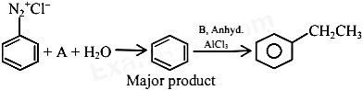  
In the chemical reactions given above \(A\) and \(B\) respectively are:

1. \(\mathrm{H}_3 \mathrm{PO}_2\) and \(\mathrm{CH}_3 \mathrm{CH}_2 \mathrm{Cl}\)
2. \(\mathrm{CH}_3 \mathrm{CH}_2 \mathrm{OH}\) and \(\mathrm{H}_3 \mathrm{PO}_2\)
3. \(\mathrm{H}_3 \mathrm{O}_2\) and \(\mathrm{CH}_3 \mathrm{CH}_2 \mathrm{OH}\)
4. \(\mathrm{CH}_3 \mathrm{CH}_2 \mathrm{Cl}\) and \(\mathrm{H}_3 \mathrm{PO}_2\)

# Question 63

What is the correct name for a molecule that has two amino groups in opposing (para) locations around a benzene ring?

1. Benzenediamine
2. Benzene-1,4-diamine
3. p-Aminoaniline
4. 4-Aminobenzenamine