PACMACK Parents Conference 2026
Plenary Sessions and Conference Workshops

Plenary Sessions

1. Africans to Africans and to the rest of the world - A generational task of obedience
Speaker: Dr Ray Mensah
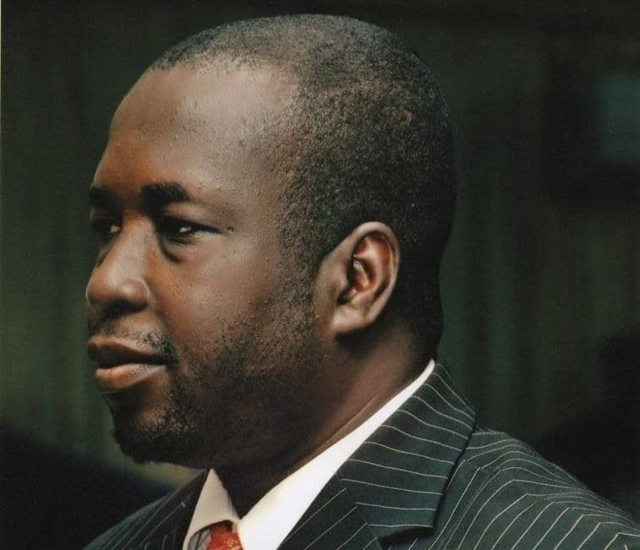
Dr Ray Mensah
Executive Director, OneWay Africa
Pastor Ray Mensa Mensah is a passionate lover of Christ with a heart for evangelism, missions, disciple-making, revival, and leadership development. He serves as Executive Director of OneWay Africa, Director of the Livingstone School of Missions, and President of the Africa Missions Association (AfMA). He previously served as a missionary in northern Botswana and as President of the Ghana Evangelical Missions Association (GEMA). With 32 years in missions, he is also on faculty at the Daniel Institute, lecturing in Evangelism & Missions and Church Planting.

2. Obedience - Not the Sacrifice (Abraham/Isaac lens Gen 22:1-18)
Speaker: Dupe Kashimawo
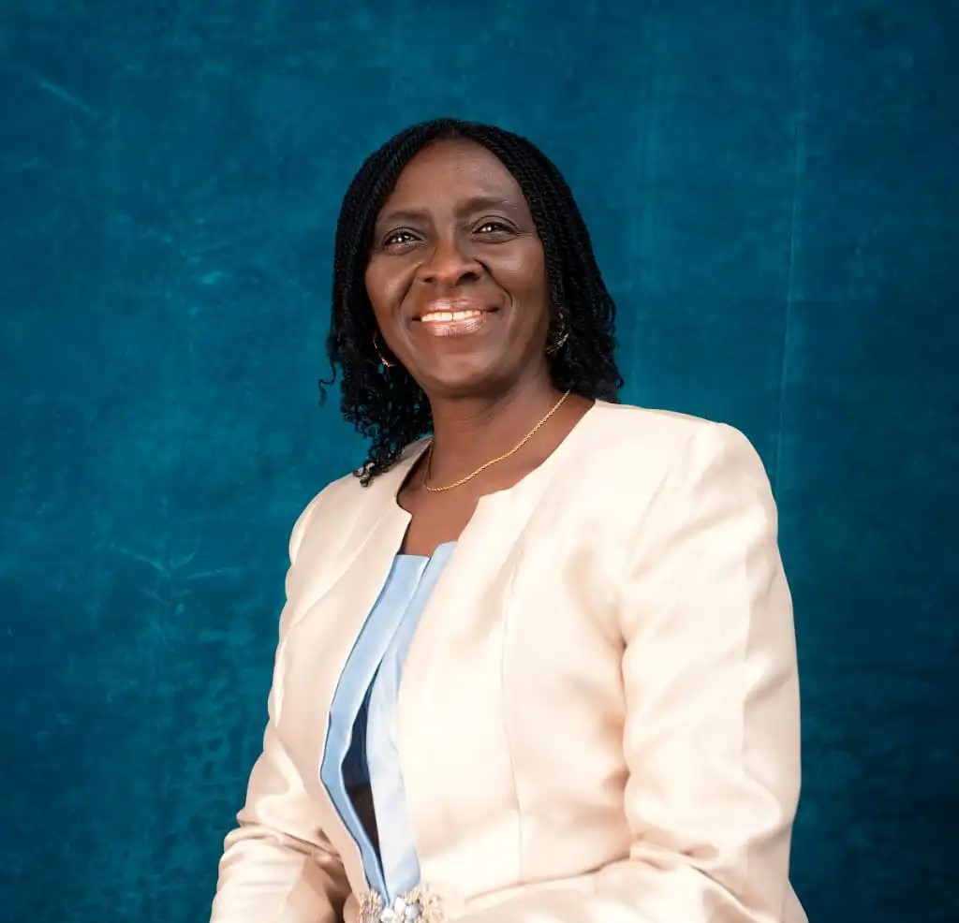
Dupe Kashimawo
Member Care Specialist & Advocate
Dupe Kashimawo is an active advocate and speaker on TCK and MK topics, offering key pastoral care and support to help families navigate transitions smoothly.

3. The children that come along: Recognising the unique Identity of the MK/TCK
Speaker: Heather Enoch
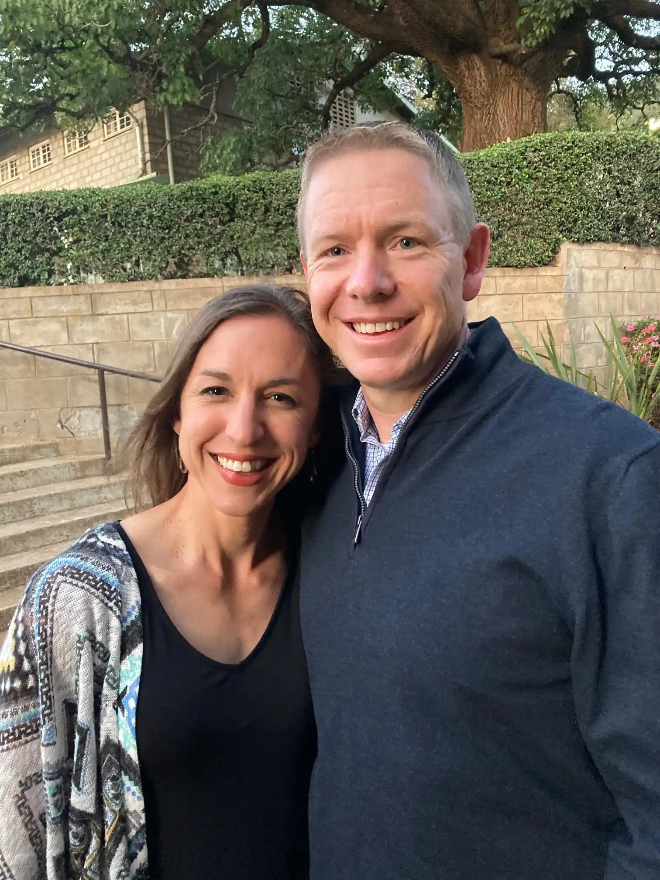
Heather Enoch
TCK Consultant, AIN Nairobi
Philip and Heather moved to Africa as a couple in 2003. Over the last 20+ years, they have served in a variety of roles in TCK Care including teaching, administration, and chaplaincy. Philip is a TCK himself. They currently live in Nairobi, Kenya where Philip serves in leadership and Heather in TCK Care. Philip and Heather have three adult children attending university in the US: Andrew, Kate, and Emily.

4. The Call - The African Missionary Parents' Experience/Challenges and things to heed
Speaker: Dr Linda Ogunsola
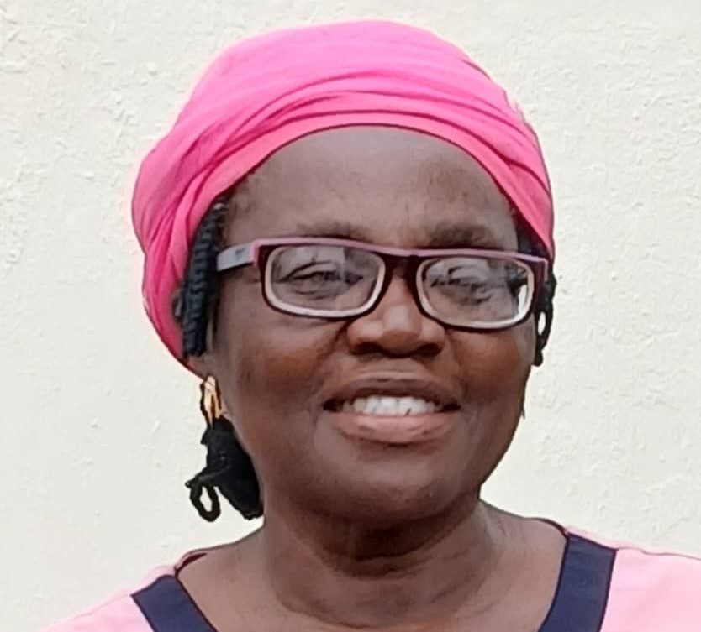
Dr Linda Ogunsola
Member Care Facilitator
Linda Atue Ogunshola gave her life to Christ as a teenager on campus in 1979. She answered the call to missions in 1984/85 and has served in cross-cultural missions for four decades, with half of that time in rural mission service. A wife and mother of four adult children raised on the mission field, she now serves as a trainer and member care facilitator with Christ's Disciples' Mission in Nigeria. She holds a PhD in Intercultural Leadership and Administration. Linda is passionate about raising a next-generation that loves and fears the Lord. She also leads Hope and Skills Foundation (HASF), mobilizing Community Bible Clubs, school fellowships, and training children/teen workers. She lives in Ibadan with her husband, James M. Ogunshola.

5. Understanding and raising MKs in an intra-continental cultural diversity
Speaker: Dr. Susan S Paul
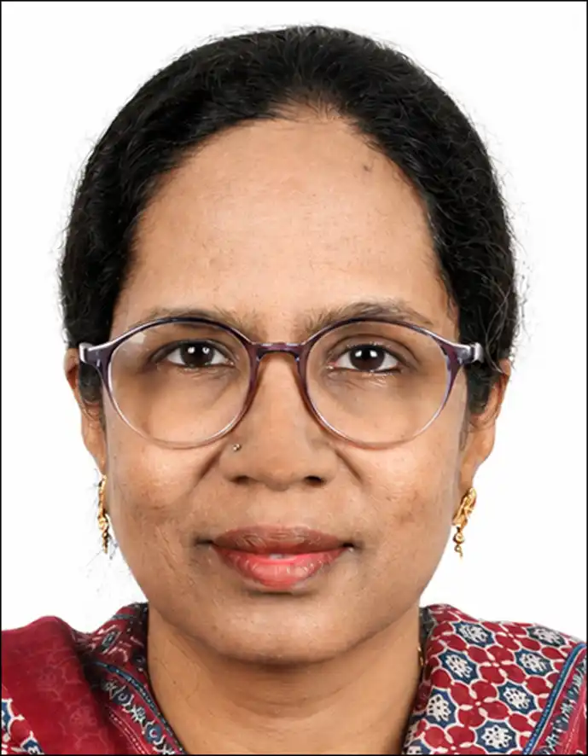
Dr. Susan S Paul
Physician, Psychologist & Missionary
Dr. Susan Sunalini Remo Paul is a physician, missionary, Certified Christian Psychologist, and disciple-maker passionate about holistic healing of body, mind, and spirit. She holds an MBBS, MD in Pathology, and PGDFM. Since 2008, she has served in cross-cultural ministry among tribal communities in southern Odisha, India, providing medical care, health education, discipleship, and community development. Married to Remo Paul, a TCK, she is raising four TCK sons and brings lived experience of missionary family life. She mentors young people, leads annual Bible camps for 800 children, and speaks on holistic health, Christian psychology, TCKs, and family life.

6. Helpful practices in parenting MKs/TCKs
Speaker: Emmanuel Oladipo
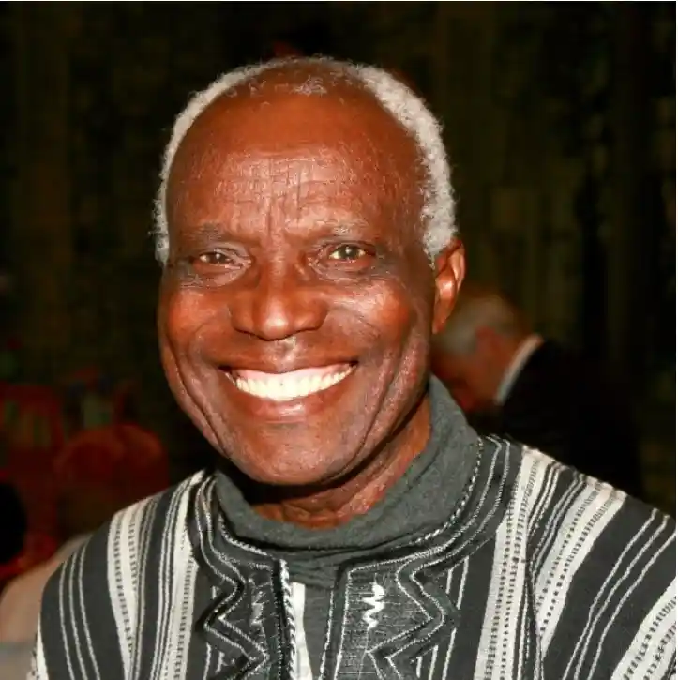
Emmanuel Oladipo
Veteran Mission Leader
Emmanuel Oladipo is a veteran mission leader and speaker with decades of experience in mobilizing and supporting cross-cultural Christian workers and their families across the continent of Africa.

7. All work is sacred - MKs/TCK potential for missional careers
Speaker: Dr Diti Olawale
Dr Diti Olawale
Photo and bio: to be added.

8. Raising Children in Faith in Hard Places and through frequent movement
Speaker: Rev Bakari Bunga
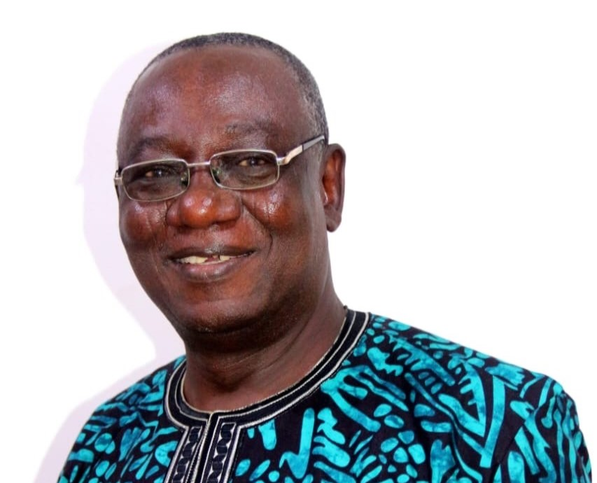
Rev Bakari Bunga
Missionary
Bakari Ibrahim Bunga served faithfully as an EMS Missionary for 40 years, 1983-2023, as a Field Missionary in the Core North, Kano, Katsina, and Sokoto. He established 33 mission schools and held key leadership roles including Outreach Coordinator, Schools Services Coordinator, and Director for Admin.

Conference Workshops

1. Preparing Families for Going & Returning
Departure and re-entry are two of the most disorienting seasons a missionary family faces. This workshop equips families with rituals and practical tools to navigate both the journey out and the journey home - emotionally, relationally, and practically.
Facilitator(s): Mindy Beetham
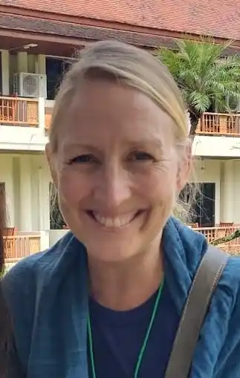
Mindy Beetham
TCK Coordinator, SIM International
Mindy Beetham is married to Chris, who with their family served with SIM in Ethiopia for ten years where she was involved with TCK education. She has now been in the role of SIM International's TCK Coordinator serving remotely and traveling from the US (Michigan) for ten years. Chris and Mindy have five young adult TCKs (ages 19-27). She has a degree in primary education and is currently studying for a master's in marriage and family counselling.

2. Managing Family vs Ministry Demands
Ministry pressure is real - and so is the cost of family life. This workshop addresses parental presence, the unique weight young mothers carry in ministry, and how to protect what matters most without guilt.
Facilitator(s): Joanna Bogunjoko
Joanna Bogunjoko
Photo and bio: to be added.

3. Education on the Field
There is no one-size-fits-all approach to educating MKs. This workshop walks families through the educational options and models available - and how to discern what works for their context, child, and calling.
Facilitator(s): John Barclay & Dupe Kash
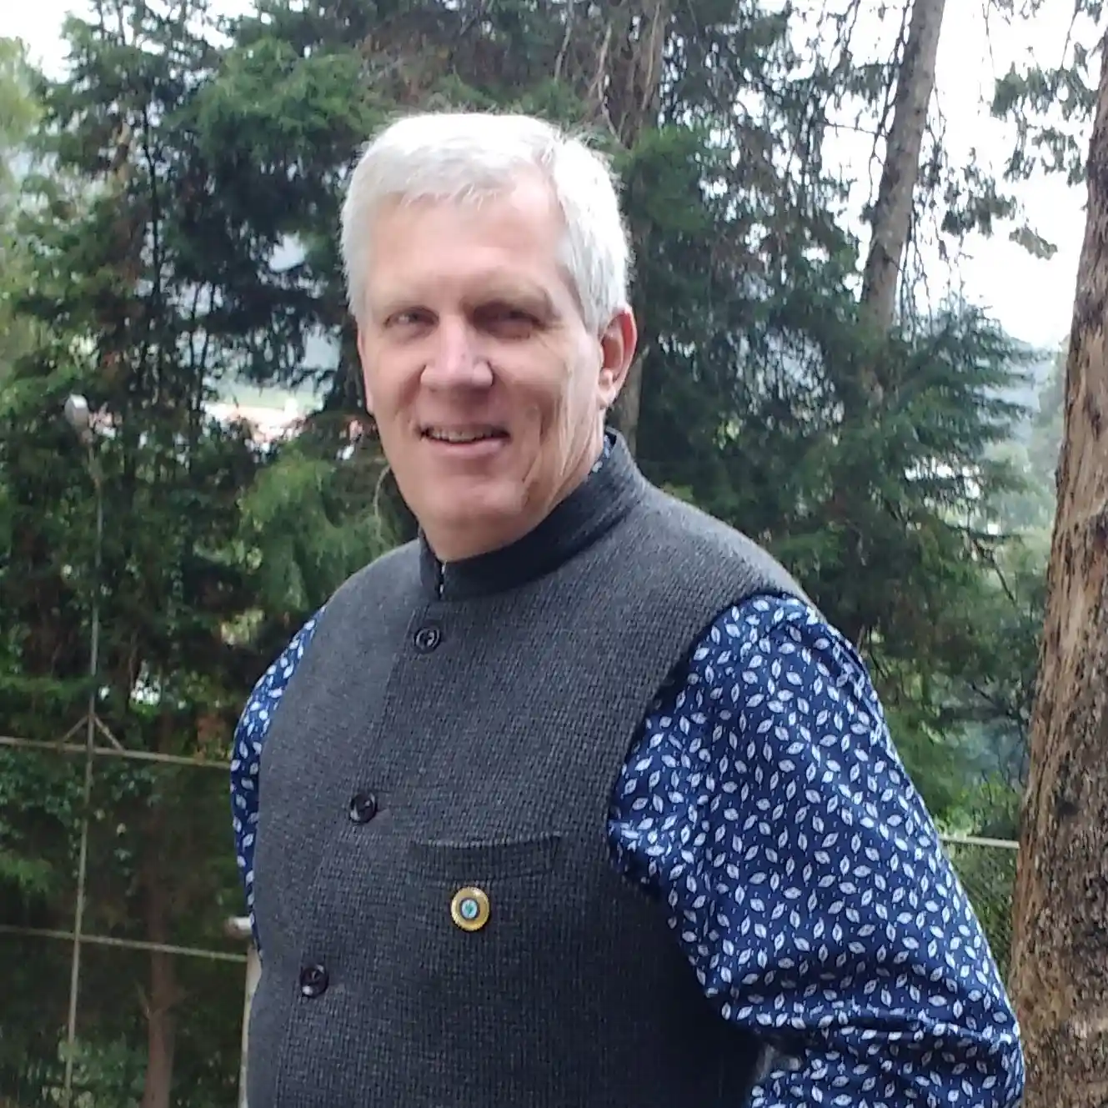
John Backlay
MK, TCK Consultant
John Barclay is an Indian-born missionary kid who spent his early years on the India-Nepal border with his Australian parents. At age six he entered boarding school in South India while his parents moved to Nepal as pioneer missionaries with United Mission to Nepal. After completing grade 10, he relocated to Australia to finish secondary school. Following work as a teacher and pastor, John and his wife Janine returned to Nepal in 1988 with Interserve Partners. For 28 years they served in school education and TCK care. He earned a doctorate in 2010 on families in cross-cultural ministry. Now busily retired in Melbourne, he stays connected to MK/TCK care in Asia and Africa and enjoys time with Janine, their three children, and five grandchildren.
Dupe Kashimawo
Member Care Specialist & Advocate
Dupe Kashimawo is an active advocate and speaker on TCK and MK topics, offering key pastoral care and support to help families navigate transitions smoothly.

4. Financial Stewardship for Missionary Families
Money conversations matter on the mission field. This workshop provides practical tools for budgeting, support-raising, and financial planning designed for the realities of missionary life.
Facilitator(s): Tolu Oladipo
Tolu Oladipo
Photo and bio: to be added.

5. Helping Children Navigate Identity & Belonging
For children raised between cultures, who am I and where do I belong are daily realities. This workshop gives parents tools to understand TCK identity formation and create home environments that anchor children - even amid constant change.
Facilitator(s): Heather Enoch
Philip and Heather Enoch
TCK Consultant, AIN Nairobi
Philip and Heather moved to Africa as a couple in 2003. Over the last 20+ years, they have served in a variety of roles in TCK Care including teaching, administration, and chaplaincy. Philip is a TCK himself. They currently live in Nairobi, Kenya where Philip serves in leadership and Heather in TCK Care. Philip and Heather have three adult children attending university in the US: Andrew, Kate, and Emily.

6. Rooted and Roaming
Frequent moves don't have to mean a fractured self. This workshop helps parents nurture a stable, Christ-centered identity in their children - one that holds firm across cultures and transitions.
Facilitator(s): Diti Olawole
Diti Olawole
Photo and bio: to be added.

7. Building Resilient Kids
Resilience is not the absence of struggle - it's learning to move through it. This workshop helps parents balance grit and grace, raising emotionally strong children without minimising the real weight of their experiences.
Facilitator(s): Heather Enoch
Philip and Heather Enoch
TCK Consultant, AIN Nairobi
Philip and Heather moved to Africa as a couple in 2003. Over the last 20+ years, they have served in a variety of roles in TCK Care including teaching, administration, and chaplaincy. Philip is a TCK himself. They currently live in Nairobi, Kenya where Philip serves in leadership and Heather in TCK Care. Philip and Heather have three adult children attending university in the US: Andrew, Kate, and Emily.

8. The Gift of the TCK Story
Every TCK carries a story worth telling. This workshop helps children own, process, and share their cross-cultural journey - not as a wound, but as a source of strength, identity, and purpose.
Facilitator(s): Mindy Beetham
Mindy Beetham
TCK Coordinator, SIM International
Mindy Beetham is married to Chris, who with their family served with SIM in Ethiopia for ten years where she was involved with TCK education. She has now been in the role of SIM International's TCK Coordinator serving remotely and traveling from the US (Michigan) for ten years. Chris and Mindy have five young adult TCKs (ages 19-27). She has a degree in primary education and is currently studying for a master's in marriage and family counselling.

9. Raising World Changers
Your MK's upbringing is not a limitation - it's a launching pad. This workshop invites parents to dream with their children about their God-given future, exploring vocation, calling, and the gifts hidden in a cross-cultural childhood.
Facilitator(s): David Ogunsola
David Ogunsola
Photo and bio: to be added.

10. When your child questions everything
Doubt and deconstruction look different in a TCK. This workshop offers a grace-filled approach to faith formation for children whose cross-cultural experiences have shaped how they encounter God and the church.
Facilitator(s): Mr Oladipo
Mr Oladipo
Photo and bio: to be added.

11. When MK'S go prodigal
What happens when the child raised on the mission field walks away. This workshop addresses rebellion and behavioral deviations in MKs - covering early red flags, emotional landscapes parents navigate, and how to love practically when the relationship is strained.
Facilitator(s): Mr Oladipo
Mr Oladipo
Photo and bio: to be added.

12. Where Is Home
Home is a complicated word for TCKs. This workshop guides families through the third culture experience through a biblical lens, helping children find meaning and belonging in their unique stories.
Facilitator(s): Ode Agabi/Heidi Tolar
Ode Agabi
Photo and bio: to be added.
Heidi Tolar
Photo and bio: to be added.

13. Recognising Trauma in Your MK
Not every wound is visible. This workshop helps parents identify signs of trauma in missionary kids, respond with grace rather than fear, and lean into the healing power of Christian community.
Facilitator(s): Patience Ahmed
Patience Ahmed
Photo and bio: to be added.

14. When to Seek Help
Asking for help is not a failure of faith. This workshop destigmatises mental health care for missionary families and helps parents navigate available resources - from the field, in transition, and beyond.
Facilitator(s): Patience Ahmed
Patience Ahmed
Photo and bio: to be added.

15. Who Pastors the Missionary Parent?
Behind every struggling MK is often a parent carrying weight in silence. This workshop asks who cares for the caregiver - and equips churches, mission organisations, and communities to build pastoral presence and sustained, grace-rooted support around both troubled MKs and the parents who love them.
Facilitator(s): Dupe and Diti Olawale
Dupe Kashimawo
Member Care Specialist & Advocate
Dupe Kashimawo is an active advocate and speaker on TCK and MK topics, offering key pastoral care and support to help families navigate transitions smoothly.

16. Supporting Adult/Independent TCKs
What happens when TCKs grow up? This workshop explores how cross-cultural childhood experiences show up in adulthood and how families and communities can offer meaningful, timely support.
Facilitator(s): Philip Enoch
Philip and Heather Enoch
TCK Consultant, AIN Nairobi
Philip and Heather moved to Africa as a couple in 2003. Over the last 20+ years, they have served in a variety of roles in TCK Care including teaching, administration, and chaplaincy. Philip is a TCK himself. They currently live in Nairobi, Kenya where Philip serves in leadership and Heather in TCK Care. Philip and Heather have three adult children attending university in the US: Andrew, Kate, and Emily.

17. Child Protection: At Home and Away from Home
Safeguarding children is a non-negotiable - wherever you serve. This workshop equips families with awareness, language, and practical frameworks to protect their children both on the field and during transitions.
Facilitator(s): Mindy/Tolu Oladipo
Mindy
Photo and bio: to be added.
Tolu Oladipo
Photo and bio: to be added.

18. Parenting in an AI-Driven and Social Media World
AI and social media are shaping how children see themselves and the world. This workshop equips cross-cultural parents with practical frameworks for healthy technology boundaries and intentional digital discipleship.
Facilitator(s): Mishael Nungkopa
Mishael Nungkopa
Photo and bio: to be added.

