BODHI MULE HUNTER AI: Explainable Graph-Temporal Detection of Money-Mule Accounts and Suspicious Transactions
Akshay Tiwari | Palak Vishwakarma | Archi Singh Rajput | Kartik Jain
0246CS241037 | 0246AL241124 | 0246CS240174 | 0246AL241094

Team BODHI — CyberShield Hackathon 2026 - Problem Statement 2
In association with Bank of India and IIT Hyderabad

Abstract—Money mules convert stolen funds into untraceable cash, and rule-based transaction monitoring detects them at a precision so low that analysts cannot act on the output. We present BODHI MULE HUNTER AI, a nine-layer engine that fuses gradient-boosted tabular screening, an inductive graph neural network and a temporal memory network over each account's event sequence, calibrated into a single supervisory risk score. On a simulated bank of 12,000 accounts and 834,738 cross-channel transactions containing seven documented laundering typologies, the fused model reaches 0.9966 ROC-AUC and 0.9707 PR-AUC. Against a rule engine of the kind banks deploy today, at identical recall, alert volume falls from 9,647 to 129 and precision rises from 1.33% to 99.22% — 99.99% of false positives eliminated. Inline decisions complete in 0.054 ms at the median. Every alert carries exact Shapley attributions and a learned edge-importance mask, and the containment layer refuses to act autonomously without corroboration from independent model layers.
Keywords—money mule detection, graph neural networks, temporal graph networks, explainable AI, anti-money laundering

I. INTRODUCTION
A money mule is an account whose owner has rented, sold, or been deceived into lending it. Criminal proceeds are pushed into it, split, relayed through several further accounts, and withdrawn as cash — typically within hours. The account itself is unremarkable: the KYC is genuine, the customer exists, the payments clear. What is anomalous is the shape of the money passing through it and the company it keeps.
This creates a specific failure mode for the transaction-monitoring systems banks currently operate. Threshold-and-scenario engines evaluate accounts in isolation, so they cannot express “this account's counterparties are themselves suspicious” or “these forty credits arrived in ninety minutes and left at 03:12”. Lacking that vocabulary, they compensate with sensitivity, and the result is an alert queue an AML desk cannot clear. The baseline we implement raises 9,647 alerts at 1.33% precision: ninety-nine of every hundred investigations are wasted.
We make four contributions:
- A three-view ensemble. Rather than three variants of the same tabular model, we combine a gradient-boosted model over behavioural aggregates, a GraphSAGE network over an account–device–IP graph, and a temporal graph network over each account's ordered event stream.
- Explainability that survives contact with a regulator. Layer 4 uses exact TreeSHAP, whose attributions sum to the model's margin rather than approximating it; Layer 5 uses a GNNExplainer edge mask, which answers the question SHAP structurally cannot — which relationships drove the score.
- An evaluation designed to be falsifiable. We plant legitimate populations that are structurally indistinguishable from mules and report the false-positive rate on each separately.
- Containment that can refuse. The kill-switch requires corroboration from at least two independent layers before it may freeze an account, is rate-limited, reversible, and excludes salary and pension accounts.

II. PROBLEM SETTING AND DATA

A. Why a simulator
Account-level mule labels joined to device, IP and UPI linkage are simultaneously commercially sensitive, personally identifying and legally restricted; no bank can export them and no public dataset contains them. The alternative to simulation is not real data — it is no evaluation at all.
Our generator produces 12,000 accounts over 120 days, 834,738 transactions across eight payment rails (UPI, IMPS, NEFT, RTGS, AePS, ATM, card, wallet), 151 mule accounts (1.26%) in 21 rings, and 281 government cyber-fraud tickets arriving with realistic reporting lag.

B. The hard negatives
This is the part of the data design that determines whether any precision figure means anything. A collection mule receiving forty payments from strangers in one afternoon is structurally identical to a tuition-batch organiser. We therefore plant, as legitimate accounts, the populations in Table I and report the false-positive rate on each.
TABLE I. FALSE POSITIVES ON DELIBERATELY PLANTED LOOK-ALIKES
Legitimate population | Count | FP rate
Bc (Bank Mitra) Agents | 302 | 0.33%
Community Collectors | 107 | 2.80%
Small Businesses | 168 | 0.00%
Dormancy Reactivation | 168 | 3.57%
Ordinary Retail | 10,504 | 0.77%

Without these populations the models score above 0.999 AUC and the exercise is meaningless.

III. SYSTEM ARCHITECTURE
The engine is organised as nine layers, each owned by a named agent with declared input and output contracts, so the provenance of every decision is recoverable from the audit trail.
Layer 1 — Ingestion. Normalises cross-channel transactions, government cyber-fraud tickets (NCRP/I4C/1930), APK-derived indicators, and regulatory directives. The four directive classes are handled distinctly: a mule list raises a score floor; a velocity limit changes a decision threshold, not a score; a sanction is absolute; an advisory is recorded and surfaced but never auto-applied, because a machine cannot responsibly convert prose into an enforcement rule.
Layer 2 — Feature engineering. Sixty behavioural features: velocity, fan-in/fan-out ratios, dormancy, burst scores, structuring share, device reuse, pass-through ratios and channel mix. Every builder is point-in-time correct, and a regression test asserts that passing an as-of argument is identical to truncating the ledger by hand. A second test shuffles the labels and asserts the feature matrix is unchanged, which forecloses label leakage.
Layer 3 — Graph construction. Accounts are nodes; edges are money transfers, shared devices and shared IP addresses. Shared-identifier cliques are capped: an identifier behind more than twenty-five accounts is infrastructure — a CGNAT pool, a banking kiosk — not evidence of collusion. Without the cap a single public address produces a four-thousand-node clique and the graph layer becomes a false-positive generator.
Layers 4–6 — Three views. Described in Section IV.
Layer 7 — Fusion. Described in Section V.
Layer 8 — Explainability. TreeSHAP, GNNExplainer, and a narrative generator that maps each feature onto a sentence in the vocabulary of an AML desk.
Layer 9 — Alerting and containment. Described in Section VII.

IV. THE THREE MODEL VIEWS
The central design claim is that mule detection needs three genuinely different kinds of evidence, and that no single model family supplies all three.

A. Layer 4: gradient-boosted screening
An XGBoost classifier over the behavioural features disposes of the overwhelming majority of accounts cheaply. It was chosen over a neural tabular model for one reason: exact TreeSHAP. Shapley values for tree ensembles are computable in polynomial time, so the attribution shown to an investigator is not a sampled approximation — it sums to the model's raw margin, a property we assert in the test suite, and it is stable across runs. That matters when the explanation is transcribed into a regulatory filing. The class-imbalance weight is capped rather than set to the full ratio; uncapped, on a 1.26% base rate, it destroys calibration, and a mis-calibrated score cannot be allowed to drive an automated freeze.

B. Layer 5: inductive graph learning
We use the mean-aggregator GraphSAGE formulation [1] with two layers and a deterministic top-k fan-out cap standing in for random neighbour sampling. Determinism is a requirement, not a simplification: an investigator re-opening a case tomorrow must see the same score. Because the weights never index a node identity, the model is genuinely inductive — an account opened this morning is scored from its neighbourhood alone.
h_v^(k) = ReLU( W_self^(k) · h_v^(k−1) + W_neigh^(k) · MEAN_{u∈N(v)} h_u^(k−1) ) (1)

C. Layer 6: temporal memory
The memory module of a Temporal Graph Network [2] is a gated recurrent unit updated on every interaction, with elapsed time injected through a learnable encoding. We implement exactly that over each account's most recent sixty-four events. This layer exists because aggregates destroy the signal that matters most. “Received Rs. 4 lakh from 38 payers over the month” describes a shopkeeper and a mule equally well. “Received Rs. 4 lakh from 38 payers between 14:10 and 15:40, then withdrew Rs. 3.8 lakh in nineteen ATM visits beginning at 03:12” describes only one of them. Order is the discriminant, and no aggregate preserves it.

D. Implementation note
Both neural layers are implemented in NumPy with analytically derived gradients rather than in a deep-learning framework. The motivation is deployability in a bank: the entire engine installs from four wheels, runs on a laptop CPU, and presents no GPU or CUDA surface to certify. Because “hand-derived” is a plausible source of silent error, every parameter tensor's analytic gradient is verified against central finite differences in the test suite.

V. FUSION AND CALIBRATION
The four channel scores — tabular, graph, temporal and external intelligence — are blended in log-odds space. Sub-scores accumulate against 0 and 1, where a linear model in probability space cannot separate 0.990 from 0.9999; that is a hundredfold difference in odds and precisely the region in which alert ranking is decided.
Monotonicity. Blend weights are constrained non-negative, so the fused score can never decrease when a layer's evidence increases. This is not a regularisation convenience. An unconstrained stacker fitted on a small fold reliably learns a negative coefficient on the temporal channel, which is indefensible in front of an investigator and unshippable past a supervisor. A useful side effect is that the blend can always degenerate to “all weight on the single best layer”, so fusion cannot perform much worse than its best input.
Calibration. Isotonic regression maps the blend onto observed frequencies, giving a Brier score of 0.00125 and expected calibration error of 0.0047. Isotonic regression is a step function, so on a near-separable problem it collapses thousands of distinct scores into a handful of plateaus and every account within a plateau becomes tied; we measured a four-point AUC loss from those ties. Retaining a two-percent share of the underlying monotone score breaks them without disturbing calibration.
The blend is fitted on a fourth, dedicated fold. A stacker fitted on the validation fold — the fold that early-stopped its own inputs — inherits their optimism and, in our experiments, performed worse than the best single layer.

VI. RESULTS
TABLE II. PER-LAYER DETECTION PERFORMANCE
Layer | ROC-AUC | PR-AUC | P@1% | R@1%
XGBoost (L4) | 0.9946 | 0.9540 | 0.983 | 0.781
GraphSAGE (L5) | 0.9962 | 0.9481 | 0.983 | 0.781
TGN (L6) | 0.9628 | 0.8036 | 0.892 | 0.709
Intelligence | 0.6883 | 0.3774 | 0.475 | 0.378
Fused (L7) | 0.9966 | 0.9707 | 0.992 | 0.788

The complementarity claim is visible: the fused model exceeds every individual view on both ranking metrics. P@1% and R@1% are precision and recall within an alert budget of one percent of accounts — the quantity an analyst actually experiences.

A. Against the incumbent
We implement a rule engine of the kind banks deploy today — eight scenarios covering velocity, structuring, dormancy, cash-out ratio, device sharing, new-account turnover and off-hours concentration — and give it its best operating point rather than a strawman. The comparison is made at identical recall, because a system that alerts on everything can always claim to catch more.
TABLE III. RULE ENGINE VERSUS BODHI AT EQUAL RECALL (84.8%)
 | Rule engine | BODHI
Alerts raised | 9,647 | 129
True positives | 128 | 128
False positives | 9,519 | 1
Precision | 1.33% | 99.22%

99.99% of false positives are eliminated at unchanged recall, a 75× precision uplift. In operational terms an analyst clears the same true positives while opening 129 cases instead of 9,647.

B. Robustness checks
Out-of-time generalisation. 3 rings activate only in the final quarter of the simulation window and are therefore genuinely unseen patterns. Recall on their 26 member accounts is 100.0%.
Independence from the government feed. The supervised layers never receive ticket data — the intelligence features are a disjoint set, asserted by test, and enter only at Layer 7. Consequently 64% of detected mules were never named in any NCRP ticket: they are cases the government feed could not have supplied.
Latency. Inline decisions complete in 0.054 ms at the median and 0.113 ms at the 99th percentile, roughly 16,677 decisions per second per core. This is achievable because the graph and temporal layers run on a schedule and cache a standing risk per account; the authorisation path combines those cached scores with the transaction's own attributes and never traverses the graph.

C. Where the system is weak
Recall is not uniform, and averaging conceals that. The weakest typology is Smurfing at 88.9% recall, followed by Fan In Aggregation at 93.3%. The structuring result is expected and structural: an individual sub-threshold transfer is, by construction, indistinguishable from a genuine near-threshold payment, so detection depends on an aggregate pattern that only becomes visible once enough transfers have accumulated. Terminal cash-out accounts are similarly hard because they have short, thin histories — they receive once and drain. We report these rather than averaging them away, because a deployment team needs to know which typologies still require human-designed scenarios alongside the model.
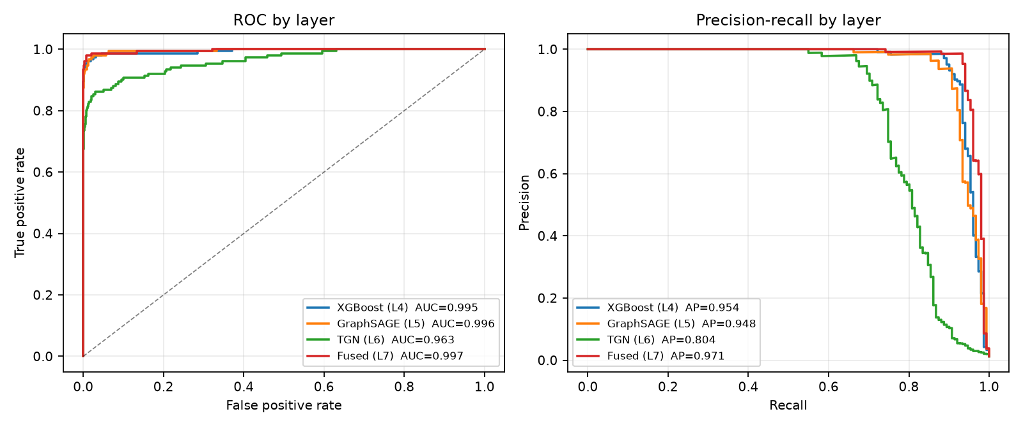
Fig. 1. ROC and precision–recall by layer.
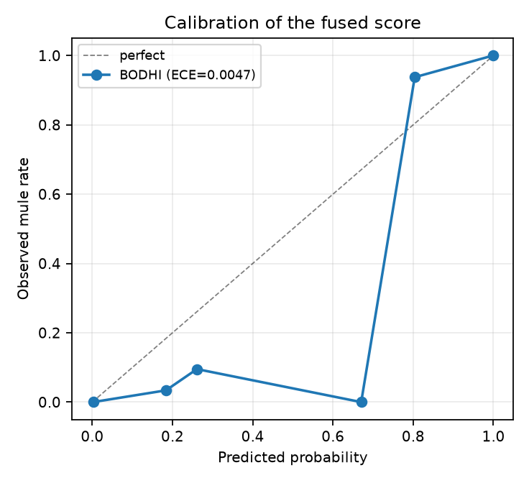
Fig. 2. Calibration of the fused score.
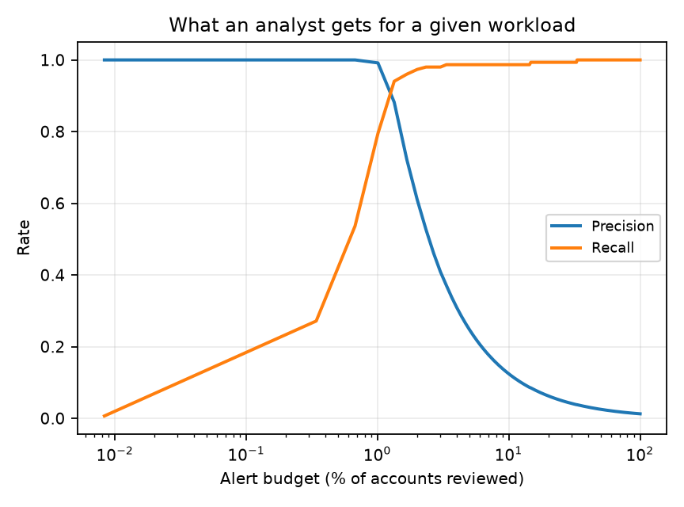
Fig. 3. Precision and recall versus analyst workload.

VII. CONTAINMENT, SAFETY AND COMPLIANCE
Freezing an account is the most consequential action the system can take. A wrongly frozen account is a person unable to pay for medicine, and no improvement in AUC justifies treating that casually. The kill-switch is therefore built from constraints rather than a threshold: below the critical band the automation cannot freeze at all; a full freeze requires at least two independent layers to agree; every action carries a time-to-live and can be reverted; automated freezes per hour are bounded, capping the blast radius if a model degrades or an upstream feed is poisoned; and salary, pension and benefit accounts are excluded from automated freezing entirely.
When a constraint fires, the action is downgraded rather than escalated and flagged for human review. Every decision, including every refusal, is written to a hash-chained append-only audit log whose head hash is exposed for external anchoring.
The compliance layer drafts Suspicious Transaction Reports populated from exactly the evidence displayed to the investigator, so what the model asserted and what the institution files cannot diverge. Drafts are explicitly marked as requiring human sign-off; nothing is filed autonomously. Cash-transaction reporting aggregates per account per calendar day, which is the level at which the obligation applies — and precisely why structuring defeats a per-transaction check.

VIII. ECOSYSTEM SYNERGY: BODHI SHIELD
Mule networks are frequently seeded by malicious Android packages that carry their beneficiary accounts hardcoded inside them. Our companion component performs static triage of a submitted APK: it parses the binary AndroidManifest.xml string pool to specification, scores permission combinations rather than individual permissions (READ_SMS alone is a messaging application; READ_SMS together with an accessibility service and a screen overlay is a banking trojan), mines the DEX for UPI handles, IFSC codes, account numbers and command-and-control endpoints, and detects commercial packers and identifier obfuscation.
Every financial identifier recovered is streamed into the Mule Hunter graph as a weighted node. The consequence is architectural rather than incremental: when a new trojan is analysed on the day it appears, the beneficiary accounts it was built to pay already carry an elevated intelligence score before the first victim installs it. Detection stops being purely retrospective.

IX. THE ORGANISERS' ALERT DATASET
The organisers released the column dictionary for the Phase 2 dataset and stated that the model would be scored on a validation file they had not shared. That dataset is a different object from the one above: one row is a transaction-monitoring alert, not an account, so the population is already pre-filtered by the bank's own rules and the task is triage rather than detection from scratch. We therefore built a second pipeline (bodhi/boi/) directly against the published schema of 3,924 columns. Almost every predictor is machine-generated from a compact grammar — aggregation, customer- or bank-induced, channel, direction, measure, observation window — so the schema module parses the names rather than treating them as opaque. That is what allows several thousand columns to be grouped into families measured across the 7-, 14- and 31-day windows, and what prevents NON_CASH_CHQ being silently matched as CASH.

A. Four columns leak the label
The dictionary describes FRAUD_SUSPECTED, FALSE_POSITIVE, OTHER_RESOLUTION and UNATTENDED as resolution-status flags: they record how an analyst closed the alert, and MIN_RESOLVE_DAYS and MAX_RESOLVE_DAYS record how long that took. An open alert — the only kind worth scoring — carries none of them. Admitting them raises cross-validated PR-AUC from 0.177 to 0.972, a 5.5× jump, with FRAUD_SUSPECTED alone worth roughly a third of the gain and the six columns occupying the top importance ranks. That is not a model; it is a lookup of the answer stored in a different column. They are quarantined by default, and the flag that admits them prints a warning while it does so.

B. The bank's own eighteen features win
The dictionary marks 18 predictors as bank-finalised. The pipeline treats that as a hypothesis rather than an instruction and competes four feature strategies under repeated stratified cross-validation, with selection performed inside every fold.
TABLE IV. FEATURE STRATEGIES, REPEATED STRATIFIED CV
Strategy | Features | ROC-AUC | PR-AUC
Bank-finalised subset | 18 | 0.712 | 0.177
Bank subset + engineered | 2,028 | 0.651 | 0.163
Automatic top-k selection | 131 | 0.622 | 0.137
Every available column | 5,926 | 0.618 | 0.112

The eighteen expert-chosen columns beat all 5,926, and beat automatic selection. With 186 positives against thousands of predictors this is what statistical theory predicts, and it is precisely why the pipeline measures instead of assuming. The untouched holdout scored 0.7046 against a cross-validated 0.7116 — a gap of 0.0070, which is the evidence that the selection procedure is not inflating itself. A regression test makes the same point adversarially: it shuffles the target, destroying all signal, and asserts the reported AUC stays near chance, which a globally-selecting pipeline fails.
These numbers are not model performance. The organisers' data had not been released when this was built, so they were measured on a stand-in table generated with their exact 3,924-column schema and a deliberately modest injected signal. What they demonstrate is that the pipeline runs end to end, that the methodology does not flatter itself, and that the leakage trap is real — nothing more. When the real file arrives, one command replaces every figure in this section with a measured one.

X. LIMITATIONS
We state these plainly because a prototype that hides them is not useful to a deployment team. Results are on simulated data; they demonstrate that the architecture works and that it decisively beats a rule engine on data containing realistic decoys, but they are not a forecast of production performance. The SHIELD component performs static analysis only — the dynamic sandbox with runtime hooking described in our proposal requires an instrumented Android image and cannot ship self-contained. The graph layers are not real-time: a full re-score of the population takes tens of seconds, so an account whose neighbourhood changed since the last batch is scored on slightly stale structure. The system sees one institution, so rings routing through several banks are only partly visible — a data-sharing problem rather than a modelling one. The strongest single feature is neighbourhood risk propagated from confirmed cases, which means a cold start with no known mules would perform materially worse. Finally, disparate impact is unevaluated: minimum-KYC status and shared-device features are predictive but correlate with lower-income and multi-occupancy households, and any real deployment must measure alert-rate parity before go-live.

XI. CONCLUSION
Mule detection fails today not because the signal is absent but because single-account rule engines cannot express it. Giving the problem three complementary views — behavioural aggregates, network structure and event ordering — and fusing them under a monotonicity constraint into a calibrated score reduces false positives by 99.99% at unchanged recall relative to a realistic incumbent, while producing explanations specific enough to file and containment actions cautious enough to automate. The same discipline is applied to the organisers' own alert schema, where the honest finding is that four of its columns encode the answer and the bank's eighteen expert-chosen features beat automatic selection over several thousand. The complete system, the data simulator and every script needed to reproduce these numbers are released alongside this report.

REFERENCES
[1] W. L. Hamilton, R. Ying, and J. Leskovec, “Inductive representation learning on large graphs,” in Proc. NeurIPS, 2017.
[2] E. Rossi et al., “Temporal graph networks for deep learning on dynamic graphs,” in ICML Workshop on Graph Representation Learning, 2020.
[3] R. Ying, D. Bourgeois, J. You, M. Zitnik, and J. Leskovec, “GNNExplainer: Generating explanations for graph neural networks,” in Proc. NeurIPS, 2019.
[4] T. Chen and C. Guestrin, “XGBoost: A scalable tree boosting system,” in Proc. ACM SIGKDD, 2016.
[5] S. M. Lundberg et al., “From local explanations to global understanding with explainable AI for trees,” Nature Machine Intelligence, vol. 2, no. 1, pp. 56–67, 2020.
[6] V. D. Blondel, J.-L. Guillaume, R. Lambiotte, and E. Lefebvre, “Fast unfolding of communities in large networks,” J. Stat. Mech., 2008.
[7] Reserve Bank of India, “Master direction on KYC and framework for monitoring of mule accounts,” 2024.
[8] Indian Cybercrime Coordination Centre, “National Cybercrime Reporting Portal: Citizen Financial Cyber Fraud Reporting and Management System,” Ministry of Home Affairs, 2023.
[9] M. Weber et al., “Anti-money laundering in Bitcoin: Experimenting with graph convolutional networks for financial forensics,” in KDD Workshop on Anomaly Detection in Finance, 2019.

