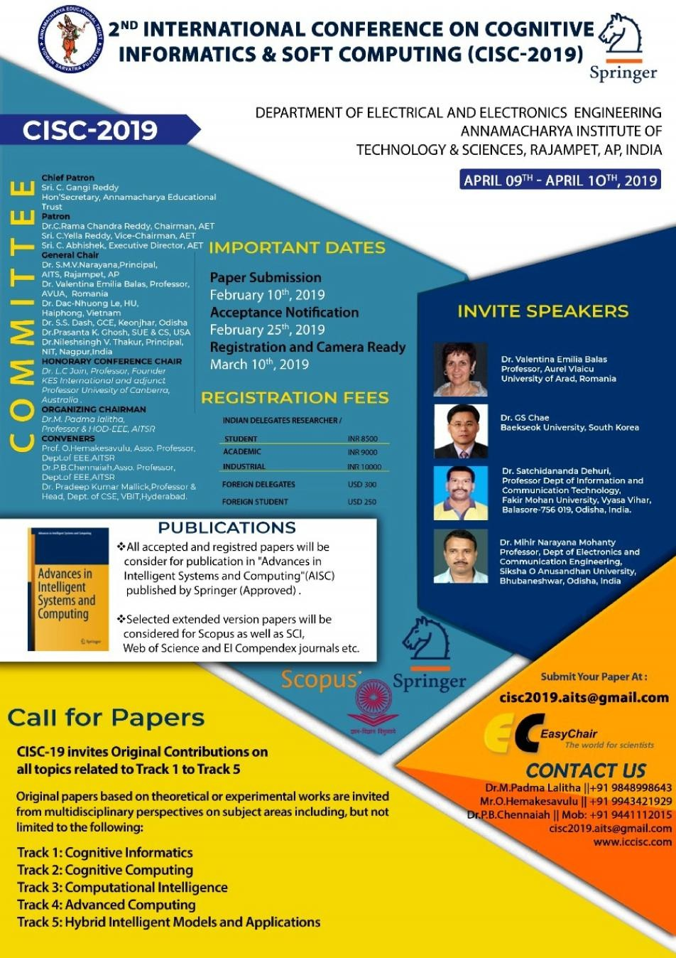

All accepted and registered papers will be consider for p blication
u
in Advances in Intellig nt Systems and Computing (AISC Series Springer)
e

MoreDetails: http://www.springer.com/series/11156.
Indexed By: ISI Proceedings, EI-Compendex, DBLP, SCOPUS, Google Scholar and Springerlink.

Listed in the UGC Approved Journal List at Index No. 1375 link: http://www.ugc.ac.in/ugc_notices.aspx?id=1604.
c
("Advances in Intelligent and Soft Computing- http://www.springer.com/series/4240" is renamed as "Advances in Intelligent Systems and Computing- http://www.springer.com/series/11156" )
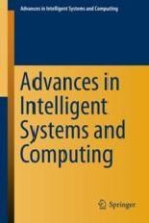


Extended Version Paper Publication:

Selected extended version papers will get published in the following Scopus indexed International Journals and Book series.

Informatics in Medicine Unlocked (Elsevier Machine Learning for Intelligent Decision Making in Biomedical Data) . | Click Here for Detais
Special Journal of Computational and Theoretical Nanoscience. | Click Here for Detais
Springer Template Springer Guidelines for Authors Man script Submission Checklist
u
C
onsent to Publish Form

SCIENCE CITATION INDEX EXPANDED JOURNAL (SCIE)
The International Journal of Electrical Engineering & Education (IJEEE) LIST OF SCOPUS JOURNALS
- International Journal of Engineering And Advanced Technology (IJEAT)
- International Journal of Recent Technology & Engineering (IJRTE)
- International Journal of Innovative Technology and Exploring Engineering (IJITEE)
- International Journal of Engineering and Technology (UAE) (IJET)
- International Journal of Mechanical and Production Engineering Research and Development (IJMPERD)
- International Journal of Simulation Systems, Science & Technology (IJSSST)
- Journal of Advanced Research in Dynamical and Control Systems (JARDCS)
- International Journal Of Information Technology Project Management (IJITPM)
- Indian Journal of Public Health Research and Development (IJPHRD)
- International Journal of Supply Chain Management (IJSCM)

UGC APPROVED JOURNALS
  - Journal of Applied Science And Computations (JACS)
  - International Journal of Research And Analytical Reviews (IJRAR)
  - Journal Of Emerging Technologies And Innovative Research (JEITR)

