If you are student or hobbyist searching for an ARM based development board, then the boards manufactured by ST microcontrollers are the perfect ones to start with. Other boards with ARM architecture include Texas instruments – TIVA boards, Raspberry Pi with its own unique features etc.

ARM based processors: When the word ARM (Advanced RISC machine) based processors is used, most of the students are under the impression for it to be complex and think of it being difficult to understand. But in reality, ARM based processors are the best ones to dive in and realize embedded systems in depth. As the name suggests, these have a RISC (Reduced Instruction Set Computing) based architecture which form the basic building blocks (hence they are called as cores) of CPU. These also form a part of modern cameras, mobile phones, laptops, wireless communication devices etc. An ARM architecture basically describes the instruction set, memory layout, instruction cycles etc. used for the processor. Sometimes there is a confusion regarding different versions of ARM architectures, for eg. (ARMv6, ATMv6-M, ARMv7-M, ARMv7-A, and so on) and the core based architectures. For the ease of understanding, a processor can be based on Cortex-M4 core and designed on ARMv7-M architecture. Each of these versions has their own advantages and disadvantages.

The Cortex (core) based architecture are sub-divided into 3 families based on the application for which it is being used. They are:

1. Cortex-A: Here **A** stands for **A**pplication. These processors are mostly used for high-end and complex computing tasks like hosting operating systems (linux), and also used for multiple software applications. These are found in modern mobile phones, tablets etc. These are also sub-divided among themselves for eg. Cortex- A5, A7, A8, A9...etc. These support several common features like single and double floating point precision, several instruction sets like ARM, THUMB, Jazalle etc.
2. Cortex-M: Here **M** stands for e**M**bedded. The targeted audience here includes students and hobbyist as it is user-friendly and is available for lower cost. These range from Cortex-M0, M1, M3, M4.. etc. Some provide better performance, some provide better efficiency. These are found in applications including IoT (Internet of things), household appliances, consumer products etc.

* Cortex-M4 is the most widely used among the Cortex-M sub-family cores. It comes with ARMv7-M instruction set, Memory protection unit (MPU), Nested vector interrupt controller (NVIC), Floating point unit (FPU), Trace, breakpoint and JTAG capabilities, Advanced Microcontroller Bus architecture (AMBA) etc.

1. Cortex-R: Here **R** stands for **R**eal-Time. These provide high performance computing with higher reliability, availability, fault tolerance and meet challenging real –time constraints.

STM based boards: ST microcontrollers have a wide range of microcontroller boards divided into 10+ sub-families, each unique with its feature. STM32F1 being the first, all of them are designed with Cortex-M core based architecture. They consist of a core processor, RAM, flash memory, debugging features and a variety of peripherals etc. Some come with additional memory interfaces like EEPROM, EPROM etc.

The below figures provide with information regarding the available ST controllers for development

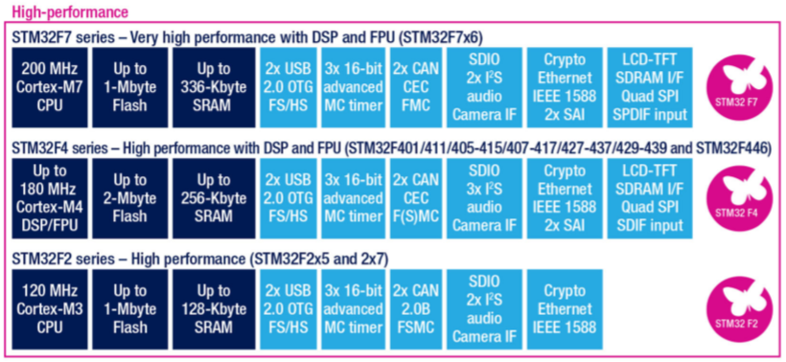

Fig .x

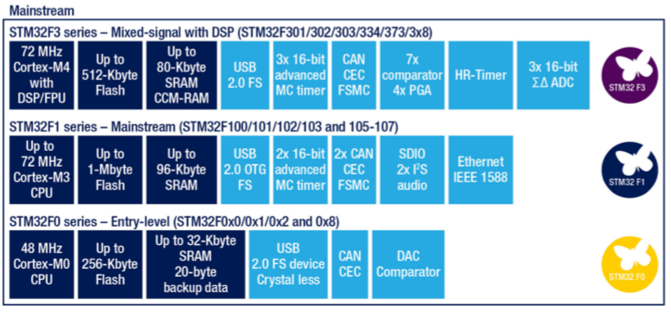

Fig. x

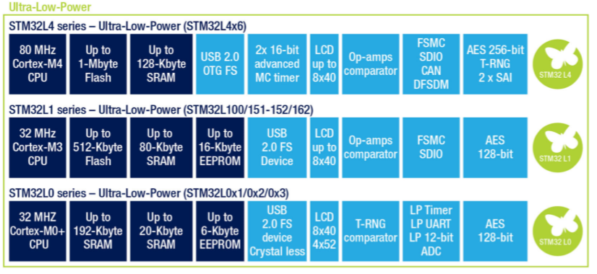

Fig. x

Advantages:

1. They are based on Cortex-M based core architecture which provides a broad range of feature for a beginner in embedded systems.
2. They are available for ARM based-toolchains, for a developer the two important things to start development would be a development board and an IDE. These can be developed on open-source tools like eclipse based workbench, Keil etc.
3. Most of have the availability of an in-circuit debugger for debuuging of the applications.
4. They have a size of 32-bit which proves a better choice over 8/16-bit controllers for a minimal cost.
5. They are available for low-cost with better performance and lower power consumption.
6. STM32 MCUs are shipped with an integrated bootloader, which allows to reprogram the internal flash memory using some communication peripherals (USART, I²C, etc.).

Board Used for development: The board used for development here is STM32F407-discovery board. The below figure shows the basic interfaces available on the board.

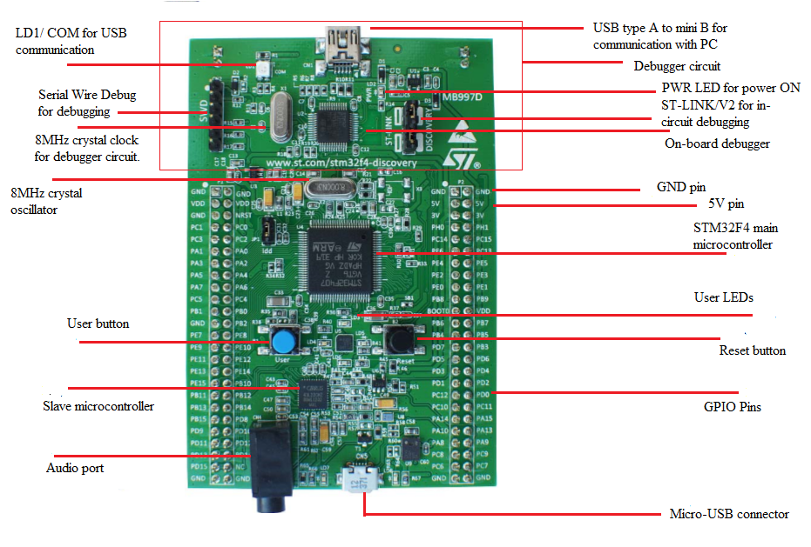

Fig. x

Features of the board:

* STM32F407VGT6 microcontroller featuring 32-bit ARM® Cortex®-M4 with FPU core, 1-Mbyte Flash memory, 192-Kbyte RAM in an LQFP100 package
* On-board ST-LINK/V2 on STM32F4DISCOVERY (old reference) or ST-LINK/V2-A on STM32F407G-DISC1 (new order code)
* USB ST-LINK with re-enumeration capability and three different interfaces:

1. Debug port
2. Virtual Com port
3. Mass storage

* Board power supply: through USB bus or from an external 5 V supply voltage.
* External application power supply: 3 V and 5 V.
* LIS302DL or LIS3DSH ST MEMS 3-axis accelerometer.
* MP45DT02 ST-MEMS audio sensor omni-directional digital microphone.
* CS43L22 audio DAC with integrated class D speaker driver.
* Eight LEDs:

1. LD1 (red/green) for USB communication.
2. LD2 (red) for 3.3 V power on.
3. Four user LEDs, LD3 (orange), LD4 (green), LD5 (red) and LD6 (blue).
4. 2 USB OTG LEDs LD7 (green) VBUS and LD8 (red) over-current.

* Two push-buttons (user and reset).
* USB OTG FS with micro-AB connector.
* Extension header for all LQFP100 I/Os for quick connection to prototyping board and easy probing.
* Comprehensive free software including a variety of examples, part of STM32CubeF4 package or STSW-STM32068 to use legacy standard libraries.

Description:

* The STM32F4DISCOVERY kit leverages the capabilities of the STM32F407 high performance microcontrollers, to allow users to easily develop applications featuring audio.
* It includes an ST-LINK embedded debug tool, one ST-MEMS digital accelerometer, a digital microphone, one audio DAC with integrated class D speaker driver, LEDs, push-buttons and an USB OTG micro-AB connector.
* The kit can be expanded to enable other functionalities like connecting to Ethernet, CAN, LCD display device etc.