|  |  |  |  |  |  |
| --- | --- | --- | --- | --- | --- |
| **Id** | **Type** | **Brand** | **Year** | **KM** | **Price**  **(TL)** |
| **1** | Otomobil | Audi | 2012 | 215.000 | 289.000 |
| **2** | SUV | Nissan | 2018 | 5.000 | 275.900 |
| **3** | SUV | Dacia | 2012 | 228.000 | 99.500 |
| **4** | Otomobil | Opel | 2006 | 156.000 | 65.000 |
| **5** | SUV | Peugeot | 2017 | 90.000 | 337.500 |
| **6** | Otomobil | Nissan | 2007 | 180.000 | 65.000 |
| **7** | Otomobil | Opel | 2008 | 228.000 | 81.500 |
| **MEAN** | **-** | **-** | **2011** | **157.428** | **173.214** |
| **MEDIAN** | **-** | **-** | **2012** | **180.000** | **99.500** |
| **MODE** | **Otomobil** | **Nissan, Opel** | **2012** | **228.000** | **65.000** |
| **MIDRANGE** | **-** | **-** | **2011.5** | **116.500** | **201.250** |

**DATASET**

**Feature Types**

|  |  |
| --- | --- |
| **Type** | Categorical - Nominal |
| **Brand** | Categorical - Nominal |
| **Year** | Date |
| **KM** | Numeric - Ratio |
| **Price (TL)** | Numeric - Ratio |

**Km variable**

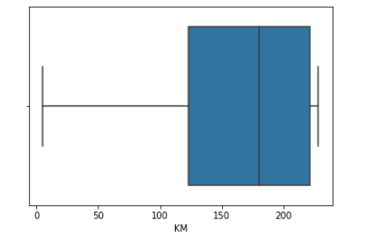**Min : 5.000**

**Q1 : 123.000**

**Q2 : 180.000**

**Q3 : 221.500**

**Max : 228.000**

**IQR : 98.500**

**Price variable**

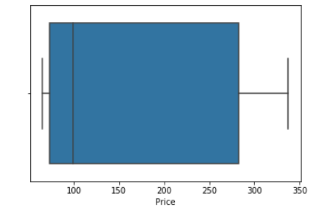**Min : 65.000**

**Q1 : 73.250**

**Q2 : 99.500**

**Q3 : 282.450**

**Max : 337.500**

**IQR : 209.200**