# IT 140 Design Document Template

## Instructions

Fill out the sections below. Be sure to remove the bracketed text before submitting your Design Document.

Kody Greenberg

## Storyboard (Description and Map)

Imagine this, you actually got a girl! But guess what time of the month it is… Mother nature is calling, and she has become, quite frankly, terrifying! However, this isn’t your first rodeo. You know exactly what she needs. You must run around the mansions 10 rooms and find 8 items. You can move North, South, East, West – depending on current room. The rooms you will need to navigate: The Ballroom (starting location), Game room, Lavatory, Cat room, Bedroom, Library, Basement, PC room, Kitchen, Wine cellar. The items: Candy, Chocolate, Potato Chips, Hygiene products, Roses, Handwritten Card, Wine, Cat. Once you have found all the items, you can present them to her, and she will be so thankful! But beware, you don’t know what room she is in! If you don’t collect everything she needs before seeing her, it’s going to be a big fight and you will end up defeated and in the doghouse.

3.10..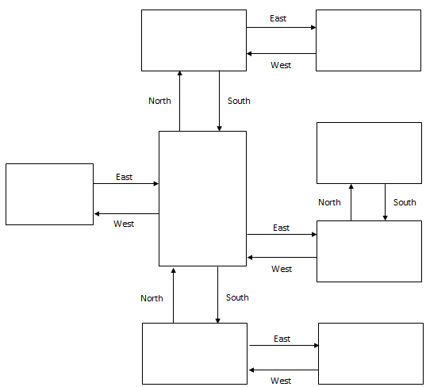

Kitchen  
Item: Candy

Bedroom  
Item: Chocolate

Wine Cellar  
Item: Wine

Basement  
Item: Roses

Cat room  
Item: Cat

Ballroom

(Starting Location)

Library  
Item: Handwritten Card

PC room

(GIRL)

Lavatory  
Item: Hygiene Products

Game room  
Item: Potato Chips

North

West

East

## Pseudocode or Flowchart for Code to “Move Between Rooms”

Start

DECLARE directions a player can MOVE in list= [North, South, East, West]

DECLARE ROOMS in list = [Ballroom : move list[0,1,2,3], Game room : move list [1,2], Lavatory : move list [0], Basement : move list[0,2], Wine cellar : move list[3], Kitchen : move list[0, 3], Bedroom : move list[1], Library : move list[1,2,3], Cat room : move list[3], PC room]

DECLARE room = room[0] (#that is ‘Ballroom’#)

DEFINE a function that takes user input and shows a NEW room.

IF the room == room [0]

IF input == move[0]

Room = room[7]

RETURN room

ELSE IF input == move[1]

Room = room[3]

RETURN room

ELSE IF input == move[2]

Room = room[5]

RETURN room

ELSE IF input == move[3]

Room = room[1]

RETURN room

ELSE

RETURN “Invalid, only type ‘North’, ‘South’, ‘East’, or ‘West’ to move”

ELSE IF the room == room [1]

IF input == move[1]

Room = room[2]

RETURN room

ELSE IF input == move[2]

Room = room[0]

RETURN room

ELSE

RETURN “Invalid, only type ‘South’ or ‘East’ to move”

ELSE IF the room == room [2]

IF input == move[0]

Room = room[1]

RETURN room

ELSE

RETURN “Invalid, only type ‘North’ to move”

ELSE IF the room == room [3]

IF input == move[0]

Room = room[0]

RETURN room

ELSE IF input == move[2]

Room = room[4]

RETURN room

ELSE

RETURN “Invalid, only type ‘North’ or ‘East’ to move”

ELSE IF the room == room [4]

IF input == move[3]

Room = room[3]

RETURN room

ELSE

RETURN “Invalid, only type ‘West’ to move”

ELSE IF the room == room [5]

IF input == move[0]

Room = room[6]

RETURN room

ELSE IF input == move[3]

Room = room[0]

RETURN room

ELSE

RETURN “Invalid, only type ‘North’ or ‘West’ to move”

ELSE IF the room == room [6]

IF input == move[1]

Room = room[5]

RETURN room

ELSE

RETURN “Invalid, only type ‘South’ to move”

ELSE IF the room == room [7]

IF input == move[1]

Room = room[0]

RETURN room

ELSE IF input == move[2]

Room = room[8]

RETURN room

ELSE IF input == move[3]

Room = room[9]

RETURN room

ELSE

RETURN “Invalid, only type ‘South’, ‘East’, or ‘West’ to move”

ELSE IF the room == room [8]

IF input == move[3]

Room = room[7]

RETURN room

ELSE

RETURN “Invalid, only type ‘West’ to move”

WHILE room is NOT room[9]

DISPLAY room

DISPLAY movement options associated with the current room

GET player direction input

CALL the function to move rooms

ELSE

CALL GET ITEM function to check if the items are in the inventory

END move

## Pseudocode or Flowchart for Code to “Get an Item”

Start

DECLARE items with keywords corresponding to rooms = [Game room : Potato Chips, Lavatory : Hygiene Products, Cat room : Cat, Bedroom : Chocolate, Library : Handwritten Card, Basement : Roses, Kitchen : Candy, Wine cellar : Wine]

DECLARE inventory = [](#empty starting out#)

DEFINE a function to pick an item up and APPEND it to the list, INVENTORY

DISPLAY “Would you like to grab ‘ITEM’? Type Y for yes”

GET input

WHILE input is anything BUT Y

DISPLAY “Make sure to grab this item to calm your girl. Please input ‘Y’ to pick it up.” GET input

End WHILE loop

APPEND the item into the INVENTORY

AFTER the player moves a room

DISPLAY ITEM in in the current room according to the keyword corresponding to the room

IF room == room[9] (#PC room#) AND the INVENTORY has 8 items(#7 indexes#)

DISPLAY “Whoo hoo! You get to sleep in bed tonight! Tomorrow’s another story… Good luck.”

END the program

ELSE IF room == room[9] (#PC room#) AND the INVENTORY doesn’t have 8 items(#7 indexes#)

DISPLAY “OH NO! You found your girl before you had all your items and are now in the doghouse. Try again later”

END the program

ELSE IF INVENTORY is full(#Meaning 8 items and 7 indexes#)

DISPLAY “Looks like you have successfully gotten all items needed to calm your girl! Now find her in the PC room far to the North and East of the Ballroom”

ELSE IF room == room[0] (#ballroom#) OR the room item is in the INVENTORY

DISPLAY “Continue on, there are more items you need to calm your girl down.”

ELSE

CALL the function of ITEM APPEND

END get item