Topic: Social Media Sentiment Analysis Title:

Combating Online Negativity: Troll Detection and Sentiment Analysis for Improved Social Media Communication

Novelty and proposed methodology:

Using Random Forest to classify the tweets. The proposed sequence of processes for train phase: topic modelling on offensive tweets and benign tweets to understand what topics are generally coverered in each. Next perform sentiment analysis to get the probability of emotions exhibited by tweets belonging to either class. Next train a random forest classifier that takes the presence of certain topics and probabilities of emotions to classify the tweets.

Team contribution: Single member team- all work has been done by me.

Work done till now:

All work that has been done till now is in this repository. (I have used python for data cleaning and R for tasks topic modelling onwards): <https://github.com/Koeliya-02/EDA_project>

I have taken the dataset from: <https://github.com/NasLabBgu/hate_speech_detection>

I have not used the entire data from here. I have only used one tsv file from here.(

[https://github.com/NasLabBgu/hate_speech_detection/blob/master/data/post_level/combined_pos t_data_2_labels.tsv)](https://github.com/NasLabBgu/hate_speech_detection/blob/master/data/post_level/combined_post_data_2_labels.tsv)

The pipeline and the codes are my own. I have used a 8:2 split for train and test set.

Data distribution of the train set.

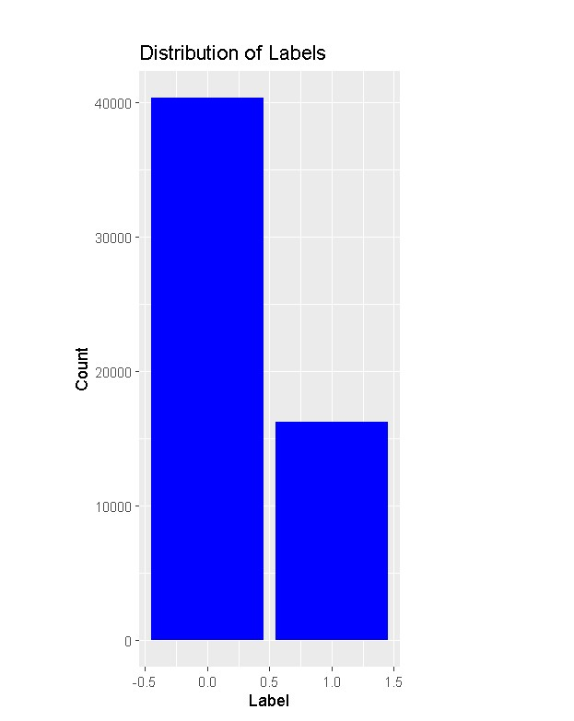

I have cleaned the data and removed twitter handles form the tweets so that the analysis can be done on the text content of the tweet alone. After that I removed the blank rows as those rows previously had tweets containing only a twitter handle.

Then I performed LDA topic modelling on the entire train set.

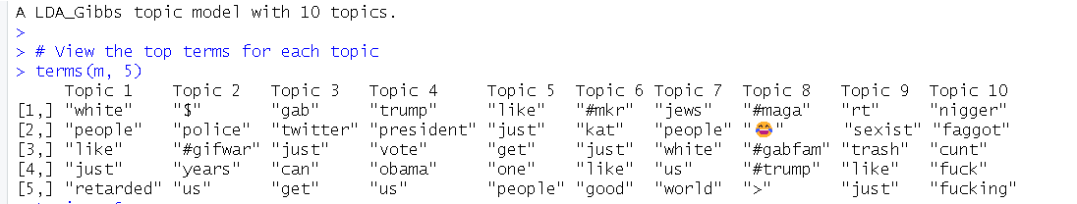

I performed topic modelling on the offensive tweets and benign tweets separately:

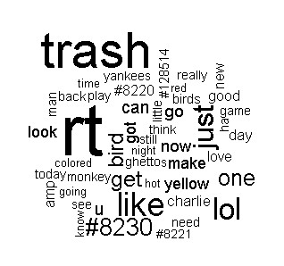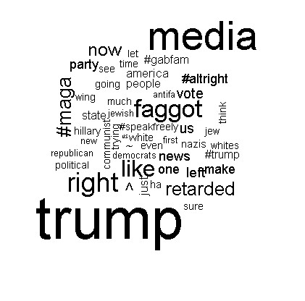

(benign tweets) (offensive tweets)

Next task in queue: Sentiment analysis. I have been facing errors in doing that. But the goal is to get the analysis like this:

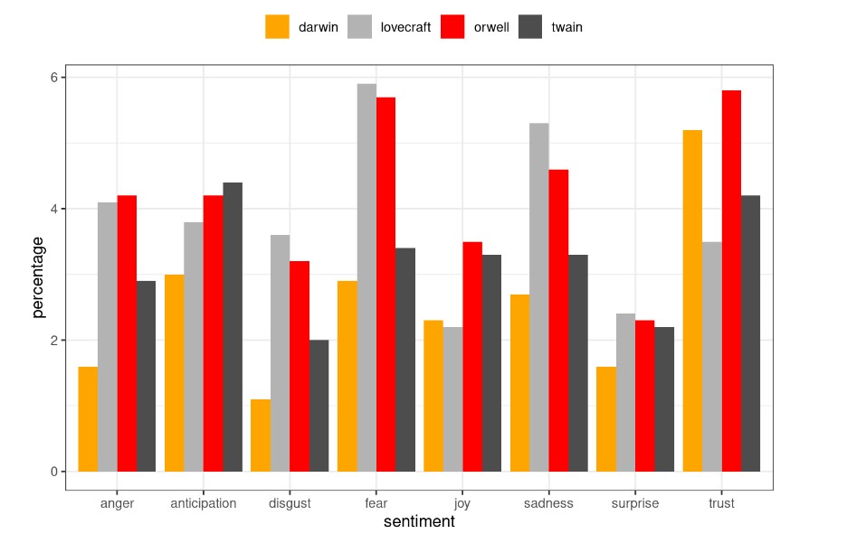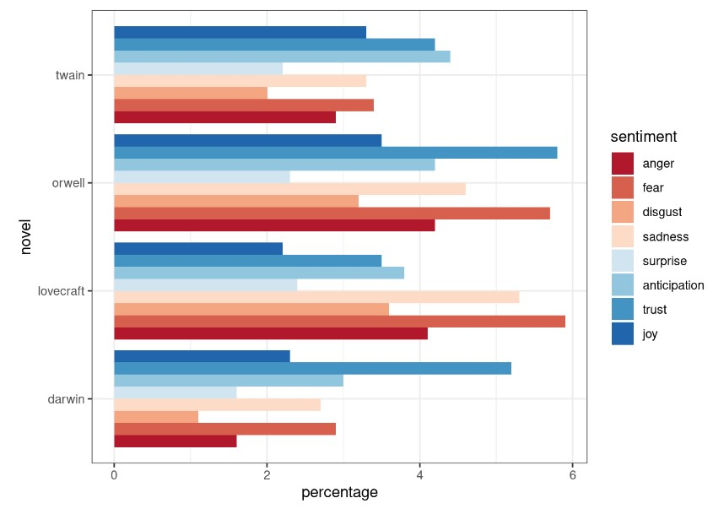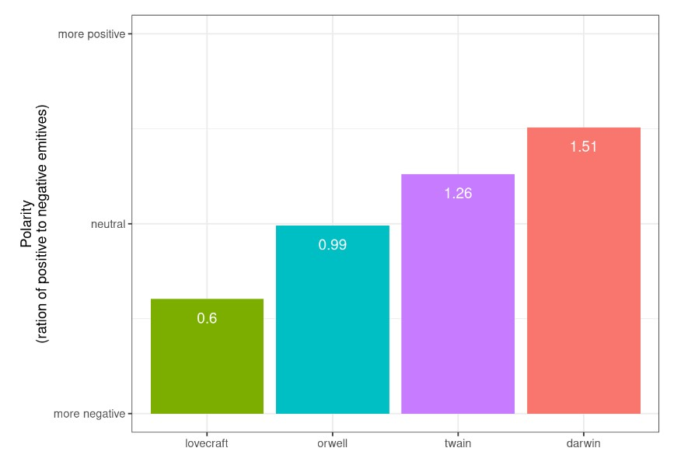

Source: [https://ladal.edu.au/sentiment.html#:~:text=Sentiment%20Analysis%20(SA)%20extracts%20informa tion,that%20assigns%20values%20to%20texts.](https://ladal.edu.au/sentiment.html%23:~:text=Sentiment%20Analysis%20(SA)%20extracts%20information,that%20assigns%20values%20to%20texts.)

I will adapt the code to obtain such statistics for the two classes of tweets as a whole and then get such values(features) for individual tweets to get the input for training the random forest classifier.