Peer-graded Assignment: Statistical Inference Course Project Part I

Investigating and comparing the Central Limit Theorem and the exponential distribution in R

Koen Vermeulen

9-8-2019

## Overview

In this project we will investigate the exponential distribution in R and compare it with the Central Limit Theorem. The exponential distribution is simulated and compared to the theoretic distribution.

## Simulations

Setting the seed, lambda, mean and standard deviation for the exponential distribution:

set.seed(2401)  
lambda <- 0.2  
mean <- 1/lambda  
sd <- 1/lambda  
exp <- 40  
n <- 1000

### Running the simulations

sampleMeans <- NULL  
for (i in 1:n) sampleMeans <- c(sampleMeans, mean(rexp(exp, lambda)))

### Sample Mean versus Theoretical Mean

Calculating the sample mean:

meanS <- mean(sampleMeans)  
meanS

[1] 5.012893

The sample mean is 5.012893, the theoretical mean is 5. There is a small difference of 0.012893.

#### Histogram of the comparison

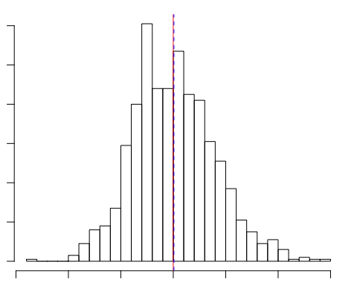

The observed sample mean is plotted as a dashed blue line and the theoretical mean is plotted as a red line.

### Sample Variance versus Theoretical Variance

Calculating the variance from the sample means:

varS <- var(sampleMeans)  
varS

[1] 0.6073928

varT <- (lambda * sqrt(exp))^-2

The variance of the sample means is 0.6073928, the theoretical mean of an exponential distribution is (lambda * sqrt(n))^-2. In this case this is 0.625. Again, the difference is only small of -0.0176072.

### Distribution

#### Histogram of means

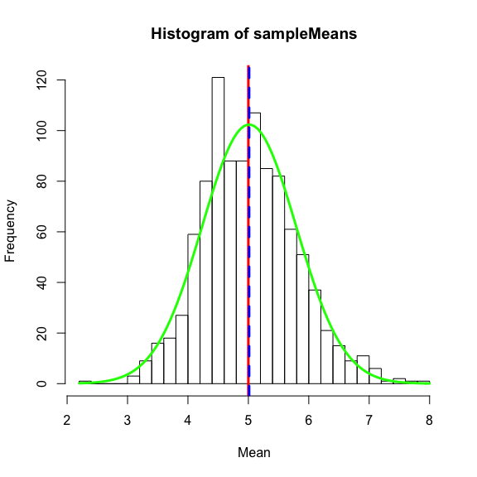

The histogram above is the same as the earlier one, expanded with the theoretical distribution. In the graph it is shown as the green line. As can be seen the distribution of the sample means is approximately normally distributed.