
Software Engineering Department
Final Project – Phase A (61998)
ORCA GCN Citation Trust
26-2-R-10
Almog Raz
Yuval Kogan

Advisors:
Dr. Renata Avros
Prof. Zeev Volkovich

Link to GitHub:
https://github.com/almograz1/ORCA-GCN-Citation-Trust

Table of Contents
1 Abstract 2
2 Introduction 2
2.1 Problem Definition 2
2.1.1 Vulnerability to Structural Manipulation 2
2.1.2 Semantic Incongruity and Latent Contextual Drift 3
2.1.3 Temporal and Dynamic Anomalies 3
2.1.4 The "Flat Graph" Fallacy 3
2.2 Related Works 3
2.3 Mathematical Background 5
2.3.1 Graph Representation 5
2.3.2 Ollivier-Ricci Curvature $(κ)$ 5
2.3.3 Multi-Modal Embedding Fusion 6
2.3.4 Metric Calculation and Statistical Validation 6
2.4 Terms & Abbreviations 7
3 Model/Approach 8
3.1 Architecture 9
3.2 Flow Chart 10
3.3 Sequence Diagram 11
3.4 System Pipeline & Functional Phases: 12
3.4.1 PHASE 1 – Data Acquisition & Pre-processing 12
3.4.2 PHASE 2 – Multi-Modal Feature Extraction 13
3.4.3 PHASE 3 – Auditing Mechanism 14
3.4.4 PHASE 4 – Final Impact Calculation & Validation 15
4 Testing Plan 17
5 Conclusion 18
6 Bibliography 19

Abstract
The traditional Impact Factor $(IF)$ remains the dominant metric for academic evaluation despite significant vulnerabilities to manipulation, including citation cartels, self-citation loops, and irrelevant "filler" citations ‎[7], ‎[10]. These flaws stem from a fundamental limitation: traditional metrics treat the citation network as a flat, unweighted count rather than a complex, multi-dimensional graph of scientific trust ‎[1].
This project presents the Curvature-Aware Impact Factor (CAIF), a novel architecture that utilizes Geometric Deep Learning to verify citation integrity. By modeling the academic landscape as a Heterogeneous Citation Graph ‎[6], the system extracts four distinct signals to audit the quality of every reference. These signals include structural robustness measured via Ollivier-Ricci Curvature $(κ)$ ‎[5], ‎[8], neighborhood influence through an ORCA-style Graph Convolutional Network (GCN)‎ [3]‎, [11], semantic relevance via Natural Language Processing (NLP) embeddings ‎[2], and Temporal Dynamics to identify anomalous citation bursts ‎[9].
These features are fused into a Multi-Modal Feature Vector ${(Z}_{e})$ and processed by a neural Citation Trust Head, which assigns a soft-weighted trust score $(w_{e}∈(0, 1))$ to each edge. The resulting Normalized CAIF (NCAIF) metric is validated against a Null Model baseline using Z-score analysis to ensure statistical significance. The architectural design of CAIF provides a theoretical framework engineered to effectively de-emphasize manipulative citation patterns, offering a more resilient, field-normalized reflection of a journal's true scientific contribution.

Introduction

Problem Definition
The evaluation of academic excellence is currently dependent on bibliometric indices, most notably the traditional Impact Factor $(IF)$. While the $IF$ is widely accepted as a proxy for journal prestige, its mathematical foundation, a simple arithmetic mean of citations calculated over a rigid two-year period, presents a significant technical oversight. It treats the global citation network as a flat, unweighted set of transactions. This topological blindness creates three critical vulnerabilities that compromise the integrity of scientific rankings:

Vulnerability to Structural Manipulation
Because the traditional $IF$ follows a frequentist approach where every incoming citation increment is weighted by exactly one, the metric is inherently susceptible to success-breeds-success biases. Under this paradigm, citation counts scale exponentially based on a journal's established historical reputation rather than the intrinsic scientific quality of individual contemporary articles. This foundational limitation underscores the necessity of transitioning from raw transactional counts to a reputation-screened evaluation metric ‎[7].

Furthermore, malicious actors and organized networks systematically exploit this lack of topological oversight. Coordinated citation cartels, defined as groups of academic journals that disproportionately and artificially cite each other in closed loops, alongside coercive editor-mandated self-citations, effectively compromise the validity of the metric [10]. Traditional evaluation frameworks lack the graph-theoretic awareness required to distinguish between an organic deep citation, which is an authentic reference that bridges two disparate fields of study, and a highly localized surface citation, which exists solely within a self-serving, manipulative structure ‎[7].

Semantic Incongruity and Latent Contextual Drift
The current paradigm lacks a verification layer to ensure that a citation is semantically justified. Citations are currently treated as atomic, binary units, regardless of the latent semantic distance between the citing and cited works. This oversight allows for "filler" citations, references used to satisfy word counts or artificially boost metrics, to carry the same weight as foundational research. Without the integration of contextual embeddings and NLP-driven similarity analysis, the metric cannot detect "Semantic Drift," where a citation occurs between nodes that share no meaningful intersection in the high-dimensional vector space of scientific discourse. Consequently, the system fails to distinguish between a citation that represents a genuine intellectual link and one that is structurally or contextually irrelevant ‎[2].

Temporal and Dynamic Anomalies
The IF operates on a fixed time window, failing to account for the velocity of information. It cannot distinguish between a "Sleeping Beauty" (a revolutionary paper that takes years to be recognized) and a "Citation Burst" (a sudden spike in citations often associated with predatory publishing tactics ‎[9]). By ignoring the temporal decay of information, the metric provides a skewed view of a journal's sustained impact.

The "Flat Graph" Fallacy
From a graph theory perspective, the academic landscape is a heterogeneous graph containing rich metadata regarding authors, affiliations, and historical trends. By reducing this high-dimensional topology to a zero-dimensional scalar value, we lose the geometric integrity of the network. There is currently no widely adopted metric that utilizes the curvature or "neighborhood health" of the graph to weigh the value of a citation, despite the proven failure of "geometric blindness" in standard network metrics ‎[11].

Related Works
In this section, we categorize previous attempts to resolve the structural vulnerabilities of the traditional $IF$ and explain their specific technical limitations. The structural flaws of the traditional $IF$ have catalyzed the development of alternative bibliometric indices, which can broadly be categorized into network-centrality measures, author-centric metrics, and emerging machine learning frameworks.

- Centrality-Based Metrics
Early improvements shifted the bibliometric paradigm away from raw transactional counts toward eigenvector centrality. Frameworks such as the Eigenfactor Score and the SCImago Journal Rank (SJR) apply PageRank-like recursive algorithms to the citation graph. However, while these methods attempt to normalize impact based on the prestige of the citing source ‎[1], they possess a critical algorithmic flaw: they operate predominantly on homogeneous graph projections and remain blind to local neighborhood geometry. Consequently, these metrics remain highly vulnerable to sophisticated, high-centrality citation cartels.
- Author-Level and Productivity Indices
Concurrently, micro-level bibliometrics emerged to evaluate individual academic output, most notably the h-index and its subsequent variants (e.g., g-index and i10-index). These metrics attempt to simultaneously quantify an individual researcher's productivity and citation impact.

While useful for localized administrative or personal assessments, these indices are easily inflated through opportunistic publishing strategies, such as “salami slicing”, which is the practice of fragmenting a single cohesive study into multiple thin papers to maximize publication counts. More fundamentally, author-centric metrics operate completely independently of macro-level graph structures, failing to provide any mechanism for evaluating the systemic integrity of a journal or the structural validity of the underlying citation network as a whole.

- Computational and Deep Learning Frameworks
Recent developments have introduced deep learning to academic graph processing, though current approaches suffer from a bifurcation between structural and semantic methods. Graph convolutional networks (GCNs) are widely deployed for node classification, yet they typically operate under a flawed assumption of absolute edge trust. Furthermore, standard GCN architectures are prone to "over-smoothing" and "over-squashing" phenomena when aggregating features across deep graph topologies ‎[4]. While recent Curvature-Aware Graph Neural Networks (e.g., CurvGNN) represent a significant stride in addressing these geometric issues ‎[3], they often focus on link prediction rather than systemic trust auditing.
In parallel, advanced language models like SciBERT and SPECTER are utilized for semantic paper similarity. While highly effective at identifying semantic drift, these models analyze textual embeddings in total isolation from the graph landscape. They lack the structural awareness necessary to detect coordinated topological manipulation, such as cross-journal syndicates or self-citation loops.

- The Gap in Current Literature
The current body of literature lacks a unified, multi-modal framework capable of simultaneously evaluating structural network geometry, semantic contextual relevance, and time-evolving temporal dynamics. Specifically, while discrete Ricci curvature has been proven effective at identifying structural bottlenecks in financial and biological networks ‎[5],‎ [8], its application remains an entirely unexplored frontier within bibliometric engineering. Current metrics suffer from "geometric blindness" ‎[11], failing to utilize the neighborhood health of the graph to weigh the value of a citation.
The Curvature-Aware Impact Factor (CAIF) directly bridges this conceptual gap. By fusing discrete geometry, topological convolution, textual semantics, and temporal analysis-as modeled in recent temporal graph network architectures ‎[9] CAIF provides a singular edge-auditing architecture that moves beyond the binary "count/no-count" limitation of traditional indices.

Mathematical Background

Graph Representation
We define the academic landscape as a heterogeneous directed graph
$G = (V, E)$, where $V$ represents nodes (Journals, Papers, Authors) and $E$ represents directed citation edges. Unlike standard citation counts, each edge $e∈E$ is treated as a high-dimensional feature carrier.

Ollivier-Ricci Curvature $(κ)$
The core structural signal in CAIF is based on the discretization of Ricci curvature onto graphs. For any two nodes $x, y∈V$, the Ollivier-Ricci curvature is defined by the Wasserstein distance $(W_{1})$ between two probability distributions $m_{x}$and $m_{y}$, which represent the local neighborhood distributions of the nodes ‎[5], ‎[8]:
$$κ\left(x,y\right)= 1 -\frac{W_{1}\left(m_{x}, m_{y}\right)}{d(x, y)}$$
- Positive Curvature $(κ> 0):$ Indicates a highly clustered, robust neighborhood.
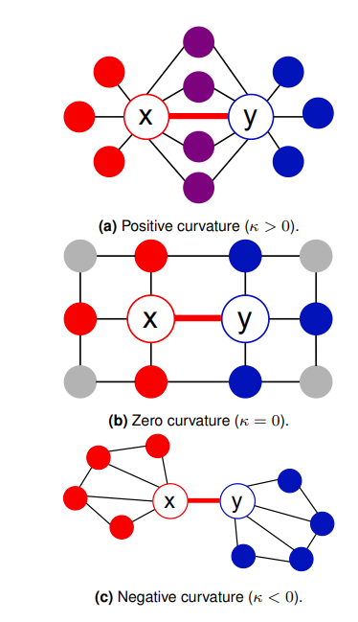
Negative Curvature $(κ < 0)$: Indicates a "bridge" or a bottleneck, often identifying disparate fields of study or anomalous links.
Fig. 1: Geometric interpretation of Ollivier-Ricci curvature $(κ)$ on graph edges. (a) Positive curvature: characterizes dense clusters; (b) Zero curvature: characterizes grid-like structures; (c) Negative curvature: identifies bridge edges between communities. Source: ‎[11].

Multi-Modal Embedding Fusion
To determine the final trust weight $w_{e}$ for a citation, the architecture utilizes a multi-modal fusion layer that integrates structural, neural, temporal, and semantic signals. The feature vector for an edge $e$, denoted as $Z_{e}$, is defined by the concatenation of these signals:
$$Z_{e}=[κ_{e}⊕γ_{gcn}⊕δ_{temp}⊕θ_{sem}]$$

The components are defined as follows:
- $κ_{e}$(Ollivier-Ricci Curvature): The core structural signal measuring local neighborhood cohesiveness.
- (GCN Embedding): The representation learning signal from the ORCA-style GCN, which reweighs messages based on curvature to mitigate over smoothing.
- (Temporal Dynamics): A score assessing the "temporal plausibility" of the citation relative to field-specific aging patterns.
- (Semantic NLP): A consistency score derived from NLP analysis of the citation context to ensure conceptual relevance.

This fused feature vector is processed by a neural Citation Trust Head. We utilize a learnable linear transformation followed by a sigmoid activation function $(σ$) to squash the result between 0 and 1, yielding the final trust weight $w(e)$:
$$w_{e} =σ(W^{T}Z_{e}+b)$$

Where $W^{T}$ is the transpose of the learnable weight vector and $b$ is the learnable bias scalar.

Metric Calculation and Statistical Validation
Once the Trust Head assigns a continuous weight $w_{e}$ to each citation, the system computes the raw Curvature-Aware Impact Factor (CAIF) for a given journal $J$ over time window $T$. This replaces the traditional binary citation count with a trust-weighted summation:
$$CAIF_{J,T}=\frac{Σ_{p∈P_{J,T}}Σ_{e∈C\left(p\right)}w_{e}}{|P_{J,T}|}$$
Where $P_{J,T}$ is the set of papers published by the journal, $C(p)$ is the set of incoming citations for paper $p$, and $w_{e}$ is the computed trust weight of edge $e$.

To ensure fairness across disciplines with different publication velocities, this raw score undergoes Field Normalization to produce the NCAIF:
$$NCAIF=\frac{CAIF_{J,T}}{μ_{field}}$$
Finally, the metric's integrity is validated against a Null Model baseline. By generating randomized, degree-preserving graph permutations, the system computes a baseline distribution of NCAIF scores $(μ_{null},σ_{null})$. The statistical significance of the journal's score is evaluated via a standard Z-score:
$$Z_{J} =\frac{NCAIF_{obs}-μ_{null}}{σ_{null}}$$
Journals failing to achieve a statistically significant Z-score boundary are flagged for potential structural manipulation.

Terms & Abbreviations
- CAIF (Curvature-Aware Impact Factor): The primary metric generated by this system. It replaces the traditional binary citation count with a trust-weighted summation of citations to evaluate a journal's authentic scientific impact.
- Citation Trust Head: The custom neural network layer in the CAIF architecture that processes the Multi-Modal Feature Vector to output a final probabilistic trust weight for a citation edge.
- Graph Convolutional Network (GCN): A neural architecture that performs "Message Passing," where each node updates its feature vector by aggregating information from its immediate neighbors. CAIF uses an "ORCA-style" GCN that adaptively weights these messages based on the edge's curvature.
- Heterogeneous Graph: A network containing different types of nodes (e.g., Authors, Journals) and edges (e.g., Cites, Affiliated-with).
- Multi-Modal Feature Vector $(Z_{e})$: The concatenated representation of an edge, combining structural $(κ)$, neural $(γ)$, temporal $(δ)$, and semantic $(θ)$ signals into a single high-dimensional tensor for classification.
- NCAIF (Normalized CAIF): The field-normalized version of the CAIF score, adjusted by the global citation average of a specific scientific discipline to allow for fair, cross-field comparisons.
- Null Model: A randomized baseline version of the citation graph that preserves the degree distribution of nodes but removes strategic patterns (like cartels). It is used to calculate the Z-score and verify that observed curvature anomalies are not due to random chance.
- Ollivier-Ricci Curvature $(κ)$: A geometric measure of whether a graph edge belongs to a dense cluster $(κ > 0)$ or acts as a bridge between communities $(κ < 0)$.
- Probability Measure $(m_{i})$: A distribution defined over the neighbors of a node $i$, typically assigned as $\frac{1}{d(i)}$for each neighbor, where $d(i)$ is the degree. This distribution is the input for calculating the Ricci curvature of an edge.
- Semantic Drift: The divergence in the latent vector space between a citing work and its reference
- Trust Score $(w_{e})$: A continuous probability value $w_{e}∈(0, 1)$ assigned to every citation edge by the neural auditor, where values closer to $0$ indicate a high probability of structural or semantic manipulation.
- Wasserstein Distance ($W_{1}$): Also known as the Earth Mover's Distance, it is a metric used to calculate the optimal transport cost required to transform one probability distribution into another. In the context of CAIF, it measures the "structural effort" to move the information density of node $x$'s neighborhood to node $y$.

Model/Approach
The Curvature-Aware Impact Factor (CAIF) framework is architected as an end-to-end processing pipeline divided into four distinct operational phases. The high-level engineering blueprint and structural relationships between modules are established in the Architecture Model (Fig. 2). The dynamic data routing through these modules is illustrated in the System Flowchart (Fig. 3), while the precise chronological interactions and execution lifelines are mapped in the Sequence Diagram (Fig. 4).
To maintain document clarity and eliminate informational redundancy, this section serves as the comprehensive functional source of truth for all three system representations. Each subsequent sub-block details the core input parameters, structural outputs, high-level functional purpose, and granular algorithmic implementation mechanics for that respective stage of the pipeline.
The system architecture progresses linearly through the following foundational phases:
- Phase 1: Data Acquisition & Pre-processing: Fetches raw publication metadata from external APIs, constructs a typed heterogeneous citation graph, and broadcasts parallel feature streams.
- Phase 2: Multi-Modal Feature Extraction: Evaluates citation edges concurrently across independent geometric, representation learning, temporal, and semantic text-embedding modules to generate a combined multi-modal tensor.
- Phase 3: Auditing Mechanism: Processes the multi-modal vectors through a trained neural Citation Trust Head to compute continuous, probabilistic edge trust weights
- Phase 4: Final Impact Calculation & Validation: Aggregates the trust weights into a raw impact score, normalizes it across scientific fields, and runs a randomized null model Z-score check to statistically validate journal integrity.

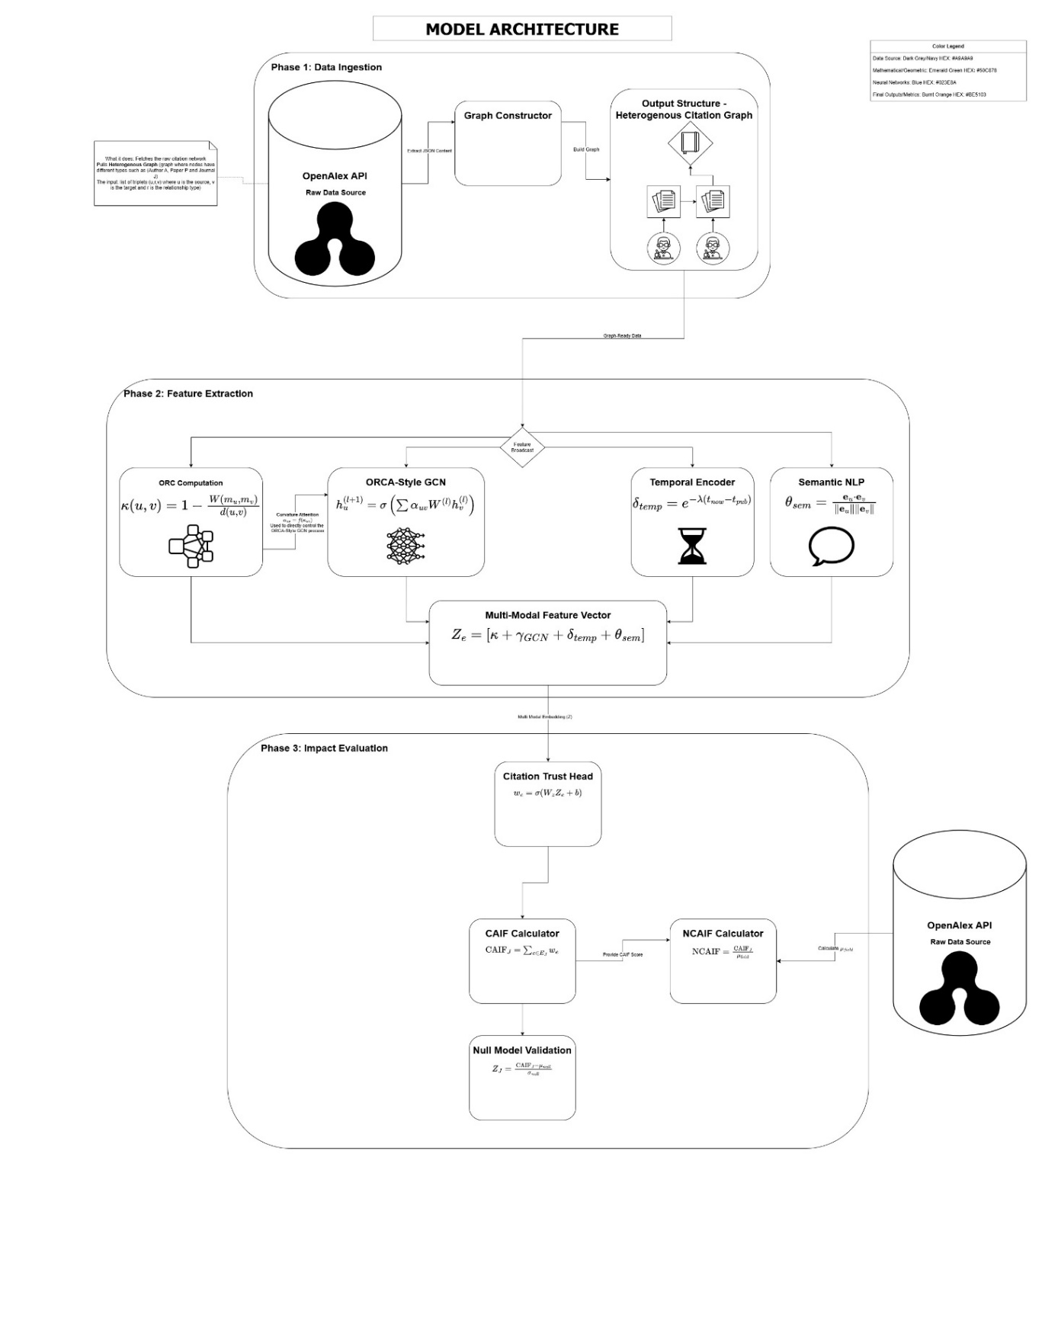
Architecture
Fig. 2: Model Architecture A three-phase layered overview of the CAIF system: data ingestion via the OpenAlex API and Graph Constructor, parallel multi-modal feature extraction (ORC, GCN, Temporal, Semantic NLP) fused into a single feature vector $Z_{e}$, and final impact evaluation through the Citation Trust Head, NCAIF Calculator, and Null Model Validation.

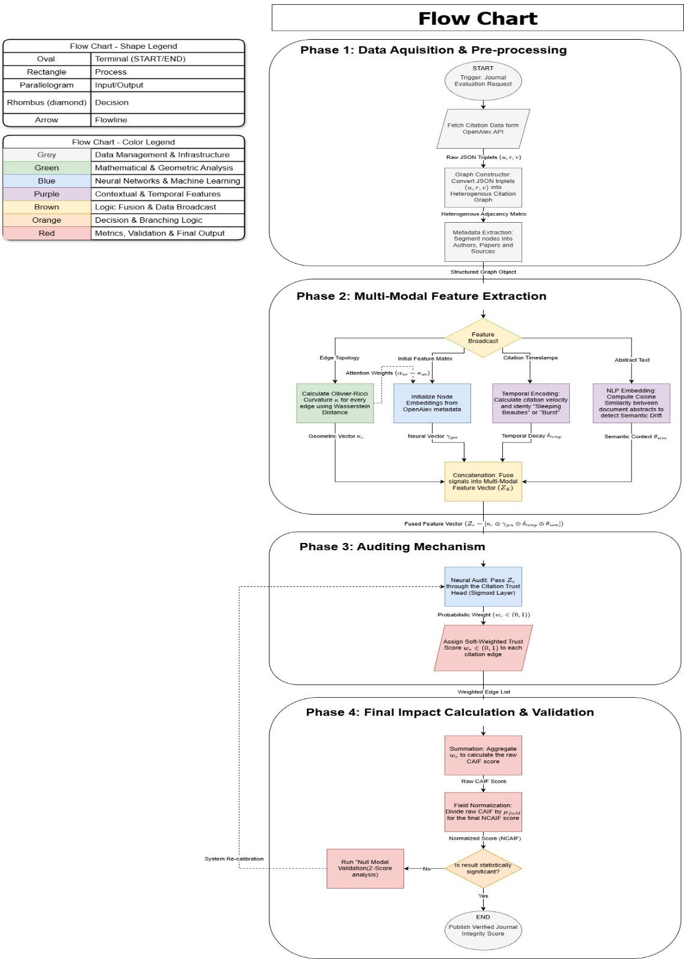
Flow Chart

Fig. 3: System Flow Chart A full end-to-end execution trace of the CAIF pipeline across four phases, highlighting the parallel fan-out of four feature streams in Phase 2 and the terminal decision gate in Phase 4, where a statistically significant Z-score publishes the verified journal integrity score and a failing score routes back to system re-calibration.

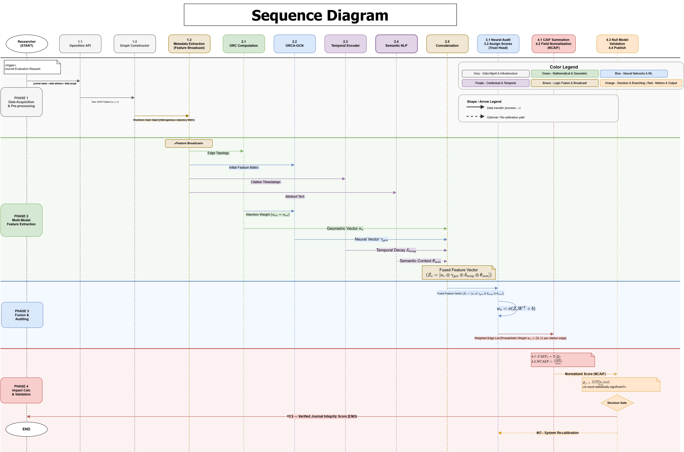
Sequence Diagram
Fig. 4: Sequence Diagram A chronological message-passing view across all eleven system actors, annotating the exact data payloads exchanged at each step, from raw JSON triplets through curvature-weighted attention, feature vector fusion, and trust score assignment, up to the final NCAIF and Z-score output.

System Pipeline & Functional Phases:

PHASE 1 – Data Acquisition & Pre-processing
Trigger: Journal Evaluation Request (START)

OpenAlex API - Raw Data Source
Input: Journal name + citation window (e.g. 2022–2023) + field scope.
Output: Raw JSON objects containing paper IDs, author lists, journal IDs, abstract text, publication dates, and citation links.
What it does: Fetches the raw citation network from OpenAlex - papers, authors, journals, and all their citation relationships with timestamps.
How it does it: Sends a sequence of HTTP GET requests to the OpenAlex REST API. First queries the endpoint filtered by journal ID and publication year to retrieve all papers published in the target journal within the citation window. Then, for each paper, queries the cited-by endpoint to pull all works that cite it. Finally resolves authors and sources endpoints to attach author and journal metadata to each heterogeneous node. Returns JSON responses that are parsed into structured records.

Graph Constructor
Input: Raw JSON responses from the OpenAlex API.
Output: Heterogeneous Adjacency Matrix and Structured Graph Object with three node classes and three edge classes.
What it does: Converts the raw JSON API responses into a structured Heterogeneous Citation Graph where nodes have distinct types - Paper $(W)$, Author $(A)$, Journal $(S)$ - and edges have distinct relationship types.
How it does it: Parses every JSON record into typed triplets $(u, r, v)$ where $u$ is the source node ID, $r$ is the relationship type (cites / authored by /published in), and $v$ is the target node ID. Builds a heterogeneous adjacency matrix by instantiating each triplet as a directed typed edge. Deduplicates nodes and indexes them by type into three separate node registries.

Metadata Extraction
Input: Structured Graph Object from the Graph Constructor.
Output: Four typed parallel data streams - Citation Timestamps, Edge Topology, Initial Feature Matrix, Abstract Text.
What it does: Segments the graph nodes by type and attaches all available metadata fields to each node, producing four typed data streams that the Phase 2 extractors will operate independently.
How it does it: Iterates through the node registry and partitions nodes into Author, Paper, and Journal buckets. For each Paper node, extracts and attaches the following: publication year and cited by timestamps (Citation Timestamps stream), adjacency list (Edge Topology stream), OpenAlex concept embeddings and author IDs (Initial Feature Matrix stream), and the abstract inverted index field decoded back to plain text (Abstract Text stream). These four streams are then broadcast in parallel to Phase 2.

Phase 1 Summary
Input: Journal evaluation request - name, citation window, field scope.
Output: Typed heterogeneous citation graph broadcast as four parallel feature streams.
Next: All four streams feed simultaneously into the four parallel extractors in Phase 2.

PHASE 2 – Multi-Modal Feature Extraction
Four extractors run in parallel on the graph from Phase 1.

ORC Computation (Geometric)
Input: Edge Topology stream from Phase 1.
Output: Geometric Vector $κ_{e}$ per edge, and Attention Weights $α_{uv}$ (A parameter that is used when updating a paper representation - that tells how much attention the neighbor in this edge should get) fed directly to the GCN.
What it does: Measures the shape of the neighborhood around each citation. If two papers share many common neighbors, the citation sits inside a tight cluster - a good sign. If they share almost none, the citation is a loose bridge between unrelated parts of the network - a warning sign.
How it does it: For each citation edge, look at the neighbors of both the citing and cited paper and measures how different those two neighborhoods are using a distance formula called Wasserstein distance. Plug the result into $κ = 1 -\frac{W}{d}$. A positive or near-zero score means a tight, coherent neighborhood. A strongly negative score flags a suspicious or isolated link. These scores are also passed straight to the GCN to control how it weighs each connection.

ORCA-Style GCN (Neural Network)
Input: Initial Feature Matrix from Phase 1 and Attention Weights $α_{uv}$ from ORC Computation.
Output: Neural Vector $γ_{gcn}$ per edge.
What it does: Runs curvature-weighted graph convolution to learn a vector representation for each paper that reflects both its content and its structural position in the citation graph, then produces an embedding consistency score per citation edge.
How it does it: Starts with each paper's topic tags from OpenAlex as its initial position. Runs several rounds of message passing where each paper updates its position by averaging the positions of its neighbors - but uses the curvature scores from 2.1 to give more weight to well-connected neighbors and less to bridge-like ones. After all rounds are done, computes the similarity between the two paper positions for each citation edge.

Temporal Encoder (Contextual)
Input: Publication dates and citation dates for every paper (Citation Timestamps stream).
Output: A timing score $δ_{temp}$ for every citation edge.
What it does: Checks whether the timing of each citation makes sense and flags any unusual patterns like citations appearing suspiciously fast or suspiciously late.
How it does it: Uses a decay formula - the further apart the publication dates, the lower the score, at a rate tuned per research field. Also, hard-blocks any citation where the citing paper is older than the cited paper, which is impossible. The document proposes implementing this through yearly citation snapshots or a temporal GNN memory update that processes citation events as they arrive.

Semantic NLP (Contextual)
Input: The abstract text of every paper.
Output: A topic similarity score $θ_{sem}$ for every citation edge.
What it does: Checks whether the two papers on either end of a citation are actually about related topics. A citation between two unrelated fields is a red flag.
How it does it: Converts each abstract into a dense numerical vector using a language model. Then for each citation, measures the cosine similarity between the two vectors. A score near 1.0 means the papers are about very similar topics. A score near 0 means they are about completely different things, which is the clearest signal of cross-field citation manipulation.

Concatenation - Multi-Modal Feature Vector
Input: The four scores $κ$, $γ_{gcn}$, $δ_{temp}$, $θ_{sem}$ - one set per citation edge.
Output: A single combined feature vector $Z_{e}$ per citation edge.
What it does: Merges the four separate scores into one vector so the next phase can work with everything at once.
How it does it: Simply joins the four values end-to-end into one list: $Z_{e} = [κ, γ_{gcn}, δ_{temp}, θ_{sem}]$.

Phase 2 Summary
Input: Four data streams from Phase 1 - connections, timestamps, topic features, abstract text.
Output: One combined feature vector $Z_{e}$ per citation edge covering geometry, learned embeddings, timing, and topic similarity.
Next: Each $Z_{e}$ goes into the Citation Trust Head in Phase 3 to get a final trust score.

PHASE 3 – Auditing Mechanism
Neural Audit - Citation Trust Head
Input: The combined feature vector $Z_{e}$ for each citation edge.
Output: A trust weight $w_{e}∈(0, 1)$.
What it does: Takes all four signals together and produces one final number per citation - how much we trust it. This is the core output of the whole model.
How it does it: Runs $Z_{e}$ through a learned formula combining all four signals with learned coefficients:
$$w_{e} =σ(W^{T}Z_{e}+b)$$
The sigmoid squashes the result to between 0 and 1. After training, the learned weight coefficients in W reveal which signal the model found most diagnostic of citation quality.
Assign Trust Scores
Input: The trust weights $w_{e}$ and the original graph.
Output: The full citation graph with a trust score attached to every edge.
What it does: Writes the trust score onto every citation edge in the graph so that the aggregation step in Phase 4 can use them.
How it does it: Attaches $w_{e}$ as a property of each edge. Clean, well-integrated citations end up close to 1.0. Suspicious citations end up close to 0.0. Everything in between is partial trust. The weighted graph then moves to Phase 4.

Phase 3 Summary
Input: Combined feature vector $Z_{e}$ per citation edge.
Output: A trust score $w_{e}∈(0, 1)$ on every citation edge in the graph.
Next: Add up all the trust scores per journal to build the impact score in Phase 4.

PHASE 4 – Final Impact Calculation & Validation
CAIF Calculator - Summation
Input: The trust-weighted citation graph - all $w_{e}$ values for citations pointing at journal $J$'s papers.
Output: A raw CAIF score per journal.
What it does: Adds up all the trust weights for citations received by a journal's papers to get a quality-adjusted impact score - replacing the traditional approach of just counting citations.
How it does it: For each journal, finds all incoming citations within the date window and adds up their $w_{e}$ values divided by the number of papers the journal published. A citation scoring 0.94 counts almost fully. One scoring 0.22 barely counts. The denominator stays the same as in traditional JIF - only the way citations are counted changes.

Field Normalization - NCAIF Calculator
Input: The raw CAIF score and citation data from across the field.
Output: A normalized score NCAIF - comparable across fields.
What it does: Adjusts the raw score so it can be fairly compared across different research fields, which naturally have very different citation rates.
How it does it: Divides the raw CAIF score for journal J by the mean CAIF score across all journals in the same scientific field, obtained from OpenAlex field metadata:
$$NCAIF_{J}=\frac{CAIF_{J}}{μ_{field}}$$
A journal whose trust-weighted citation sum equals the field average receives an NCAIF of 1.0; journals above or below that baseline score proportionally higher or lower, making cross-field comparisons directly interpretable.

Null Model Validation - Decision Gate
Input: The NCAIF score and a distribution of scores from randomly rewired versions of the graph.
Output: A Z-score and a yes/no decision on whether the result is statistically meaningful.
What it does: Checks whether the journal's score is genuinely impressive or just a side effect of its size, field, or age profile. If the score is not clearly better than random, it gets flagged as unreliable.
How it does it: Creates many fake versions of the citation graph where citations are shuffled randomly but everything else - journal sizes, publication dates, field labels, degree sequence, citation age distribution - stays the same. Computes NCAIF on each fake graph to build a baseline distribution. Then checks how many standard deviations the real score sits above that baseline using

$$Z_{J}=\frac{NCAIF_{obs}\left(J\right)-μ_{null}\left(J\right)}{σ_{null}\left(J\right)}$$
If it clears the threshold, the score is published. If not, it is flagged.

Publish Verified Journal Integrity Score
Input: NCAIF confirmed by the Z-score test.
Output: A verified journal integrity score - ready to use in place of the traditional JIF.
What it does: Combines the field-adjusted score and the statistical check into one final metric and publishes it.
How it does it: Reports both NCAIF and the Z-score together. High on both means the journal is genuinely strong. High NCAIF but low Z means the score is probably explained by structural factors, not quality. High NCAIF but negative Z is a warning sign - the journal gets many citations, but they look no better than random, which is what citation manipulation looks like.

Phase 4 Summary
Input: Trust-weighted citation graph and field-wide citation data from OpenAlex.
Output: A verified journal integrity score - NCAIF backed by a statistical significance test.
Next: Publication. One paper on the method, one on the bibliometric case study.

Testing Plan
Test ID | System Phase | Test Name | Description | Expected Outcome
01 | Data Ingestion | API Ingestion & Parsing | Feed the OpenAlex fetcher a mocked JSON response with missing data fields (e.g., missing abstract). | System handles missing fields gracefully without crashing the pipeline.
02 | Data Ingestion | Graph Edge Construction | Verify that the graph constructor correctly builds heterogeneous triplets (Paper -> Cites -> Paper). | Adjacency matrix correctly maps directed edges between valid node IDs.
03 | Data Ingestion | Floating-Point Exception Check | Process citation network metadata that approaches extreme maximum boundary values for publication tracking timestamps. | Calculation pipeline executes without raising underflow, overflow, or NaN (Not a Number) runtime flags.
04 | Feature Extraction | ORC Geometry Logic | Test the Ollivier-Ricci Curvature math on a perfect "clique" (tight cluster) and a "bridge" (single link). | Clique outputs a positive curvature score; Bridge outputs a negative curvature score.
05 | Feature Extraction | Temporal Validity | Input a citation where the citing paper is published before the cited paper (chronologically impossible). | Temporal Encoder assigns a penalty score of exactly 0.
06 | Feature Extraction | Semantic Cosine Range | Input two identical abstracts, and two completely opposite abstracts into the NLP module. | Outputs exactly 1.0 for identical, and near 0.0 for opposite.
07 | Feature Extraction | Zero-Citation Boundary | Input an isolated paper node that contains exactly zero inbound and outbound citations. | System initializes the node cleanly and bypasses division-by-zero calculation traps.
08 | Feature Extraction | Isolated Component Scaling | Pass a completely disconnected graph layout (two separate sub-clusters with zero interconnecting edges). | System computes local structural and embedding vectors for each component without infinite processing loops.
09 | Feature Extraction | ORC-to-GCN Intercept Dependency | Mock the ORC output to pass zeroed attention weights directly into the GCN attention intercept layer. | GCN suppresses message passing along those specific edges while keeping the rest of the network convolution stable.
10 | Feature Extraction | Multi-Modal Dimensional Fusion | Verify the structural array shape immediately following vector concatenation. | The fused array dimension exactly equals the sum of the four separate module lengths.
11 | Auditing | Activation Boundaries | Force extreme vector values (e.g., 9999 or -9999) through the Neural Audit Trust Head. | Sigmoid activation strictly outputs a weight inside the open interval: $w_{e}∈(0, 1)$
12 | Auditing | Neural Audit Convergence | Train/execute the Trust Head using an identical, repeating vector sequence across multiple iterations. | Output trust weights stabilize asymptotically toward a deterministic value without weight divergence.
13 | Impact Calculation | CAIF Summation Math | Pass a test graph of 10 papers with known, hardcoded trust weights to the CAIF Aggregator. | The output matches the manual mathematical sum perfectly.
14 | Impact Calculation | Macro Field Normalization | Apply extreme scaling parameters where the field global citation average is set to extreme baseline constants. | Math correctly executes the normalized fraction while retaining double-precision floating-point resolution.
15 | Validation & Loop | Null Graph Rewiring | Run the graph shuffling algorithm on a test citation network. | Edge connections change, but total degree sequence (journal sizes) remains identical.
16 | Validation & Loop | Degenerate Graph Rewiring | Run the random graph shuffling process on a trivial graph structure (e.g., a simple 3-node triangle). | The shuffling function terminates safely without an infinite loop while preserving exact degree sequences.
17 | Validation & Loop | Z-Score Rejection Gate | Manually set an NCAIF score that falls exactly on the mean of the null distribution. | Decision Gate accurately flags the result as Not Statistically Significant.
18 | Validation & Loop | Adaptive Re-calibration Loopback | Manually force a low-confidence/high-variance output at Phase 4 to trigger the system re-calibration pathway. | Control loop detects the low-significance flag, re-routes back to Phase 3, and executes a second pass.

Conclusion
The traditional Impact Factor, despite its widespread adoption, is a fundamentally flawed metric. Its reliance on flat, binary citation counts renders it structurally blind to manipulation, semantically unaware of contextual relevance, and temporally insensitive to citation dynamics. These are not edge-case limitations; they are foundational design failures that undermine the integrity of academic evaluation at scale.
This project introduces the Curvature-Aware Impact Factor (CAIF) as a principled response to these failures. By representing the academic landscape as a Heterogeneous Citation Graph and extracting four independent, complementary signals (Ollivier-Ricci Curvature, GCN-based neighborhood embeddings, temporal plausibility, and semantic NLP similarity), CAIF elevates the citation from a binary event to a high-dimensional, auditable signal. The neural Citation Trust Head fuses these signals into a continuous trust weight per citation edge, enabling the final NCAIF metric to reflect genuine scientific contribution rather than raw citation volume.
Critically, the framework's statistical validation through Null Model Z-score analysis ensures that the resulting scores are not artifacts of network size, field publication rates, or citation age distributions. This transforms CAIF from a heuristic into a statistically grounded, reproducible metric.
The CAIF architecture represents a convergence of geometric deep learning, graph signal processing, and bibliometric science, applied to a real-world problem with direct implications for how academic institutions, funding bodies, and publishers assess scientific quality.

Bibliography
- Bornmann, L. (2020). How can citation impact in bibliometrics be normalized? A new approach combining citing-side normalization and citation percentiles. Quantitative Science Studies, 1(4), 1553–1569. https://doi.org/10.1162/qss_a_00089
- Donner, P., Stahlschmidt, S., Haunschild, R., & Bornmann, L. (2025). Does citation context information enhance the validity of citation analysis for measuring research quality? An empirical comparison of peer assessments and enriched citations. Quantitative Science Studies, 6, 967–987. https://doi.org/10.1162/qss.a.15
- Li, H., Cao, J., Zhu, J., Liu, Y., Zhu, Q., & Wu, G. (2022). Curvature graph neural network. Information Sciences, 592, 50–66. https://doi.org/10.1016/j.ins.2021.12.077
- Nguyen, K., Hieu, N., Nguyen, V., Ho, N., Osher, S., & Nguyen, T. (2023, July 23–29). Revisiting over-smoothing and over-squashing using Ollivier-Ricci curvature [Poster presentation]. International Conference on Machine Learning (ICML), Honolulu, HI, United States. https://icml.cc/virtual/2023/poster/24144
- Ollivier, Y. (2009). Ricci curvature of Markov chains on metric spaces. Journal of Functional Analysis, 256(3), 810–864. https://doi.org/10.1016/j.jfa.2008.11.001
- Priem, J., Piwowar, H., & Orr, R. (2022). OpenAlex: A fully-open index of scholarly works, authors, venues, institutions, and concepts. arXiv. https://doi.org/10.48550/arXiv.2205.01833
- Safón, V., Docampo, D., & Cram, L. (2025). Screening articles by citation reputation. Quantitative Science Studies, 6, 405–420. https://doi.org/10.1162/qss_a_00355
- Samal, A., Sreejith, R. P., Gu, J., Liu, S., Saucan, E., & Jost, J. (2018). Comparative analysis of two discretizations of Ricci curvature for complex networks. Scientific Reports, 8, Article 8650. https://doi.org/10.1038/s41598-018-27001-3
- Shen, J., Haqqani, M. A. A., Hu, B., Huang, C., Xie, X., Lee, T., & Zhang, J. (2024). Temporal graph neural network-powered paper recommendation on dynamic citation networks. arXiv. https://doi.org/10.48550/arXiv.2408.15371
- Wren, J. D., & Georgescu, C. (2022). Detecting anomalous referencing patterns in PubMed papers suggestive of author-centric reference list manipulation. Scientometrics, 127, 5753–5771. https://doi.org/10.1007/s11192-022-04503-6
- Zhang, D., Wang, X., Wang, Y., & Chen, H. (n.d.). Beyond geometric blindness: Leveraging Ollivier-Ricci curvature for effective knowledge graph completion. Semantic Web Journal. https://www.semantic-web-journal.net/content/beyond-geometric-blindness-leveraging-ollivier-ricci-curvature-effective-knowledge-graph

