מעבדה 3 – מערכות הפעלה

מגישים:
- יובל כוגן - 207840042
- כרמל פרץ – 208635268

תרגיל 1:
קוד:
#include <stdio.h>
#include <stdlib.h>
#include <unistd.h>
#include <fcntl.h>

int main(int argc, char* argv[]){
int firstFile, secondFile, newTextFile, charCounterFirstFile, charCountSecondFile;
int i = 0,j = 0;
char bufferFirstFile[256], bufferSecondFile[256];

if (argc != 3){
printf("The function must get 3 arguments.\n");
exit(1);
}

// Open both of the files.
firstFile = open(argv[1], O_RDONLY, 0);
if (firstFile < 0){
printf("First file has failed to open.\n");
exit(1);
}
secondFile = open(argv[2], O_RDONLY, 0);
if (secondFile < 0){
printf("Second file has failed to open.\n");
exit(1);
}

// Looks for a difference
while ((charCounterFirstFile = read(firstFile, bufferFirstFile, 256)) > 0 && (charCountSecondFile = read(secondFile, bufferSecondFile, 256)) > 0){
while (i < charCounterFirstFile && j < charCountSecondFile){
if (bufferFirstFile[i] != bufferSecondFile[j]){
printf("Different files\n");
newTextFile = open("compare.txt", O_WRONLY | O_CREAT, 0644);
if (newTextFile < 0){
printf("The new Text file has failed to open.\n");
exit(1);
}

// Move the file pointers backwards
lseek(firstFile, 0, SEEK_SET);
lseek(secondFile, 0, SEEK_SET);

// Read each file until the end and write it in the new text file.
while ((charCounterFirstFile = read(firstFile, bufferFirstFile, 256)) > 0){
write(newTextFile, bufferFirstFile, charCounterFirstFile);
}
while ((charCountSecondFile = read(secondFile, bufferSecondFile, 256)) > 0){
write(newTextFile, bufferSecondFile, charCountSecondFile);
}

close(newTextFile);
return 0;
}
i++;
j++;
}
i = 0;
j = 0;
}

// Close all of the file handlers.
close(firstFile);
close(secondFile);
printf("Identical files\n");

return 0;
}

קובץ sh:
cd ~/operatingSystems/lab3/targil1
cc compare.c -o compare
./compare a.txt b.txt
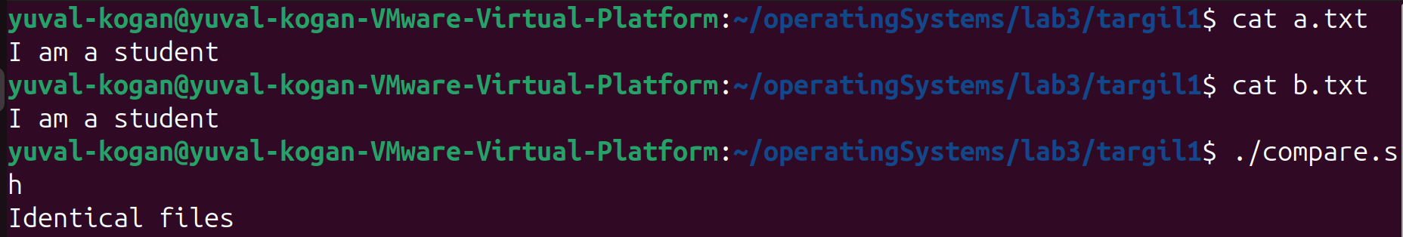
פלט - דומה:

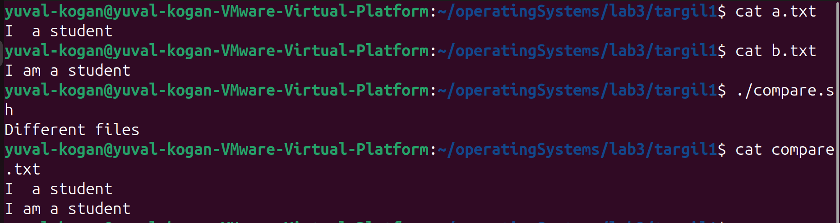
פלט – שונה:
תרגיל 2:
קוד:
#include <stdio.h>
#include <stdlib.h>
#include <string.h>
#include <unistd.h>
#include <fcntl.h>
#include <sys/stat.h>

int main(int argc, char* argv[]){
int mainFile, encryptedFile, bytesRead;
int bufferSize = atoi(argv[2]);
char* buffer[bufferSize];

if (argc != 4){
printf("The function must get 4 arguments.\n");
exit(1);
}

if ((mainFile = open(argv[1], O_RDONLY, 0)) < 0){
printf("Opening the main file for reading has failed.\n");
exit(1);
}

if (mkdir("./encrypted",0700) == -1){
printf("Making the new directory has failed\n");
exit(1);
}

if ((encryptedFile = open("./encrypted/a.txt", O_RDWR | O_CREAT, 0644)) < 0){
printf("Opening the new a.txt file in the directory \"encrypted\" has failed.\n");
exit(1);
}

while ((bytesRead = read(mainFile, buffer, bufferSize)) > 0){
write(encryptedFile, buffer, bytesRead);
if (bytesRead == bufferSize){
write(encryptedFile,argv[3], strlen(argv[3]));
}
}

close(mainFile);
close(encryptedFile);

return 0;
}

קובץ sh:
cd ~/operatingSystems/lab3/targil2
cc createEncryptedCopy.c -o createEncryptedCopy
./createEncryptedCopy a.txt 2 xx

פלט:
