מעבדה 2 – מערכות הפעלה

מגישים:
- יובל כוגן - 207840042
- כרמל פרץ – 208635268

תרגיל 1:
קובץ sh:

echo "START"
mkdir $1
cd ./$1
touch $USER.txt
man wc | head -n 2 >> $USER.txt
man wc | tail -n 2 >> $USER.txt
chmod -w $USER.txt
echo "END"

תרגיל 2:
קוד C:
#include <stdio.h>
#include <stdlib.h>

int main(int argc, char* argv[]) {
// Variable to store the desired result
int result = atoi(argv[1]);

// Variables for loop iteration and storing numbers
int i, j, firstNumber, secondNumber;

// Check if there are at least four arguments
if (argc < 4) {
// Print error message and exit if there are insufficient arguments
printf("2 numbers do not exist.\n");
exit(1);
}

// Nested loops to compare each pair of numbers
for (i = 2; i < argc; i++) {
for (j = i + 1; j < argc; j++) {
// Convert arguments to integers
firstNumber = atoi(argv[i]);
secondNumber = atoi(argv[j]);

// Check if sum of two numbers equals the desired result
if (firstNumber + secondNumber == result) {
// Print the pair of numbers that satisfies the condition
printf("2 numbers exist: %d + %d = %d\n", firstNumber, secondNumber, result);
return 0;
}
}
}

// Print message if no pair of numbers satisfies the condition
printf("2 numbers do not exist.\n");
return 0;
}

קובץ sh:

cd ~/operatingSystems/lab2/targil2
cc chekNum.c -o chekNum
./chekNum 100 5 6 7 50 50
./chekNum 100 1 2 3

טרמינל:
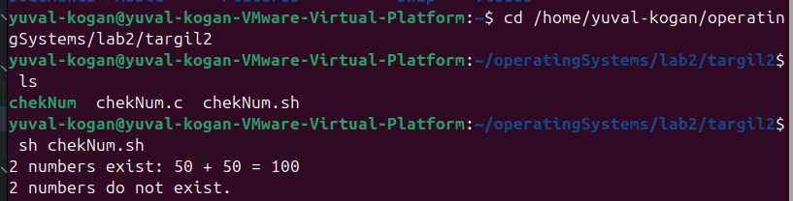

תרגיל 3:

קוד C:
#include <stdio.h>
#include <stdlib.h>
#include <string.h>

int main(int argc, char* argv[]) {
// Declare variables
char* mainString = argv[1]; // Store the input string
char* slicedElement; // Store the elements after splitting
int i; // Loop variable

// Check if there are no arguments (excluding the program name)
if (argc == 1) {
// Print error message and exit if no arguments are provided
printf("The function needs more arguments to start running.");
exit(1);
}

// Convert all lowercase letters to uppercase in the input string
for (i = 0; i < strlen(mainString); i++) {
if (mainString[i] >= 'a' && mainString[i] <= 'z') {
mainString[i] -= 32; // ASCII conversion to uppercase
}
}

// Tokenize the modified string based on underscore delimiter
slicedElement = strtok(mainString, "_");
while (slicedElement != NULL) {
// Print each tokenized element
printf("%s\n", slicedElement);
// Move to the next token
slicedElement = strtok(NULL, "_");
}

return 0;
}

קובץ sh:
cd ~/operatingSystems/lab2/targil3
cc catByAt.c -o catByAt
./catByAt Linux_Is_Amazing

טרמינל:
