Bank Marketing Case Study
Understanding Term Deposit Subscription Behavior
AnalystLab Africa Data Analytics Internship Program
Week 5: Business Analytics Case Study
Dataset: Bank Marketing Dataset (Kaggle)

1. Introduction
Banks regularly run outbound marketing campaigns to encourage customers to subscribe to term deposits a fixed-term savings product that locks funds for a set period in exchange for interest. However, campaign performance varies widely across customer segments, and undirected outreach can be costly and inefficient.
This report analyzes a real-world Bank Marketing dataset of 11,162 customer contacts to understand which customer characteristics and campaign approaches are most strongly associated with subscribing to a term deposit. The goal is to translate exploratory data analysis into concrete, actionable recommendations that can improve the efficiency and effectiveness of future marketing campaigns.

2. Business Problem Statement
Why do some customers subscribe to term deposits while others do not, and which customer groups are more likely to respond positively to marketing campaigns?
Answering this question allows the bank to move from a one-size-fits-all marketing approach to a targeted strategy prioritizing the customers and channels most likely to convert, while reducing wasted effort on low-probability contacts.

3. Dataset Description
The dataset contains 11,162 rows and 17 columns, with one row per customer contacted during a term deposit marketing campaign. Key columns include:
- Demographics: age, job, marital status, education level
- Financial profile: average yearly account balance, existing credit default, housing loan, personal loan
- Campaign details: contact method, day and month of last contact, call duration, number of contacts made
- Previous campaign history: days since last contact (pdays), number of previous contacts, previous campaign outcome
- Target variable: deposit whether the customer subscribed to a term deposit (yes/no)
The target variable is reasonably balanced: 47.4% of customers subscribed ("yes") and 52.6% did not ("no"), meaning no single class dominates the dataset.

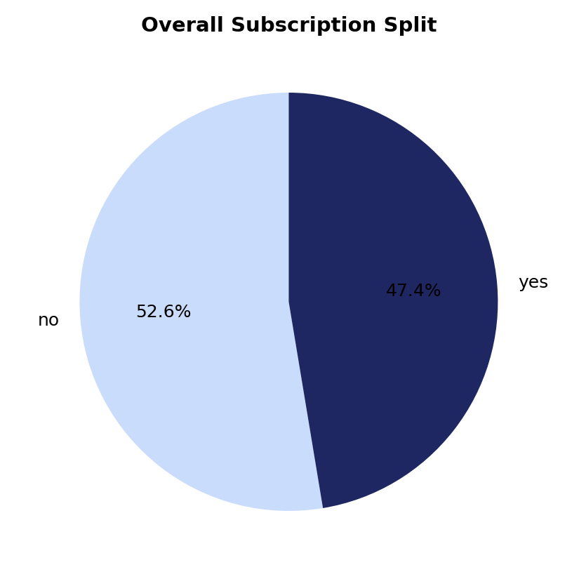
Figure 1: Overall term deposit subscription split

4. Data Analysis Process

4.1 Data Cleaning
The dataset contained no missing (NaN) values and no duplicate rows. However, two data quality issues required attention:
- Several categorical columns (job, education, contact, poutcome) use the placeholder value "unknown" rather than a true missing value. Since dropping these rows would have discarded up to 74.6% of the data in the case of poutcome, "unknown" was retained as its own valid category throughout the analysis rather than removed.
- The pdays column uses -1 to indicate a customer was never previously contacted, which is not a genuine numeric value. A new boolean column, was_previously_contacted, was created from this field to avoid distorting numeric summaries and comparisons.
The cleaned dataset was exported as bank_cleaned.csv for reproducibility and inclusion in the project repository.

4.2 Distributions of Key Variables
Customer age is right-skewed, concentrated between 30-40 years old, with fewer older customers represented in the dataset.
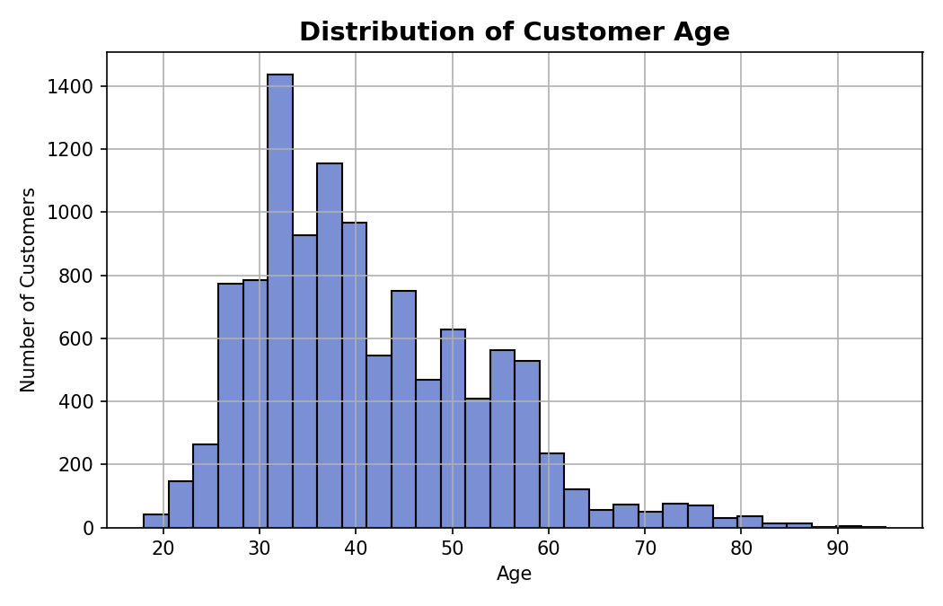
Figure 2: Distribution of customer age
Account balance is heavily right-skewed most customers hold modest balances (median ~€550), while a small number of high-balance outliers pull the mean up to ~€1,528. The median is more representative of a "typical" customer than the mean.
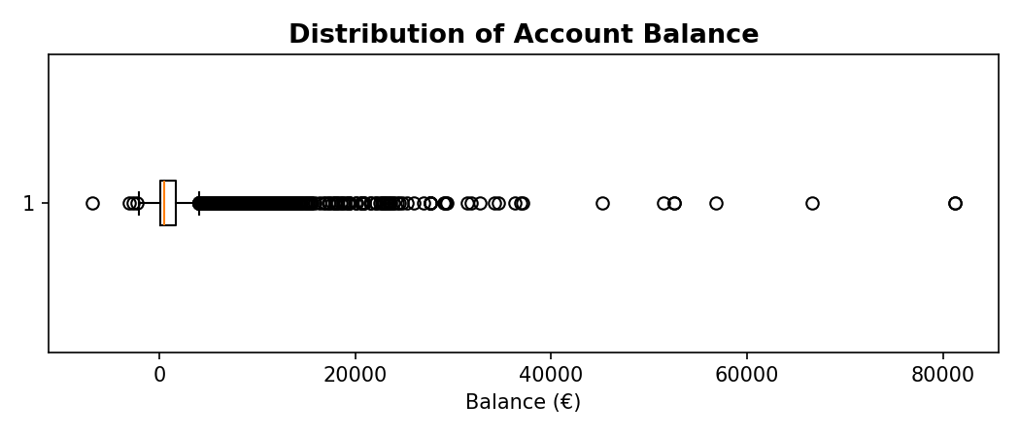
Figure 3: Distribution of account balance

4.3 Demographic Drivers
Bar charts comparing subscription rate across job type, education, marital status, and age group reveal a consistent pattern: customers with fewer competing financial commitments students, retirees, and single customers subscribe at notably higher rates.
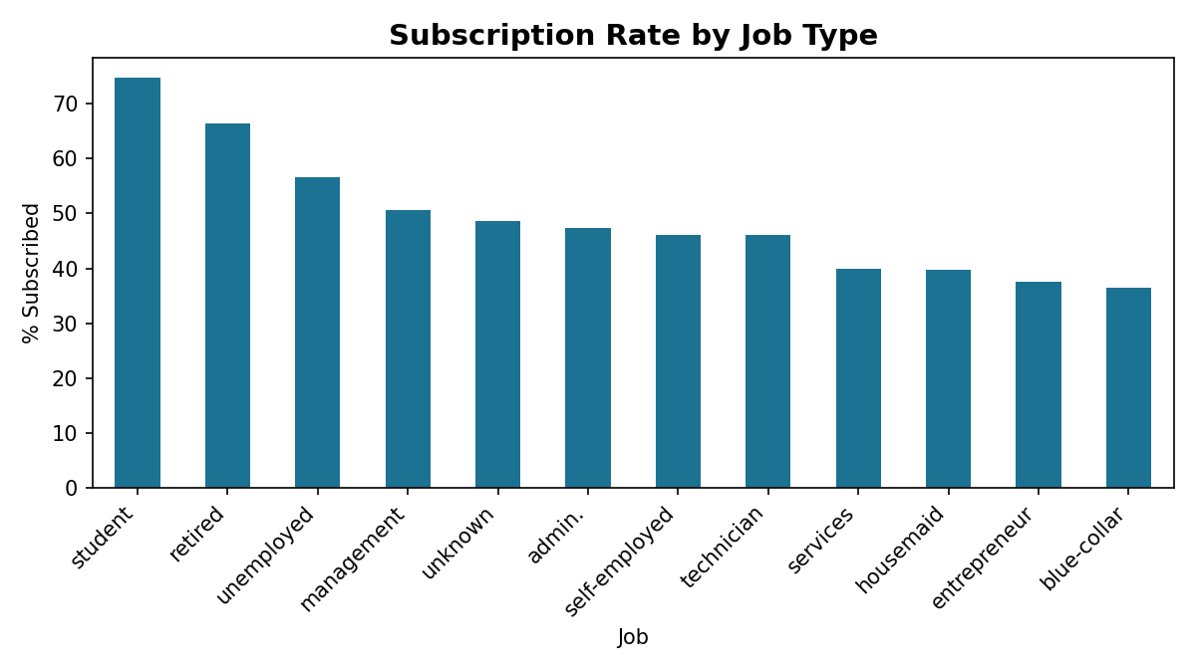
Figure 4: Subscription rate by job type
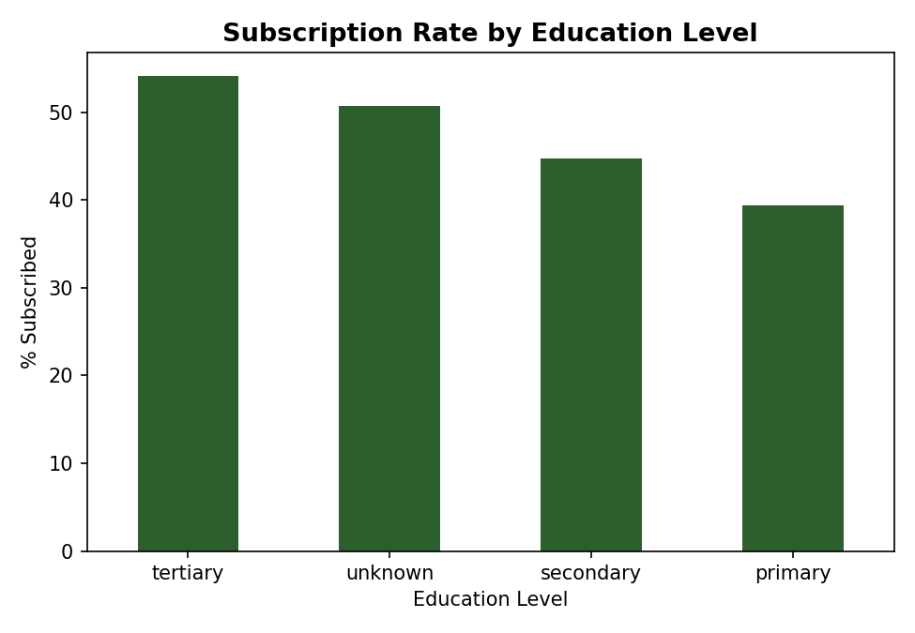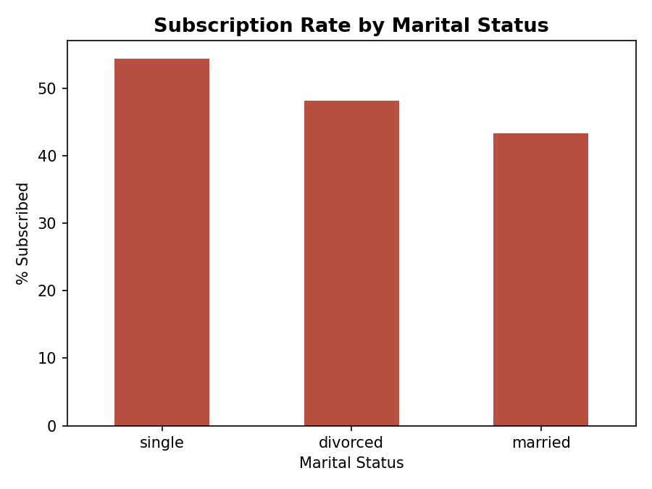
Figure 5: Subscription rate by education level (left) and marital status (right)
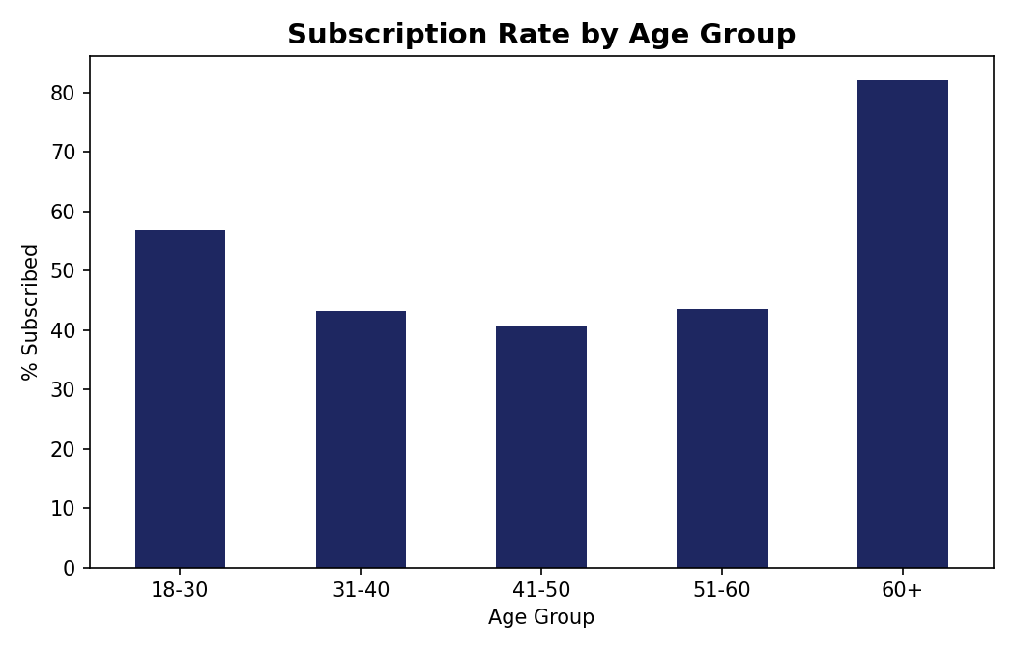
Figure 6: Subscription rate by age group

4.4 Campaign & Contact Drivers
Previous campaign outcome and contact method also strongly influence subscription, as shown below.
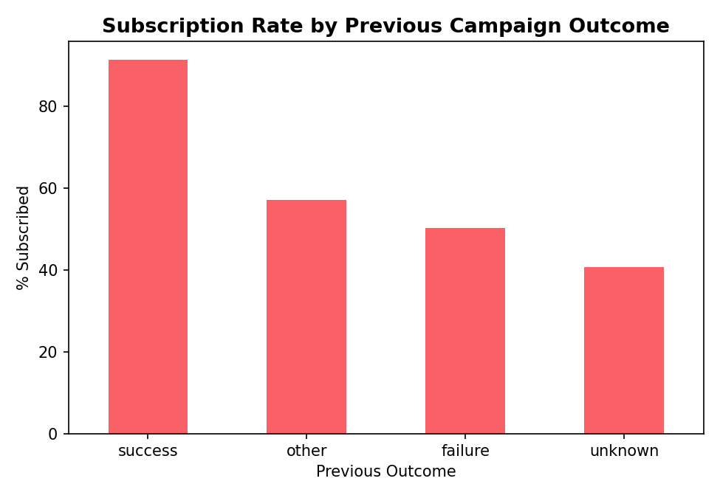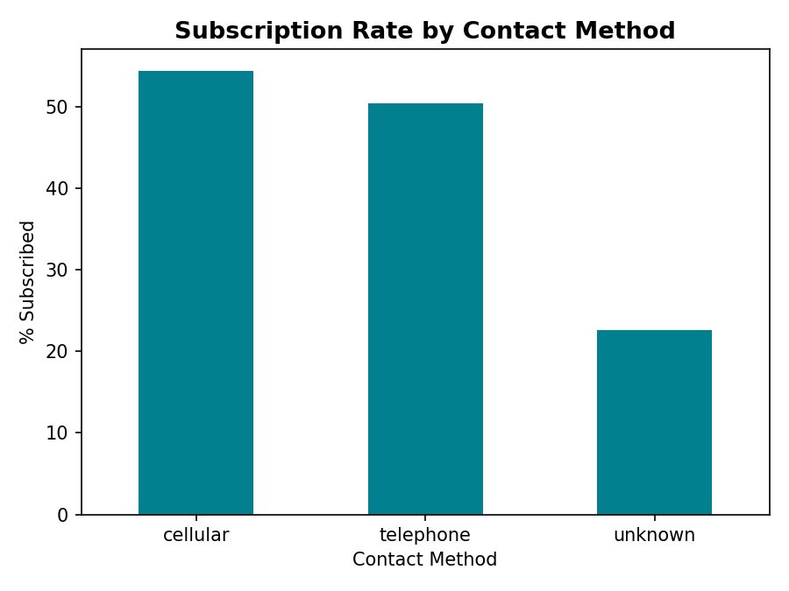
Figure 7: Subscription rate by previous campaign outcome (left) and contact method (right)

4.5 Trends Over Time & Variable Relationships
Subscription rate also varies by month, though low-volume months should be interpreted cautiously given uneven contact volume across the year.
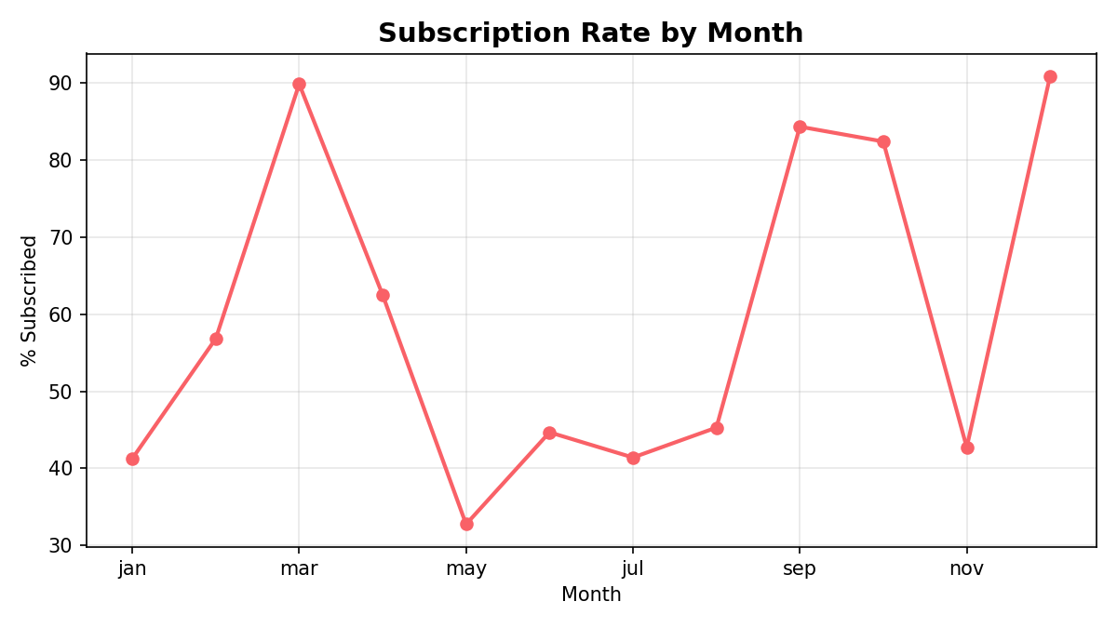
Figure 8: Subscription rate by month
A correlation heatmap of numeric variables shows mostly weak relationships between features, with the exception of pdays and previous (0.51), which is expected since both relate to prior contact history.
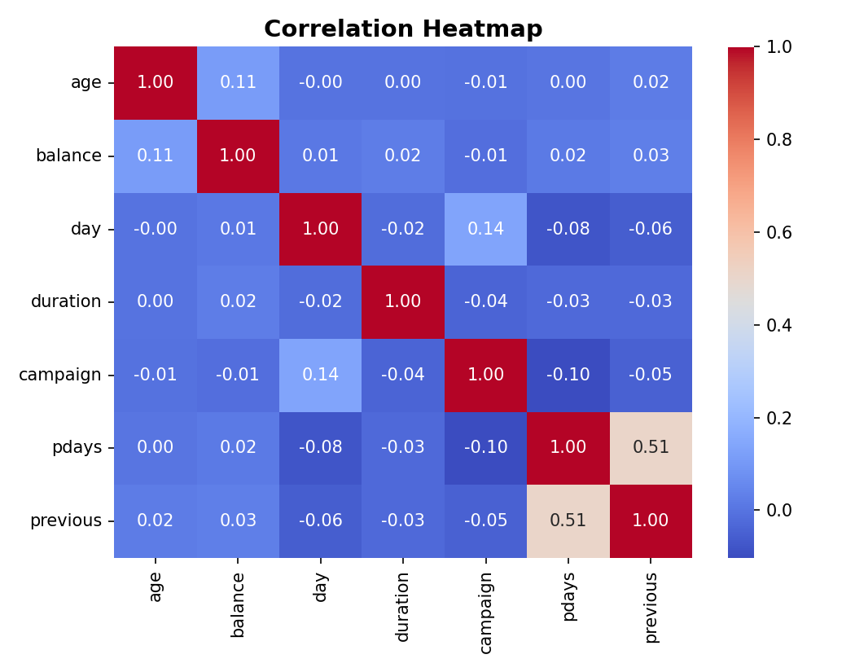
Figure 9: Correlation heatmap of numeric variables
Finally, comparing account balance directly against subscription outcome confirms that subscribers hold a higher balance overall nearly double the median of non-subscribers (€733 vs €414).
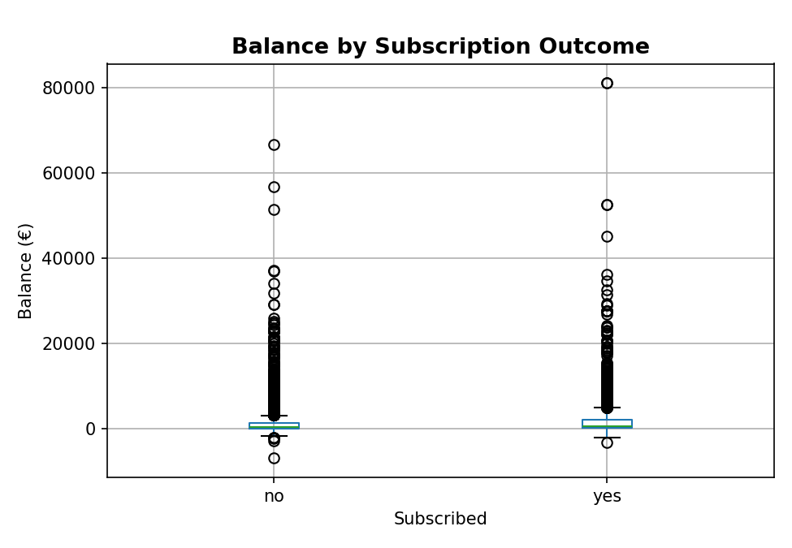
Figure 10: Account balance by subscription outcome

5. Key Findings
- 1. Previous campaign success is the strongest single predictor of subscription: customers who succeeded in a previous campaign subscribe again at ~91%, compared to ~41% for customers never previously contacted.
- 2. Age shows a U-shaped relationship with subscription: customers aged 60+ (~82%) and 18-30 (~57%) subscribe far more than working-age adults 31-50 (~41-43%).
- 3. Job type strongly influences subscription: students (~75%) and retirees (~65%) subscribe at much higher rates than blue-collar workers or entrepreneurs (~36-38%).
- 4. Contact method matters: cellular (~54%) and telephone (~50%) contacts convert far better than contacts with an unrecorded ("unknown") method (~23%), which represents 21% of all customers.
- 5. Single customers subscribe at a higher rate (~54%) than married customers (~44%), and education level shows a moderate positive relationship (tertiary ~54% vs primary ~38%).
- 6. Subscribers hold nearly double the median account balance of non-subscribers (€733 vs €414).
- 7. May had the highest contact volume (25% of all contacts) but the lowest subscription rate (~33%), suggesting a possible mismatch between campaign timing/volume and customer receptiveness.

6. Business Insights
Subscription is driven far more by a customer's life stage and financial circumstances than by campaign mechanics alone. Customers with fewer competing financial commitments students, retirees, and single customers are consistently more receptive, a pattern that shows up independently across age, job, and marital status.
The single strongest driver, however, is the customer's own history with the bank: prior campaign success predicts future success far better than any demographic factor. This represents a low-effort, high-return opportunity for re-engagement.
At the same time, working-age (31-50), married, blue-collar or entrepreneur customers represent the hardest-to-convert segment likely also the largest share of the overall customer base while a meaningful share of customers (21%) are being reached through a contact channel that isn't being properly recorded, and converting far worse as a result.

7. Recommendations
- 1. Prioritize re-engaging customers with previous campaign success, since they convert at nearly double the overall average rate (~91% vs ~47%).
- 2. Shift marketing focus and messaging toward students, retirees, and single customers, who consistently show the highest subscription rates across multiple variables.
- 3. Reduce reliance on unrecorded ("unknown") contact methods by investigating the data gap and shifting more contacts toward cellular or telephone channels, which convert roughly twice as well.
- 4. Reconsider campaign timing and volume, particularly around May, where the campaign's largest push coincided with its weakest performance spreading contact volume more evenly could improve overall efficiency.
- 5. Incorporate account balance as a pre-screening signal for outreach prioritization, since higher-balance customers convert at nearly double the rate of lower-balance customers.

8. Conclusion
This analysis shows that term deposit subscription is shaped primarily by a customer's life stage, financial standing, and prior relationship with the bank, rather than by campaign volume alone. By prioritizing previously successful customers, focusing on the most receptive demographic segments, improving contact channel reliability, and rebalancing campaign timing, the bank has a clear, data-backed path to improving conversion rates while reducing wasted outreach effort.

