**READ ME**

**Project Abstract**

**ZeroWaste – Smart Food Donation Platform**

Every day, a large amount of food goes to waste, while many people still suffer from hunger. Our project, ZeroWaste, is a smart web platform designed to reduce food waste by connecting food donors with those in need.

The main goal is to ensure that surplus food reaches receivers quickly and efficiently, using modern web technologies and location-based features.

ZeroWaste serves three types of users: Donors, Receivers, and Admins.

Donors can be individuals, restaurants, or hotels who want to share leftover food.

Receivers include NGOs, orphanages, and shelters that can collect and distribute the food to people in need.

Admins manage users, donations, and ensure smooth operation of the system.

The website is built using React.js, Tailwind CSS, and Node.js, with MongoDB as the database. We’ve implemented a real-time map using Leaflet, which shows all available food donations as pins based on their location. This helps receivers quickly find nearby food without confusion.

Donors can log in, add food donation details like quantity, type, expiry time, and pickup location. Receivers can log in, view nearby donations on the map, and request the food. Admins have their own panel to view all users and donations, and manage the system.

The platform offers a clean, simple, and responsive interface for all users. Each user type has a dedicated dashboard designed for ease of use and clear access to features.

In summary, ZeroWaste is a practical and efficient food donation system that uses geolocation and smart design to bring together donors and receivers. It helps reduce food waste, supports social welfare organizations, and promotes a culture of sharing and sustainability — one donation at a time.

**Welcome Page**

When users first open the app, they see the **Welcome Page**. It gives a quick idea about the purpose of the platform. It shows options to **Login** or **Sign Up**, depending on whether the user is new or already has an account.

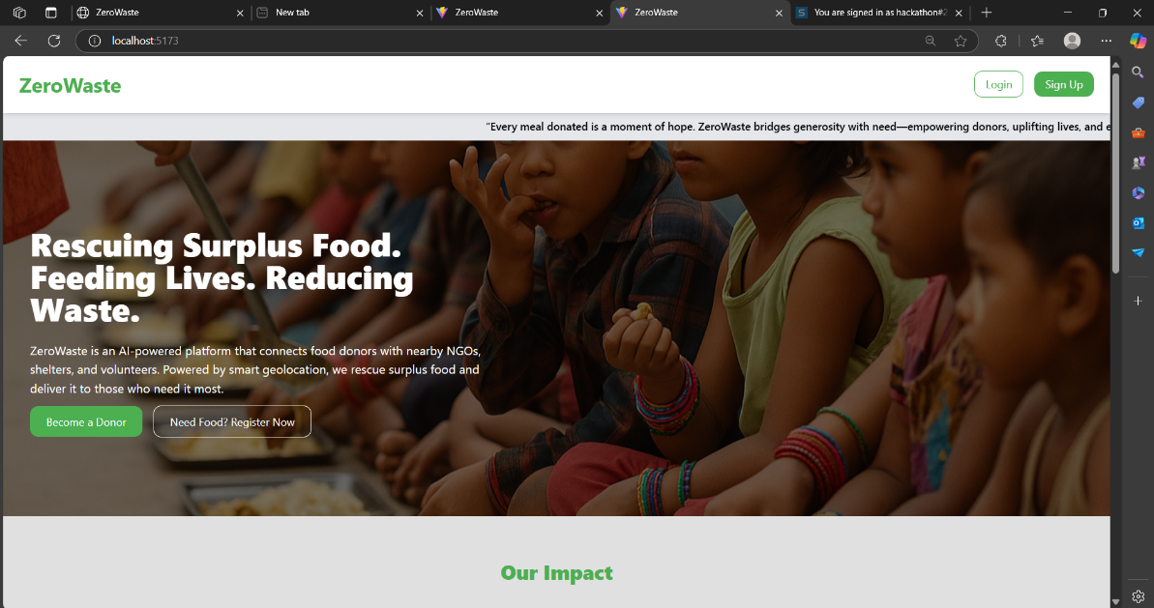

**Signup page**

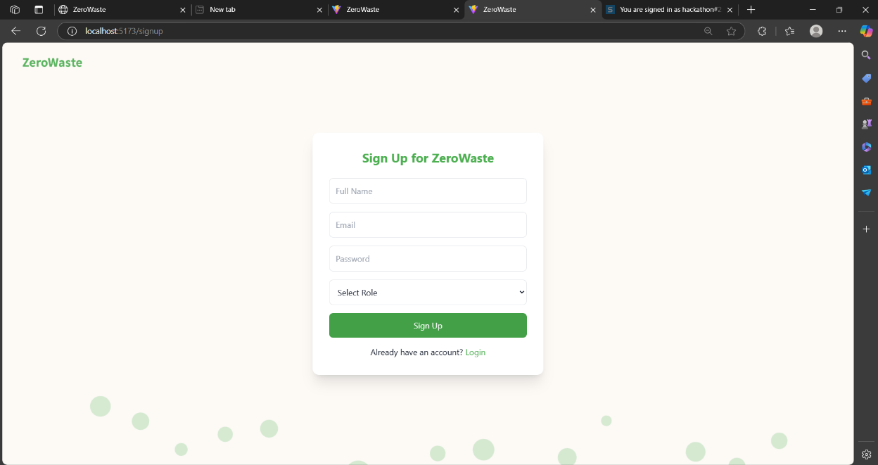

**Login page**

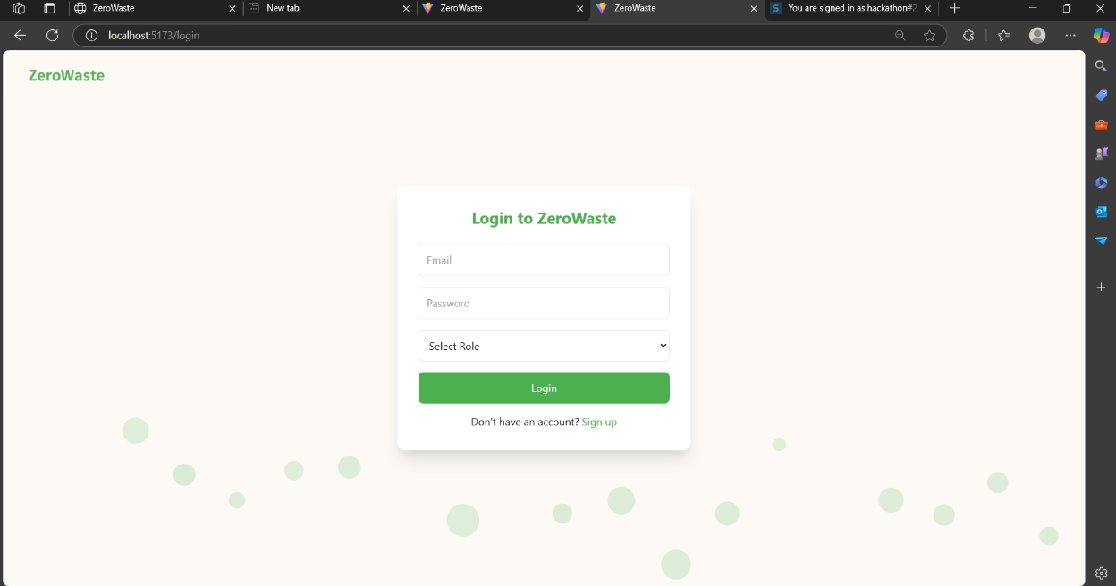

**ADMIN SECTION:**  
Admin is the controller of the website where he can have the access to all the data and he can also have the options to manipulate the donor and receiver dashboard. The components that admin have are:  
**1. Dashboard**

Shows platform stats like users, food posts, pickups, and alerts.  
Gives a quick overview of activity and growth.

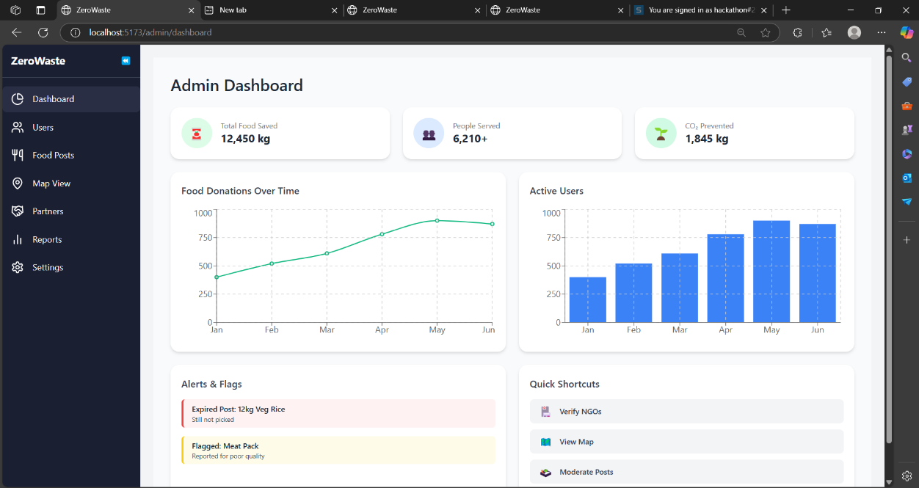

**2. Users**

Lists all users with role and status management.  
Admins can filter, view, and control access.

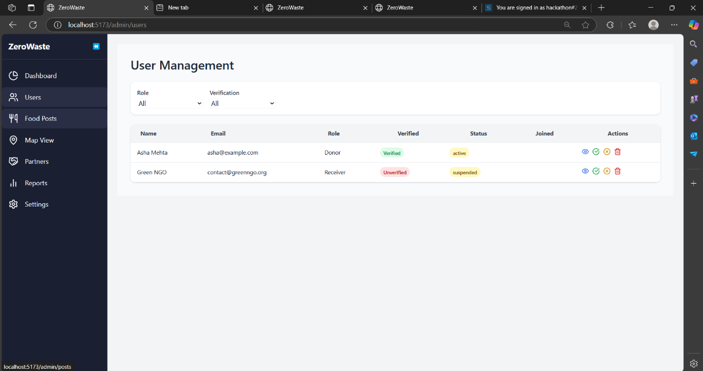

**3. Food Posts**

Displays all food donation posts with details.  
Admins can review, approve, or remove posts.

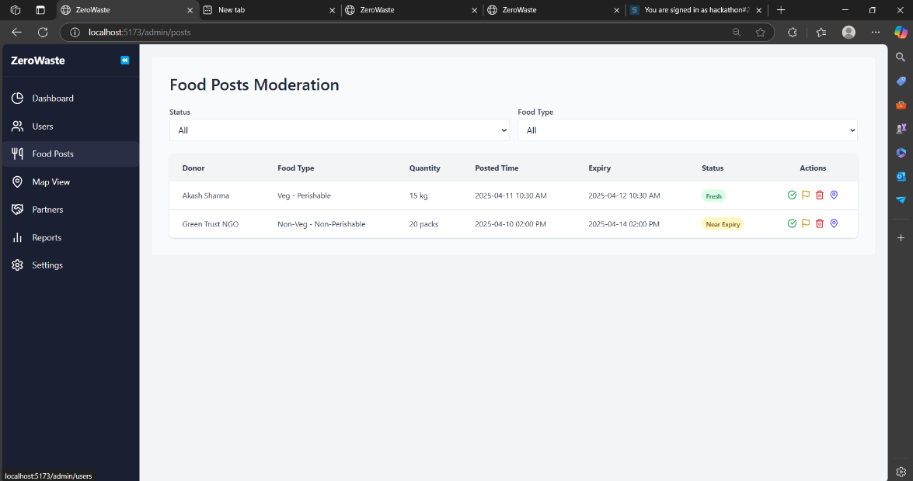

**4. Map**

Shows live locations of donations and pickups.  
Helps in tracking and managing logistics.

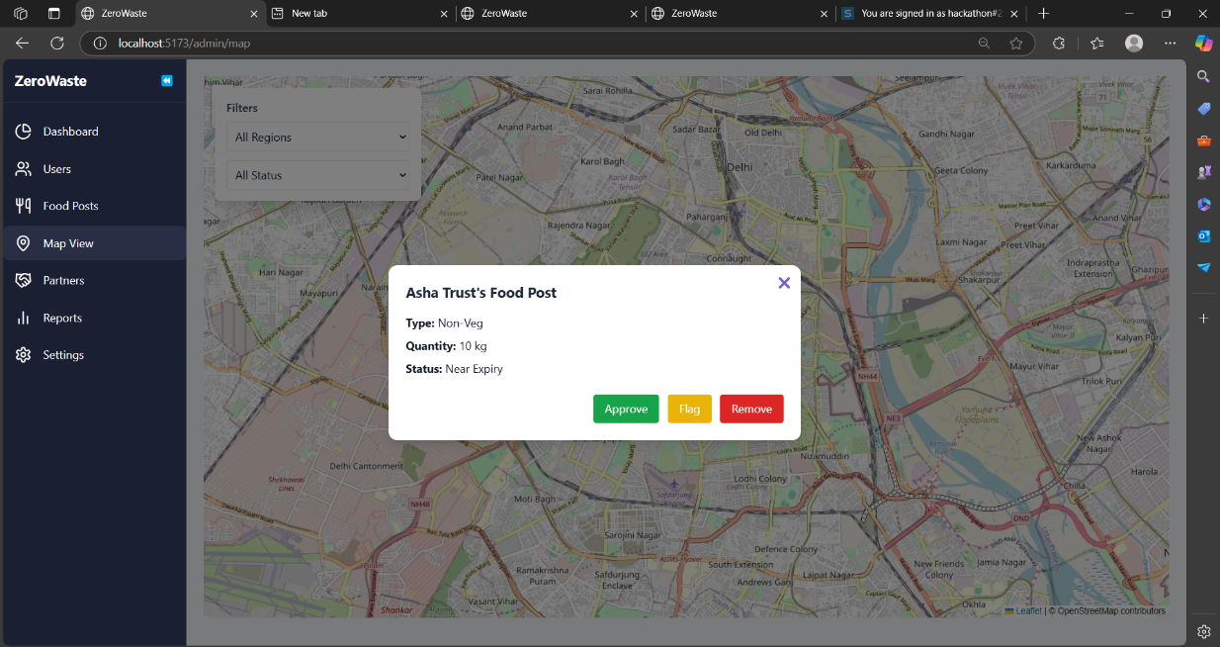

**5. Partners**

Lists all NGO and partner organizations.  
Admins can view, verify, and manage them.

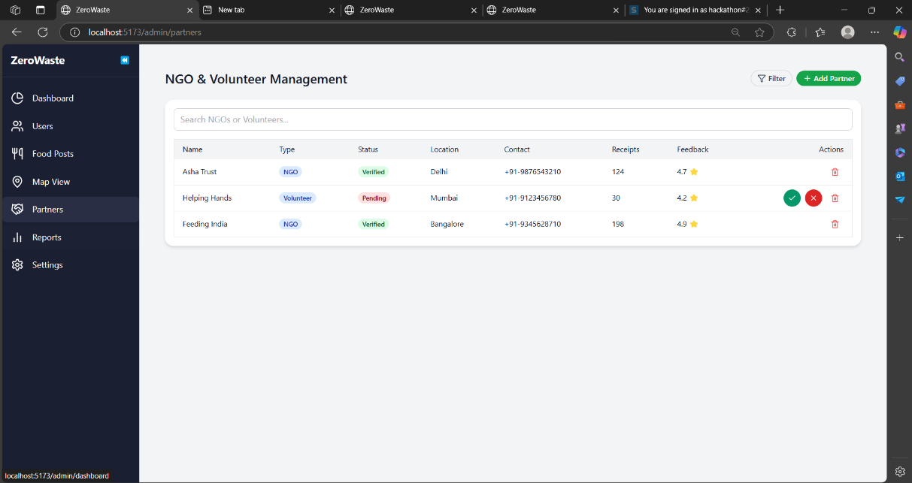

**6. Reports**

Generates reports on users, posts, and activity.  
Supports filters for detailed insights.

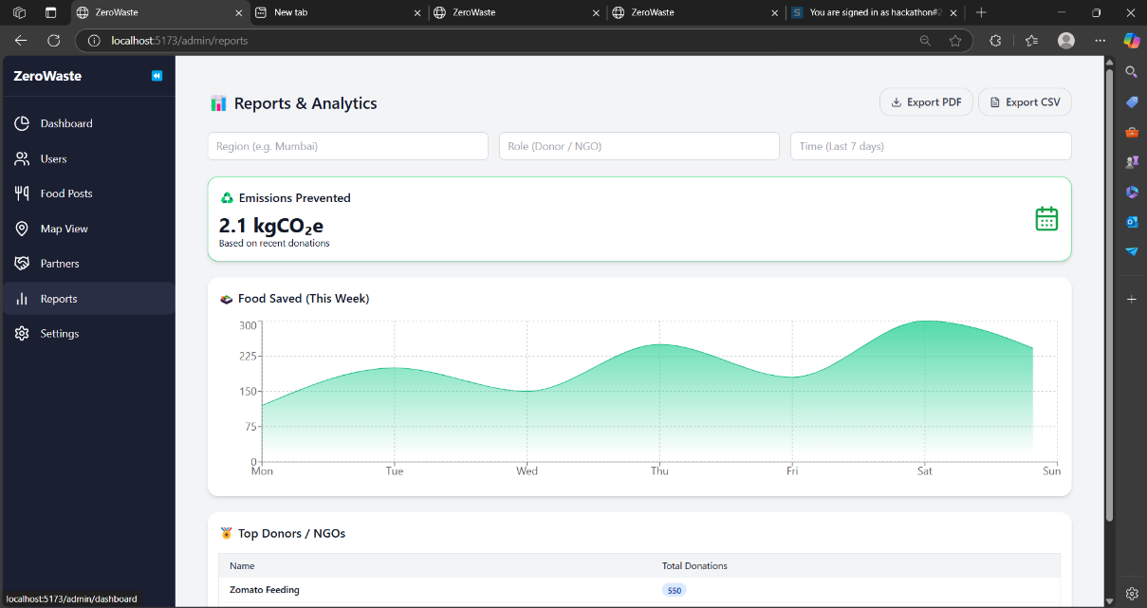

**7. Settings**

Allows platform-wide configuration and preferences.  
Covers account, system, and feature settings.

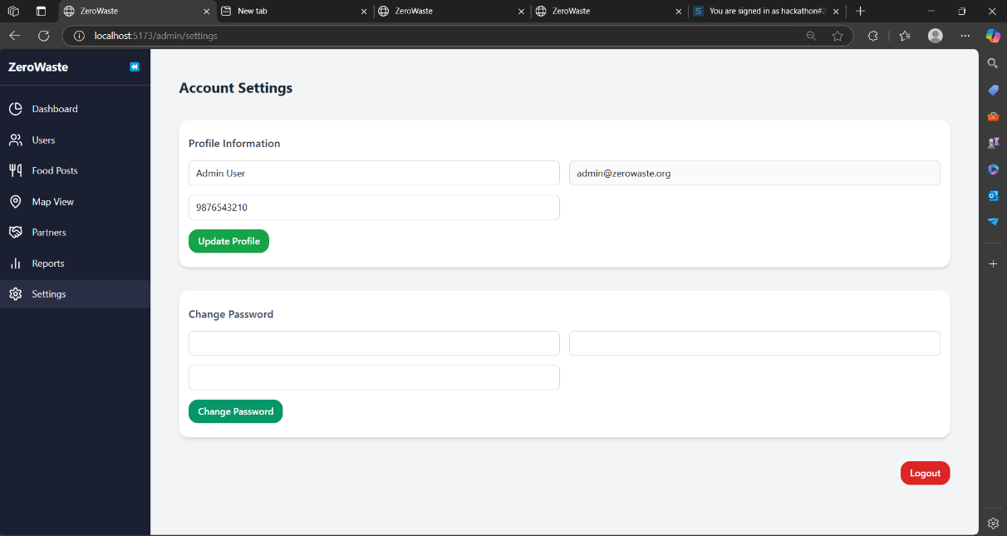

**DONOR SECTION:**

Donor is the one who creates an order when ever he has the food. Donor has multiple components that inlcude:  
  
**1. Donor Dashboard**

A snapshot that shows stats like total posts, pickups, and donations completed.

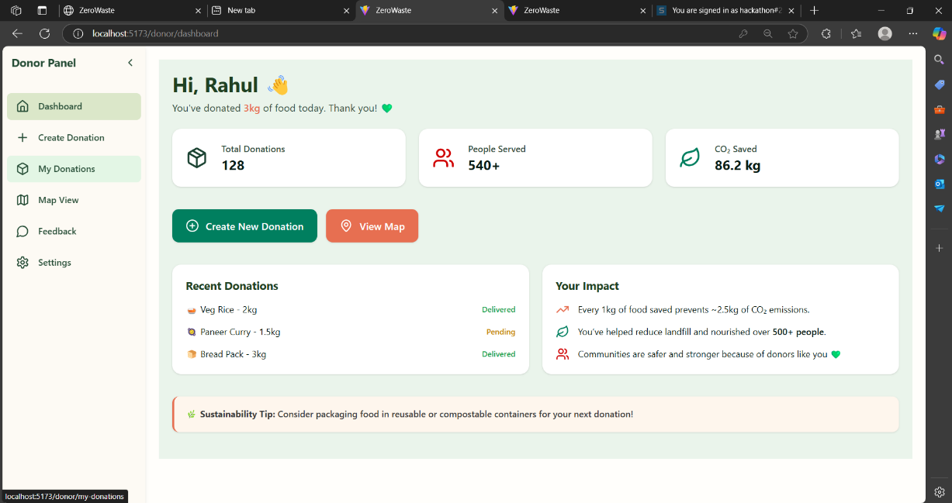

**2. Create Donation**

Form to submit a new food donation with details.  
Simple and fast way to offer surplus food.

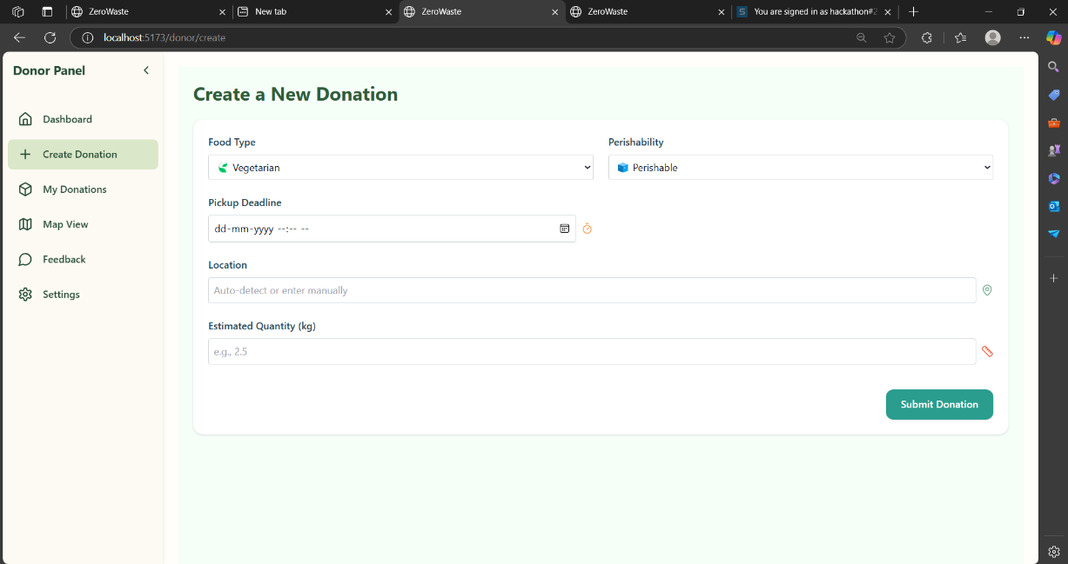

**3. Feedback & Ratings**

Shows feedback from NGOs after receiving donations.  
Helps donors improve and feel appreciated.

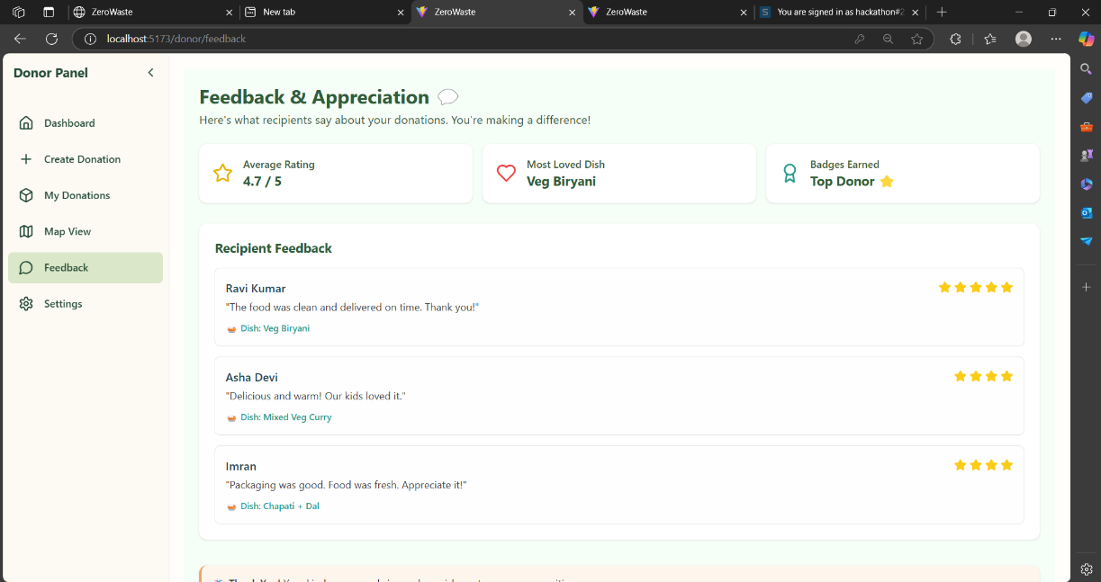

**RECEIVER SECTION :**

Receiver is the one who receives the food , when donor creates a donation that can be claimed by a receiver. Receiver can be individuals or NGOs or or trusts. The receiver section include:  
  
**1. Dashboard**

Lists all active recent pickups from donors and some stats.  
Receivers can filter, view details, and request pickups.

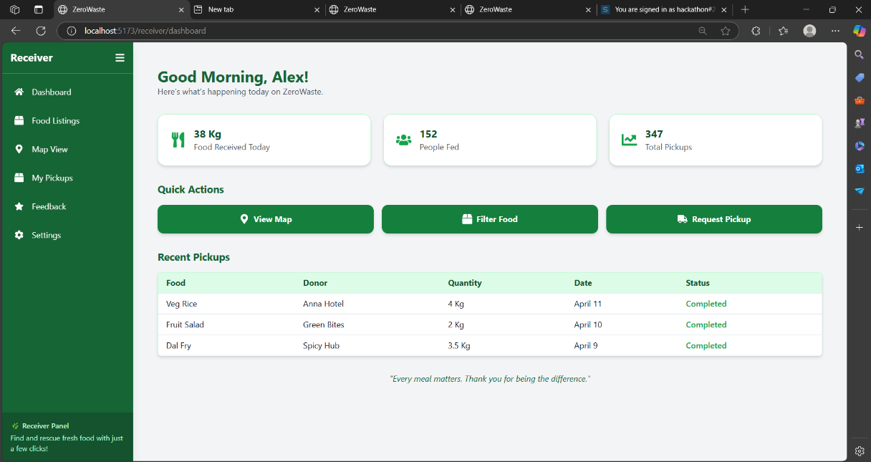

**2. Food listings**

List of all donations created by the donors that are available to pickup with location details.

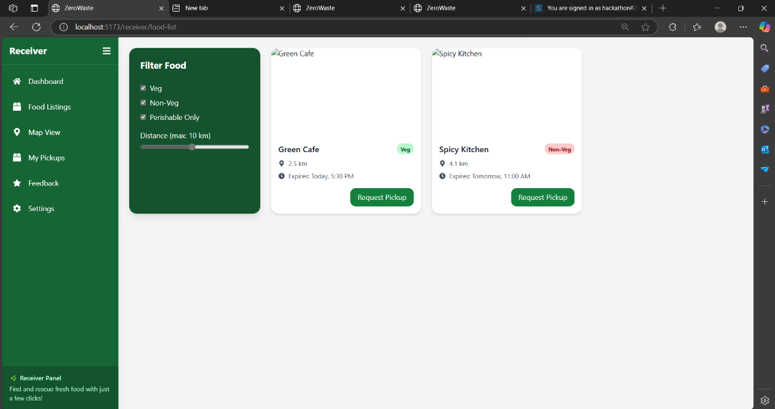

**3. Receiver Settings**

Receivers can update their profile, contact info, and password.  
It helps maintain a personalized and secure experience.

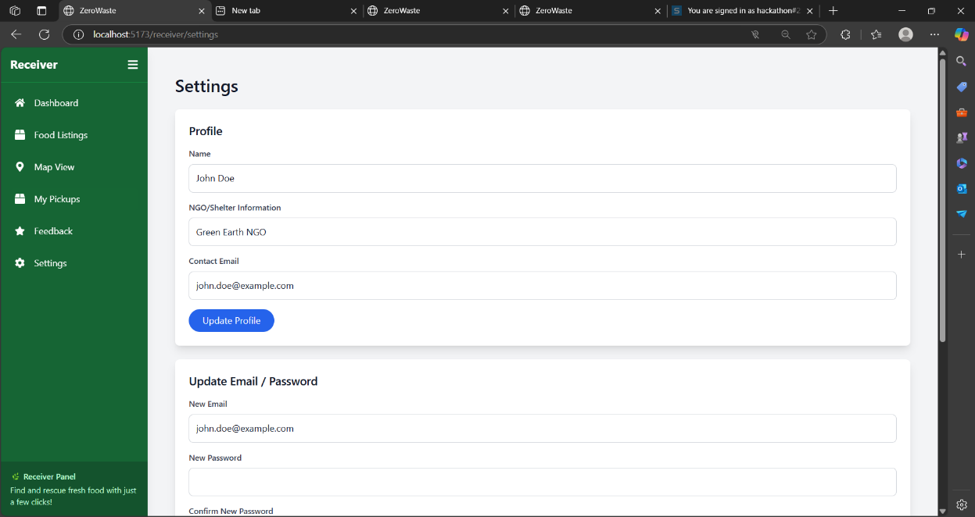

**Conclusion :**  
  
This food donation platform was built to connect donors and receivers in an easy and smart way. By using maps, location features, and clear user roles, we made sure that food can be shared with less waste and more care.

Our goal was to create a useful, real-world solution that looks good and works well. With simple design, clear flow, and working backend APIs, the project is ready for real use or future upgrades. We hope this system can inspire others to reduce food waste and help communities in need.