**UNIVERSITY OF LONDON**



**COURSEWORK REPORT**

**BUSINESS ANALYTICS, APPLIED MODELLING & PREDICTION**

**Student:** Nguyen Dinh Khoi

**ID:** 200665977

**Word count:** 1423/1500

**HO CHI MINH CITY, FEBRUARY, 2022**

**TABLE OF CONTENTS**

PART I: INTRODUCTION 1

PART II: ANALYSIS 2

DASHBOARD 1. OVERALL ANALYSIS 2

DASHBOARD 2. LOCATION ANALYSIS 3

DASHBOARD 3. PRODUCT ANALYSIS 5

DASHBOARD 4. SHIPPING COST ANALYSIS 7

DASHBOARD 5. FORECAST ANALYSIS 9

PART III: CONCLUSION AND RECOMMENDATIONS 11

**SUMMARY**

This report analyzes the performance of the business from 2017 to 2020, with five dashboards illustrating different aspects of the firm. Dashboard 1 focuses on the general situation over the period. It measured the total number of customers, sales, profits, and profits ratio. The data was given in numbers and illustrations using line and bar graphs. Dashboard 2 examines operations in distinct markets and countries globally. Through this dashboard, senior management may have a more accurate look at the sales and profits generated in each region. They can also evaluate the performance of each area by observing the comparisons provided in numbers, graphs, and map form. Dashboard 3 follows up with the displays of the popularity of various items and the profits they generate. This part further analyzes and explains Dashboard 2 as it provides precise data in three main categories, namely furniture, office supplies, and technologies. Dashboard 4 calculates the shipping cost of products in different areas and its ratio to sales. The information was illustrated in line graph form to provide a visualized comparison between regions. Additionally, the shipping costs were calculated individually based on some sub-categories. Dashboard 5 predicts future trends in sales, product groups, and countries. The predictions are for the year 2022, with precise analysis from the former period. Unsurprisingly, with the development of the current economic situation, all figures may experience an upward trendline for the upcoming year, despite some fluctuations during the period. Finally, there will be some recommendations to maximize the business profits, regarding to the management and construction of the global supply chain.

## PART I: INTRODUCTION

The data used shows the details of customers' transactions from January 2017 to December 2020. With the data obtained, I have created some visualizations to analyze the performance of the business. Below are five business analytics dashboards that demonstrate further significant information.

## PART II: ANALYSIS

### DASHBOARD 1. OVERALL ANALYSIS

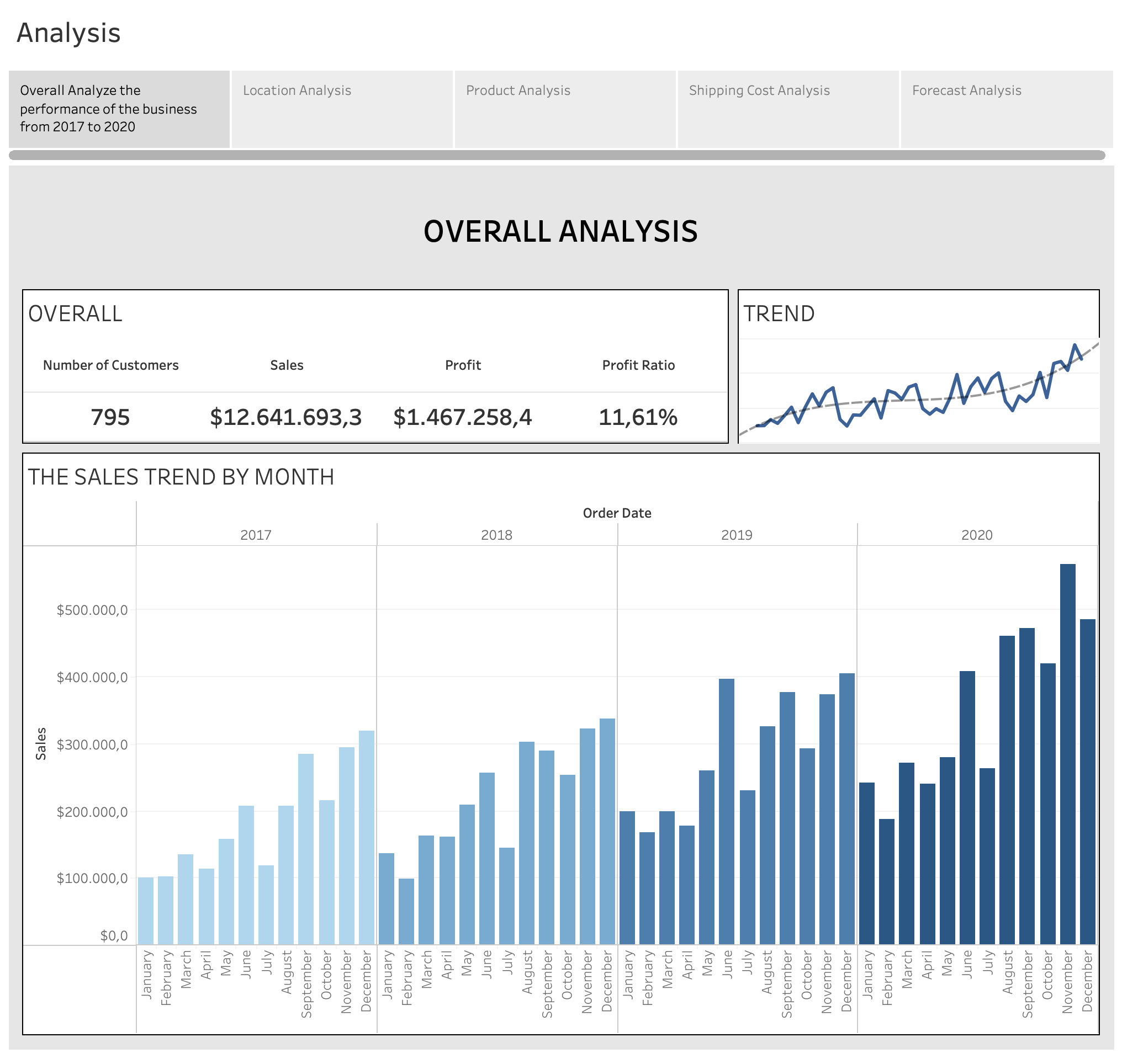

From 2017 to 2020, the business had 795 shopping customers, selling more than $12.6 million. Profit earned nearly $1.6 million, accounting for 11.61% of revenue. The trendline shows that the total sales over the years have increased despite periods of decline.

For more detail, refer to the bar chart showing the company's revenue by months of the year. The months with the highest sales are almost all in the 3rd and 4th quarters. The most prominent are November and December, with sales always leading. Some reasons for this trend is due to customers' behavior, such as, at the end of the year, they often shop to prepare for the new year, and the year-end promotions have motivated them to buy more.

### DASHBOARD 2. LOCATION ANALYSIS

After looking at the company's overall revenue and profit, let's dive deeper into the region's business.

In terms of market, the region that brought in the highest sales was APAC, with total revenue of nearly $3.6 million. Following APAC are the EU, the US, and the LATAM with $2.9, $2.3, and $2.1 million, respectively.

In terms of countries, the US, Australia, France, China, and Germany are those with the highest sales, in descending order. Significantly, the US had sales of 2.5 times higher than the second country, Australia. This explains why when aggregating data by market, the APAC region is at the top because it includes Australia and China, and many neighboring countries. The US itself is a country, but it has been considered a separate market since it has brought in great sales compared to other countries.

It is not surprising that the profit distribution map of countries shows that the US and Australia are the two countries that bring the highest profits for businesses. The darker the blue color, the larger the profit. The yellow and orange show that the business situation in those countries is suffering a loss. Although Canada and Russia have extensive areas, their profits are only $17.8 and $22.5 thousand, less than 10% compared to the US.

Looking at the monthly sales for each country, the US showed a trend similar to the general tendency analyzed above, with sales in the last months of the year being significantly higher than in the first half. This may be because there are many promotion events at the end of the year, such as Black Friday or Christmas, where people often buy more than usual. However, for other countries, the trend character of the population is not clearly expressed. Australia, for instance, has almost similar sales from May to December.

### DASHBOARD 3. PRODUCT ANALYSIS

Next is about the business performance by product. In general, the sales of three main product groups, namely technology, furniture, and office supplies, shared similarities.

Technology category brought in the highest sales and profit with $4.7 million in sales and $663 thousand in profit, even though the number of products sold is only nearly a quarter of the total. All products in this group obtained great sales with more than $700 thousand each. Profits are also considerable, especially copiers, with $258 thousand in profit, accounting for 17.13% of sales.

Next is furniture items. Although the sales of these items are also significantly high ($4.1 million), the profit generated is exceptionally low with only $285 thousand, accounting for less than 10% of sales.

More specifically, chairs and bookcases are the two groups that bring in positive revenue and profit. Although tables also had good sales, they generated negative profits. This might be why furniture products in total could not create higher profits. Additionally, production costs can also affect the profitability of these products.

Office supplies remained stable with $3.7 million in sales and $500k in profit. It is also the group with the highest number of sales.

In detail, storage and appliances are the two leading items in terms of sales and profits. Products, such as Paper, Envelopes, Labels, although having low sales (compared to the general market), brought high profits. For instance, Paper created up to 24% compared to the sales of the company.

There is also a scatter plot shows the distribution of items by quantity and profit. The size of the circle represents sales. Copiers led in terms of profits, followed by Phones and Bookcases.

### DASHBOARD 4. SHIPPING COST ANALYSIS

Overall, the amount of shipping costs has remained at a stable level over the year, with no unexpected effects. As the number of the sold products increased, the shipping cost also raised. The combined column and line chart on the left shows that the shipping costs did not inflate too much over time. Moreover, the costs are also not too significant when compared to sales, only approximately 5-10%.

When grouped by items, the treemap shows that phones account for the highest amount of shipping costs, at $184.9 thousand, followed by chairs and bookcases with $164.2 and $155.4 thousand, respectively. Surprisingly, storage's quantity is higher than that of phones (shown in the scatter plot of product analysis dashboard), but its shipping costs are lesser. The color of the cells represents the cost ratio, with the darker the color, the higher the cost ratio, and vice versa. Accessories and Art are the two items with the highest cost ratio, about 11%. In general, the cost ratio by items is not too large, only about 5 - 11%, similar to the conclusion when analyzing the combined line and column chart.

By market, APAC leads in cost, then followed by the EU. The subsequent two positions are held by US and LATAM alternately. Canada has impressive shipping costs, with very little over the years.

### DASHBOARD 5. FORECAST ANALYSIS

When applying a forecasting tool to the analysis, the trendline indicates that sales might continue to increase in the next two years (2021 and 2022). Especially in 2022, although the sales predicted will fluctuate with some sharp declines during the year, they will continue to increase at the end, similar to the upward trend of previous years. Profit will also grow but not too great compared to the earlier period, generally maintaining a stable level.

In terms of categories, technology is expected to continue to capitalize in sales, with sales growing by a considerable margin. Furniture and Office supplies will also increase sales, but not with the potential of technology.

Regarding countries, the top five leading countries are expected to remain with the US, Australia, France, Germany, and China. The US still maintains its performance in the first place, far ahead in sales compared to others. In the lower tier, Australia, France, and Germany may compete fiercely in the sales race. Australia remains in second place, while Germany is forecast to overtake France in 2021 by a large margin of change. On the other hand, China is expected to experience a decline in sales, leaving an extensive gap behind other countries in the top 5.

The predictions above are based on the observation and calculation of the previous period, and the assumption of no unexpected events may occur. Therefore, it is only advisable to refer, not completely believe that this scenario will happen correctly.

## PART III: CONCLUSION AND RECOMMENDATIONS

1. **Conclusion**

- According to the analysis, the performance of the business has progressed well with the steady growth of sales, along with a profit ratio of 10%.

- The best performing market is the APAC, with two major contributors being Australia and China. Additionally, by country, the US obtained the highest sales and profits.

- In terms of products, technology items, such as phones and copiers contribute the most to sales and profits. Next are products belonging to the group of office supplies.

- Shipping costs are proportional to the level of sales. Unsurprisingly, the market with the most considerable shipping costs is APAC, and the item with high shipping costs is Phones.

- In the following years, it is predicted that sales will continue to rise, along with an increasing demand for purchasing technology items. The US will still be the leading product consumption market.

1. **Recommendations**

With the increasing demand for technology products, we should invest in advertising and utilize new technology products to customers through distribution channels in different markets. Additionally, each market or country has its characteristics. Therefore, to drive more sales, we have to set up distinctive management groups for each region. We also need to construct or connect global supply chains to reduce shipping costs, then we can optimize profits for the business.

**APPENDICES**

[1] Sultan Global (April 9, 2019), “Tableau Tutorial - Global Superstore Performance Dashboard” [Youtube]

Available at:

<https://youtu.be/kIZDb_pHvX0>

[2] Olushola Olojo (March 8, 2021), “Business Dashboard: Sales Performance” [Tableau Public]

Available at:

<https://public.tableau.com/app/profile/olushola.olojo/viz/SalesPerformanceDashboard_16151463994130/SalesPerformanceDashboard>

[3] Amanda Dudley (September 1, 2021), “Business Analysis Report: Writing Guide From Preparation To Submission” [Website]

Available at:

<https://www.batimes.com/articles/business-analysis-report-writing-guide-from-preparation-to-submission/>