Assignment 1 Documentation

Docker Set Up
In the /etc/hosts file, set the following addresses
# DSA5208 MongoDB replica set
127.0.0.2 mongo1
127.0.0.3 mongo2
127.0.0.4 mongo3

Docker-compose.yaml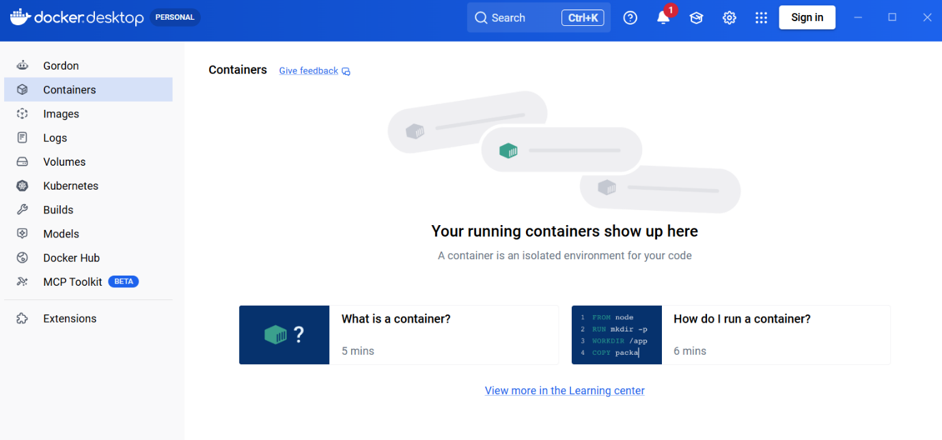
docker compose down -v
docker compose up -d
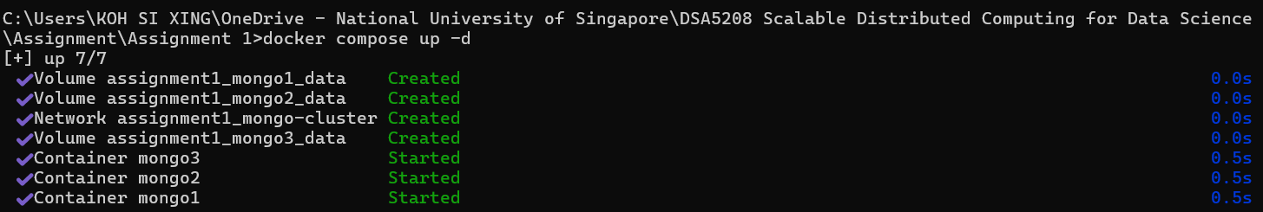
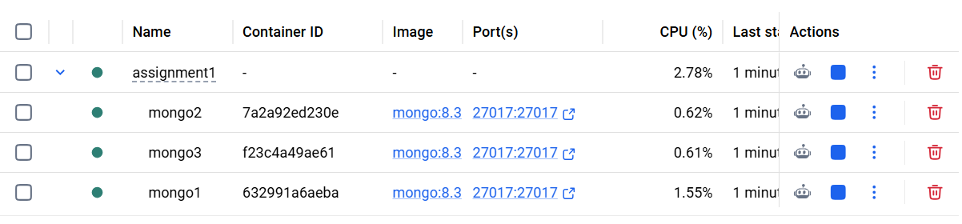
docker exec -it mongo1 mongosh
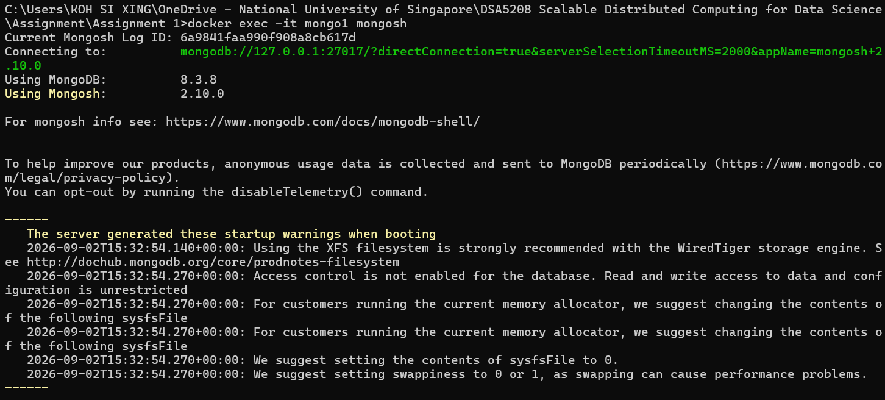
rs.initiate({
_id: "dsa5208",
members: [
{ _id: 0, host: "mongo1:27017" },
{ _id: 1, host: "mongo2:27017" },
{ _id: 2, host: "mongo3:27017" }
]
});

At the start, there will be 3 secondaries. The servers will elect a primary which takes a few seconds to decide.
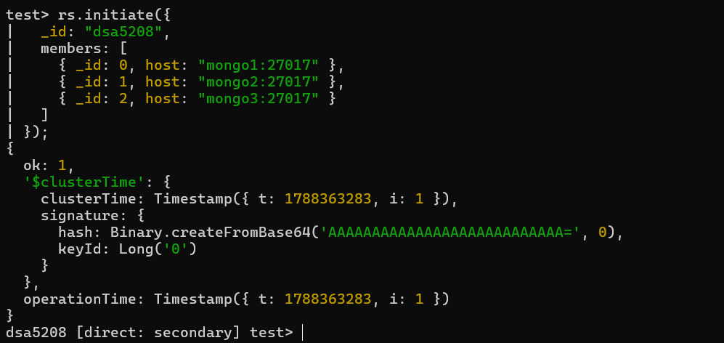
Mongo 1 has been selected as the primary
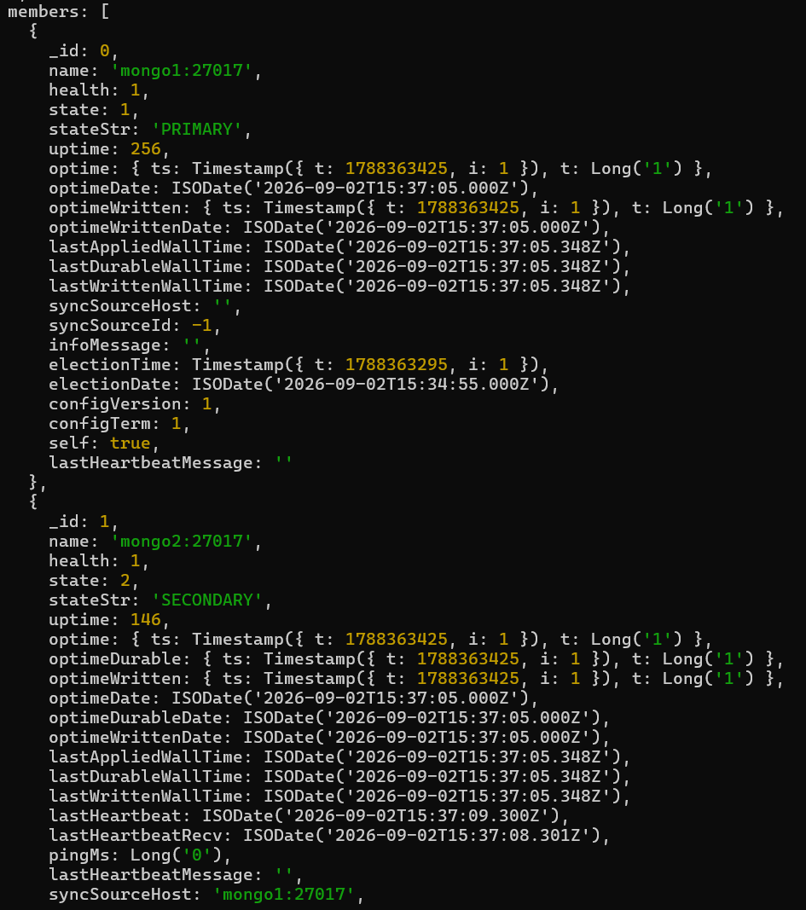
Connection in MongoDB Compass
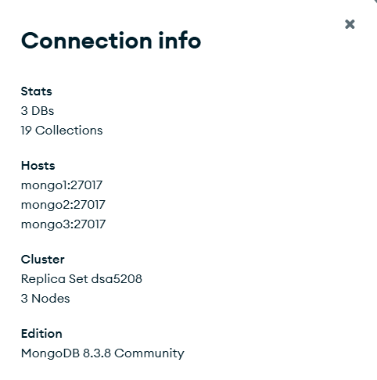

Checks on Jupyter
client = MongoClient(
"mongodb://mongo1:27017,mongo2:27017,mongo3:27017/?replicaSet=dsa5208",
serverSelectionTimeoutMS=5000
)
hello = client.admin.command("hello")
print("Replica set:", hello.get("setName"))
print("Primary:", hello.get("primary"))
print("Writable primary:", hello.get("isWritablePrimary"))
for name in ["mongo1", "mongo2", "mongo3"]:
try:
c = MongoClient(f"mongodb://{name}:27017/?directConnection=true",
serverSelectionTimeoutMS=5000)
info = c.admin.command("hello")
print(name, "is connected to:", info.get("me"))
except Exception as e:
print(name, "FAILED:", e)

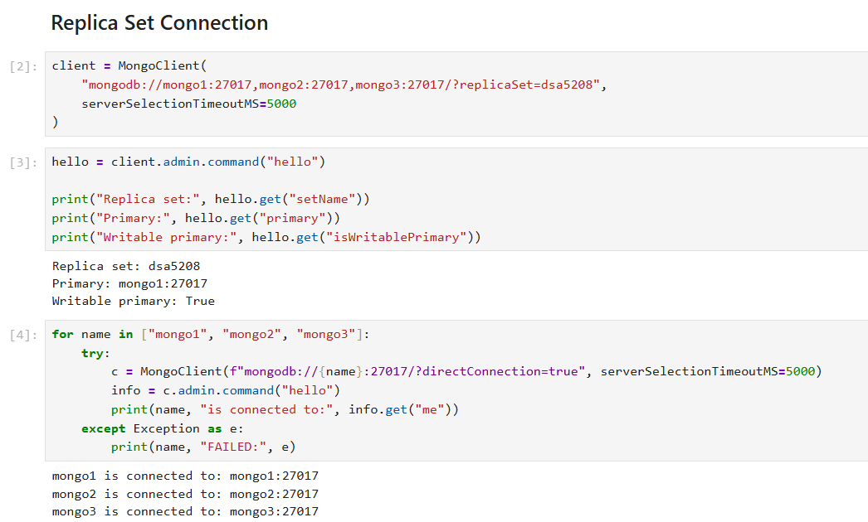
Reference
https://www.mongodb.com/docs/manual/reference/command/find/
https://www.mongodb.com/docs/manual/reference/command/insert/
https://www.mongodb.com/docs/manual/reference/command/update/

https://www.mongodb.com/docs/manual/reference/command/hello/
https://www.mongodb.com/resources/products/compatibilities/deploying-a-mongodb-cluster-with-docker
https://factory.ai/open-source-wikis/mongo?page=systems%2Ffail-points.md

