Programming test:

The Joensuu Regional Library is aiming to migrate all of Eastern Finland's municipal libraries under one system, Koha ILS. This will manifest as improved material availability for all participant libraries, as more resources for modernizing the web-library and as straight ILS license savings. This in turn will cause increased inter library loans, higher material transportation volumes, more varied web-services and generally a huge boost for participating member libraries. (this is actually true)

Nothing good comes without a cost however. Increased usage creates more library-offendees, or outright library criminals. This creates a need to start a inter-library criminal transportation network, for collecting this library-rabble.
As a part of this effort, we need to plan our collection logistics.
Deliver, for our criminals pickup truck driver, a tool to find a route to visit all of our libraries.

The driver needs to be able to set the time taken to travel between the three different lines, for example:
-Red line – 25 minutes
-Blue line – 15 minutes
-Green line – 5 minutes

The driver needs to be able to choose from where he starts his journey, but must always visit each library at least once. He/she can only travel between established lines.

You don't need to take into account any other specifics. Just the time to travel between libraries, because the criminals are dropped on his pickup truck on the fly.
It is enough to reach all of the libraries, the driver can find his own way back to the disposal center.

The program must output a clear, visual and traceable route plan and total traveling time.

Functional limitations:

- The program must be done in Perl.
- Must use Asynchronous Javascript calls.
- It must run on an apache2 application server in a Debian derivative Linux environment.
- The program must be made available as a git repository (eg. In GitHub).
- To install the program, it is “git cloned” to a directory with apache2's Perl execution permissions. Zero setup time!
(You can still use Perl packages however, you just need to figure out how.)
- Business logic need not be optimal, any result will do.
- User interface works on Chrome or Mozilla.
- The program reads the libraries' route information from the given example text database.

Other deliverables:
- Work logs for the time taken to complete the assignment. Short descriptions of how many hours per day was spent on this assignment and what was done during those hours.

Implementation notes:
- If accessing the git repository needs credentials, those must be submitted to the reviewer. Reviewer will not accept any invitations or create no accounts to any external service.
- Reviewer fetches the submission with the command “git clone <repository url>” using the given credentials. Nothing more.
Here are the contents of the example text database:

{
"nodes": [
"Outokumpu",
"Polvijärvi",
"Sotkuma",
"Viinijärvi",
"Käsämä",
"Liperi",
"Siikasaari",
"Ylämylly",
"Marjala",
"Joensuu",
"Lehmo",
"Rantakylä",
"Kontiolahti",
"Paihola",
"Eno",
"Reijola",
"Kulho",
"Niittylahti",
"Heinävaara",
"Hammaslahti",
"Kiihtelysvaara",
"Tuupovaara"
],
"edges": [
{
"start": "Outokumpu",
"end": "Polvijärvi",
"color": "green"
},
{
"start": "Outokumpu",
"end": "Viinijärvi",
"color": "green"
},
{
"start": "Polvijärvi",
"end": "Sotkuma",
"color": "green"
},
{
"start": "Sotkuma",
"end": "Marjala",
"color": "green"
},
{
"start": "Liperi",
"end": "Ylämylly",
"color": "green"
},
{
"start": "Kontiolahti",
"end": "Eno",
"color": "green"
},
{
"start": "Kulho",
"end": "Heinävaara",
"color": "green"
},
{
"start": "Niittylahti",
"end": "Heinävaara",
"color": "green"
},
{
"start": "Hammaslahti",
"end": "Kiihtelysvaara",
"color": "green"
},
{
"start": "Kiihtelysvaara",
"end": "Tuupovaara",
"color": "green"
},
{
"start": "Sotkuma",
"end": "Käsämä",
"color": "blue"
},
{
"start": "Käsämä",
"end": "Ylämylly",
"color": "blue"
},
{
"start": "Marjala",
"end": "Lehmo",
"color": "blue"
},
{
"start": "Joensuu",
"end": "Lehmo",
"color": "blue"
},
{
"start": "Lehmo",
"end": "Kontiolahti",
"color": "blue"
},
{
"start": "Joensuu",
"end": "Kulho",
"color": "blue"
},
{
"start": "Reijola",
"end": "Kulho",
"color": "blue"
},
{
"start": "Niittylahti",
"end": "Hammaslahti",
"color": "blue"
},
{
"start": "Heinävaara",
"end": "Kiihtelysvaara",
"color": "blue"
},
{
"start": "Viinijärvi",
"end": "Käsämä",
"color": "red"
},
{
"start": "Käsämä",
"end": "Liperi",
"color": "red"
},
{
"start": "Liperi",
"end": "Siikasaari",
"color": "red"
},
{
"start": "Ylämylly",
"end": "Marjala",
"color": "red"
},
{
"start": "Marjala",
"end": "Joensuu",
"color": "red"
},
{
"start": "Joensuu",
"end": "Rantakylä",
"color": "red"
},
{
"start": "Rantakylä",
"end": "Lehmo",
"color": "red"
},
{
"start": "Joensuu",
"end": "Reijola",
"color": "red"
},
{
"start": "Reijola",
"end": "Niittylahti",
"color": "red"
},
{
"start": "Kontiolahti",
"end": "Paihola",
"color": "red"
},
{
"start": "Paihola",
"end": "Eno",
"color": "red"
}
]
}
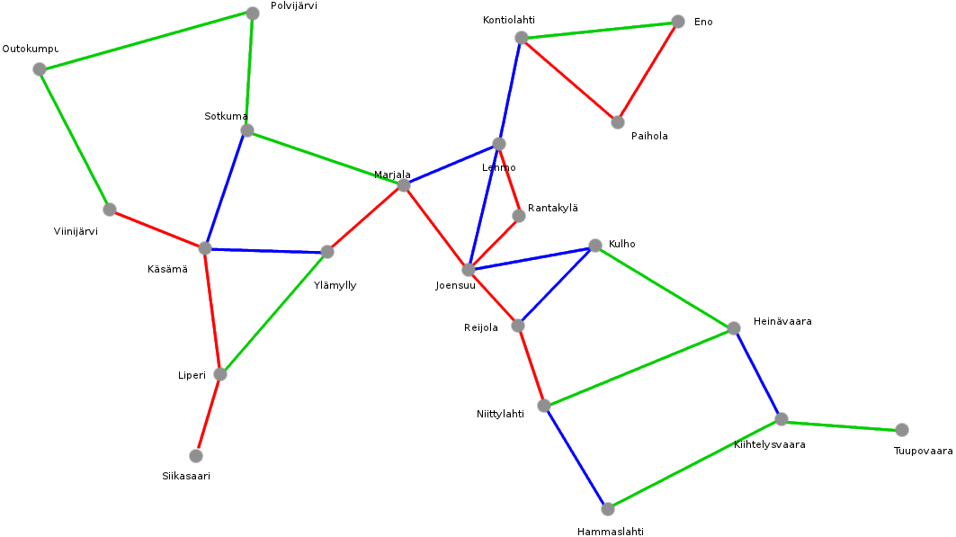
This is a picture representation of the library topography.

