PROBLEM SET 3
Due on Monday April 4, 2022, 10:00 am ET

I - INSTRUCTIONS

To successfully complete this problem set, please follow these steps:
- Download this Word document file into your computer and download the datasets into a data subfolder in your problem set-specific RStudio Project directory.
- Insert your answers into this document and organize your code in a R script. You can also insert non-Word objects such as handwritten work or screenshots in your answers.
- Once your document is complete, please save it as a PDF.
- Please submit an electronic copy of the PDF and your replicable R script to the Canvas assignment page.
II - IDENTIFICATION
- Your information
Your Last Name: | Takata
Your First Name: | Kohei

(2) Group Members (please list the classmates you worked with on this problem set):
Compliance with Harvard Kennedy School Academic Code (mark with an X below)
 | Yes | No
I certify that my work in this problem set complies with the Harvard Kennedy School Academic Code | X

For this problem set, we will be examining the following paper:

Stevenson, Betsey, and Justin Wolfers. 2006. "Bargaining in the Shadow of the Law: Divorce Laws and Family Distress," Quarterly Journal of Economics, 121 (1): 267-88.

Tips: For this problem set, you may find it more efficient to go back and forth between the conceptual and data analysis questions, as many questions are paired.
Instructions: Please keep your answers concise. Most subquestions can be answered in 1-2 sentences. Bolding or italicizing keywords also help grading.

Conceptual Questions

- Read the paper.
  - Clearly state the primary research question that the authors are trying to answer.
Questions are how the unilateral divorce changed family violence and whether the option provided by unilateral divorce reduced suicide and spousal homicide

  - In 2-3 sentences, explain the main finding of the paper using non-technical jargon, as if you were writing a brief policy memo.
Authors found that unilateral divorce reduced female suicide by 8-16 % in the states introduced the law. Further, they also found a 30% decline of domestic violence for both men and women. In addition, they found a 10% decline in females murdered by their parents.

  - What are the two mechanisms that the authors discuss by which unilateral divorce laws may have reduced suicide rates among married women?
First, the act allows women to end the relationship unilaterally, if she felt her marriage was not successful. Second, women can take advantage of the threat of divorce to prevent husband from abusing her.

- The authors used a difference-in-differences (DD) design because they believed a comparison between state-years with and without unilateral divorce to be lacking. What are two possible confounders that would bias the results from a simple comparison and are hard to measure? Explain the mechanism of the omitted variable and use the omitted variable bias formula to argue whether it would lead to an understatement or overstatement of the true effect.
Confounders can be found in time trend.

- Macroeconomic factor
If the economy in the US was not doing in that time, that could have increased the number of suicide. Therefore, authors need to do DD to take a counterfactual into account. Otherwise, they would overestimate the impact of unilateral divorce act.

- Gun control
I guess the most common way of suicide in the US is by gun. If the federal-government had tightened gun control policy at that time, that would reduce the number of suicide as it becomes more difficult to commit suicide by gun. Therefore, authors need to do DD to take a counterfactual into account. Otherwise, they would overestimate the impact of unilateral divorce act.

- The authors’ main regression is:
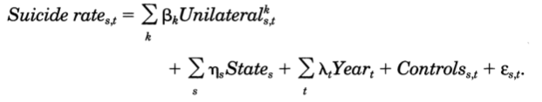
What kind of regression specification is this? Explain each term in the regression. How should we interpret the $β_{k}$ coefficients?
Specification: OLS.

The dependent variable (suicide rate): the suicide rate of all persons
The first term (unilateral): a series of dummy variables set equal to one if a state at year t had adopted unilateral divorce k years ago
The second term (state): state-fixed effects for state s
The third term (year): year-fixed effects for year t

\beta_k coefficients: the percentage change in the suicide rate due to the adoption of unilateral divorce laws k years ago

- What does the parallel trends assumption claim in this specific context? Why or why not do you think it is reasonable? Explain this in a way that someone not well-versed in statistics would understand.
The parallel trends assumption is the idea that without the treatment (adoption of unilateral divorce), the divorce rates in both treatment and control groups should have followed the same time trend (changed toward similar direction with the similar degree). I believe this is not reasonable, as there should be many factors which affects on divorce rate, and factors may have changed only in some states. Especially, in this case, the authors attempted long-term comparison, such as difference in 20 years later. I would have been convinced if it is more short time span. But I believe I need to be careful for the parallel trends assumption for the long-term comparison because many other things could happen during that period.

- The authors use the suicide rate for all women, not just those who have been married, “to avoid endogeneity problems posed by the possibility that marriage decisions may respond to divorce regime.” Give one example of such an endogeneity problem. How would it bias the results?
The exogenous factor is unilateral divorce, and that would increase divorce rate. But the divorce may affect on suicide rate. For example, divorced women without enough income tend to commit suicide. In that case, looking at only married women cannot capture the whole impact cause by the adoption of unilateral divorce, and that would underestimate the whole impact.

- Comment on how the effect of divorce laws on male suicide differ from their effect on female suicide. Given the difference in baseline suicide rates for men and women, would you expect the elasticity of male suicide to be different from the elasticity of female suicide with respect to unilateral divorce laws?
According to Table1, there was not significant effect of unilateral divorce on the number of male suicides.
The suicide rate in baseline is higher for men than women. Thus, it is still possible to be the same elasticity for both men and women, even if the percent change is larger.
e. g. Given the same number of population,
(100% => 80%: 20% decline,
30% => 10%: 66% decline) But both have the same elasticity.

- Give two ways that Figure I increases the credibility of the results presented in Table I. Would you change anything about how Figure I is presented?
- The figures by age shows the decline in suicide was especially strong for prime age women, which I believe the marriage relationship can be more unstable than other generations. The decline for old generation was small, as this can be the result of survival bias (women with bad marriage had committed suicide already). Of course, there was not significant change in young generation, as they should not have been married yet. All of these observations match author’s story, so it increases credibility.
- All figures support the parallel trend assumption, as the coefficients are close to zero before the treatment. This also increases credibility.
- If I can change one thing, I would change the range of shadow from 1 S.E. to 1.96 S.E. because it is hard to see whether the coefficients are significant or not at a glance.

- The authors present DD estimates of the effect of unilateral divorce laws on domestic violence in Table II. The first row presents the results from a simple DD and the next three rows sequentially add controls to address concerns about bias.
  - What is one potential source of bias in the DD with state fixed effects and individual-level controls that would be eliminated by the addition of state-level time-varying controls?
Difference in economic situation. Recession can be positively correlated with suicide through higher unemployment rate. Therefore, by controlling time-varying controls, the bias can be eliminated.

  - What is one potential source bias in the DD that remains even after the addition of all these controls?
Unobservable state-level varying factors.
DD generally assumes those unobservable factors are controlled, based on the parallel trends assumption, which can be checked from past trends. However, no one knows whether it is really controlled in the experiment period.
In this case, for example, some famous local celebrities’ suicide might have changed the attitude toward suicide, which can increase in the number of suicides in some states. But, this is not generally observable and difficult to control the impact as this have never happened before. Therefore, this would overestimate the impact of unilateral divorce.

- The authors present estimates of the effect of unilateral divorce laws on intimate homicide in Table III. What is the regression specification they run (Hint: Read the note to Table III)? Write down the regression equation and describe the estimator’s relationship to a simple DD.
$$Intimate Homicide _{s,t}=β*Unilateral_{s,t}+\sum_{s}{η_{s}State_{s}+\sum_{t}{λ_{t}Year_{t}}}+Control_{s,t}+ε_{s,t}$$
Here, the specification is two-way FE. Compared to a simple DD case, we have one estimate for the entire post-period, while DD only compares changes in specific time period.

- Figure II plots an event study of the effect of unilateral divorce laws on intimate homicide.
  - What concerns does this figure raise?
Even before the adoption of act, authors found downward trends of intimate homicide. We are left to judge whether this decline in homicide predated the law change to an extent that undermines our results.

  - How does the triple-difference (reported in column 4 of Table III) address some of these concerns?
Instead of assuming that, in the absence of divorce reform, intimate homicide would remain unchanged, the triple difference assumes that the change in nonintimate homicide is the relevant baseline. So the changes from the changes in nonintimate homicide is the causal effect of unilateral divorce.

  - Write down a regression equation to estimate the triple-difference results in Table III.
Assuming the control variables are the same for intimate homicide and nonintimate homicide. The regression formula should be as follows. The only change for the triple difference is the input (the gap between intimate homicide and nonintimatehomicide)

- Regression for intimate homicide
$IntimateHomicide_{s,t}=β*Unilateral_{s,t}+\sum_{s}{η_{s}State_{s}+\sum_{t}{λ_{t}Year_{t}}}+controls_{s,t}+ε_{s,t}$

- Regression for nonintimate homicide
$NonIntimateHomicide_{s,t}=\hat{β}*Unilateral_{s,t}+\sum_{s}{\hat{η_{s}}State_{s}+\sum_{t}{\hat{λ_{t}}Year_{t}}}+controls_{s,t}+\hat{ε_{s,t}}$

- Triple difference
$Homicide_{i,s,t}=β*intimate_{i}*Unilateral_{s,t}+α*Unilateral_{s,t}+γ*intimate_{i}+\sum_{s}{\left(\hat{η_{s}}\right)State_{s}+\sum_{t}{\left(λ_{t}\right)Year_{t}}}+controls_{s,t}+^{}ε_{s,t}$

- What is a specific example of a potential threat to a) internal validity and b) external validity in this study?
- Internal validity: spillover effect. If the resident can change the state easily, a couple who want to divorce may move to a state with unilateral divorce act. In that case, this would underestimate the effect of unilateral divorce on suicide because it would decrease the number of suicides in a state where a couple lived.
- External validity: norm of suicide. Even if unilateral divorce act is adopted, women cannot divorce due to religious pressure in the religious region. In that case, the effect of unilateral divorce on suicide can be smaller in that region.

Data Analysis

For this problem set, you can rely on a two-part demo: constructing variables for DD, and estimating DD coefficients with the two-way fixed effects estimator. A data appendix at the end describes the dataset and the key variables.
In this section, we will estimate the effect of unilateral divorce laws on female suicide. In the problem set link, we have provided a lightly cleaned version of their main analysis files: stevenson_wolfers_210.dta. Keep this file in a subfolder called data of your problem set Rstudio Project; this will facilitate our submission verification described at the end of this part. The data we are using is available from Justin Wolfers’ website.
- We will begin by estimating a simple 2x2 difference-in-differences regression.
  - The year in which the greatest number of states passed unilateral divorce laws was 1973. Using data on states that passed unilateral divorce laws in 1973 and those that never passed unilateral divorce laws, run a simple 2x2 DD regression to estimate the effect of unilateral divorce laws on ln(suiciderate_jag) for women, clustering standard errors at the state level. Report the estimated effect and the standard error below.
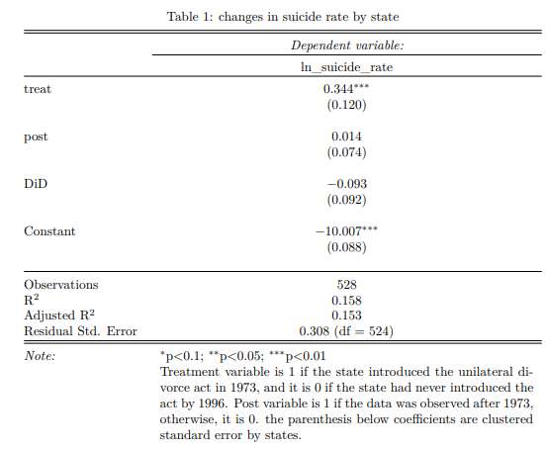

  - Interpret the point estimate. Explain which treatment/control groups are being compared so that someone without statistical training could understand.
The coefficient of treat suggests the average difference in the divorce rate between the treated in 1973 and the non-treated until 2000 was 34.4 %. The coefficient of post suggests the average change in the divorce rate from 1964-1973 to 1974-1996 regardless treatment was 1.4 % of increase, under the parallel trends assumption. The coefficient of DiD suggests the average difference in changes in the divorce rate from 1964-1973 to 1974-1996 between the treated in 1973 and the non-treated until 2000 was -9.3% of decrease. In short, the divorce reform reduced the divorce rate in the treated in 1973 by 9.3%, on average.

  - Are the results significant? Can you rule out substantively meaningful effect sizes?
No, the effect is not statistically significant, as the p-value is larger than 0.05. However, given the relatively large coefficients, the substantively meaningful effect cannot be ruled out.

- Now we will assess whether the parallel trends assumption is reasonable in this setting by estimating an event study, pooling data from all the states.
  - Consider the following event study regression specification:
$$Y_{st}=\sum_{j≠-1}{β_{j1}\left(t-divyear_{s}=j\right)}+γ_{s}+δ_{t}+ϵ_{st},$$
Interpret the coefficients.

After controlling states (γs) and years (δt), (t − divyears = j) shows the year t-j, where j is the year when the unilateral divorce act introduced. Then, Yst shows the level of divorce rate in a state s at time t. Therefore, βj implies the treatment effect for each year before/after the introduction of the act, holding others constant.

  - Plot the event study, being sure to include confidence bands as well as point estimates (Hint: Follow Andrew Goodman-Bacon’s mini-guide here).

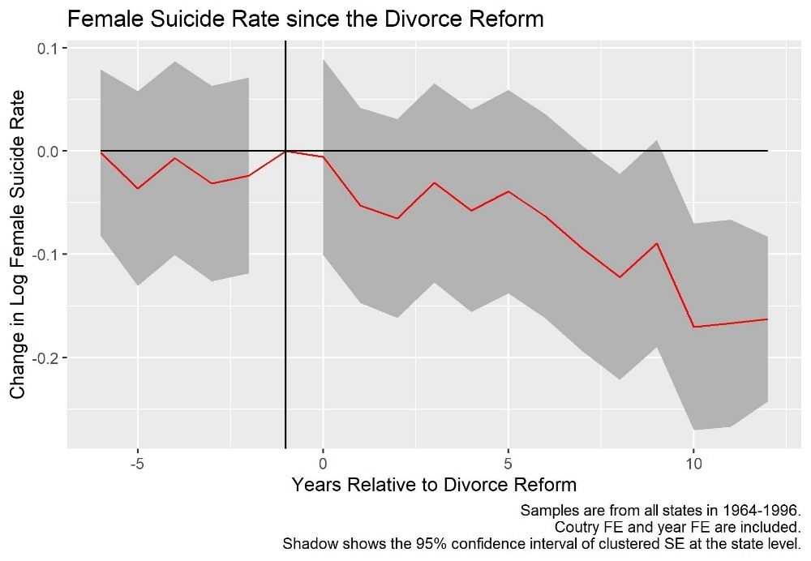

  - Interpret the figure. Does it support the parallel trends assumption? How do the effects of the reform appear to unfold over time?
If the parallel trends assumption does not hold, the coefficients before the treatment can be significantly different from 0. This is because potentially some other factors may affect the divorce rate before the divorce reform. The chart above shows that coefficients before treatment are not statistically different from 0. Therefore, the parallel trends assumption hypothesis cannot be rejected by that.
The effect of divorce reform appears to be tangible as time goes by since the reform. The chart shows the coefficients after t=10 are negatively significant.

- Now estimate the pooled DD effect using a two-way fixed-effect regression specification.
  - Report the coefficient and standard error clustered at the state level. How does the point estimate compare to the simple 2x2 estimate from question 12? How do the standard errors compare?

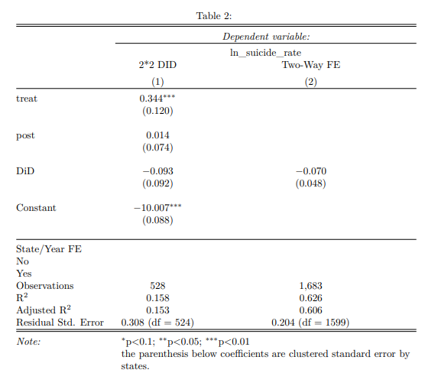

Both the point estimate and SE became smaller in model (2) than (1).

  - How should we think about the two-way fixed-effects estimate? What comparisons are being made? How many are there? Categorize these comparisons into four distinct groups.

The formula of two-way Fixed Effect model is as follows.
$$Y_{st}=β*treament_{st}+γ_{s}+δ_{t}+ϵ_{st}$$
$β$ is the estimate of treatment effect for the entire post-period. Under the parallel trends assumption, the combination of state and year fixed effect can control all the difference in initial level and time trend. Thus, the remained average difference between treated and non-treated should be $β$.

There are only two types in equation: whether treatment variable is 1 or 0.
In type 1(treatment =1), there are two groups.
1. state where the act had been introduced since 1964.
2. state where the act had been introduced during 1964-1996; post-introduction

In type 2(treatment =0), there are two groups.
3. state where the act had never been introduced until 1996.
4. state where the act had been introduced during 1964-1996; pre-introduction

  - Given the event study you estimated in question 13, what concerns might you have about some of these comparisons? Do you think the two-way fixed-effects estimate may be biased? If so, in what direction?
In Question 13, I showed there is a downward time trend in the coefficient of the treatment effect. As time goes since the introduction of the act, the effect becomes negatively more significant. However, as the treatment effect in the two-way fixed effect model captures the average treatment effect for the
entire post-period, this cannot capture the dynamics of the coefficient in Q13. Therefore, there is a risk of bias in two-way fixed effects. In this case, because there is a downward time trend in the negative value, the beta can be overestimated in the short run, and underestimated in the long run

DDs in Your Own Work

- Drawing from your own experience and interests, suggest a question that you might try to answer using a difference-in-differences model. As you think through what this would entail, explain the following aspects of your proposed analysis:

  - Propose a specific policy question. Explain why you think this is an interesting and important policy question. Provide evidence that there is not already a conclusive answer to this question.
The effect of school closure during COVID on SAT. It is hard to provide evidence for “not” conclusive or not as I need to confirm there is ‘not’ such a paper.
Anyway, this topic is still new. SO I believe there is not conclusive answer yet.

  - Describe your treatment group.
Student who experienced school closure during COVID.

  - Propose a comparison group and explain why you chose that group. In your answer, make sure to explain what the parallel trends assumption would mean for your analysis and whether you think that assumption will be satisfied.
Comparison group is students who did not experienced school closure. The parallel trends assumption in this case is that students should have the parallel trend for SAT score. And I believe this is reasonable because there should be a common trend for the average score of SAT, depending on difficulty of question in the year.

  - Describe the fixed effects that you would use in your difference-in-differences specification.
School and Years

  - [Optional] Describe how you would cluster your standard errors, if at all.
School

  - Provide three examples of confounding issues that would be addressed by using the fixed effects that you include.
      - Average SAT score every year can be addressed by the year fixed effect.
      - School teaching quality effect can be addressed by the school fixed effect.
      - Student ability effect can be addressed by the school fixed effect.

  - Provide three examples of additional issues that might still bias your estimates despite using a difference in differences specification. How might you consider addressing those issues?
School-level varying factors: such as
      - School budget for online teaching:
This may change the impact of online teaching.
      - Retirement of effective teachers
This may suddenly change the quality of teaching in that school.
      - Whole COVID cases in the area:
This may change the impact of school closure as students can be really stressed out.
For (1) and (3), these can be included in the regression formula as control variables. But, (2) is a kind of unobservable variable. So, it is hard to control.

Reminder: please include your replicable separately in your submission.

Appendix for Data Analysis

Variables
The data for this problem set is a state-by-year panel. Observations are uniquely identified by state, year, and sex. The data has the following key variables:
- st and year are the state and year variables.
- sex indicates whether the outcome is observed for males or females. It is coded as 1 for males and 2 for females.
- divyear is the year of unilateral divorce reform.
- unilateral indicates whether unilateral divorce is legal.
- suiciderate_jag is the suicide rate.

Coding Hints
Question 12 (a) – Suggested Steps:
- Basic data cleaning.
  - Select only relevant observations. (Which gender? For what variable do we need to remove the NAs?)
  - Remember we’ll be looking at the log of the suicide rates! Create a new variable.
  - You may want to change the class of st and year .
- Create variables specifically for 2x2 DiD
  - Create a new dataset for this regression. You will need to create 3 new variables: “treat”, “post” and “treat*post” (the product of the first two).
  - Treat: it should be 1 for the observations that are treated (year of unilateral divorce reform passed in 1973), and 0 for not treated (never had unilateral divorce reform in our timeline, i.e., reform passed in 2000).
  - Post: year of treatment is 1973, so the post-period should be 1 for the years after 1973.
  - Only keep the treated and control observations, as defined in the question. In other words, we only want to keep observations for which the reform was passed in 1973 and in 2000.
- Run 2x2 DiD
  - You can use felm.
  - Remember to cluster the st. errors at the state level.

Question 13 (b)
- Create variables for event study.
  - Create a new dataset for the event study
  - The key variable you want to create here is “lag”: a reference “time” variable that tells you for each observation how far the year is from the time of treatment. For instance, if the reform passed in 1973 in one state, 1972 should have lag=-1, 1974 should have lag =+1, etc. If another state passed the reform in 1980, observations in that state should have lag =-5 for 1975, lag =3 for 1983, etc.
  - Only consider 6 periods before the treatment, and 12 periods after. (so lag should be between -6 and 12). You can force lag to be -6 for all the periods before, and 12 for all the periods after.
  - You want to relevel lag so that your reference year is the year before the treatment (careful here: if lag is a factor, that would be the 6th factor in order!)
- Estimate event study.
  - Use felm, remember to add state and year FE, and cluster st. error at the state level.
- Plot event study – suggestions:
  - Plot the lag variable you created on the x axis.
  - You can use geom_ribbon to plot the confidence intervals (specify ymin, ymax within aes).
Question 14
- Careful here: the treatment here is whether unilateral divorce is legal or not.

We abide by the Harvard Kennedy School Academic code for all aspects of the course. In terms of problem sets, unless explicitly written otherwise, the norms are the following: You are free (and encouraged) to discuss problem sets with your classmates. However, you must hand in your own unique written work and code in all cases. Any copy/paste of another’s work is plagiarism. In other words, you can work with your classmate(s), sitting side-by-side and going through the problem set question-by-question, but you must each type your own answers and your own code. For more details, please see syllabus.

