

Name: Keith Ng Khooi Yang, NRIC: S8171117 H

Address: Blk 672C #10-558 Yishun Ave 4 S(763672)

Email: master.keith81@gmail.com Contacts: 8932 6513 Date of Birth: 05/07/1981

**Cyraphim Pte Ltd (IoT Vendor)**

Job Title: Business Development Manager (Team Manager)

Start Date: Feb 2018 End Date: 31 March 2020

**Job Description**:

* Understand and assist in getting customer data for workflow consulting in the space of Internet of things (IoT).
* Drive technology adoption and collaborations with government and institutions.
* Develop high quality business strategies and plans ensuring alignment with short-term and long-term objectives
* Lead and motivate Team / Channel partners to advance engagement develop a high performing results.
* Oversee all operations and business activities to ensure they produce the desired results and are consistent with the overall strategy and mission
* Make high-quality investing decisions to advance the business and increase profits
* Enforce adherence to legal guidelines and policies to maintain the company’s legality and business ethics
* Review financial and non-financial reports to devise solutions or improvements
* Build trust relations with key partners and stakeholders and act as a point of contact for important shareholders
* Analyse problematic situations and occurrences and provide solutions to ensure company survival and growth
* Maintain a deep knowledge of the markets and industry of the company
* Works with customers to streamline company policies and rules
* Oversees budgets to make sure there are no unnecessary expenditures
* Develops and directs all networking safeguards to reduce the risk of outside breaches and protect sensitive internal and external client information
* Evaluates new technology and makes recommendations on technological solutions
* Uses technological assets to help ease use for employees and clients
* Consistently evaluates technical efficiency and influence changes as necessary
* Identifies competitive advantages and technological trends for the benefit of a company
* Directs the development and possible implementation of policies in instances of a breach, also known as disaster recovery plans

**Singapore Telecommunication Ltd (Singtel Ltd)**

Job Title: Cyber Security Sales Specialist (FSI Global Accounts)

Start Date: March 2017 End Date: Jan 2018

**Job Description**:

* Drive strategic business development for security in Singapore and regionally and working with counterpart to ensure profitability & sustainable revenue and market share for Singtel and affiliates’ security growth.
* Formulate strategy and plan to drive growth and new business inclusively of short and long-term goals in achieving number with the account teams.
* Collect and consolidate market competitive information, analyses and propose solutions to ensure Group’s products and services remain competitive.
* Devise focus accounts and products / solutions strategic development and understanding of niche and constructing corporate niche to maximize growth and customers’ retention.
* Share and guide counterparts / team in developing new market vertical and focused products / solutions niche and play s as to ensure early stage customer and solution foothold.
* Ensure successful collaboration between internal / Group or various business units with all functions / countries to ensure successful on board of customers and key / regional customers & projects.
* Manage product life cycle, software lifecycle and moving trends and upcoming technology trends / new security threats.
* Manage business RFPs/ tenders and principal’s leads and to ensure projects timeline are met.
* Primary sectors FSI, Enterprise.
* Ground breaking for new accounts for OCBC Group and SGX and its members.
* Vendors Management, Client management, Alliances management.

**Key Success:**

Won Cyber training with OCBC, BOS GEL penetration testing.

Won SGX Security rating solutions and training for Communications driven trainings.

Deustche Bank won threat isolation.

CIMB won Cyber security training.

Chubb Asia pacific for DDOS and consulting for security posture.

**Emerio GlobeSoft Pte Ltd ( a Company of NTT Communications )**

Job Title: Manager, Sales & Business Development

Start Date: Dec 2015 End Date: March 2017

**Job Description**:

* Drive strategic business development for security in Singapore and Malaysia and working with countries to ensure profitable revenue and market share, required to work very closely with NTT Communications and NTT Data wo ensure successful project consulting and deliveries such as IoTs.
* Formulate strategy and plan to drive growth and new business inclusively of short and long-term goals.
* Collect and consolidate market competitive information, analyses and propose solutions to ensure NTT Group’s products remain competitive.
* Devise focus accounts and products / solutions strategic development and understanding of niche and constructing corporate niche to maximize growth and customers’ retention and business development.
* Share and guide counterparts / team in developing new market vertical and focused products / solutions niche and play s as to ensure early stage customer and solution foothold.
* Ensure successful collaboration between internal / Group with all functions / countries to ensure successful on board of customers and key / regional customers & projects.
* Manage product life cycle, software lifecycle and moving trends and upcoming technology trends / new security threats.
* Manage business tenders and principal’s leads and to ensure projects timeline are met.
* Primary sectors Government, FSI, Enterprise.
* Ground breaking for new accounts for Ministry of Home Affairs.
* Vendors Management, Clients management, Alliances management.
* Developing sales and go to market strategies, plan lead generations and product marketing strategies.

**Key Success:**

Closed Ministry of Foreign Affairs and their oversea offices, IHIS.

**EGuardian Pte Ltd (IT Distributor)** Job Title: Arista & Aruba Product Manager

Start Date: Feb 2014 End Date: Dec 2015

**Job Description**:

* Own the solution sales activities within the sales process to gain the technical win and the customers trust in the area of Security Operations.
* Participate in solution led sales calls and prospect visits, qualifying the customer’s requirements
* Gather requirements, develop use cases, and fully understand the client's business needs and constraints.
* Be able to present Security Operations in terms of people, process, technology and how this solves the customers’ need and outcomes.
* Provide exemplary technical expertise on customer product and solution demonstrations
* Create unsolicited solution proposals and ensure it meets or exceed the customer’s requirements and is fit for the intended purpose.
* Ownership of the technical or solution response to RFIs/RFPs and orchestration of the virtual teams to help deliver a comprehensive consultative response.
* Present the solution proposal to the customer, demonstrate how we solve the customer’s requirements and how this aligns to the customers outcomes and differentiate from the competition
* When required, lead the proof of concept from engagement, ownership of all activities and orchestration, through to completion
* Retain a competent level of knowledge and technical hands on experience across McAfee Security Operations product portfolio.
* Keep abreast of security trends and industry analysts reports and leverage this knowledge to drive technical sales wins.
* Play a pro-active "Technical Account Management" role within your target accounts including building a trusted relationship, monitoring/managing customer issues in partnership with support, expand existing footprint and drive competitive displacements.
* A mentor for SEs and a team player, sharing best practices, providing feedback to product management
* Support customer beta activities and early adopter programs
* Participate in the Global Presales Enablement program, through delivery of formal classroom training

Key Success: National Art Gallery USD 3.6 million, Marina bay Sands USD 2.8 million. National Heritage board USD 1 million.

**Company Name: Kyi-Tech Solutions Pte Ltd (System Integrator)** Job Title: Business Development Manager

Start Date: August 2008 End Date: Dec 2013

**Job Description**:

* Turnkey solution for IT Network, data & IT security solutions
* Secondary solution formed up of IT Infrastructure, Hardware and Software Solutions and Performance Monitoring Solution. Inclusive of Data Center Security.
* To monitor individual and team target and strategies applied to help company achieve desired targets and profit.
* Vendors & Clients Management.
* Develop high quality business strategies and plans ensuring alignment with short-term and long-term objectives
* Lead and motivate subordinates to advance employee engagement develop a high performing managerial team
* Oversee all operations and business activities to ensure they produce the desired results and are consistent with the overall strategy and mission
* Make high-quality investing decisions to advance the business and increase profits
* Enforce adherence to legal guidelines and policies to maintain the company’s legality and business ethics
* Review financial and non-financial reports to devise solutions or improvements
* Analyse problematic situations and occurrences and provide solutions to ensure company survival and growth
* Maintain a deep knowledge of the markets and industry of the company
* Oversees IT budgets to make sure there are no unnecessary expenditures
* Develops and implements all internal communication systems, such as email and instant messaging
* Plans and implements proper Internet usage policies for employees
* Evaluates new technology and makes recommendations on technological solutions
* Uses technological assets to help ease use for employees and clients
* Consistently evaluates technical efficiency and direct changes as necessary
* Makes presentations to board of directors
* Identifies competitive advantages and technological trends for the benefit of a company
* Primary sectors FSI, Transportation, & Logistics

Key Success: SSMC 160k, Knight Frank 300k, Pacific International lines 280k, City Development 380k,

Comfort Delgro 400k, First Capital Insurance 40k, Eastern Group Rm 500k, Johor Land Rm 850k, KSL 280k

**Company Name: Autoscan Technologies Pte Ltd** **(System Integrator)** Job Title: Sales Manager (Team Lead)

Start Date: Nov 2007 End Date: July 2008

**Job Description**:

* Proposal / Projects Manage of Telemetric & Telemetry, GPS, RFID and RTLS solutions.
* Conduct Demo, Presentations, Proposals and Supervise site survey, site calibrations and projects management.
* Liaising and manage with resellers, partners and customers both local and oversea.
* Monitor quota and strategies applied, conduct reporting every week and bring up and anticipate any issues with regards to the delivery of projects.
* Analyze, evaluate market opportunities & Technology trends and execute appropriate sales strategy and program to improve sales team quota. Manage business tender and projects.

Key Success: UK taxi project 1.3 million; DHL 1.8 million, Schenker Logistics 1.8 million, Alexander Hospital 1.2 million

**Quantiq International Pte Ltd (IT Distributor)**  Job Title: Account Manager

Start Date: August 2004 End Date: Oct 2007

**Job Description:**

* Sales of IT security and monitoring through channel partners (sales & Presales) & direct end users’ engagements.
* GTM plans, Event, Workshop & Marketing campaigns to generate new leads.
* Present, Propose & provide sales & product update to channels & EU.
* Monitor Channels Pipelines / targets and execute strategies to help company achieve desired targets and profit.
* Analyze, evaluate Market / Technology and execute appropriate sales strategy and program to gain sales revenue & market share.
* Manage business tenders and principal’s leads and to ensure projects timeline are met.
* Primary sectors Government, FSI, Transportation, Logistics and Manufacturing.

**Key Success:**

Closed SSMC 250k, Straits Trading 180k, PIL 100k, Flextronics 250k, Agilent 350, NTUC Income 1.5mil.

**Education / Qualifications**

**Current: University of Northampton**

Course: Degree in Psychology and Counseling

Tentative Date of completion: Oct 2021

Current Certification : PMI PMP

Tentative Data of Completion : Dec 2020

**Completed** - **Higher Diploma in Psychology & Counselling**

Date: Sept 2017

**EC Council – Certified Ethical Hacker**

Date: November 2017

Some Other Certifications -

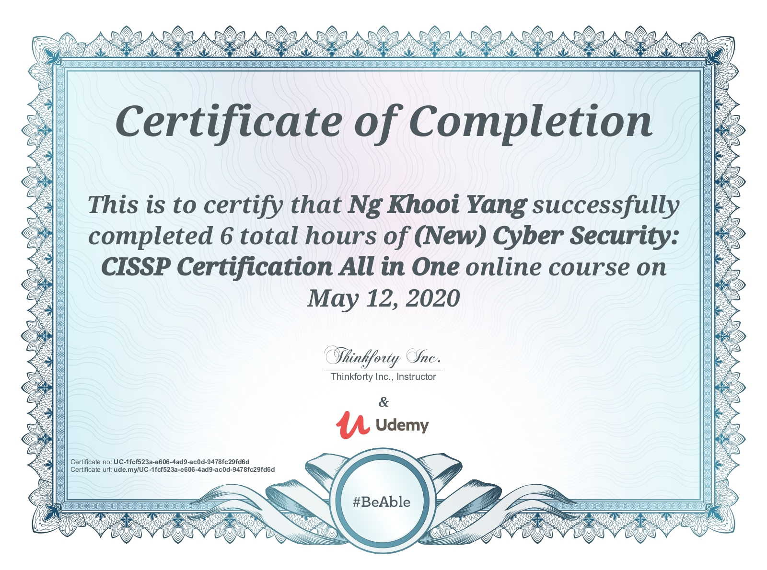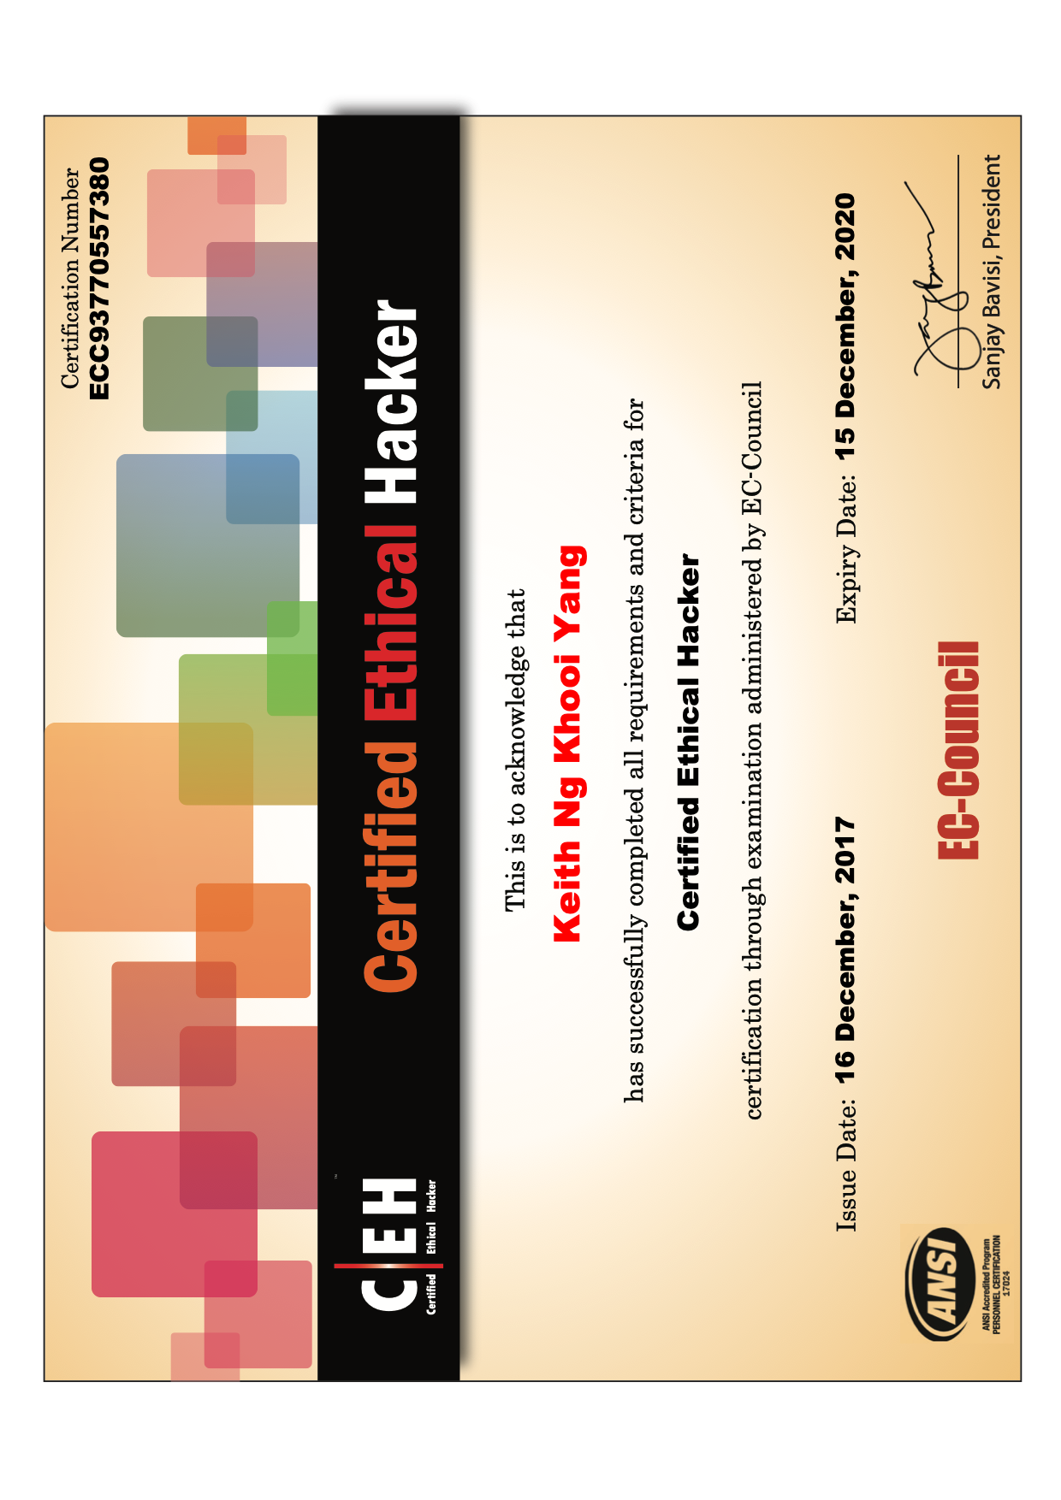



**Software Skills -**

Python 3, R, Flesk, Metaspoilt, Acunetix, Rapid7, Nmap, Visio, Nessus, Checkmarx, Kali Linux.

**University of Cambridge International Examinations**

Course / Major: Mass Communications Qualification: TMC/CIE Diploma End Date: May 2007

School Name: Teck Whye Secondary School Qualification: O’Level End Date: June 2000

**Core Skills –**

Big Picture & Strategic Thinking, Strong Verbal Communication, Organization Skills, Prioritizing, Balance, Multitasking, Industry Experience, Decisiveness, Persuasion, Flexibility, Open Schedule, Leadership Skills, Listening Skills, Business Acumen, Talents Identifications and Acquisitions.

Advanced IT Knowledge, Critical Thinking, Motivator, Technological Analysis, Research, Business,

Basic Computational Skills, Excellent Communication Skills, Public Speaking, Presentations, Team Building, Industry Knowledge, IT Terminology, Computer Network Development and Maintenance, Client Management