SmartFind: AI-Powered Lost & Found Management System
Topic: Multi-Agent AI System using LLM APIs for Real-World Lost Item Recovery in Public Transit

Abstract
Lost and found management in public transit is a slow, manual, and frustrating process for both passengers and transit staff. Items are logged by hand, descriptions rarely match, and most belongings are never returned to their owners. SmartFind is a multi-agent AI system that automates and modernizes this entire process using three distinct types of AI agents, each powered by a different existing AI service — no custom model training required.
When a passenger loses an item, they visit the SmartFind web application and chat with a Conversational Intake Agent powered by the Claude API (Anthropic). The chatbot guides them through describing the lost item — type, color, route, and time — in natural language. The extracted details are saved as a structured report. A Visual Matching Agent then uses the Claude Vision API to analyze photos of found items uploaded by transit staff, extracting structured visual features (item type, color, brand, markings) from each image. These extracted features are compared against the passenger’s lost item report by Claude, returning the top matches ranked by visual and descriptive similarity. A third agent, the Predictive Analytics Agent, runs nightly using Claude API (Haiku) (Google Cloud) to identify high-risk routes and stations from historical data and generate a daily hotspot map for transit authorities.
The backend is built in Go (Golang) for high-performance REST API and gRPC handling, and the AI agents are built in Python. A React frontend provides a passenger-facing web dashboard and a transit authority UI for managing found items, viewing hotspot maps, and tracking case resolutions. The project demonstrates how three specialized AI agents — a conversational intake agent, a vision-based image matching agent, and an analytics summary agent — all powered by the same Claude LLM, can be combined into a single working system to solve a complex real-world problem.

Group Members
# | Name | Role
1 | Saugat | Go Backend — REST API & Database
2 | Samarpan | Go Infrastructure — Docker, CI/CD, Cache & gRPC
3 | Suman | Python AI — All 3 Agents via Claude API (Intake, Vision Matching, Analytics)
4 | Murari | Frontend — React Dashboard & Transit UI

AI Agents
# | Agent | Service Used | Type | What It Does
1 | Conversational  Intake Agent | Claude API  (Anthropic) | LLM  (Generative AI) | Passenger opens the web app and types to the chatbot. Claude asks follow-up questions to collect the item type, color, route, and time. Once enough detail is gathered, it files a structured report automatically.
2 | Description  Matching Agent | Claude Vision API  (claude-haiku-4-5) | Vision + LLM  (Image Analysis) | When transit staff log a found item, they upload a photo. Claude Vision analyzes the image and extracts structured visual features: item type, color, brand logos, size, and distinguishing markings. Claude then compares these visual features against the passenger’s lost item report and returns the top 3 matches ranked by combined visual and descriptive similarity.
3 | Predictive  Analytics Agent | Claude API (Haiku)  (Google Cloud) | Tabular ML  (Prediction) | Runs nightly on historical loss records. PostgreSQL aggregates counts by station, route, and time window. Claude receives only the pre-computed data and writes a concise 3-sentence operational briefing for transit staff. SQL does the analysis, Claude writes the summary.

App Workflow
System Architecture
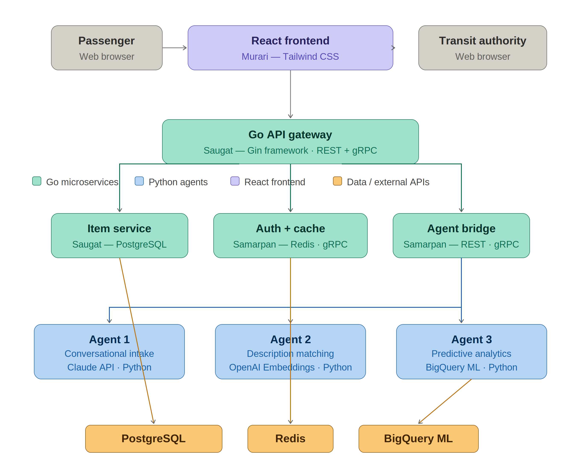
Step-by-Step Workflow
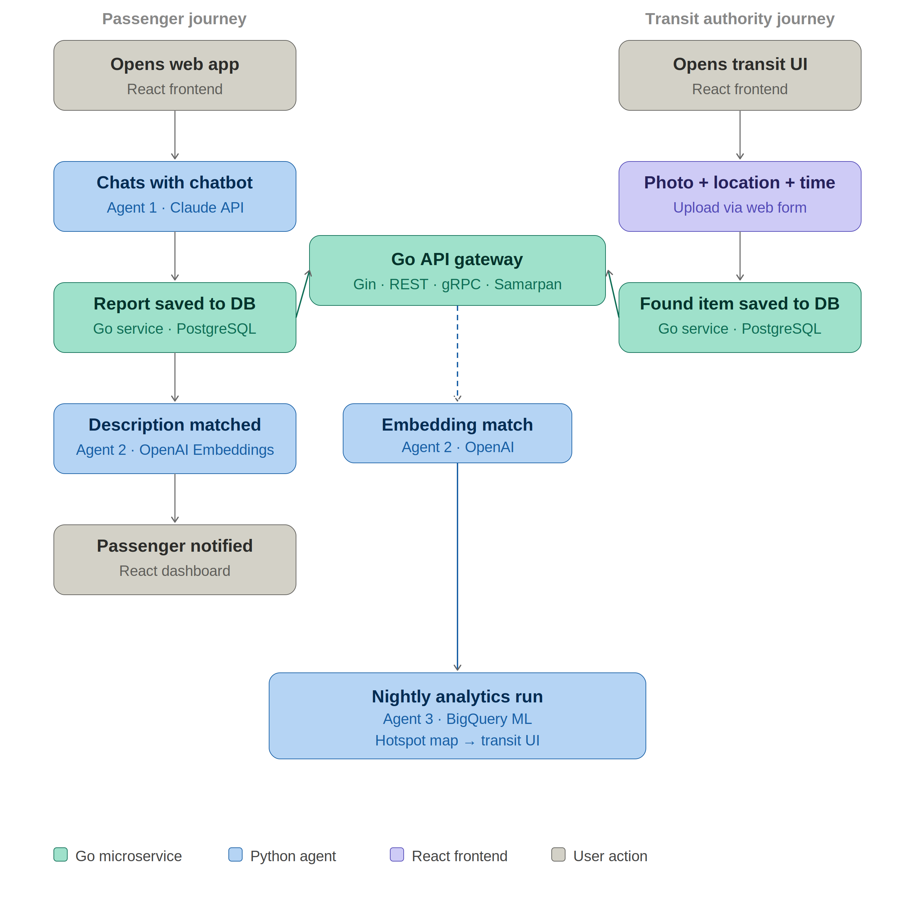

Project Gantt Chart — 1 Month Implementation Plan
PROCESS | WHO | WEEK 1 | WEEK 2 | WEEK 3 | WEEK 4
WEEK 1 — Foundation & Setup
Define contracts & JSON schemas  All agree on every API format | All
Set up repo, Docker & CI/CD  Samarpan creates the project structure | Samarpan
Go API Gateway — mock responses  Saugat builds fake endpoints for testing | Saugat
Python agent stubs  Suman creates 3 placeholder endpoints | Suman
Claude API key setup (all 3 agents)  Suman configures Claude API key, tests vision + text endpoints | Suman
Frontend project setup  Murari sets up React + Tailwind | Murari
WEEK 2 — Core Development
Go backend — real database  Saugat connects PostgreSQL, real queries | Saugat
Go REST & gRPC bridge to agents  Samarpan wires HTTP & gRPC calls to agents | Samarpan
Agent 1 — Claude API chatbot  Suman builds conversational intake via Claude API | Suman
Agent 2 — Claude Vision image matching  Suman builds image upload handler + Claude Vision feature extraction + LLM match scoring | Suman
Frontend — report lost item page  Murari builds the web chatbot report form | Murari
WEEK 3 — Agents & Integration
Agent 3 — Claude analytics (SQL + LLM summary)  Suman builds SQL aggregation + Claude LLM summary agent | Suman
Wire all 3 agents into pipeline  Go calls all 3 agents end-to-end | All
Frontend — dashboard & transit UI  Murari builds passenger & transit staff UI | Murari
Redis caching layer  Samarpan caches hot item & session data | Samarpan
End-to-end integration test  All test the full pipeline together | All
WEEK 4 — Testing & Delivery
Evaluate all 3 AI agents  Suman checks accuracy of each agent | Suman
Frontend — final polish & testing  Murari fixes bugs, tests all web pages | Murari
Prepare presentation  All build slides & rehearse the demo | All
Go Backend: Saugat (API), Samarpan (Infra) Python AI: Suman (Claude API — Intake, Vision Matching, Analytics) Frontend: Murari (React UI)

