**INITIAL NOTES**

**AS IS**

V (Vehicle) owned by O (Owner) 🡪 O sells it to B (Buyer) [B signs a paper contract]

Contract certified by A (Authority), B pays stamp to certify (+ eventual pays notary service if notary involved)

Sale recorded on certificate of ownership (owned by O)

B brings sale contract and certificate of ownership to PRA office (here B pays for transfer); PRA office records as new owner B

**TO BE**

V (Vehicle) owned by O (Owner) 🡪 O sells it to B (Buyer) [through digital contract]

Contract certified by A (Authority) working for PRA through checking the SPID of B [no stamp]

Sale recorded on digital certificate of ownership (stored in PRA Server) and PRA transfer the certificate of ownership to B (new owner), certified through SPID

**1.ORGANIZATIONAL MODEL**

PRA

Office (not used anymore in TO BE, now WebSite)

Authority

Owner

Buyer

**2a.PROCESS TABLE (TO BE [+AS IS])**

|  |  |  |  |  |
| --- | --- | --- | --- | --- |
| **NAME** | **INPUT** | **OUTPUT** | **DESCRIPTION** | **OU INVOLVED** |
| Selling | Vehicle | Digital contract | V (Vehicle) owned by O (Owner) 🡪 O sells it to B (Buyer) [through digital contract] | Owner  Buyer |
| Contract verification | Digital contract | Contract verified | Contract certified by A (Authority) working for PRA through checking the SPID of B [no stamp] | PRA (Authority)  Buyer |
| Sale recording (new ownership) | Sale | Certificate of ownership updated | Sale recorded on digital certificate of ownership (stored in PRA Server) and PRA transfer the certificate of ownership to B (new owner), certified through SPID (B receives confirm) | PRA  Buyer |

**2b.FUNCTIONAL MODEL (BPMN + UML class) of TO BE**

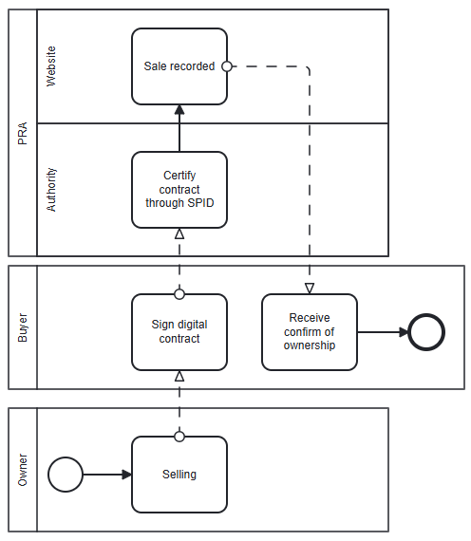

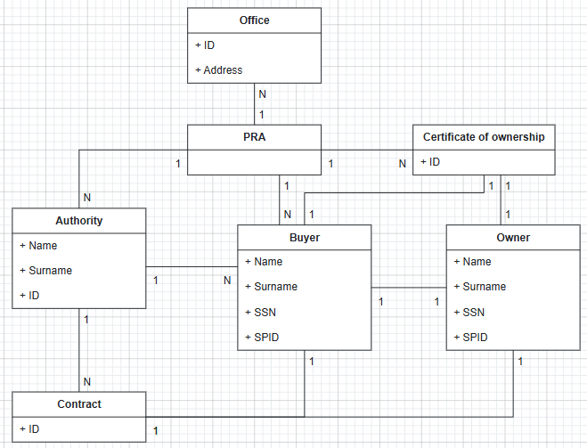

**3a.TECH MODEL (UML deployment) of TO BE**

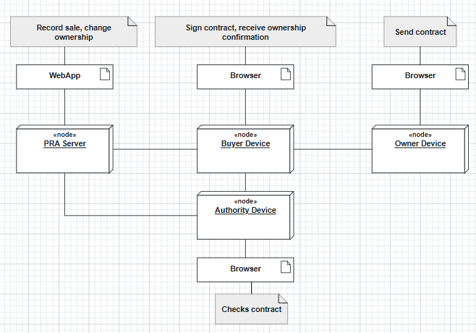

**3b.BUSINESS RULE** = a vehicle without tag can’t circulate

**5.KPI** (considering these high-level business goals (or CSF): CSF1 increase customer satisfaction, CSF2 reduce the cost of the process)

|  |  |  |  |  |
| --- | --- | --- | --- | --- |
| **CSF**  **Name** | **KPI**  **Category** | **KPI**  **Name** | **KPI Description** | **Unit of measure** |
|  | General | N_vehicles | Number of vehicles |  |
|  |  | N_contracts | Number of contracts |  |
| CSF2 | Efficiency | C_vehicle | Total cost of vehicles/number of vehicles | Euro |
| CSF2 |  | C_contract | Total cost of contracts/number of contracts | Euro |
| CSF1 | Service | LT_selling | Leading time from beginning of selling process to vehicle sold | t |
| CSF1 |  | LT_recording | Leading time from vehicle sold to sale recorded (+ change of ownership done) | t |
| CSF1 | Quality | Q | Non-conform contracts/total contracts | % |
| CSF1 |  | Q_S | Buyer satisfaction | % |

**6.COMPARISON AS-IS vs TO-BE using KPI**

|  |  |  |
| --- | --- | --- |
| **KPI** | **AS IS** | **TO BE** |
| N_vehicles | Number of vehicles | = |
| N_contracts | Number of contracts | More contracts because now contract is digital, so the process is faster and the contracts produced/checked are more |
| C_vehicle | Total cost of vehicles/number of vehicles | = |
| C_contract | Total cost of contracts/number of contracts | Now contract is digital, so the cost of a single contract is lower (no paper, all digital) |
| LT_selling | V (Vehicle) owned by O (Owner) 🡪 O sells it to B (Buyer) [B signs a paper contract]  Contract certified by A (Authority), B pays stamp to certify (+ eventual pays notary service if notary involved) | V (Vehicle) owned by O (Owner) 🡪 O sells it to B (Buyer) [through digital contract]  Contract certified by A (Authority) working for PRA through checking the SPID of B [no stamp]  So, the process if faster |
| LT_recording | Sale recorded on certificate of ownership (owned by O)  B brings sale contract and certificate of ownership to PRA office (here B pays for transfer); PRA office records as new owner B | Sale recorded on digital certificate of ownership (stored in PRA Server) and PRA transfer the certificate of ownership to B (new owner), certified through SPID  So, process is faster (and with less actors involved) |
| Q | Non-conform contracts/total contracts | Before checked with “marca da bollo”, now the authority uses digital SPID of Buyer to certify contract |
| Q_S | Buyer satisfaction | Thanks to faster processes and less responsibilities/actions taken by Buyer, Buyer’s satisfaction increase |

**7.SOFTWARE FUNCTIONS TO BE**

|  |  |
| --- | --- |
| **PROCESS/ACTIVITY** | **SW FUNCTION(S) NEEDED** |
| Selling | Send contract (Owner Device)  Receive and sign contract (Buyer Device) |
| Contract verification | Show SPID (Buyer Device)  Check (Authority Device) |
| Sale recording (new ownership) | Sale recorded and ownership transferred (PRA Server)  Receive confirm (Buyer Device) |

**8.PROS & CONS of implementing TO BE**

|  |  |  |
| --- | --- | --- |
|  | **PROS** | **CONS** |
| PRA | All process digitalized, so no cost on offices, more flexibility | Cost of IT infrastructure |
| Office |  | No more necessary |
| Authority | Easier and faster process thanks to SPID | Learning how to check using SPID |
| Owner | No paper involved, more flexibility |  |
| Buyer | No paper involved, more flexibility, no needed to pay “marca da bollo”; no needed to brings the contract to a office (all digital) | Learning how to sign digital contract and how to use SPID |

**9.TCO**

|  |  |  |
| --- | --- | --- |
| **PHASE** | **COSTS** | **CAPEX or OPEX** |
| **Construction**  **Selection** | Developing WebApp (PRA)  Developing IT infrastructure (PRA) | CAPEX |
| **Deployment** | Installing WebApp  Training Authorities/Employees | CAPEX |
| **Operation** | Electricity  Internet  Send/receive data (SPID) | OPEX |
| **Maintenance** | Device maintenance (Authorities)  Server maintenance (PRA)  WebApp bug fixes | OPEX |
| **Dismissal** | Dismiss  Data migration | OPEX |

**10.ROI (10 years used, so no dismissal in Year 5)**

|  |  |  |  |  |  |
| --- | --- | --- | --- | --- | --- |
| **Year/Cost or Saving** | **Year 1 (CAPEX)** | **Year 2** | **Year 3** | **Year 4** | **Year 5** |
| **Cost** | Construction  Selection  Deployment | Operation  Maintenance | Operation  Maintenance | Operation  Maintenance | Operation  Maintenance |
| **Saving** | Less error on contracts  More efficiency (more contracts per year) | Less error on contracts  More efficiency (more contracts per year) | Less error on contracts  More efficiency (more contracts per year) | Less error on contracts  More efficiency (more contracts per year) | Less error on contracts  More efficiency (more contracts per year) |

**11.Outsourcing (invento io per svolgerlo [faccio outsourcing di WebApp, ma è un pacchetto installato localmente e di data su cloud google])**

|  |  |  |  |  |
| --- | --- | --- | --- | --- |
| Object | **Activity/Service** | **Unicity** | **Location** |  |
| WebApp | Application | Shared | On-site | Outsourced |
| PCs, Laptops | IT infrastructure | Shared | On-site | Insourced |
| Google Cloud | Application/Cloud infrastructure | Shared | Off-site | Outsourced |

**DOMANDE:**

9)

10)

11)

12)

13)