**INITIAL NOTES**

NHS

Citizen (Fiscal code, age, income, type of illness, type of prescription)

Practitioner

**AS IS**

Citizen visits Practitioner 🡪 Practitioner decides other visits needed, produces RFT (request) from NHS

RFT digital (ID, Date) 🡪 recorded in NHS IS

Treatment (ID, nominal cost [paid from NHS to Entity who gives treatment], cost for citizen) 🡪 recorded in NHS IS

Citizen contacts Entity (gives RFT number, fiscal code, date for treatment)

Citizen accepted by Entity (Office checks RFT + issues invoice) 🡪 Citizen pays invoice (Payment System) 🡪 Then come back to Office, Office schedules treatment

Treatment delivery: Doctor performs Treatment and produces Report

Citizen comes back at Office and collects Report

**TO BE**

Citizen receives Report through e-mail

**1.ORGANIZATIONAL MODEL**

NHS

Practitioner

Entity

Office

Doctor

Citizen

Payment System

**2a.PROCESS TABLE (TO BE [+AS IS])**

|  |  |  |  |  |
| --- | --- | --- | --- | --- |
| **NAME** | **INPUT** | **OUTPUT** | **DESCRIPTION** | **OU INVOLVED** |
| Initial visit | Begin visit | RFT | Citizen visits Practitioner 🡪 Practitioner decides other visits needed, produces RFT (request) from NHS | Citizen  NHS  Practitioner |
| Contact entity | RFT, Fiscal code | Date for treatment | Citizen contacts Entity (gives RFT number, fiscal code, date for treatment) | Citizen  Entity |
| Acceptance | RFT | Schedule treatment | Citizen accepted by Entity (Office checks RFT + issues invoice) 🡪 Citizen pays invoice (Payment System) 🡪 Then come back to Office, Office schedules treatment | Citizen  Entity  Office  Payment System |
| Treatment delivery | Begin treatment | Report | Treatment delivery: Doctor performs Treatment and produces Report | Citizen  Entity  Doctor |
| Report received | Report | Report received | Citizen receives Report through e-mail | Citizen  Entity |

**2b.FUNCTIONAL MODEL (BPMN + UML class) of TO BE**

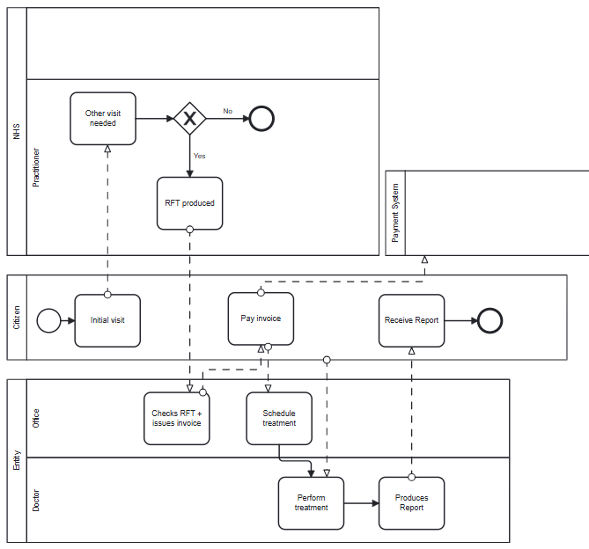

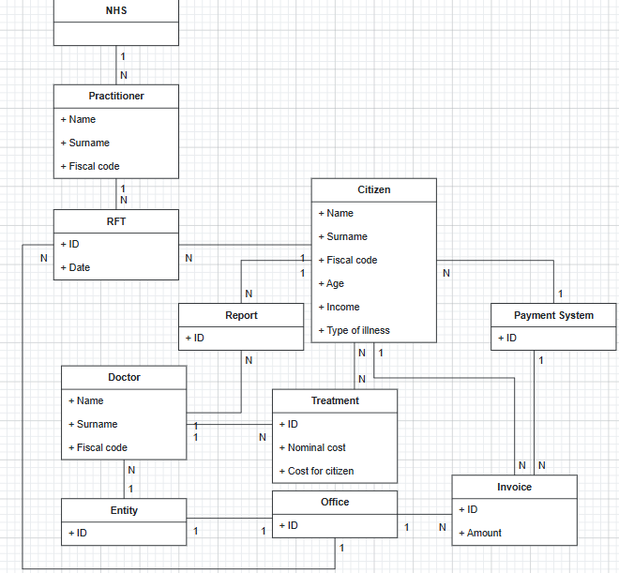

**3a.TECH MODEL (UML deployment) of TO BE**

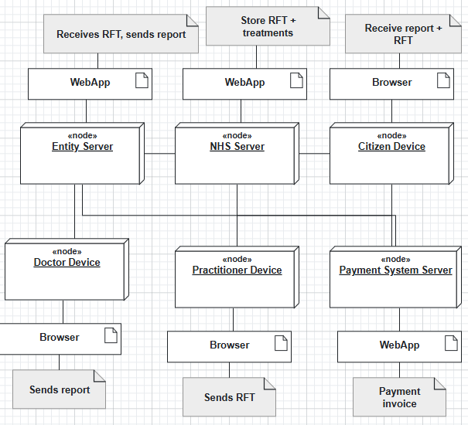

**3b.BUSINESS RULE** : No treatment can be delivered without a valid RFT

**5.KPI** (considering these high-level business goals (or CSF): CSF1 increase citizen satisfaction, CSF2 reduce the cost of the process)

|  |  |  |  |  |
| --- | --- | --- | --- | --- |
| **CSF**  **Name** | **KPI**  **Category** | **KPI**  **Name** | **KPI Description** | **Unit of measure** |
|  | General | N_RFT | Number of RFT |  |
|  |  | N_treatments | Number of treatments |  |
| CSF2 | Efficiency | C_treatment | Total cost of treatments/number of treatments | Euro |
| CSF2 |  | C_citizens | Total cost of treatments/number of citizens | Euro |
| CSF1 | Service | LT_RFT | Leading time between initial visit and RFT produced | t |
| CSF1 |  | LT_report | Leading time between treatment and result | t |
|  | Quality | Q | Non-conform RFTs/Total RFTs | % |
| CSF1 |  | Q_S | Citizen satisfaction | % |

**6.COMPARISON AS-IS vs TO-BE using KPI**

|  |  |  |
| --- | --- | --- |
| **KPI** | **AS IS** | **TO BE** |
| N_RFT | Number of RFT | = |
| N_treatments | Number of treatments | = |
| C_treatment | Total cost of treatments/number of treatments | Report is now digitalized and citizen doesn’t need to go to receive it, so less expenses |
| C_citizens | Total cost of treatments/number of citizens | Report is now digitalized and citizen doesn’t need to go to receive it, so less expenses |
| LT_RFT | Leading time between initial visit and RFT produced | = |
| LT_report | Leading time between treatment and result | Report is now digitalized and citizen doesn’t need to go to receive it, so less time |
| Q | Non-conform RFTs/Total RFTs | = |
| Q_S | Citizen satisfaction | Report is now digitalized and citizen doesn’t need to go to receive it, so more satisfaction |

**7.SOFTWARE FUNCTIONS TO BE**

|  |  |
| --- | --- |
| **PROCESS/ACTIVITY** | **SW FUNCTION(S) NEEDED** |
| Initial visit | Send RFT (Practitioner Device, NHS Server)  Receive RFT (Citizen Device) |
| Contact entity | Contacts entity (Citizen Device)  Checks RFT, Fiscal code + date (Entity Server) |
| Acceptance | Accepts citizen, receive invoice, schedule treatment (Entity Server)  Pays invoice (Citizen Device, Payment System Server) |
| Treatment delivery | Produce report (Doctor Device) |
| Report received | Send report (Entity Server)  Receive report (Citizen Device) |

**8.PROS & CONS of implementing TO BE**

|  |  |  |
| --- | --- | --- |
|  | **PROS** | **CONS** |
| Entity | Faster, not report on paper | Server must send the report to citizen |
| Office | Faster, not report on paper | The office has to send the report to citizen |
| Citizen | Faster, not needing to collect report |  |

**9.TCO**

|  |  |  |
| --- | --- | --- |
| **PHASE** | **COSTS** | **CAPEX or OPEX** |
| **Construction**  **Selection** | Developing WebApp  Developing IT infrastructure  Developing Web Mail System | CAPEX |
| **Deployment** | Installing WebApp  Installing Web Mail System  Training employees | CAPEX |
| **Operation** | Electricity  Internet  Send/receive emails | OPEX |
| **Maintenance** | Device maintenance (Doctor, Office)  Server Maintenance (Entity) | OPEX |
| **Dismissal** | Dismiss  Data migration | OPEX |

**10.ROI**

|  |  |  |  |  |  |
| --- | --- | --- | --- | --- | --- |
| **Year/Cost or Saving** | **Year 1** | **Year 2** | **Year 3** | **Year 4** | **Year 5** |
| **Cost** | Construction  Selection  Deployment | Operation  Maintenance | Operation  Maintenance | Operation  Maintenance | Operation  Maintenance |
| **Saving** | Less error on reports  More efficiency (more reports delivered per year) | Less error on reports  More efficiency (more reports delivered per year) | Less error on reports  More efficiency (more reports delivered per year) | Less error on reports  More efficiency (more reports delivered per year) | Less error on reports  More efficiency (more reports delivered per year) |

**11.Outsourcing**

|  |  |  |  |  |
| --- | --- | --- | --- | --- |
| Object | **Activity/Service** | **Unicity** | **Location** |  |
| Data space - cloud | IT infrastructure | Shared | Off-site (cloud) | Outsourced |
| Laptops | IT infrastructure | Unique | On-site | Insourced |
| ERP/CRM | Application | Shared | Off-site (external service) | Outsourced |

**DOMANDE:**

9)

10)

11)

12)

13)