**INITIAL NOTES**

**AS IS (solo se non cambia dal TO BE scrivi, altrimenti inutile)**

/*The office of the city administration operates a hot line. Citizens or employees of the administration (and the city police) can call the hot line to signal a malfunction.*/

**TO BE**

Tickets digital

City administration has DB of tickets and traffic lights; ticket has id and it’s linked to a traffic light.

Traffic light has ID and geolocalization

Citizen/police officer opens ticket using webpage; EXT (external company) is notified and takes charge of the ticket. When ticket closed: EXT writes result of the maintenance activity on webpage (adding cost [material + hours]); administration is notified and city police decide if checking the traffic light: if done, ticket enriched with the result of the inspection.

Administration can monitor maintenance activities, defectivity (traffic lights with malfunctions) and how many closed tickets are verified by the city police.

**1.ORGANIZATIONAL MODEL**

Administration

City police

Employees

EXT (external company)

Citizen

**2a.PROCESS TABLE (TO BE [+AS IS])**

|  |  |  |  |  |
| --- | --- | --- | --- | --- |
| **NAME** | **INPUT** | **OUTPUT** | **DESCRIPTION** | **OU INVOLVED** |
| Ticket opening | Ticket opened | EXT takes charge | Citizen/police officer opens ticket using webpage; EXT (external company) is notified and takes charge of the ticket. | Citizen or Police officer  EXT |
| Ticket closed | Ticket closed | Notify admin | EXT writes result of the maintenance activity on webpage (adding cost [material + hours]); administration is notified and city police decide if checking the traffic light | EXT  Administration  Police |
| Check the light | Decision ok | Ticket + inspection result | if decision of checking ok: check done, ticket enriched with the result of the inspection | Police Administration |
| Monitor | Monitoring | Monitoring result | Administration can monitor maintenance activities, defectivity (traffic lights with malfunctions) and how many closed tickets are verified by the city police. | Administration |

**2b.FUNCTIONAL MODEL (BPMN + UML class) of TO BE**

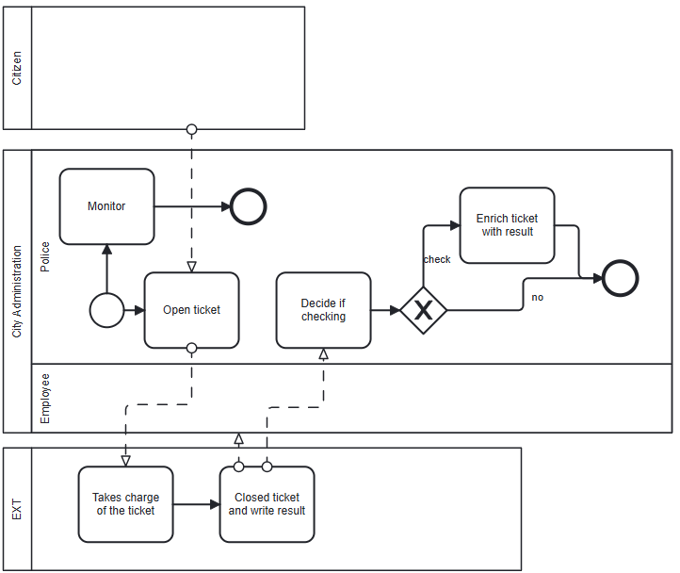

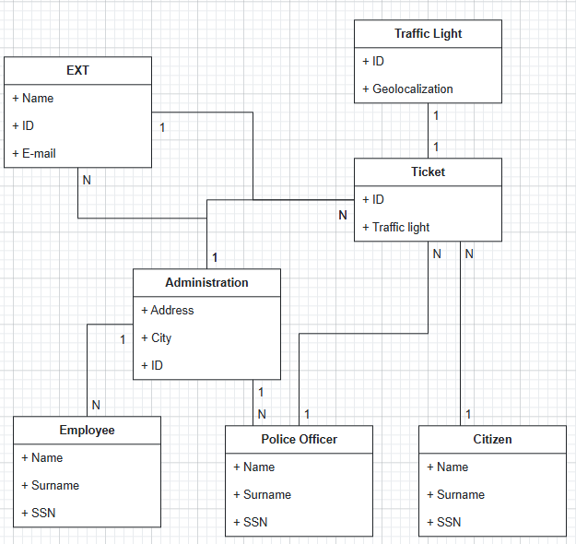

**3a.TECH MODEL (UML deployment) of TO BE**

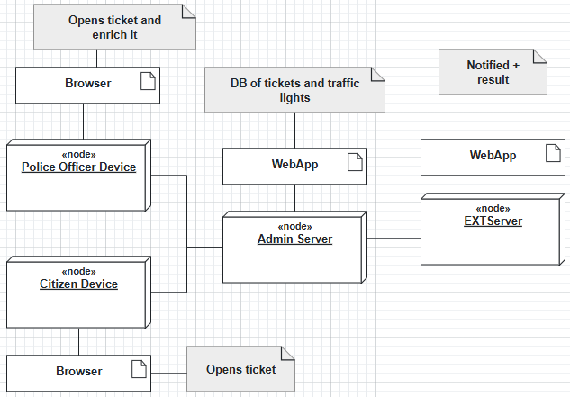

**3b.BUSINESS RULE** = the number of tickets invoiced by EXT corresponds to the tickets recorded

**5.KPI** (considering these high-level business goals (or CSF): CSF1 increase citizen safety, CSF2 reduce the cost of maintenance for the administration)

|  |  |  |  |  |
| --- | --- | --- | --- | --- |
| **CSF**  **Name** | **KPI**  **Category** | **KPI**  **Name** | **KPI Description** | **Unit of measure** |
|  | **General** | N_tickets | Number of tickets |  |
|  |  | N_checkings | Number of checkings |  |
|  | **Efficiency** | C_ticket | Total cost tickets/number of tickets | euro |
| CSF2 |  | C_checking | Total cost of checking/number of checks | euro |
| CSF1 | **Service** | LT_ticket | Leading time between ticket opened and ticket closed | t |
|  | **Quality** | Q | Non-conform tickets/total tickets | % |
| CSF1 |  | Q_S | Number of checking/total tickets closed | % |

**6.COMPARISON AS-IS vs TO-BE using KPI**

|  |  |  |
| --- | --- | --- |
| **KPI** | **AS IS** | **TO BE** |
| N_tickets | Number of total tickets | More tickets because it’s all digital so the leading time between ticket opening and closing is less |
| N_checkings |  | Checking is faster thanks to digital process, so more checks in a period |
| C_ticket | Total cost tickets/number of tickets | More tickets because it’s all digital (faster process) 🡪 cost of a single ticket is less |
| C_checking |  | Checking is faster thanks to digital process (more checks in a period), so the cost of a single inspection is less |
| LT_ticket | Leading time between ticket opened and ticket closed | Less thanks to digital |
| Q | Non-conform tickets/total tickets | Police can check now, so non-conform tickets are less |
| Q_S |  | Less (as above) |

**7.SOFTWARE FUNCTIONS TO BE**

|  |  |
| --- | --- |
| **PROCESS/ACTIVITY** | **SW FUNCTION(S) NEEDED** |
| Ticket opening | Open ticket (Police officer Device or Citizen Device)  Receive notification (EXT Server) |
| Ticket closing | Write result (EXT Server)  Receive notification (Administration Server) |
| Inspection | Start check (Police officer Device)  Receive enriched ticket (Administration Server) |
| Monitor | Monitor maintenance activities, defectivity (traffic lights with malfunctions) and how many closed tickets are verified by the city police (Administration Server) |

**8.PROS & CONS (Entities of the organizational model – Pros – Cons) of implementing TO BE**

|  |  |  |
| --- | --- | --- |
|  | **PROS** | **CONS** |
| Administration | More tickets, less leading time between ticket opening and closing, faster; doesn’t check the number of tickets; always active (not 8-20) | Cost of IT infrastructure |
| Employee |  | Not requested because he doesn’t receive call and doesn’t call the EXT |
| City police | Work more because now checks the traffic light | More work to do |
| EXT (external company) | Direct communication with administration | Cost of IT infrastructure |
| Citizen | Can now directly open a ticket |  |

**9.TCO (costs of implementing TO BE)**

|  |  |  |
| --- | --- | --- |
| **PHASE** | **COSTS** | **CAPEX or OPEX** |
| **Construction/Selection** | Developing IT infrastructure  Developing WebApp | CAPEX |
| **Deployment** | Training employees  Installing WebApp | CAPEX |
| **Operation**  **(raw material)** | Electricity  Internet  Send/receive data | OPEX |
| **Maintenance** | Device maintenance  Server maintenance (EXT, Administration)  WebApp bug fixes | OPEX |
| **Dismissal** | Dismiss  **Data migration** | OPEX |

**10.ROI**

|  |  |  |  |  |  |
| --- | --- | --- | --- | --- | --- |
| **Year/Cost or Saving** | **Year 1 (CAPEX)** | **Year 2** | **Year 3** | **Year 4** | **Year 5** |
| **Cost** | Construction, Selection, Deployment | Operation, Maintenance | Operation, Maintenance | Operation, Maintenance | Operation, Maintenance |
| **Saving** | Less errors on tickets  More efficiency (tickets per day) | Less errors on tickets  More efficiency (tickets per day) | Less errors on tickets  More efficiency (tickets per day) | Less errors on tickets  More efficiency (tickets per day) | Less errors on tickets  More efficiency (tickets per day) |

**11.Outsourcing**

|  |  |  |  |  |
| --- | --- | --- | --- | --- |
| Object | **Activity/Service** | **Unicity** | **Location** |  |
| Server | IT infrastructure | Unique | On site | Insourced |
| WebApp | Application | Unique | On site | Outsourced |

In **Object** mettiamo il *prodotto* in questione, in **Activity/service** mettiamo *IT* *Infrastracture* se si tratta di HW, *Application* se si tratta di SW, in **Unicity** mettiamo se è unico o no e in **Location** mettiamo *in* *site* (se si trova dentro l’organizzazione) o *off* *site* (fuori dall’organizzazione) infine diciamo se è Outsourced (proviene da un’azienda esterna) o Insourced (di proprietà dell’organizzazione).

**DOMANDE:**

9) Consider again the case of exercise 1. Now assume that the IT infrastructure is developed and maintained by company EXT (the company in charge of traffic light maintenance). The city administration accesses the ticket management application ‘as a service’ offered by EXT. What are pros and cons of this configuration?

City administration = pros 🡪 mustn’t administrate all the things (so less work to do), cons 🡪 not control on everything

EXT = pros 🡪 more control and more money, cons 🡪 more work to do and more things to administrate

10) In ITIL the service operation process must handle incidents, problems and events. Which is the difference between incident, problem, event?

Incident = unplanned interruption to IT

Problem = cause of incident

Event = detectable occurrence in IT

11) Considering the case of exercise 1, propose a few SLAs that the city administration could use to monitor the outsourcing relationship with EXT.

Cost, Response Time, Quality, Flexibility

12) Describe the multi sided business model, and provide an example of it

Sells to 2 or more different but interdependent customer segments (group of customers); an example is Esselunga that sells both food and gadgets.