**INITIAL NOTES**

**AS IS (solo se non cambia dal TO BE scrivi, altrimenti inutile)**

**TO BE**

Exam text is digital

Administration defines exam periods and, for each course and period, 1 or 2 exam sessions (takes place in VC in a time slot)

Student enroll in exam session for a course (but must have followed the course)

2 days before the exam session enrollment closes and Teacher receives the list of students enrolled

Exam text (now digital) is defined by Teacher on exam platform

University IS sends to all students enrolled a URL to access the exam platform; Student logs, Platform identifies student (ID on webcam); Student perform exam

End of exam 🡪 Teacher corrects exams (on platform) and publishes results + records them in University IS

**1.ORGANIZATIONAL MODEL**

University

Administration

IS

Teacher

Student

**2a.PROCESS TABLE (TO BE [+AS IS])**

|  |  |  |  |  |
| --- | --- | --- | --- | --- |
| **NAME** | **INPUT** | **OUTPUT** | **DESCRIPTION** | **OU INVOLVED** |
| Define period | Start definition | Exam and sessions defined | Administration defines exam periods and, for each course and period, 1 or 2 exam sessions | University  Administration |
| Enrollment | Student enroll | Student enrolled | Student enroll in exam session for a course (but must have followed the course) | University  Student |
| Receive list | List sent | List received | 2 days before the exam session enrollment closes and Teacher receives the list of students enrolled | University  Teacher |
| Exam definition | Exam definition | Exam defined | Exam text (now digital) is defined by Teacher on exam platform | Teacher |
| Exam | URL | Exam performed | University IS sends to all students enrolled a URL to access the exam platform; Student logs, Platform identifies student (ID on webcam); Student perform exam | University  IS  Student |
| End of exam | Exam | Result + record | End of exam 🡪 Teacher corrects exams (on platform) and publishes results + records them in University IS | Teacher  University  IS |

**2b.FUNCTIONAL MODEL (BPMN + UML class) of TO BE**

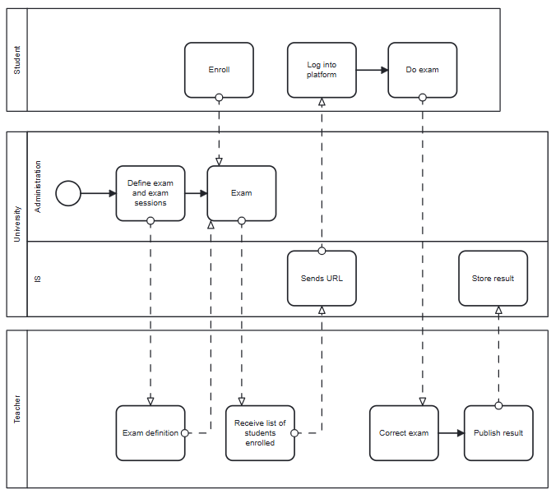

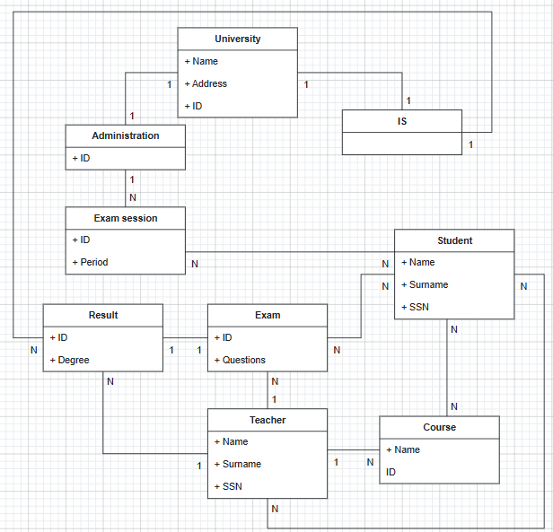

**3a.TECH MODEL (UML deployment) of TO BE**

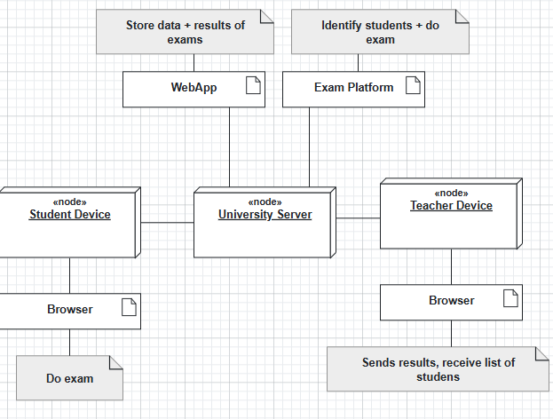

**3b.BUSINESS RULE** = to enroll the student must have followed the course

**5.KPI** (considering these high-level business goals (or CSF): CSF1 assure fairness (no cheating), CSF2 reduce the cost of exam management)

|  |  |  |  |  |
| --- | --- | --- | --- | --- |
| **CSF**  **Name** | **KPI**  **Category** | **KPI**  **Name** | **KPI Description** | **Unit of measure** |
|  | General | N_exams | Number of exams |  |
|  |  | N_students | Number of students |  |
| CSF2 | Efficiency | C_exam | Total cost of exams/number of exams | Euro |
|  |  | C_student | Total cost of students’ enrollments/number of students | Euro |
|  | Service | LT_exam | Leading time from student’s enrollment to exam done | t |
|  |  | LT_result | Leading time from exam done to result received | T |
| CSF1 | Quality | Q | Non-conform exams (cheating)/total exams | % |
|  |  | Q_s | Student’s satisfaction | % |

**6.COMPARISON AS-IS vs TO-BE using KPI**

|  |  |  |
| --- | --- | --- |
| **KPI** | **AS IS** | **TO BE** |
| N_exams | Number of exams | More exams, because are digital, so the correction is faster and more students can try the exam |
| N_students | Number of students | More students because also students that don’t live in the city of the University can try the exam so the enrollments increase |
| C_exam | Total cost of exams/number of exams | More exams, so cost is more distributed (less cost of a single exam) |
| C_student | Total cost of students’ enrollments/number of students | = |
| LT_exam | Leading time from student’s enrollment to exam done | = |
| LT_result | Leading time from exam done to result received | Faster because exams are digitalized |
| Q | Non-conform exams (cheating)/total exams | = |
| Q_s | Student’s satisfaction | Increase because students not in the city can do exam from home |

**7.SOFTWARE FUNCTIONS TO BE**

|  |  |
| --- | --- |
| **PROCESS/ACTIVITY** | **SW FUNCTION(S) NEEDED** |
| Define period | Define exam period (University Server) |
| Enrollment | Send enrollment (Student Device)  Receive enrollment (University Server) |
| Receive list | Close exam session and send list of students (University Server)  Receive list (Teacher Device) |
| Exam definition | Define exam (Teacher Device)  Receive exam (University Server) |
| Exam | Send URL and identify student (University Server)  Log and do exam (Student Device) |
| End of exam | Correct exam, publish results (Teacher Device)  Record results (University Server) |

**8.PROS & CONS of implementing TO BE**

|  |  |  |
| --- | --- | --- |
|  | **PROS** | **CONS** |
| University | More students enrolled, exams’ correction faster, students more satisfied | Cost of IT infrastructure |
| IS | More involved in exam correction and for URL sent | Not involved in exam enrollment, cost of IT infrastructure |
| Teacher | All digitalized, he doesn’t need to print paper and can modify exam if something is wrong | Need training to interface with exam platform |
| Student | Can do exam from home, more satisfied |  |

**9.TCO**

|  |  |  |
| --- | --- | --- |
| **PHASE** | **COSTS** | **CAPEX or OPEX** |
| Construction  Selection | Developing WebApp  Developing Platform  Developing IT infrastructure | CAPEX |
| Deployment | Installing WebApp  Installing Platform  Training teachers | CAPEX |
| Operation | Electricity  Internet  Send/receive data (exams) | OPEX |
| Maintenance | Device maintenance (Teacher)  Server maintenance (University)  Platform bug fixes | OPEX |
| Dismissal | Dismiss  Data migration | OPEX |

**10.ROI**

|  |  |  |  |  |  |
| --- | --- | --- | --- | --- | --- |
| **Year/Cost or Saving** | **Year 1** | **Year 2** | **Year 3** | **Year 4** | **Year 5** |
| **Cost** | Construction, Selection, Deployment | Operation, Maintenance | Operation, Maintenance | Operation, Maintenance | Operation, Maintenance |
| **Saving** | Less error on exams  More efficiency (more exams per year) | Less error on exams  More efficiency (more exams per year) | Less error on exams  More efficiency (more exams per year) | Less error on exams  More efficiency (more exams per year) | Less error on exams  More efficiency (more exams per year) |

**11.Outsourcing**

|  |  |  |  |  |
| --- | --- | --- | --- | --- |
| Object | **Activity/Service** | **Unicity** | **Location** |  |
| Respondus + moodle | Application | Not unique | On site | Outsourced |
| Machines | IT infrastructure | Shared | On site | Insourced |

**DOMANDE:**

9)

10)

11)

12)

13)