**INITIAL NOTES**

D1 (DRIVER1) with V1 (VEHICLE1) & I1 (INSURANCE1) 🡪 ACCIDENT 🡪 D2 (DRIVER2) with V2 (VEHICLE2) & I2 (INSURANCE2)

D1 responsible 🡪 I1 pay for repair V2

Damage claim process starts with claim request 🡪 estimation by insurance adjuster

BUSINESS RULE = value of repair < commercial value of car

**AS IS (solo se non cambia dal TO BE scrivi, altrimenti inutile)**

I2 reimburse D2 for damages on V2 (not I1); I2 selects an insurance adjuster (IA) + email him

IA choose appointment with D2 to evaluate; after appointment, IA sends report on V2

I2 analyzes and if accepted sends to D2 (by paper letter) the reimbursement proposed

D2 can agree (brings V2 to body shop, V2 repaired, D2 pays + sends invoice to I2; I2 reimburses D2 + pays a fee to IA + closes process)

**TO BE**

Same, but I2 selects a list of body shops; BS selected from D2 evaluate damage + sends it to I2

I2 not ok 🡪 IA to evaluate; finally I2 and BS agree, BS repairs ; I2 pays BS and possibly a fee to IA

**1.ORGANIZATIONAL MODEL**

Insurance (I1 & I2)

Driver (D1 & D2)

Body shops (BS)

Insurance adjuster (IA)

**2a.PROCESS TABLE (TO BE [+AS IS])**

|  |  |  |  |  |
| --- | --- | --- | --- | --- |
| **NAME** | **INPUT** | **OUTPUT** | **DESCRIPTION** | **OU INVOLVED** |
| Claim request | I2 start claim | Selected BS | I2 selects a body shop (BS) | I2  D2  BS |
| BS evaluate | BS evaluate | BS sends report on V2 to I2 | BS selected from D2 evaluate damage + sends it to I2 | I2  BS  D2 |
| Report analyzed | Report from BS | Decision & repairment from BS | I2 not ok 🡪 IA to evaluate; finally I2 and BS agree, BS repairs | I2  BS  IA |
| Payment | Decision & repairment | Payments | I2 pays BS and possibly a fee to IA | I2  BS  IA |

**2b.FUNCTIONAL MODEL (BPMN + UML class) of TO BE**

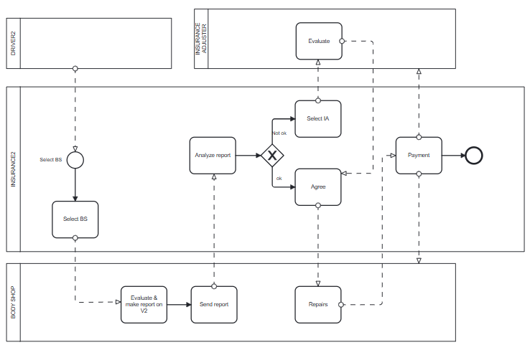

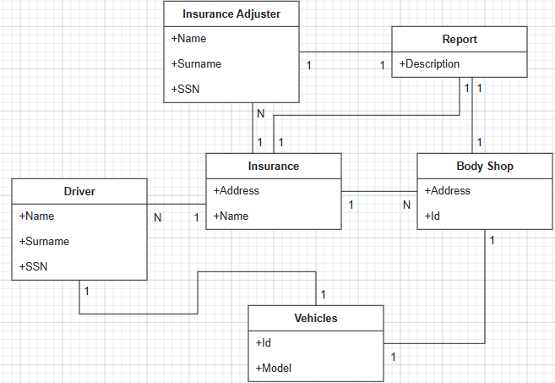

**3a.TECH MODEL (UML deployment) of TO BE**

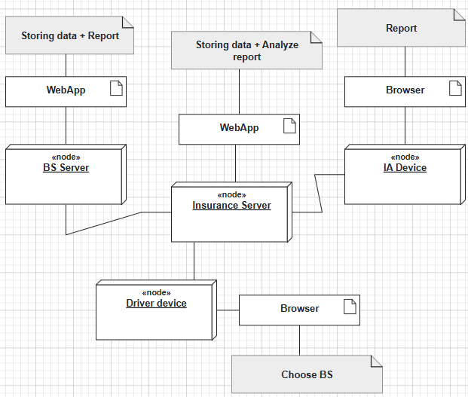

**3b.BUSINESS RULE** = value of repair < commercial value of car

**5.KPI** (considering these high-level business goals (or CSF), CSF1 maximum convenience for driver CSF2 decrease cost of claim process)

|  |  |  |  |  |
| --- | --- | --- | --- | --- |
| **CSF**  **Name** | **KPI**  **Category** | **KPI**  **Name** | **KPI Description** | **Unit of measure** |
|  | **General** | **N_** claims | Number of claims per year |  |
|  |  | **N_** BS | Number of Body Shops |  |
| CSF2 | **Efficiency** | **C**_repairment | Total cost/Number of claims | $ |
| CSF1 | **Service** | **LT**_claim | Lead Time from claim request to repairment | t |
| CSF1 |  | **LT**_repair | Lead Time from report ok to repairment | t |
|  | **Quality** | **Q** | Non-conform reports/ Number of claims | % |

**6.COMPARISON AS-IS vs TO-BE using KPI**

|  |  |  |
| --- | --- | --- |
| **KPI** | **AS IS** | **TO BE** |
| **N_** claims | Number of claims per year | More claims because they are managed faster(*) |
| **N_** BS | Number of Body Shops | = |
| **C**_repairment | Total cost/Number of claims | Decrease because more claims(*) |
| **LT**_claim | Email IA + Email Report + Paper Letter Reimbursement | All digital, so faster |
| **LT**_repair | Paper letter to ask if D2 agree, then repairment | Direct repairment, faster |
| **Q** | Non-conform reports/ Number of claims | Thanks to IA, less non-conform reports |

**7.SOFTWARE FUNCTIONS TO BE**

|  |  |
| --- | --- |
| **PROCESS/ACTIVITY** | **SW FUNCTION(S) NEEDED** |
| **BS selection** | Search BS (Driver Device)  List of BS (Insurance Server) |
| **BS Damage evaluation** | Send report (BS Server)  Receive report (Insurance Server) |
| **IA Damage evaluation** | Send report (IA Device)  Receive report (Insurance Server) |
| **Payment** | Send payment (Insurance Server)  Receive payment (BS Server)  Receive fee (IA Device) |

**8.PROS & CONS (Entities of the organizational model – Pros – Cons) of implementing TO BE**

|  |  |  |
| --- | --- | --- |
|  | **PROS** | **CONS** |
| **Insurance (I1 & I2)** | Claim managed faster  Less costs of a single claim, better quality | Cost of digital infrastructure (IT) |
| **Driver (D1 & D2)** | Better quality  Direct choice of BS  Less time for repairment | No agreement before repairment, direct invoice after it |
| **Body shops (BS)** | More work, more money for it |  |
| **Insurance adjuster (IA)** |  | Less work |

**9.TCO (costs of implementing TO BE)**

|  |  |  |
| --- | --- | --- |
| **PHASE** | **COSTS** | **CAPEX or OPEX** |
| **CONSTRUCTION**  **SELECTION** | Developing WebApp  IT management (for BS, Insurance) | CAPEX |
| **DEPLOYMENT** | Installing WebApp on Insurance Server  Training employees | CAPEX |
| **OPERATION** | Electricity  Internet  Data sharing (BS, IA, I2) | OPEX |
| **MAINTENANCE** | Insurance Server, BS Server, Driver Device and IA Device maintenance | OPEX |
| **DISMISSAL** | Dismiss  Data migration | OPEX |

**10.ROI (for $Δt$ costs [1° anno CAPEX, 2-5° anno maintenance + operation] & savings [risparmi dovuti al TO BE])**

|  |  |  |  |  |  |
| --- | --- | --- | --- | --- | --- |
| **Year/Cost or Saving** | **Year 1 (CAPEX)** | **Year 2** | **Year 3** | **Year 4** | **Year 5** |
| **Cost** | Construction, selection, deployment costs | Maintenance, operations cost | Maintenance, operations cost | Maintenance, operations cost | Maintenance, operations cost |
| **Saving** | No errors during reports delivery  More efficiency (claims per year) | No errors during reports delivery  More efficiency (claims per year) | No errors during reports delivery  More efficiency (claims per year) | No errors during reports delivery  More efficiency (claims per year) | No errors during reports delivery  More efficiency (claims per year) |

9) Describe at least one of the cognitive biases that affect decisions

REPETITION = more repeated, more trusted

AUTHORITY BIAS = authority more trusted

CONFIRMATION BIAS = use only information convenient

10) Describe the PICK chart as used to select processes to improve

POSSIBLE = easy + low payoff

IMPLEMENT = easy + high payoff

CHALLENGE = difficult + high payoff

KILL = difficult + low payoff

11) A company has two full time employees, and one part time (50%) employee. How many FTE does the company have?

1+1+0.5 = 2.5

12) Describe the high level software functions offered by a CRM

Commercial logistics, support for multichannel interaction, after sale support and analysis for customer

13) Write one or more examples of technological innovations that deeply impacted a business domain, and therefore the strategy of companies within the domain Digital cameras (Fuji vs Kodak)