**INITIAL NOTES**

Revision = Author of the Paper sends her paper to the journal, paper assigned to Editor

Editor selects 3 Reviewers + send paper to them

Reviewer reads the paper and sends back to the editor Revisions + judges the Paper as ‘accept’, ‘accept with minor revision’, ‘accept with major revision’, ‘reject’

Editor collects Revisions, makes a decision about the paper (accept, accept with major revision, etc), and sends all to Author

Author decides to retire the paper, or revise it and resend (and the same cycle is repeated [usually ends after 2 cycles])

**AS IS (solo se non cambia dal TO BE scrivi, altrimenti inutile)**

Email used:

Author sends the paper as a PDF file attached to an email

Editor sends the paper to the Reviewers via email

Reviewers send back their revisions as text in emails

Editor summarizes the revisions in one email to be sent back to the author

**TO BE**

Website used:

Editors (only here cited), reviewers, authors have an account on the web site

Author uploads the paper on the repository

Reviewers access the paper from the repository + upload their reviews

Author accesses the reviews on the repository

**1.ORGANIZATIONAL MODEL (TO BE)**

Journal

Editor

Reviewer

Author

**2a.PROCESS TABLE (TO BE [+AS IS])**

|  |  |  |  |  |
| --- | --- | --- | --- | --- |
| **NAME** | **INPUT** | **OUTPUT** | **DESCRIPTION** | **OU INVOLVED** |
| Create account | Credentials | Account created | Editors (only here cited), reviewers, authors have an account on the web site | Editor  Author  Reviewer  [Journal (Website)] |
| Upload paper | Paper | Paper uploaded | Author uploads the paper on the repository | Author  [Journal (Website)] |
| Review | Paper accessed | Review uploaded | Reviewers access the paper from the repository + upload their reviews | Reviewer  [Journal (Website)] |
| Access reviews | Access website | Read reviews | Author accesses the reviews on the repository | Author  [Journal (Website)] |

**2b.FUNCTIONAL MODEL (BPMN + UML class) of TO BE**

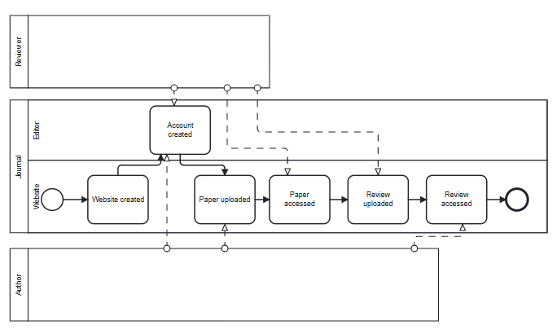

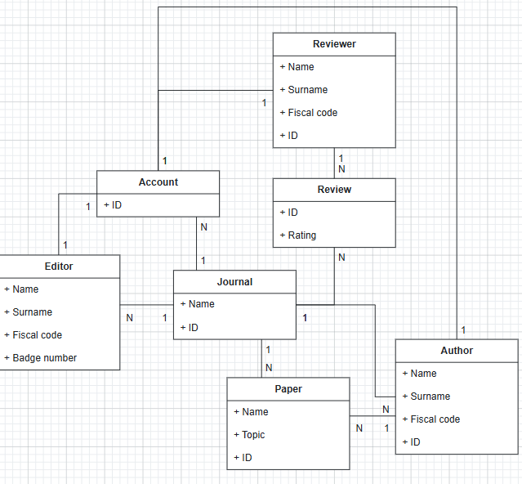

**3a.TECH MODEL (UML deployment) of TO BE**

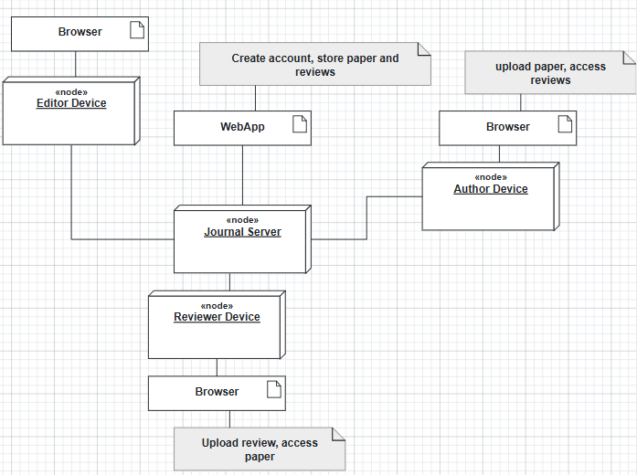

**3b.BUSINESS RULE** = reviewers must not know the name of the other reviewers

author does not know the names of the reviewers

reviewers do not know the name of the paper’s authors

Editor must select 3 Reviewers

**5.KPI** (considering these high-level business goals (or CSF): CSF1 maximum convenience for users (authors, editors, reviewers), CSF2 cost effectiveness for the organization)

|  |  |  |  |  |
| --- | --- | --- | --- | --- |
| **CSF**  **Name** | **KPI**  **Category** | **KPI**  **Name** | **KPI Description** | **Unit of measure** |
|  | General | N_papers | Number of papers |  |
|  |  | N_reviews | Number of reviews |  |
| CSF2 | Efficiency | C_paper | Total cost of papers/number of papers | euro |
| CSF2 |  | C_review | Total cost of reviews/number of reviews | euro |
| CSF1 | Service | LT_paper | Leading time from paper accessed to review done | t |
| CSF1 |  | LT_review | Leading time from review accessed to decision taken | t |
| CSF1 | Quality | Q | Rejected papers/total papers | % |
| CSF1 |  | Q_s | Author satisfaction | % |

**6.COMPARISON AS-IS vs TO-BE using KPI**

|  |  |  |
| --- | --- | --- |
| **KPI** | **AS IS** | **TO BE** |
| N_papers |  | = |
| N_reviews |  | = |
| C_paper | Total cost of papers/number of papers | Less because uploading on website is cheaper than transferring via email |
| C_review | Total cost of reviews/number of reviews | Less because uploading on website is cheaper than transferring via email |
| LT_paper | Leading time from paper accessed to review done | Process faster thanks to website instead of email; less actors involved (no editor in the middle) |
| LT_review | Leading time from review accessed to decision taken | Process faster thanks to website instead of email; less actors involved (no editor in the middle) |
| Q | Rejected papers/total papers | = |
| Q_s | Author satisfaction | More satisfied because the process is cheaper and faster |

**7.SOFTWARE FUNCTIONS TO BE**

|  |  |
| --- | --- |
| **PROCESS/ACTIVITY** | **SW FUNCTION(S) NEEDED** |
| Create account | Begin account creation (Editor, Reviewer, Author Device)  Account created (Journal Server) |
| Upload paper | Upload paper (Author Device)  Receive paper (Journal Server) |
| Review | Access paper + upload review (Reviewer Device)  Host paper + receive review (Journal Server) |
| Access reviews | Access review + decide (Author Device)  Host review (Journal Server) |

**8.PROS & CONS of implementing TO BE**

|  |  |  |
| --- | --- | --- |
|  | **PROS** | **CONS** |
| Journal | Communication faster; cost of single paper/review uploaded is cheaper; no needed Editors in the process | Cost of IT infrastructure + Training employees to use it |
| Editor |  | No more needed to be the man in the middle of the communications |
| Reviewer | Can upload reviews faster, without passing through editor | More responsibility (direct uploading to Journal Website) + learning how to use website |
| Author | Can upload papers faster, without passing through editor | More responsibility (direct uploading to Journal Website) + learning how to use website |

**9.TCO**

|  |  |  |
| --- | --- | --- |
| **PHASE** | **COSTS** | **CAPEX or OPEX** |
| **Construction**  **Selection** | Developing WebApp (Journal)  Developing IT infrastructure (Journal) | CAPEX |
| **Deployment** | Install WebApp (Journal)  Training employees (Journal, Editor)  Training authors and reviewers | CAPEX |
| **Operation** | Electricity  Internet  Send/receive data | OPEX |
| **Maintenance** | Device maintenance (Editor, Reviewer, Author)  Server maintenance (Journal) + website bug fixes | OPEX |
| **Dismissal** | Dismiss  Data migration | OPEX |

**10.ROI (if dismissal at year 10)**

|  |  |  |  |  |  |
| --- | --- | --- | --- | --- | --- |
| **Year/Cost or Saving** | **Year 1** | **Year 2** | **Year 3** | **Year 4** | **Year 5** |
| **Cost** | Construction  Selection  Deployment | Operation  Maintenance | Operation  Maintenance | Operation  Maintenance | Operation  Maintenance |
| **Saving** | Less error on papers  More efficiency (more papers/reviews per year) | Less error on papers  More efficiency (more papers/reviews per year) | Less error on papers  More efficiency (more papers/reviews per year) | Less error on papers  More efficiency (more papers/reviews per year) | Less error on papers  More efficiency (more papers/reviews per year) |

**11.Outsourcing (supposing WebApp outsourced but installed locally, Data space on Google Cloud)**

|  |  |  |  |  |
| --- | --- | --- | --- | --- |
| Object | **Activity/Service** | **Unicity** | **Location** |  |
| Website | Application | Shared | On site | Outsourced |
| PCs | IT infrastructure | Shared | On site | Insourced |
| Google Cloud | IT infrastructure (+ Application front-end) | Shared | Off site | Outsourced |

**DOMANDE:**

9) Operation Level is a level of horizontal Anthony’s model (organizational level + group served by IS) and serves Operational managers, Low-level managers. Necessity of IS depends on Intensity of product (IP, level of information needed to describe product) and Intensity of process (IO, level of information needed to describe process)

10) BOM (Bill of Materials) is the list of products/services used to describe “Manufacturing” (one of the Primary processes’ sectors)

11) Product innovation is 1 of the 3 divisions of activity in unbundling BM pattern (Unbundling 🡪 division of activity in Product innovation, infrastructure management and customer relationship) and is the division that focuses on innovation of products.

12) Incompetent people overestimate themselves, while competent people recognize difficulty

13) Dissatisfaction for current situation * Vision of future * First steps of change > (must overcome) Resistance to change (function of type of change [1^st order = automate, 2^nd order = inform, 3^rd order = transform]; can be implicit/explicit and can come from individuals or organization)