# Activity 1

You are required to create a project plan for a DVD search application. (NOTE: A sample application will be provided) Create a project plan with a project management program and produce a final plan sheet in a JPG or PDF format. Clearly specify which project management program is used for this task.

a. The project is to develop a DVD search application named DVD Search App.

b. The application will let the user search a DVD or DVDs by a keyword.

c. A DVDs data file is provided in an excel file format, DVD.xls. The file contains more than 2000 DVD titles. You will need to find a way to store the titles in a database table, e.g. in a SQL file. Include your SQL statements that deploys the database, tables and records, e.g. dvd.sql file.

d. The user must be able to search/find DVDs by part of DVD title, for example the keyword “monkey” should find all DVDs that include it.

i. 12 Monkeys (DTS)

ii. 12 Monkeys: Collector's Edition

iii. 12 Monkeys (Special Edition/ Dolby Digital)/ Jackal

iv. Monkey Shines

e. Determine the management tools (software development methodology, project management software, source-control system and collaboration software) to be used and justify the reason of your choice.

Software development methodology

Agile methodology

In this project, Agile model is used because whole project can be divided into a couple of sections and each of them can be tested separately. Planning, require analysis, designing, building and testing are implemented several times and this methodology can develop the program that has user interactions.

Agile model believes that every project needs to be handled differently and the existing methods need to be tailored to best suit the project requirements. In Agile, the tasks are divided to time boxes (small time frames) to deliver specific features for a release. (TutorialPoint, n.d.)

Project Management software

Microsoft Project

I chose MS Project because it can deal with both project planning and scheduling features and features above. Thanks to this feature you don’t have to use multiple management programs.

Features:

* You can adjust due dates with easy drag and drop scheduling
* You can allocate resource and workload management
* MS Project improves the visibility of projects.

Source-control system

Git

I chose Git for a source control system. Git has following features and pros:

It is superfast and efficient performance platform and easily maintainable and robust. This is cross-platform. When you do actions in Git, nearly all of them only add data to the Git database. It is hard to get the system to do anything that is not undoable or to make it erase data in any way. As with any VCS, you can lose or mess up changes you haven’t committed yet, but after you commit a snapshot into Git, it is very difficult to lose, especially if you regularly push your database to another repository. Because of feature, you can experiment without taking a risk.

(Git, n.d.)

Collaboration Software

Trello

This user interface is intuitive and easy to use and you can use this application on desktop and mobile apps, which comes to handy. Trello is a great collaboration tool when you don't need a heavy-duty project management app. It's also a little lighter than Editors' Choice Asana, which gives you an interface that you can use for more than just kanban boards. In the class, even if the project become big, it is in the function of this application. It is important to be used by all members and usability is also important aspect. In addition to that, you might need to do the set actions again and again.  In these cases, he rules of your board will be to follow one action (called a trigger) with another action, every time. When that's the case, you can create an automation.

(Duffy, 2021)

f. Create a project plan for the development of this application.

MS Project

Resource page

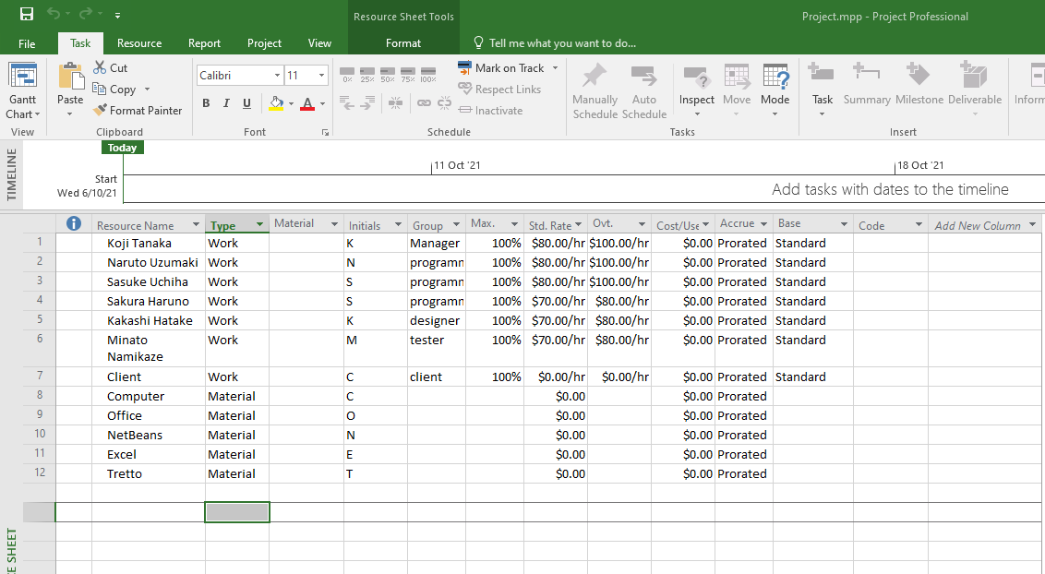

Gantt Chart

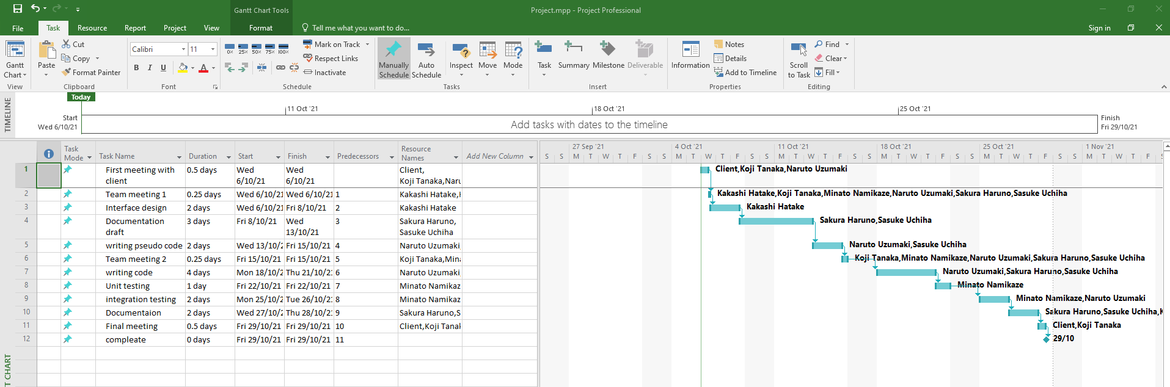

g. As part of the process of development, enter the source files into your source control system. (NOTE: You may use the sample program provided) Provide the link to your source control system.

Create a new repository on GitHub

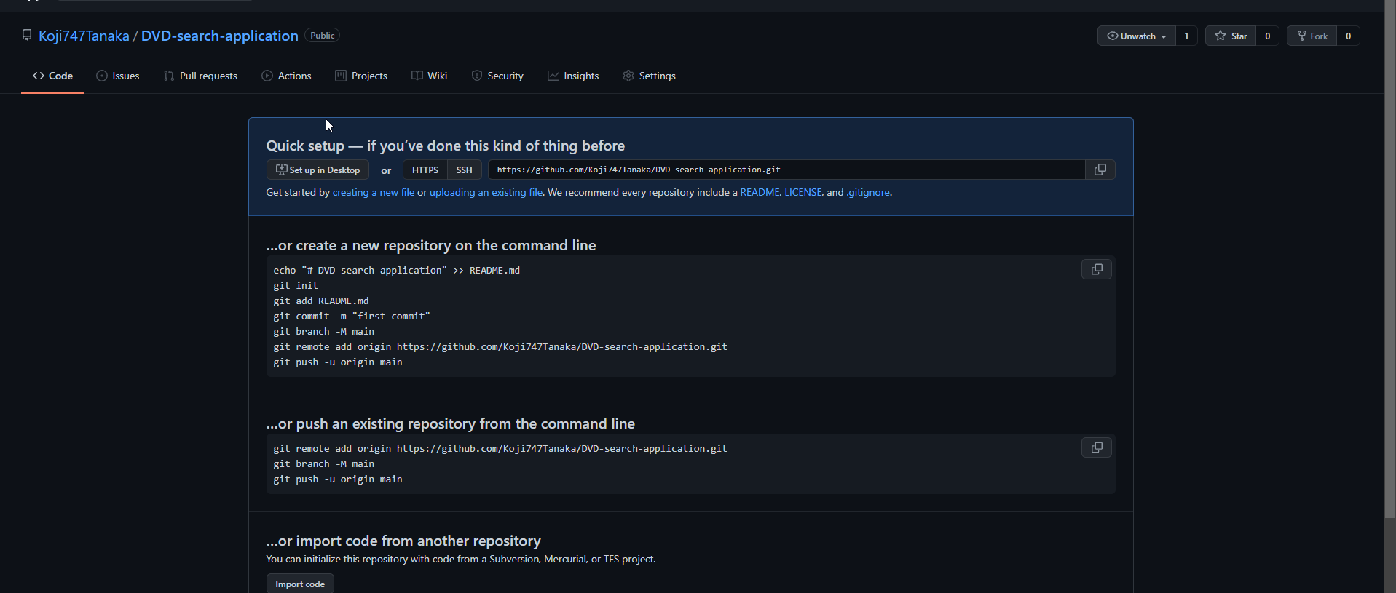

h. As part of the process of development, demonstrate the use of the collaboration environment of your choice. Demonstrate monitoring the collaboration environment with screenshots. Adjust your plan as required. Provide the link to your collaboration environment.