Welcome to Game Engine Development

Installation: W02-01 1:29:00

D:\SEAGATE_DATA\GBC\S5\GAME 3121_GAME ENGINE DEVELOPMENT I\ASSIGN\KH_GAME-3121\ogre\build\bin\debug\plugins.cfg

D:\SEAGATE_DATA\GBC\S5\GAME 3121_GAME ENGINE DEVELOPMENT I\ASSIGN\KH_GAME-3121\ogre\build\bin\debug\resources.cfg

Open "D:\SEAGATE_DATA\GBC\S5\GAME 3121_GAME ENGINE DEVELOPMENT I\ASSIGN\KH_GAME-3121\OrgreTemplateV2\OgreTemplateV2.sln"

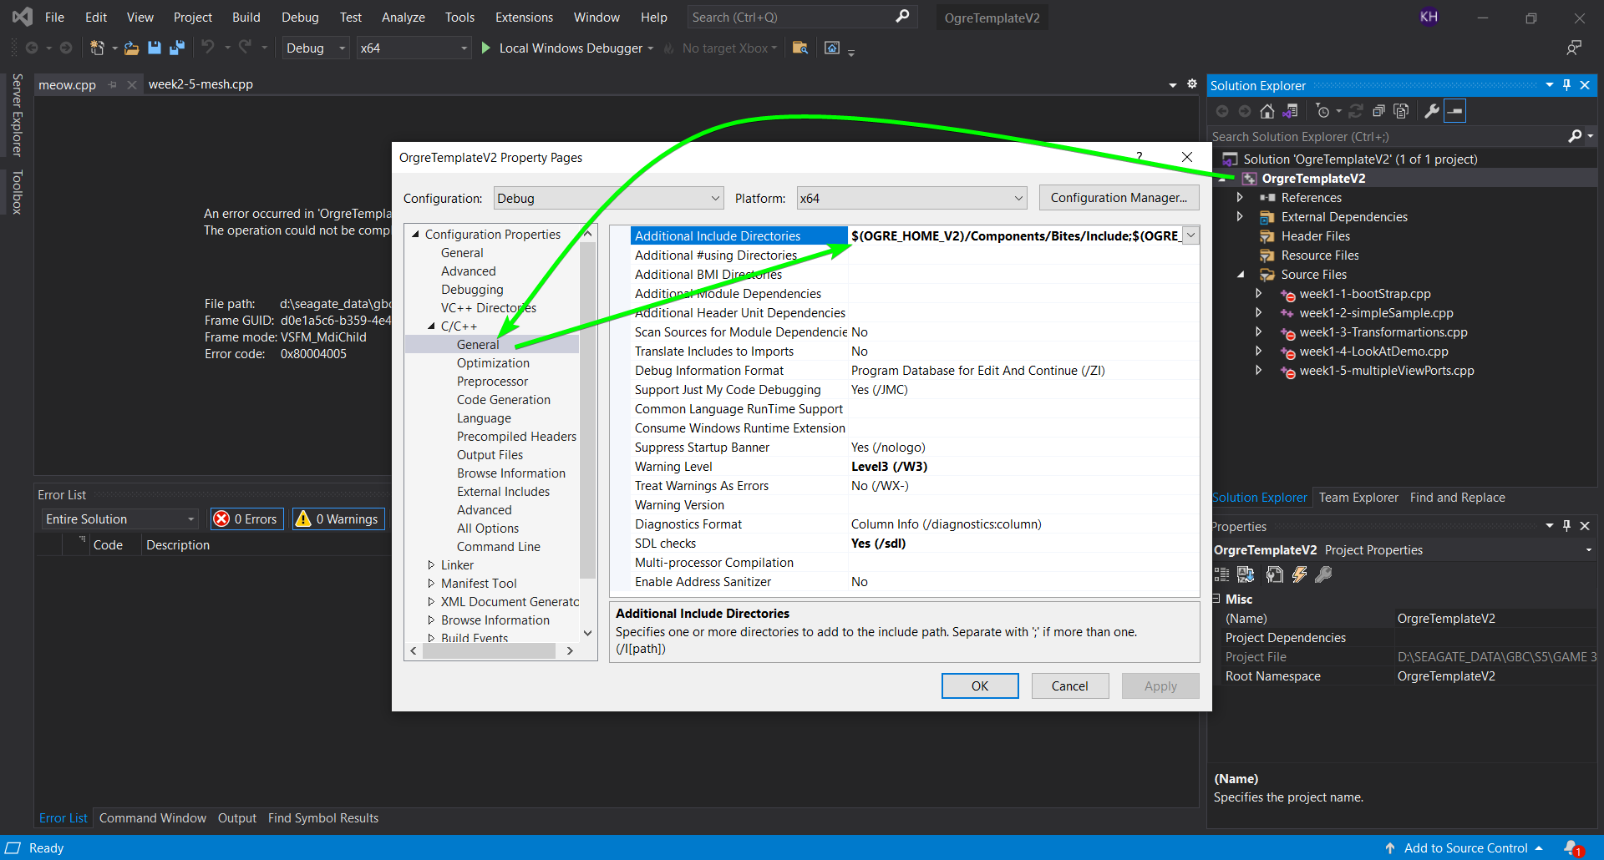

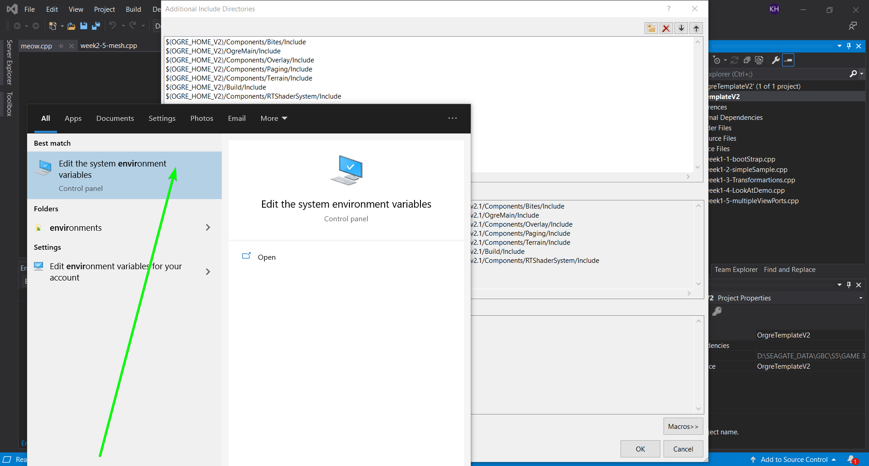

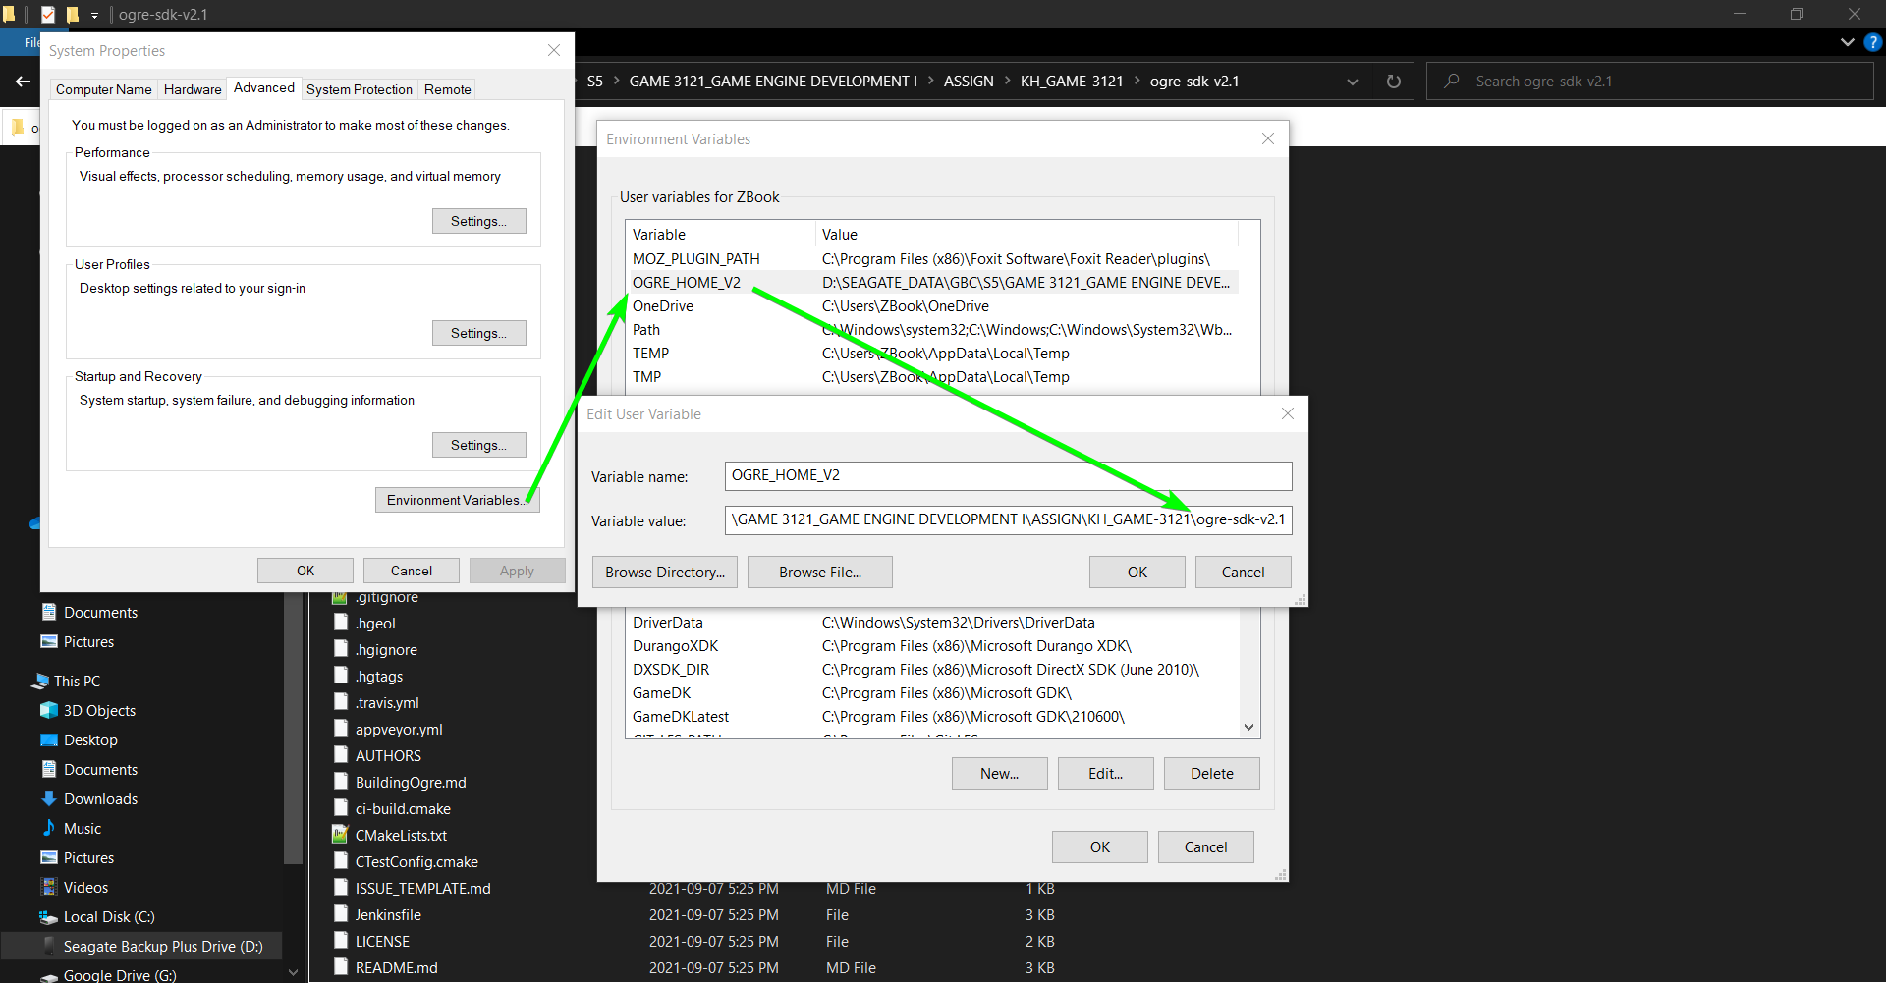

"D:\SEAGATE_DATA\GBC\S5\GAME 3121_GAME ENGINE DEVELOPMENT I\ASSIGN\KH_GAME-3121\OrgreTemplateV2\OrgreTemplateV2\x64\Debug\resources.cfg": Replace C:/Hooman/GBC/GAME3121/Course Materials/GameEngineDevelopment/ogre-sdk-v2.1 with D:/SEAGATE_DATA/GBC/S5/GAME 3121_GAME ENGINE DEVELOPMENT I/ASSIGN/KH_GAME-3121/ogre-sdk-v2.1