GAME3011_A2 Lock Picking

By Trung Le (Kyle Hunter)

# Theme

* Pixel art lock picking mini game with room for both randomization and manual design.

# Input

* Click on different rings to rotate them a certain amount (this is randomized when level loads)
* While dragging the key with left mouse, hold right mouse to rotate key
* If it’s a match for that ring, ring will turn black

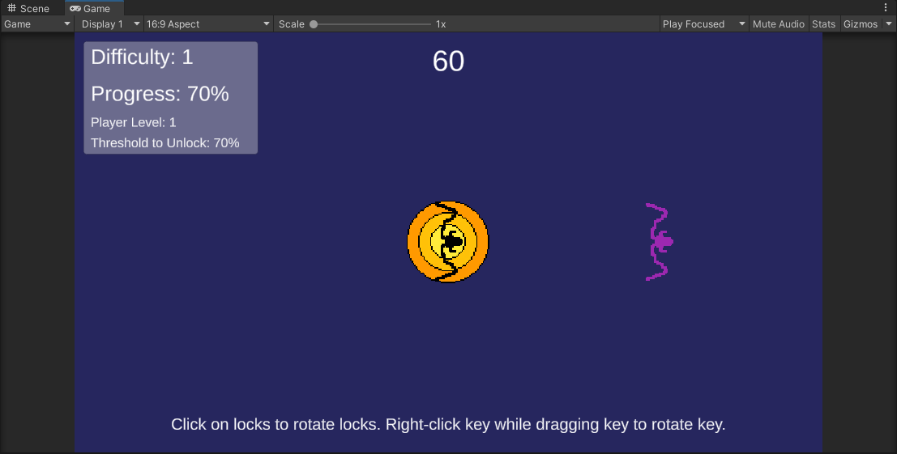

# Difficulty

* 3 levels with increasing complexity and reduced time limit

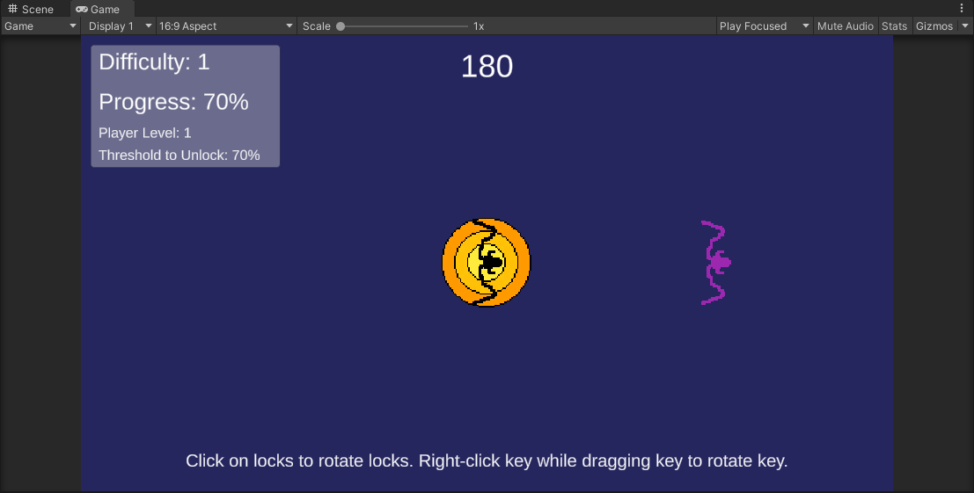

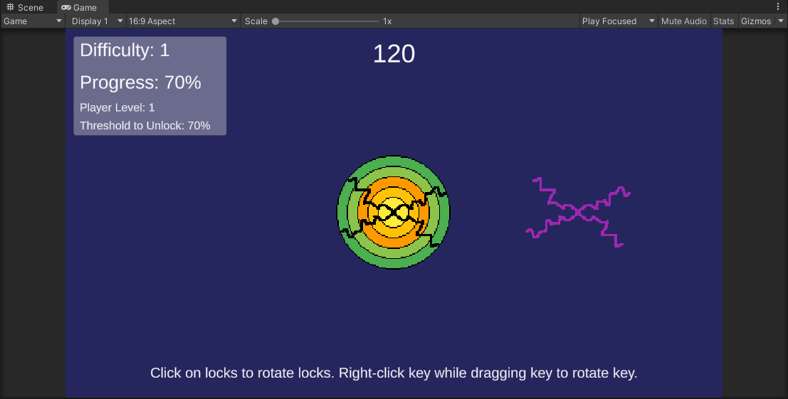

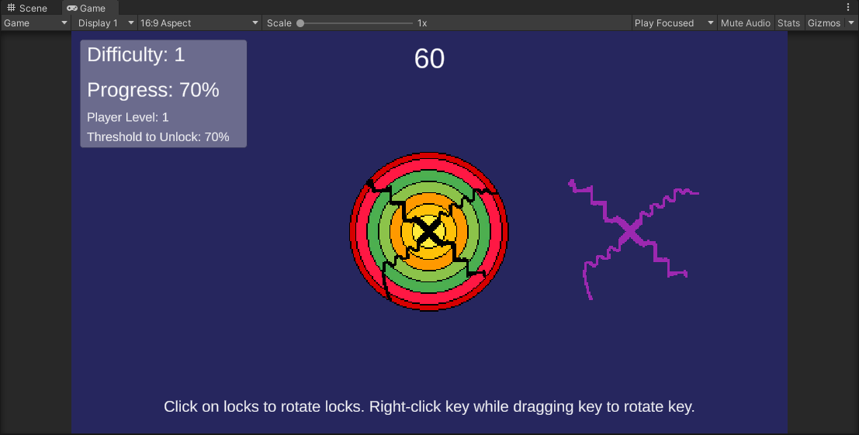

# Player Skill

* There are 3 levels of player skills, the higher the level, the less you have to match to unlock.
  + Level 1: 100% match to unlock
  + Level 2: 80% match to unlock
  + Level 3: 60% match to unlock