GAME3011_A3 Match3

By Trung Le (Kyle Hunter)

# Theme

* Explosive Match-3 game with a theme of adventure. Match 3 gems to cause them to explode and gain score.

# Input

* Click on a gem and drag horizontally or vertically. It will only swap if the destination has a match.

# Objects

* 7 types of gems, 1 type of immoveable object

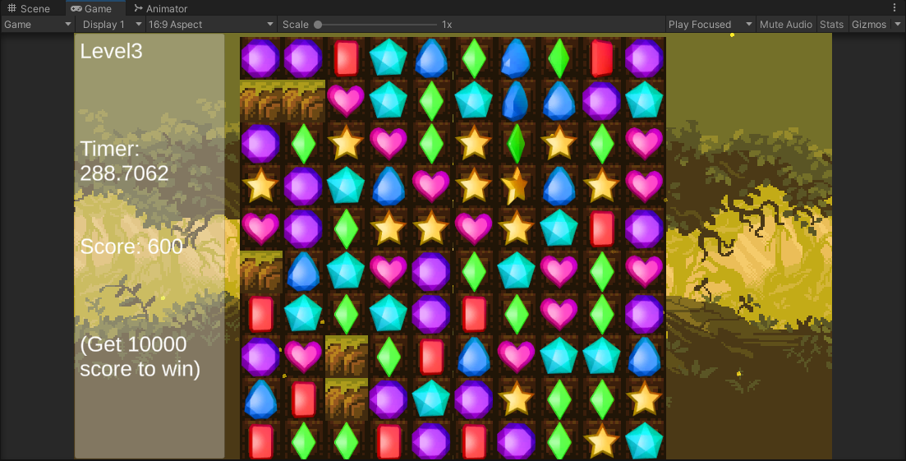

* In level 3, match 4 or more for a 50% chance of a big explosion on a random spot that has a match.

# Difficulty

* 3 levels with increasing complexity. Get 10000 score to win.
* Level 1: 4 gem types, no immoveables, no bomb.
* Level 2: 5 gem types, has immoveables, no bomb.
* Level 3: 7 gem types, has immoveables, has bomb.

# Extra Features

* Gems explode violently when matched, with randomized force & torque.
* In level 3, match 4 or more for a 50% chance of a big explosion on a random spot that has a match.
* AAA graphics and great soundtrack!