GAME 2005_GAME PHYSICS_A1

By Trung Le - 101264698 | Shu Deng – 101260645

# Part 1: Physics Problem



$v_{i}=95 m/s$

$m=2.2 kg$

$R=485 m. θ= ?$

$Since R= \frac{v_{i}^{2}\sin{2θ_{i}}}{g}$

$Therefore \sin{2θ_{i}= \frac{R g}{v_{i}^{2}}= \frac{485 x 9.8}{{95}^{2}}}=0.527$

$2θ_{i}=31.779$

$θ_{i}=15.89$

$R_{max}= ?$

* $Since the maximum range occurs at θ_{i} = {45}^{°}$,
* $Therefore R_{max}= \frac{{95}_{}^{2}\sin{(2{x45)}_{}}}{9.8}$ = 920.918 m

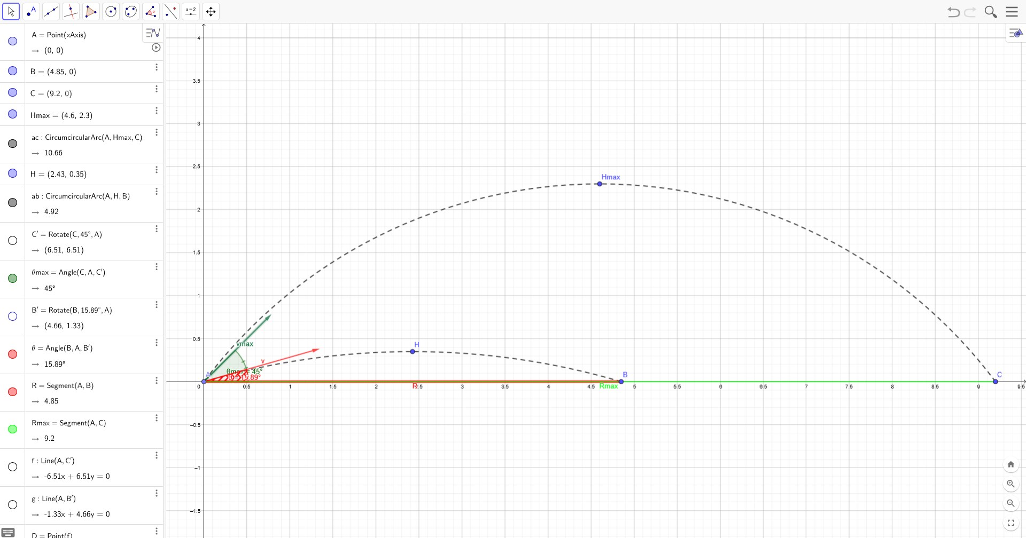

* Red: first case where R = 485m
* Green: second case for Rmax