|  |
| --- |
| BRICKWORK GAMES   |
| Game Design Document |
| **“Adrenaline”** |
| **Producer:** Mehrara Sarabi (Mary)  **Art:** Chris Tulip, Madeline Villarroel  **Designer:** Franz Rios, Shu Deng  **Engineer:** Eric Galway, Matthew Lekatis,  Tyler Langer, Trung Le (Kyle)  **QA:** Jaan Sangha  Version 0.1.2  All work Copyright © 2019 by Brickwork Games.  All rights reserved. |
| **Brickwork Games** |
|  |

|  |
| --- |
| Sep 23rd 2019 |

**TABLE OF CONTENTS**

0. Version History 3

1. Game Overview 4

2. Game Play Mechanics 4

3. Game Dynamics 4

4. Game Aesthetics 5

5. Camera 5

6. Controls 5

7. Saving and Loading 6

8. Interface Sketch 6

9. Menu and Screen Descriptions 7

10. Game World 8

11. Levels 9

12. Game Progression 10

13. Character/Game Avatar 10

14. Non-player Characters (NPC) 10

15. Enemies/Obstacles 11

16. Weapons 11

17. Items/Pick-ups 11

18. Abilities 12

19. Scoring 12

20. Puzzles/Mini game 12

21. Sound Index 12

22. Story Index 12

23. Art / Multimedia Index 13

24. Future Features 13

# Version History

Version 0.1.1 (Shu)

* Added the high concept of the game.

Version 0.1.2 (Kyle)

* Reformatting to allow auto-generation of table of content. Added a few general ideas to Weapons, Abilities, Bonuses.

Version 0.2 (Chris)

* Added names to different sections that need to be completed. Blank sections can be completed by anyone willing.
* Updated Game World/levels sections.

Version 1.0 (Shu)

* Finished the first official iteration of the Game Design Document (GDD).
* Deleted the “Vehicles”, “Cheat Code”, “Script” and “Design Notes” sections for the current design.
* Chris updated art and sound assets, UI, and enemies’ section.
* Mary filled in the abilities and scoring section. Also edited the document before it being uploaded on blackboard.

Version 1.1 (Mary)

* Updated the number of health the player has and the enemies’ section, after trying out the paper prototype of the game.

Version 1.2(Chris)

* Updated Interface, Menu and Screen descriptions pictures. Added new info to Enemies and Obstacles, Abilities and Story.

# Game Overview

* **Goal:** The player must explore the game world, complete game levels, strengthen their character, avoid character’s death and defeat the ultimate enemies/bosses to win this game.
* **Audience:** Teenagers and young adults
* **Genre:** Two-dimensional (2D) hack n’ slash platformer
* **Setting:** Dark fantasy
* **Platform:** Personal computer (PC)
* **Features:** The game mechanics mainly feature intense combat against various creatures, distinctive skill and level system of character, abundant interactivity with the game world and surprising secrets uncovered by attentive players. Moreover, the unique active reactions of game character, for example “adrenaline” system, provide more options for gameplay and pleasure for players during this game.

# Game Play Mechanics

* **Rules:** In this game, the player controls the main character to move around the game world. The player can finish a level by reaching the end position and defeating any creatures in the way if necessary. These creatures are enemies to the character and may do fatal damage. In return, the player can fight the creatures to gain “experience”, “powerups” and increase the “level” of character to enhance “skills” and overall performance. The character can also activate different special effects on himself/herself, which depends on the health points (HP) or status and may alter the gameplay for player to cope with. As for the environment, the player can interact with various objects in the game to help them overcome obstacles, fight enemies or get killed in reverse and even change the game world.
* **Move methods:** The player can make the character walk, run, jump, slide, spot dodge and move with grappling hook.
* **Fight/Combat:** The main character can use melee, ranged and area of effect (AOE) attacks. The melee attacks include light or heavy attack on the ground and aerial attack in the air.
* **“Adrenaline” System:** The character has 5HP, for every 2HP lost an Adrenaline System is added. The adrenaline systems can include, Increased speed, jump height, more damage. The effects are either randomized or pre-built in.

# Game Dynamics

* **Win conditions:** The player must avoid dying which is losing all their 5 hearts. To do that they should kill and/ or avoid the damages from the enemies on their way. Furthermore, the player must complete all the levels and defeat all the bosses on the last level.
* **Winning strategies:** The player must learn how to utilize all the tools provided in the game as well as the buffed statistics (stats) or effects triggered by different conditions such as “adrenaline”.

# Game Aesthetics

* **Visual:** The graphics of the game is of pixel art style featuring dark fantasy visual effect.
* **Audio:** The background music (BGM) and sound effects use heavy metal rock music.
* **Overall Feeling:** The game has an intense and fast-paced feeling, especially when player is under the “adrenaline” effect.

# Camera

* **Description:** The camera is fixed looking at the side of the main character and environment, following his movement. The character is always placed at the center of the view, except that in the scene of boss fight, the camera is fixed at the center of the scene.

# Controls

* **Control Methods:** The players use keyboard to control the main character of the game. The player may use mouse to interact with the user interface (UI).
* **Control Pattern:**

|  |  |
| --- | --- |
| MOVE UP | W |
| MOVE DOWN | S |
| MOVE LEFT | A |
| MOVE RIGHT | D |
| JUMP | SPACE |
| CROUCH | C |
| LIGHT ATTACK | J |
| HEAVY ATTACK | K |
| RANGED ATTACK | L |
| MENU | ESC |
| MENU – SELECT | MOUSE - LMB* |
| MENU – BACK | MOUSE – RMB** |

*Left mouse button  
**Right mouse button

# Saving and Loading

* **Description:** The game can be saved at certain places or “checkpoints”, from which players can resume their journey after loading or failure in the game. Players cannot save this game at any time they want in the current version of design.

# Interface Sketch

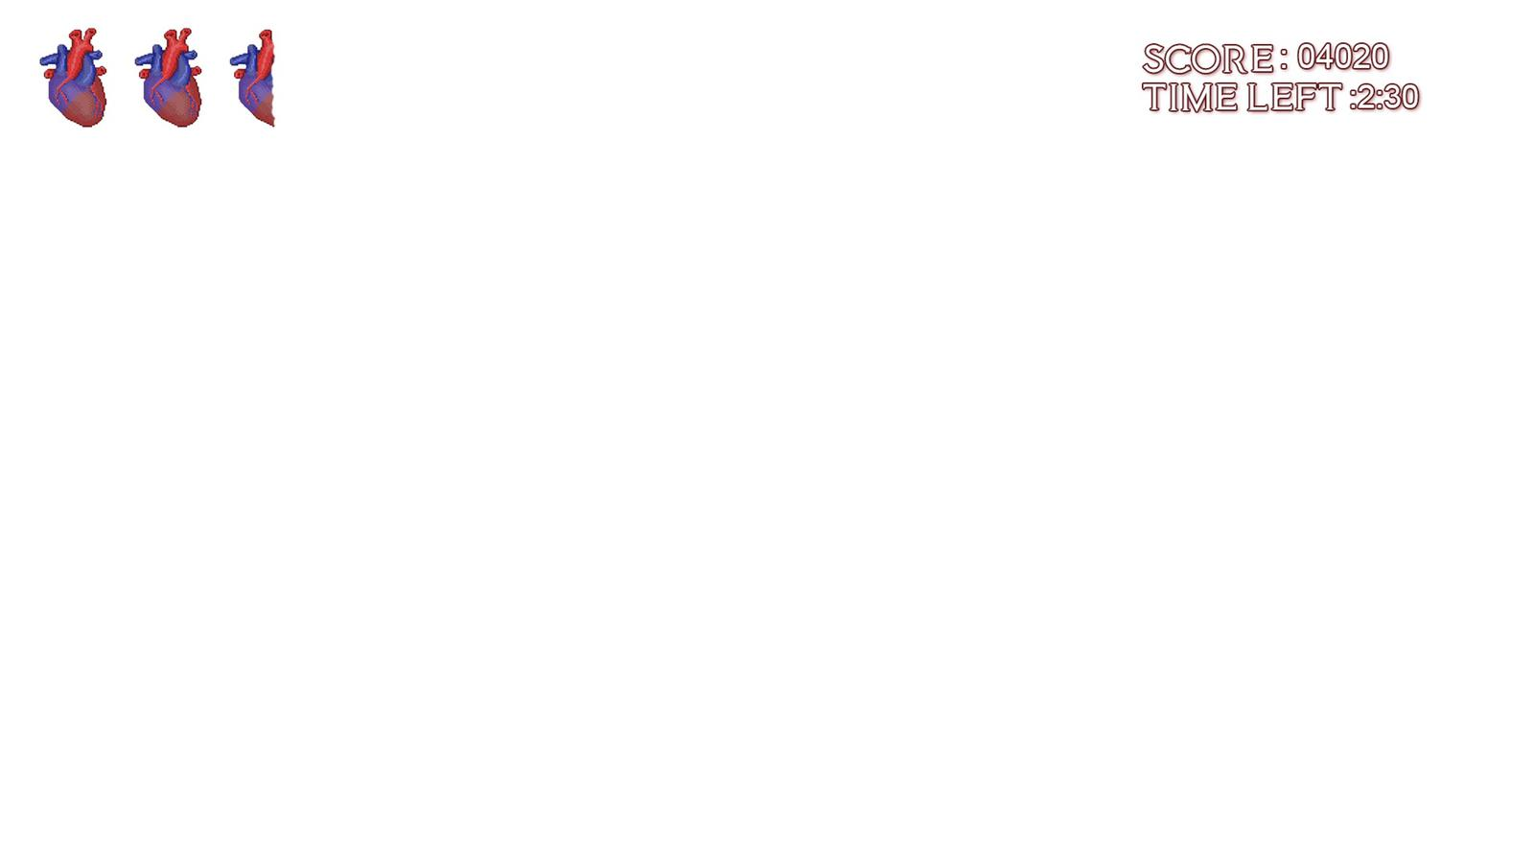

# Menu and Screen Descriptions

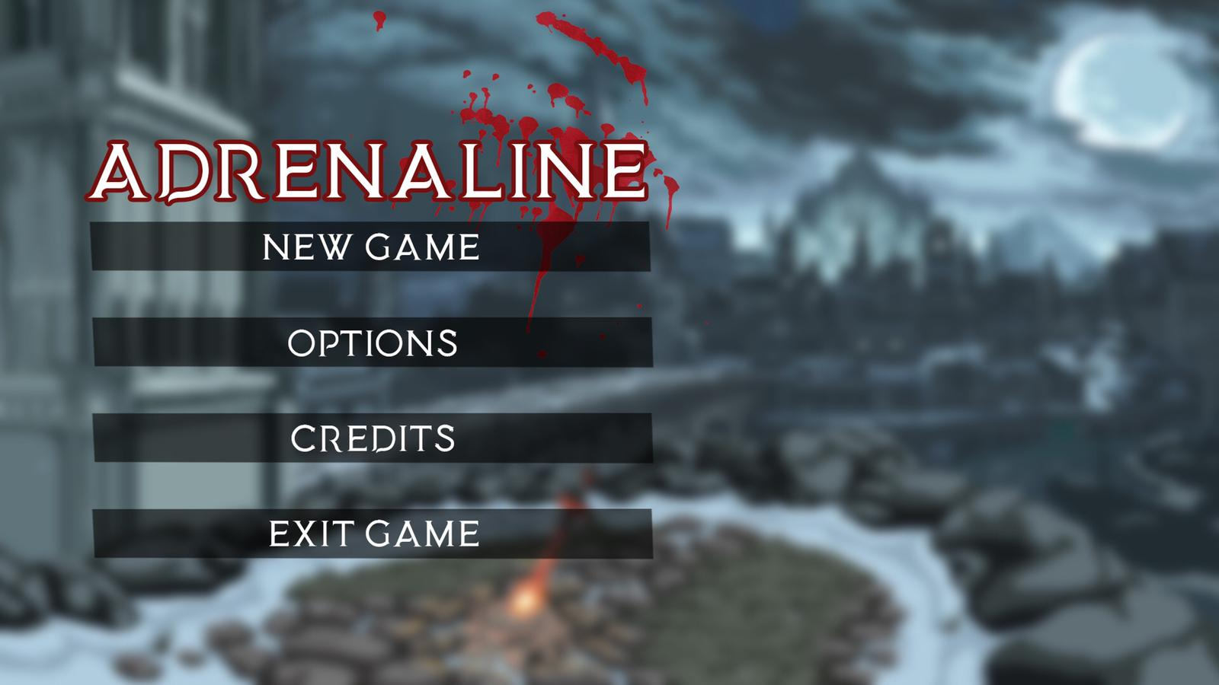

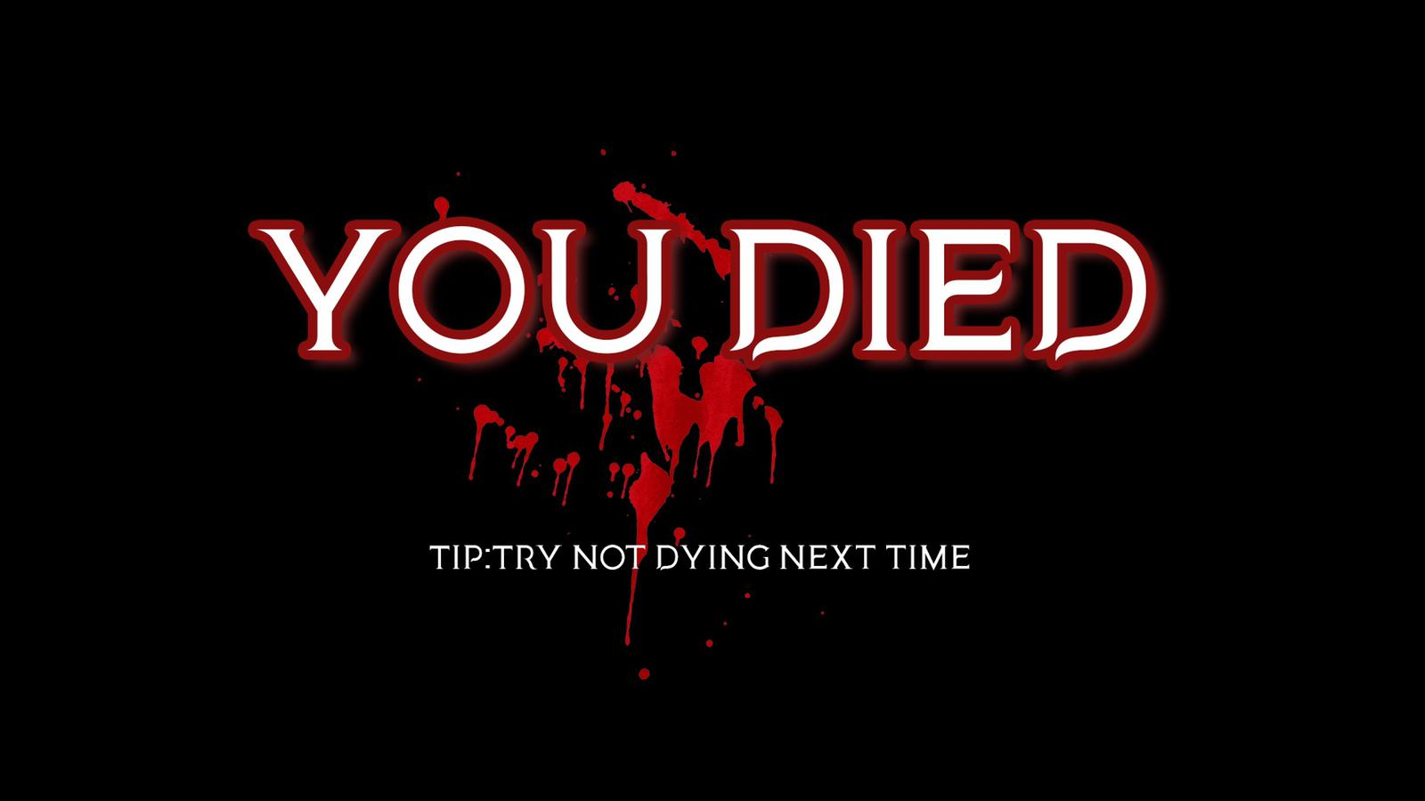

# Game World

* **Theme and Setting:** A dark fantasy dangerous world where many different types of monsters roam the lands. The game world features some Satanic cult and a corrupted kingdom.
* **Concept Art:**

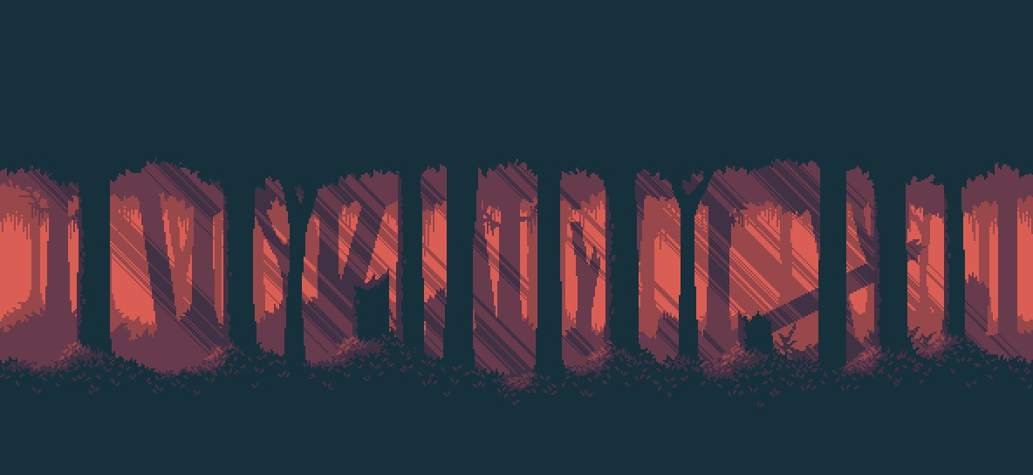

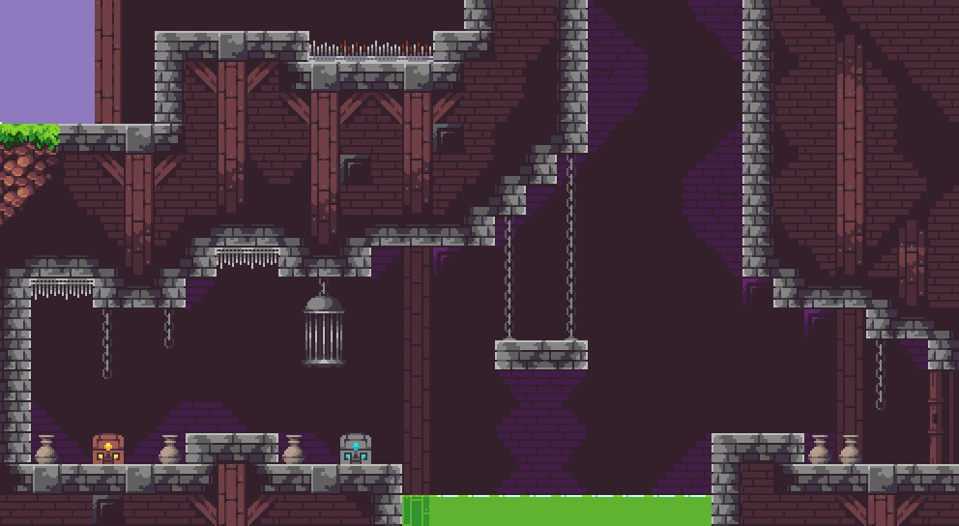

# Levels

There are 3 levels within the game, last level being a 2-phase boss fight.

* **Level 1:** The first level starts at the gates to the city. The protagonist must make his/her way through the forest to get to the fort. More natural monsters spawn out here (i.e. wolves, goblins). This level is set up like a horizontal platformer where the goal is to reach the rightest side of the screen.
* **Level 2:** Second level takes place inside the attacked fort. The protagonist must ascend through the fort to the top where the hostage is being held. This level is set up as vertical platformer where the goal is to reach the top of the screen.
* **Level 3:** The last level is just a boss room. A cramped room with a couple platforms. You start by fighting the sorcerer through its first phase until it takes enough damage to trigger the second phase. At this point it's revealed the hostage was the mastermind behind everything and transforms, killing the sorcerer in the process.

# Game Progression

The game progression has been explained in “11. Levels” section. In conclusion, player will be facing more powerful enemies as they make their way to the next level. They will also be able to gain more skills and pickup items as they go on. The places in which different levels take place change too.

# Character/Game Avatar

* **Description:** The main character of this game is a barbarian living in the forest. He is wielding dual axes as main weapons.  
  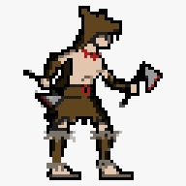

# Non-player Characters (NPC)

* **List of NPCs:**

|  |  |  |
| --- | --- | --- |
| NPC | DESCRIPTION | CONCEPT ART |
| Voice of the forest | It will guide the player and give them the back story |  |

# Enemies/Obstacles

As the player progresses in the game, he/ she will face a greater number of enemies at once. At some points there will be arena fights where players basically get locked in a “room”, and can’t get out until they kill the swarm of enemies.

* **List of Enemies/Obstacles:**

|  |  |  |  |
| --- | --- | --- | --- |
| ENEMIES | DESCRIPTION | CONCEPT ART | HEALTH/DAMAGE |
| Imp: Strong Aerial Enemy | Flies along above ground. Damages player with thrown fireballs or with collision |  | Health: High  Collision Damage: Low  Fireball Damage: High |
| Bat : Weak Aerial Enemy | Spawned in swarms and attacks the player together. Damages player with collision and follows player movement |  | Health: Low  Collision Damage: Low |
| Skeleton Warrior: Weak Ground Enemy | Moves slowly along the ground and attacks when the player is in range. Does not follow player. |  | Health: Low  Collision Damage: High |
| Hell Hound: Strong Ground Enemy | Moves quickly along the ground and attacks by jumping on the player. Follows the player. |  | Health: High  Collision Damage: High |

# Weapons

* **Melee combat:** Dual axes (details in “18.Abilities”)
* **Ranged combat:** Throwing axes (details in “18.Abilities”)

# Items/Pick-ups

* **List of Items/Pick-ups:**

|  |  |
| --- | --- |
| ITEMS | DESCRIPTION |
| Grappling hook | Helps player move in the air |
| Health pickup | Recovers the player’s hp |
| Rage pickup | Recovers the player’s rage |
| Throwing axe | Player’s main/melee weapon |
| Treasure | Extra “Score” |

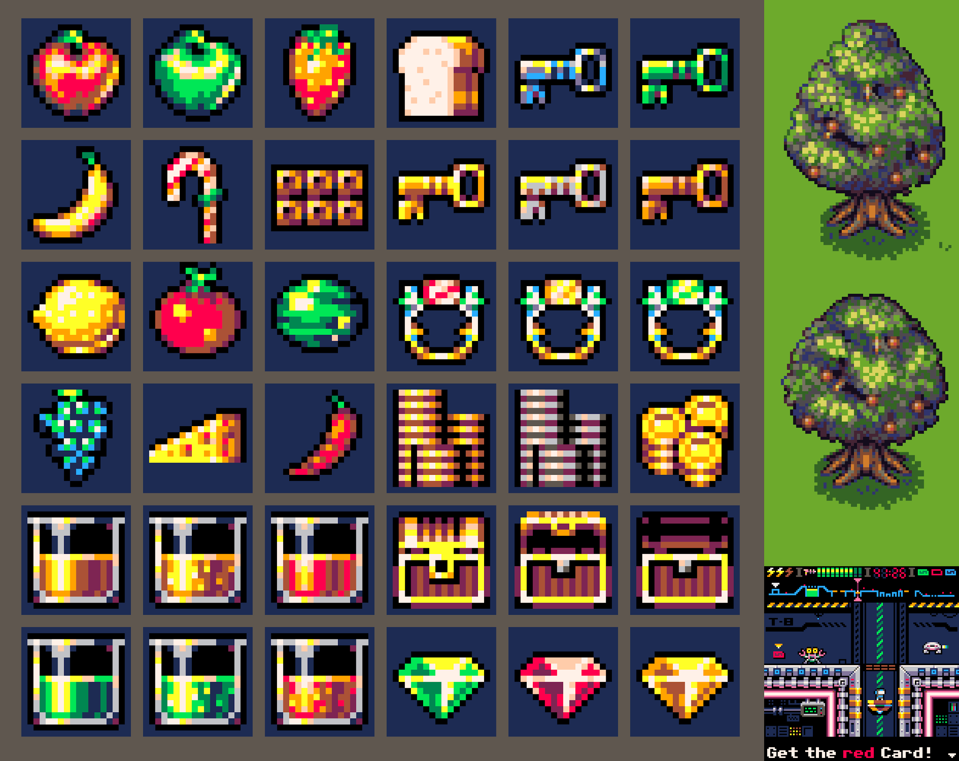

# Abilities

* **Attacks:**
  + **Weak Grounded Attack:** Quick horizontal swipe, low damage, small hitbox.
  + **Heavy Grounded Attack**: Slow vertical slice, high damage, large hitbox.
  + **Weak Aerial Attack**: Spin attack, hits twice for low damage, large hitbox.
  + **Strong Aerial Attack**: Double axe slice downwards, high damage, large hitbox.
  + **Ranged Attack**: Thrown straight, low range, low damage.
* **Grappling hook:** Player will achieve this ability as they get to level two. They need it since this level has vertical platforms. This ability will attach the grappling hook to the nearest available point to the player. Therefore, they do not need to aim for the point.
* **Adrenaline Buffs**:
  + **Damage**: The player has increased damage (X2).
  + **Move-Speed**: Faster horizontal movement.
  + **Jump Height**: Higher jump height.
  + **Haste**: Lower “lag” between attacks.

# Scoring

Scoring is based on these primary things: time, number of enemies killed, pickups, and the number of HP that they are left with when they finish the game.

Also, players can achieve higher scores than usual, if they are under “adrenaline” effect.

For example, if they normally get 10 points for killing an enemy, they will get 15 points if they kill the same enemy under the effect.

# Puzzles/Mini games

Since our game does not have any puzzles or mini games, we describe the “Boss Fight Mechanics” here.

**First phase:** Battle the sorcerer; it teleports around and throws fireballs

**Second phase:** Awakened demon, slides along the ground and jumps above the player trying to crush the player.

# Sound Index

<https://www.soundjay.com/human-sounds.html>

# Story Index

* **Story Synopsis:** Protagonist is from the kingdom of “Dragma”, an aristocratic city with high poverty. Game begins as the protagonist goes to rescue a captured member of the royal family. Taken by an “evil” sorcerer, they retreat to a fort surrounded by woods outside of the city. The sorcerer corrupts the inhabitants of the fort turning them to an assortment of monsters.
* Level 1(Forest): The Barbarian awakens in his cave/home to the voice of the forest calling to him. After leaving his home the voice guides the barbarian through the tutorial area. Once completed the voice tasks the player with stopping the destruction in the forest.
* Level 2(Town): Once in the town the player learns from passing towns NPCs that the stream of demons is originating from the castle. The player makes his way through the town quickly and into the castle where he then has to climb up it
* Level 3(Throne Room): The top of the castle houses the throne room where the player finds the sorcerer with the king and a demon portal (or maybe some orb). After defeating the sorcerer he casts one more spell to turn the king into a big grotesque demon. After the player beats the demon the game is won, but there is no way for the player to close the portal.

# Art / Multimedia Index

**Background Image:** <https://aethrall.itch.io/demon-woods-parallax-background>

**Tile-sets:** <https://szadiart.itch.io/pixel-dark-forest>

**Enemies:** https://corwin-zx.itch.io/dc-monster-pack

# Future Features

Skins for character and weapons.