
FACULTY OF INFORMATION COMMUNICATION TECHNOLOGY
DTECH102 Fundamentals Of Computer Systems

We/I, hereby attest that contents of this attachment are my own work. Referenced works, articles, art, programs, papers, or parts thereof are acknowledged at the end of this paper. This includes data excerpted from CD-ROMs, the Internet, other private networks, and other people’s disk of the computer system.
Title | : IDIVIDUAL ASSIGNMENT
Lecturer/Examiner | : MR. RICHARD ARUNA
Name of Student/s | : GIDEON BRINSLEY JOHNOSN
Student ID No. | : 905003790
Class | : BIT 1101
Semester/Year | : 1/2

Student’s Signature :
(If submission is for a group work, all students’ names MUST appear above and put down their signatures here)

LECTURER’S COMMMENTS/GRADE: | for office use only  DATE : ______________  TIME : ________________  RECEIVER’S NAME :  …………………………………………………..

TABLE
3 Acknowledgements

4 Introduction

5 Artificial Intelligence Ethics

6 The benefits of Artificial Intelligence

8 The future of Artificial Intelligence

11 Conclusion

12 References

Acknowledgements
I would like to express my gratitude and appreciation to Mr. Richard Aruna for his guidance in not only computer systems and hardware but also in furthering my education, his unwavering support to not only me but my class no matter he has showed us a profound dedication throughout our academic journey. His passion for Computer systems and his commitment to me and my fellow classmates can be seen through his lectures. His lectures are truly inspiring.
Mr. Aruna conveys difficult information with clarity and simplicity allowing everyone in class to keep up, that makes his lectures stimulating and leaves you with an enriching experience. His practical’s leaves us with great hands-on knowledge and his theoretical lectures teaches us how each component operates.
Furthermore, I am very appreciative of the time and effort Mr. Aruna has invested in not only lecturing but also mentoring my fellow students and I beyond the classroom.

Page 3.
Introduction
Artificial intelligence is the science of making machines that can think like humans. AI technology can process large amounts of data in ways, unlike humans. My report will serve as an introductory guide to AI, the ethics of AI, the benefits of AI, the future of AI.
The era of artificial intelligence began in the 1950s with the development of the first electronic computers. Researchers at that time explored the idea of creating machines that could think and learn like humans. This led to the development of early AI tools which were designed to solve mathematical and logical problems.
Today, most of the world uses AI tools such as Chat GPT, Deep AI, and DALL-E 2 these are the forefront of AI innovation. These tools use advanced algorithms and machine learning techniques to generate creative content and solve complex problems.
AI is reliant on microchips, which support the cognitive functions of AI-enabled applications that are compute and memory-intensive. The continued evolution of semiconductors has enabled AI to become part of our everyday devices.

Page 4.

Artificial Intelligence ethics

Artificial intelligence ethics is a system of moral principles and techniques intended to inform the development and responsible use of artificial intelligence technology. The purpose of an AI code is to provide stakeholders with guidance when faced with an ethical decision regarding the use of artificial intelligence. AI is moving at such a blistering pace and with any powerful technology, organizations need to build trust with the public and be accountable to their customers and employees.
Trust
Every company using AI is subject to scrutiny. Ethics theater, where companies amplify their responsible use of AI through PR while partaking in unpublicized gray-area activities, is a regular issue. Unconscious bias is yet another. Responsible AI is an emerging capability aiming to build trust between organizations and both their employees and customers.
Data security
Data privacy and the unauthorized use of AI can be detrimental both reputationally and systemically. Companies must design confidentiality, transparency and security into their AI programs at the outset and make sure data is collected, used, managed and stored safely and responsibly.
Transparency and explainability
Whether building an ethics committee or revising their code of ethics, companies need to establish a governance framework to guide their investments and avoid ethical, legal and regulatory risks. As AI technologies become increasingly responsible for making decisions, businesses need to be able to see how AI systems arrive at a given outcome, taking these decisions out of the “black box.”
Control
Machines don’t have minds of their own, but they do make mistakes. Organizations should have risk frameworks and contingency plans in place in the event of a problem. Be clear about who is accountable for the decisions made by AI systems and define the management approach to help escalate problems when necessary.
Page 5.

The Benefits of Artificial Intelligence

Artificial Intelligence has made has pushed the boundaries of the way computer machines used to operate and functions to make humans lives a lot simpler. Some of the ways AI has contributed is Reducing human error, AI-enabled computers make zero errors if programmed correctly. AI models are based on predictive analysis thus leaving no scope for errors. AI helps to save both time and resources and helps achieve accurate and efficient results. AI enables automation of routine monotonous tasks in areas such as data collection, data entry, customer focused business, email responses, software testing, invoice generation and many more. Employees get time to focus on such tasks which require human abilities. AI helps in gathering reliable and valuable insights at a much faster pace, along with important algorithms enable machines to bring consolidated data and predictions.
Artificial Intelligence has made significant contributions in several areas like health care, finance, transportation, and manufacturing. There are numerous benefits when using AI daily for starters banks, insurance companies, and other financial service providers increasingly use AI technology to improve operations. AI can assist with tasks like managing investments, processing financial transactions, and providing better customer service. AI analyzes large amounts of data and predicts future market trends. This helps banks and investors decide where to invest their money. With millions of transactions happening every day, it’s tough for a person to keep track of them all and identify any fraudulent activity. But with the help of AI and machine learning algorithms, thousands of transactions can be processed in seconds, and the software can be trained to detect potentially fraudulent activities, making it easier to prevent future problems. The bank must verify your application when you apply for a loan or credit card. The software can now handle various elements like your credit score, financial history, and more, reducing waiting times for approval and leaving less room for errors. So, you can get your loan or credit card faster and more accurately.

Page 6.

Navigation apps like Google Maps and Waze rely on large amounts of geographical data to provide users with accurate and up-to-date information about their routes. But this data is constantly changing, with new construction, road closures, and other updates happening
constantly. To keep up with this constant flow of information, AI programmers use machine learning algorithms to process and analyze huge amounts of data, including satellite images. Using imaging algorithms built on CNN and GNN these algorithms can quickly and accurately tag road features and update digital maps in real time.
Gamers can now experience more exciting and engaging gameplay thanks to AI-powered innovations in the gaming industry. Instead of assessing players’ skills, these games now use AI to create more interesting challenges for gamers, keeping them hooked for hours.
Some games even use Virtual reality headsets to provide players with CBT, enhancing their gaming experience. As the player progresses through the game, AI analyzes their behavior and adapts the gameplay to suit their preferences. This means gamers can enjoy a personalized gaming experience tailored to their preferences and gameplay style.
It may seem unlikely, but AI healthcare is already changing the way humans interact with medical providers. Thanks to its big data analysis capabilities, AI helps identify diseases more quickly and accurately, speed up and streamline drug discovery and even monitor patients through virtual nursing assistants.
And finally AI in education will change the way humans of all ages learn. AI’s use of machine learning, natural language processing and facial recognition help digitize textbooks, detect plagiarism and gauge the emotions of students to help determine who’s struggling or bored. Both presently and in the future, AI tailors the experience of learning to student’s individual needs.

Page 7.

The future of Artificial Intelligence

According to the 2023 research most people are concerned about the implications generative AI on data security, ethics, and bias. In fact, 81% of customers want a human to be in the loop, reviewing and validating generative AI outputs. According to researchers, 50% of organizations used AI in 2022. IDC is forecasting global AI spend to increase a staggering 26.9% in 2023 alone. A recent survey of customer service professionals found adoption of AI had risen by 88% between 2020 and 2022. latest research estimates that generative AI could add the equivalent of $2.6 trillion to $4.4 trillion annually across the 63 use cases. Generative AI will revolutionize the way we work. A survey suggests AI has the potential to automate 40% of the average workday, according to research firm Valoir.
The widespread use of generative artificial intelligence has raised public awareness of its ability to increase productivity and efficiency, as well its risks. So, what are the largest and most influential technology analyst firms saying about the impact of generative AI on the future of work and enterprise? According to researchers, generative AI will make an increasingly strong impact on enterprises over the next five years, researchers predict that, By 2024, 40% of enterprise applications will have embedded conversational AI, up from less than 5% in 2020. By 2025, 30% of enterprises will have implemented an AI-augmented development and testing strategy, up from 5% in 2021. By 2026, generative design AI will automate 60% of the design effort for new websites and mobile apps. By 2026, over 100 million humans will engage robocolleagues to contribute to their work. By 2027, nearly 15% of new applications will be automatically generated by AI without a human in the loop, which is not happening at all today. More than 55% of all data analysis by deep neural networks will occur at the point of capture in an edge system by 2025, up from less than 10% in 2021.

Page 8.
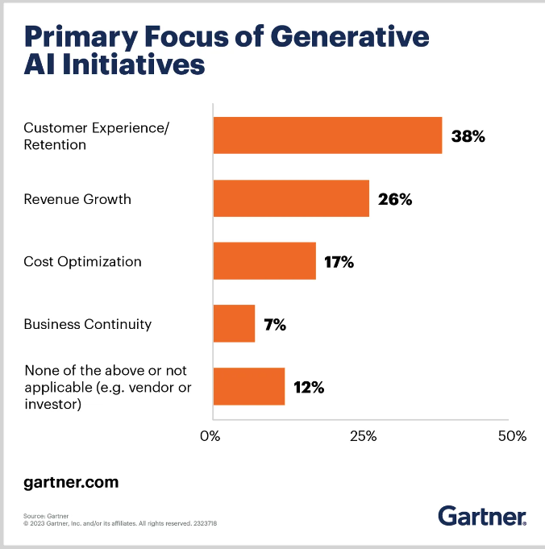

Page 9.
Generative AI is positioned on the Peak of Inflated Expectations on the Gartner Hype Cycle for Emerging Technologies, 2023.

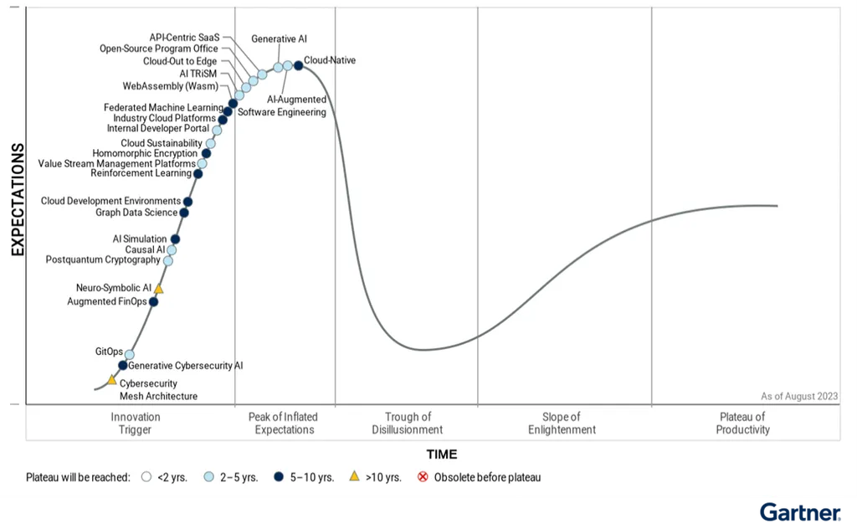

Page 10.

Conclusion
Artificial Intelligence represents a transformative force with far-reaching implications for society and industry. This report has provided a foundational understanding of AI, the ethics of AI, the benefits of AI, and the future of AI. As AI continues to evolve, it is imperative that responsible development practices and ethical frameworks guide its integration into our daily lives.
Artificial Intelligence has the potential to revolutionize numerous aspects of our lives, driving efficiency, innovation, and improving our ability to solve complex problems. However, it's important to approach its development and deployment responsibly, addressing ethical concerns and ensuring that AI benefits society as a whole.

Page 11.
References

For the introduction
- https://newsroom.lamresearch.com/the-era-of-artificial-intelligence
- https://cosmovici-ip.com/news/the-era-of-ai-its-evolution-and-protection-from-an-intellectual-property-perspective/#:~:text=Introduction%20in%20the%20AI%20era&text=From%20the%201960s%20until%202010s,neural%20networks%2C%20and%20genetic%20algorithms.

For the artificial intelligence
- https://www.techtarget.com/whatis/definition/AI-code-of-ethics#:~:text=AI%20ethics%20is%20a%20system,develop%20AI%20codes%20of%20ethics.
- https://www.accenture.com/us-en/insights/artificial-intelligence-summary-index#:~:text=The%20benefits%20of%20AI,-There%20are%20many&text=End%2Dto%2Dend%20efficiency%3A,downtime%20by%20predicting%20maintenance%20needs

Page 12.
For the benefit of artificial intelligence
- https://www.netapp.com/artificial-intelligence/what-is-artificial-intelligence/
- https://www.accenture.com/us-en/insights/artificial-intelligence-summary-index#:~:text=The%20benefits%20of%20AI,-There%20are%20many&text=End%2Dto%2Dend%20efficiency%3A,downtime%20by%20predicting%20maintenance%20needs.
- https://www.blockchain-council.org/ai/what-are-the-benefits-of-artificial-intelligence-in-our-daily-lives/#:~:text=AI%20has%20made%20significant%20contributions,fraud%20and%20make%20investment%20decisions.
- https://www.forbes.com/advisor/in/business/software/advantages-of-ai/

For the future of artificial intelligence
- https://www.zdnet.com/article/what-analyst-are-saying-about-the-future-of-generative-ai/
- https://builtin.com/artificial-intelligence/artificial-intelligence-future

Page 13.

