Name: Jian Yu Kok GTID: 903550380

**Describe each indicator you use in sufficient detail that someone else could reproduce it. You should also provide a compelling description regarding why that indicator might work and how it could be used. You should also provide one or more charts that convey how each indicator works in a compelling way. (up to 8 charts).**

**Momentum Indicator**

Variables: n (Number of periods)

An indicator that shows the momentum of the stock. Calculated by dividing current closing price with closing price n periods ago.

$$Momentum=\frac{price\left[t\right]}{price[t-n]}-1$$

Momentum value is > 0 if price is rising, <0 if price is dropping.

As the value of momentum constantly fluctuates, I created a threshold, Momentum > 0.2 means that the stock is bullish, which Momentum < -0.2 means that the stock is bearish.

This indicator can show us the trend on the market and show us when to buy/sell or close a trade depending on the current momentum value.

For example, long stocks if momentum is high, short when momentum is low.

The following is a chart showing the momentum indicator.

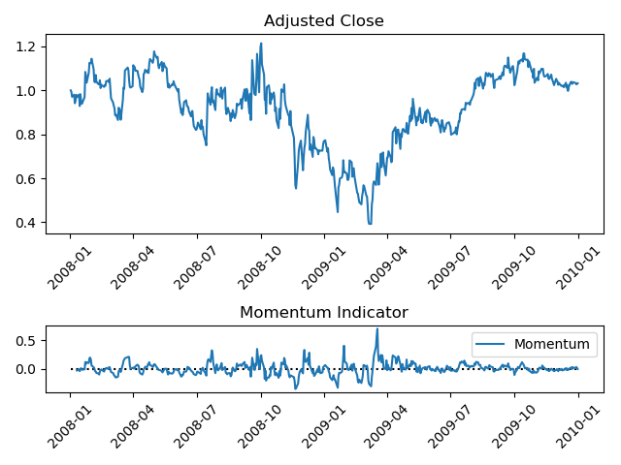

**Simple Moving Average (SMA)**

Variable: n (number of periods)

Simple moving average is the average of the closing price of the last n periods. I used this to make other indicators.

**Bollinger Band Indicator**

Variable: n (number of periods), k (multiplier for standard deviation)

Bollinger Band Indicator includes 3 line.

*SMA (middle band)*

*bb_low = SMA + standard_dev * k (upper band)*

*bb_high = SMA – standard_dev * k (lower band)*

The following is an example of Bollinger Band Indicator.

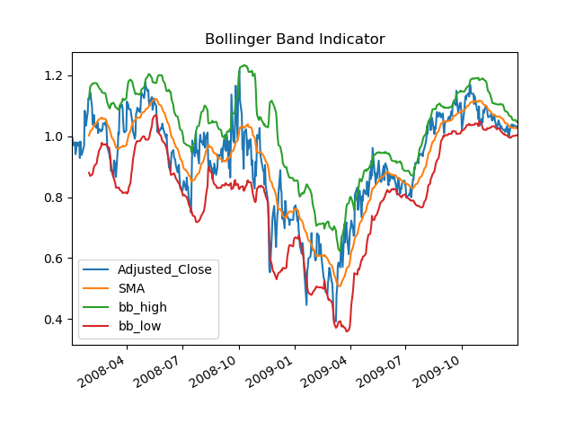

The gap between bb_high and bb_low represents the volatility of the stock. Large gap indicates high volatility, and small gap represent otherwise.

bb_high and bb_low also represents the resistance and support line of the stock price. Meaning that if the stock price reaches them, it will most probably be deflected back and not exceed the line.

This is obviously not always true, and there are cases when the price breaks out instead. However, most of the trades occur within bb_high and bb_low

Therefore, one way to trade with this indicator, is to long if price hits bb_low, short if price hits bb_high and close the trade when price hits bb_mean.

**Stochastic Indicator**

Variable: n (number of periods)

Stochastic Indicator is a momentum indicator. It can be used to determine if stocks are overbought or oversold, and be used to detect bullish and bearish trends.

Stochastic Indicator consist of 2 lines.

$$lowest=lowest trade of the last n periods$$

$$highest=highest trade of the last n periods$$

$$Stochastic Line=\frac{close-lowest}{highest-lowest}*100$$

$$Signal Line=SMA(Stochastic Line, num_{period}=3)$$

When the Stochastic Line > 80, it represents an overbought market. When Stochastic Line < 20, it represents an oversold market.

The Stochastic Line crossing through the Signal line, is considered to be a reversal signal as well. 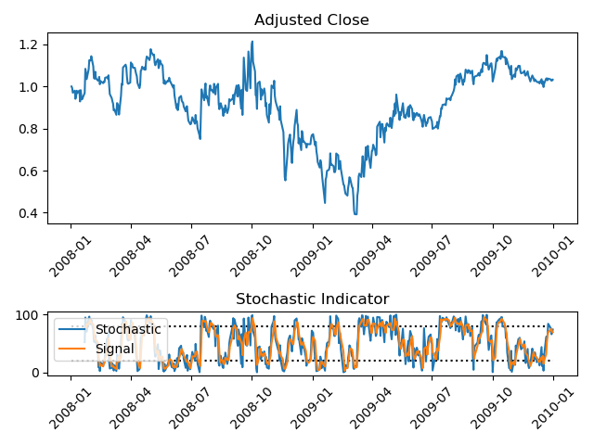

One possible strategy to trade with this indicator, is to long when the Stochastic Line < 0.2, and Stochastic Line crosses the signal line. To short when the Stochastic Line > 0.8, and Stochastic Line crosses the signal line.

**For the best possible strategy, describe how you created it and any assumptions you had to make to make it work. Provide a chart that illustrates its performance versus the benchmark.**

For the best possible strategy, I created it by looking at the stock price for the next day and long if it was higher, short if it was lower.

The assumption I had to make is that there are no commission charges, and that I am able to look into the future.

Results for TheoreticallyOptimalStrategy:

Date Range: 2008-01-01 00:00:00 to 2010-01-01 00:00:00

Sharpe Ratio of Fund: 13.300308134893116

Cumulative Return of Fund: 5.7861

Standard Deviation of Fund: 0.00454648281478629

Average Daily Return of Fund: 0.0038092281584798833

Final Portfolio Value: 678610.0

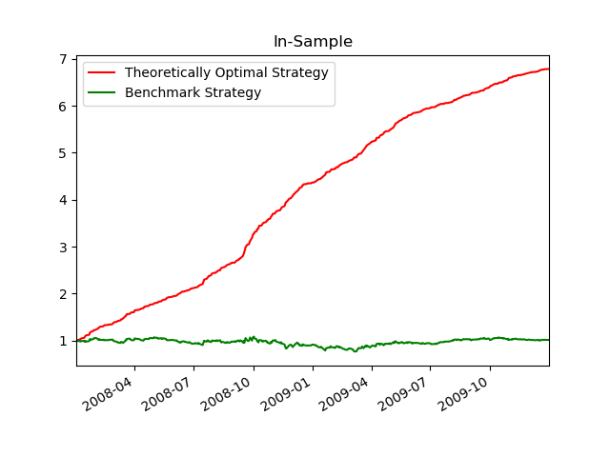

**For your manual strategy, describe how you combined your indicators to create an overall signal. How do you decide to enter and exit your positions and why? Why do you believe (or not) that this is an effective strategy? Provide a chart.**

I settled down on 3 indicators. Bollinger Band, Stochastic and Momentum.

I combined the indicators together by using if statements, together with logical operators such as `and` and `or`.

I used Bollinger Band and Stochastic Indicator as my long and short indicator.

If bb_high smaller than current price

If Stochastic value larger than OVERBUY_THRESHOLD

Long

If bb_low larger than current price

If Stochastic value smaller than OVERSELL_THRESHOLD

Short

I used multiple indicators for this as a single indicator tends to not be extremely accurate. As such, I tried to improve the accuracy of the signal by combining the signals from multiple indicators. If Bollinger Band gives me a long signal, I will only perform this if the market is oversold (Which means that there is a tendency for price to rise) and vice versa.

I used Momentum and Bollinger Band for my close signal

If on long position

If current price <= bb_mid or momentum < BEARISH_THRESHOLD

Close Long

If on short position

If current price >= bb_mid or momentum > BULLISH_THRESHOLD

Close Short

For the close signal, I also made use of multiple indicators, Momentum and Bollinger Band. However, instead of combining the 2 indicators, I made it such that if any one of the indicators give off a close signal, the trade will close. I got to this solution by trial and error. I realised that closing the trade only when I receive both the close signal resulted in a bad result. As such, I tried to relax the closing condition slightly, and it helped significantly. This is probably due to the fact that it is rare for both of the closing signal to occur at the same time, which made it hard to close the trade when I combined the 2 signals with an ‘and’ operator.

Most of the decision I have made in this strategy are based a logical combination of the indicators that I have decided to use. And if those indicators works as it was stated, this strategy should be able to work effectively. However, I believe that this strategy should not work well with out of sample data as I have made certain decisions arbitrarily based on observation with past results, and without any real supported proof behind why it works.

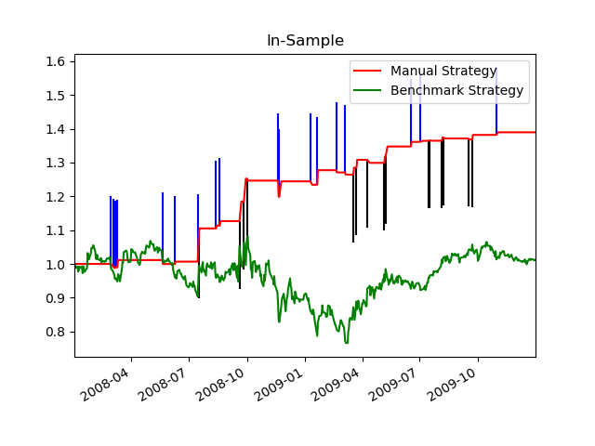

**Compare the performance of your manual strategy versus the benchmark for the in sample and out of sample time periods. Provide a chart.**

The performance for the In-sample data is considerably better compared to using the out-of-sample data.

The manual strategy obtained a final portfolio value that is 36.8% better than the benchmark strategy for in sample data, and a final portfolio value that is 23% better than the benchmark strategy for the out-of-sample data.

|  |  |  |
| --- | --- | --- |
|  | In-Sample | Out-of-sample |
| Benchmark | 101230.0 | 91660.0 |
| Manual Strategy | 138487.9499999998 | 114090.0 |
| Percentage Difference | 36.8% | 24.4% |

The difference for the performance is due to the fact that I have created the strategy based on the In-sample data. This means that I have most likely overfitted the strategy to do well for the in-sample data, which resulted in it not being able to perform well for the out-of-sample data as the market condition is now different.



