Phishing Detection Report (80:20 Imbalanced Dataset, Top 20 Features, SMOTIFIED-GAN)

# 1. Dataset Overview

This dataset represents an 80:20 imbalanced phishing detection scenario using the top 20 selected features. The SMOTIFIED-GAN approach was applied to balance the training data before model evaluation.

# 2. ROC Curves

* Logistic Regression

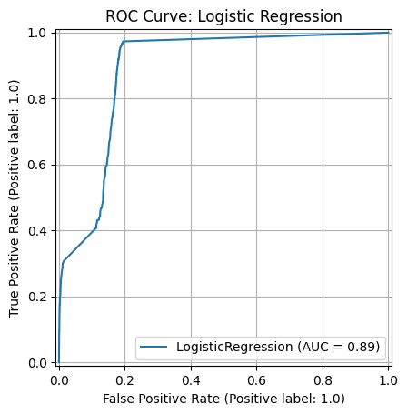

* Random Forest

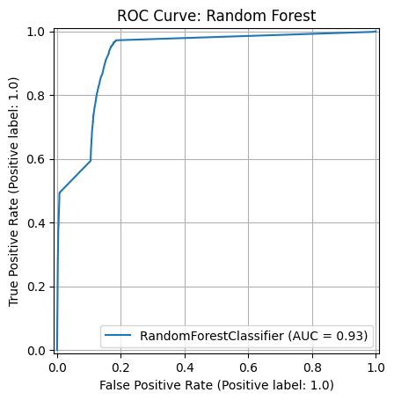

* XGBoost

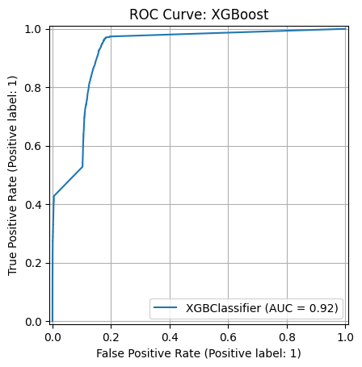

* CatBoost

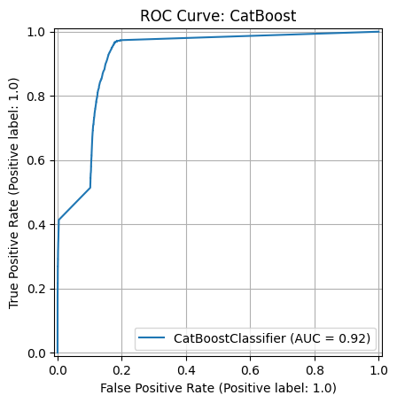

* Stacking Ensemble

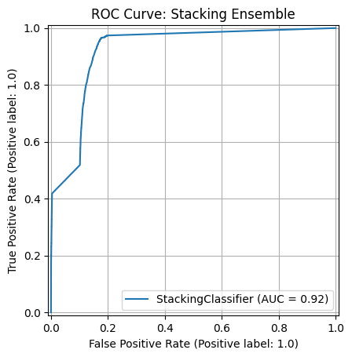

# 3. Confusion Matrices

* Logistic Regression

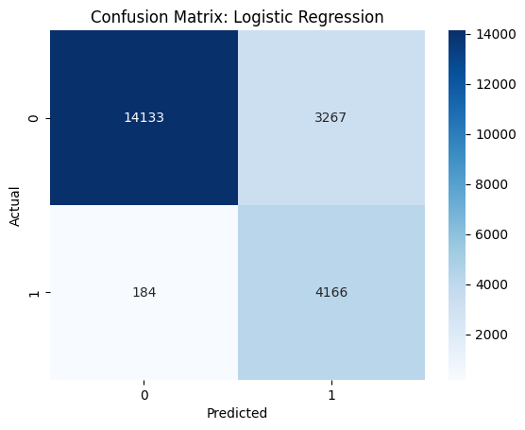

* Random Forest

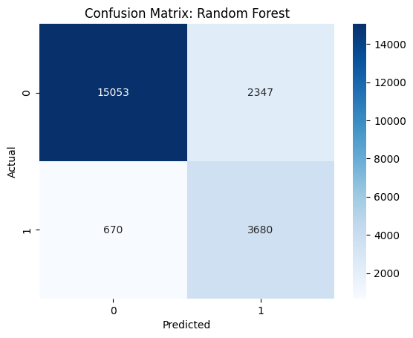

* XGBoost

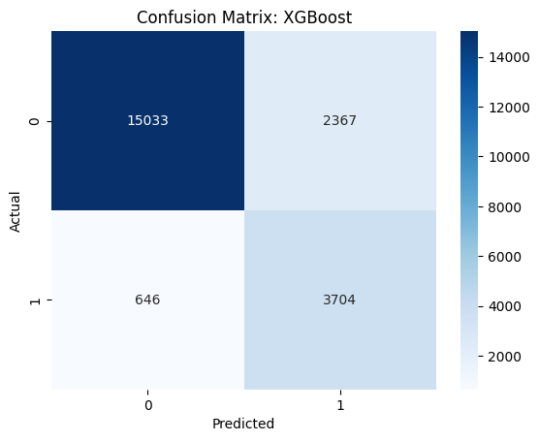

* CatBoost

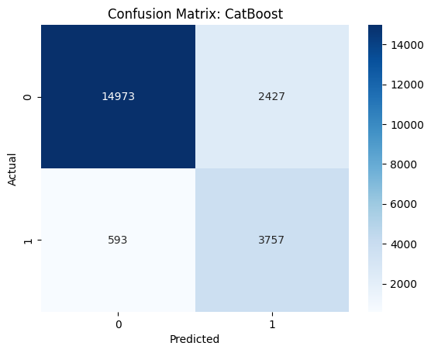

* Stacking Ensemble

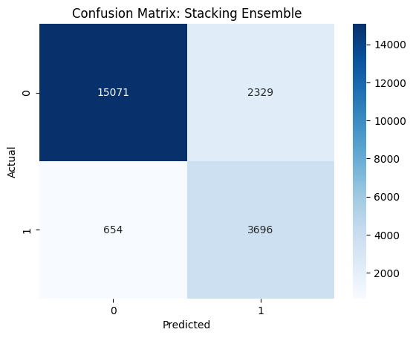

# 4. Evaluation Metrics

This section contains evaluation metrics for all classifiers on the balanced training set and real test set.

## Train Set Scores

|  |  |  |  |  |  |
| --- | --- | --- | --- | --- | --- |
| Model | Accuracy | Precision | Recall | F1 Score | ROC-AUC |
| Logistic Regression | 0.9045412561576355 | 0.8447692267324395 | 0.9912253694581281 | 0.9121559405589947 | 0.9045412561576355 |
| Random Forest | 0.926539408866995 | 0.8916214382632293 | 0.9711206896551724 | 0.9296746050459798 | 0.9265394088669952 |
| XGBoost | 0.9201662561576355 | 0.8839034544840779 | 0.9673953201970443 | 0.923766684306462 | 0.9201662561576355 |
| CatBoost | 0.919689039408867 | 0.8816316246255494 | 0.9695504926108375 | 0.9235032771741521 | 0.9196890394088669 |
| Stacking Ensemble | 0.9235991379310344 | 0.8885155169005733 | 0.96875 | 0.9268996803794206 | 0.9235991379310344 |

## Test Set Scores

|  |  |  |  |  |  |
| --- | --- | --- | --- | --- | --- |
| Model | Accuracy | Precision | Recall | F1 Score | ROC-AUC |
| Logistic Regression | 0.8413333333333334 | 0.5604735638369434 | 0.9577011494252874 | 0.7071204277348723 | 0.884971264367816 |
| Random Forest | 0.8612873563218391 | 0.6105856976937116 | 0.8459770114942529 | 0.7092608653753494 | 0.8555459770114943 |
| XGBoost | 0.8614712643678161 | 0.6101136550815351 | 0.8514942528735632 | 0.7108722771327128 | 0.8577298850574713 |
| CatBoost | 0.8611494252873563 | 0.607535575679172 | 0.8636781609195402 | 0.7133092842225176 | 0.8620977011494252 |
| Stacking Ensemble | 0.8628505747126437 | 0.6134439834024896 | 0.8496551724137931 | 0.7124819277108434 | 0.8579022988505747 |

## Cross-Validation Scores

|  |  |  |  |
| --- | --- | --- | --- |
|  | Accuracy | F1 Score | ROC-AUC |
| Logistic Regression | 0.9036699507389162 | 0.9114103317300868 | 0.895386978572642 |
| Random Forest | 0.9146059113300492 | 0.9184727665378729 | 0.9428615927345968 |
| XGBoost | 0.9146059113300493 | 0.9187495312050824 | 0.9434233207551748 |
| CatBoost | 0.9145566502463055 | 0.9185874583729688 | 0.9432818832051252 |
| Stacking Ensemble | 0.9153694581280789 | 0.9194238557740324 | 0.9122883927054769 |