Final Exam 2023(Long Answer)

Student Full Name

2023-04-22

Question 1: Suppose you have a dataset called “students” containing information on the age, gender, and test scores of 100 students.

1. Create a dataframe with three columns: age (22, 20, 19, 19, 18, 20, 17), gender (Female, Male, Male, Female, Male, Female, Female), and test scores (7 sample data between 40 to 100) using the sample function and set.seed(25).
2. Calculate the mean and standard deviation of the test scores.
3. Create a boxplot of the test scores.
4. Calculate the correlation between age and test scores.
5. Create a scatter plot to show the relationship between age and test scores, where the latter is the response variable in the dataframe.
6. Add a regression line to your scatter plot.

# Answer (a) below:   
set.seed(25)  
test_scores<-sample(40:100,7,replace = TRUE)  
test_scores

## [1] 46 68 63 99 64 88 47

students <- data.frame(age = c(22, 20, 19, 19, 18, 20, 17),gender = c(  
 "Female", "Male", "Male", "Female", "Male", "Female", "Female"),  
 testScores = test_scores)  
students

## age gender testScores  
## 1 22 Female 46  
## 2 20 Male 68  
## 3 19 Male 63  
## 4 19 Female 99  
## 5 18 Male 64  
## 6 20 Female 88  
## 7 17 Female 47

# Answer (b) below:   
mean_score = mean(students$testScores)  
mean_score

## [1] 67.85714

sd_score = sd(students$testScores)  
sd_score

## [1] 19.69288

# Answer (c) below:   
boxplot(students$testScores,main = "The boxplot for student scores",sub =   
 "Written by Koki Itagaki")

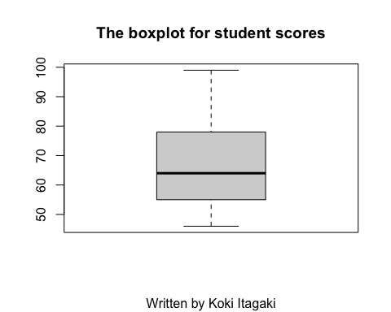

# Answer (d) below:   
cor<-cor(students$age,students$testScores)  
cor

## [1] 0.001507941

# Answer (e) below:   
  
plot(x = students$age, y = students$testScores,main = "The scatter plot of age and scores",  
 xlab = "age of students", ylab = "test scores of students")  
  
  
  
  
  
# Answer (f) below:   
  
abline(lm(students$testScores~students$age),col = "red")

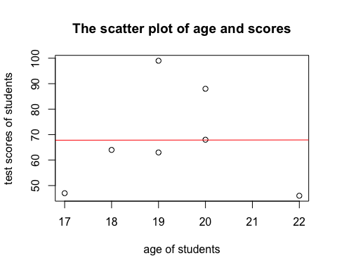

Question 2: Download, save, and read in the file “insurance.csv” from Brightspace. This dataset contains the age, the gender, body mass index of the person who has purchased the insurance policy, the number of children/dependents the insured person has, and the amount charged for the insurance policy, which is the response variable in this dataset.

1. Create 3 plots illustrating the relationship between the response variable and and each explanatory variables.
2. Fit a linear regression model including all of the explanatory variables. Be sure to write out the regression equation.
3. Determine which variable(s) (if any) are not significant in the model using 0.05 as the criteria.
4. Using the model from part (c) to predict the amount of charges for a female aged 30 with 1 child, a bmi of 34.2.

insurance= read.csv("/Users/itagakikouki/stat123/insurance.csv")  
age<-insurance$age  
bmi<-insurance$bmi  
children<-insurance$children  
charges<-insurance$charges  
# Answer (a) below:   
par(mfrow = c(2, 2))  
plot(x=age, y = charges,main = "The scatter plot of age and charges")  
plot(x=bmi, y = charges,main = "The scatter plot of bmi and charges")  
plot(x=children, y = charges,main = "The scatter plot of number of children and charges")  
  
  
   
  
# Answer (b) below:   
lm_charge<-lm(charges~age+bmi+children)  
lm_charge

##   
## Call:  
## lm(formula = charges ~ age + bmi + children)  
##   
## Coefficients:  
## (Intercept) age bmi children   
## -6916.2 240.0 332.1 542.9

#The regression equation is y = b0 + b1x1 + b2x2 + b3x3  
#Now we know the numbers of b0,b1,b2,and b3.  
#So, the regression equation is now y = -6916.2 + 240.0*x1 + 332.1*x2 + 542.9*x3  
  
  
  
# Answer (c) below:   
  
summary(lm_charge)

##   
## Call:  
## lm(formula = charges ~ age + bmi + children)  
##   
## Residuals:  
## Min 1Q Median 3Q Max   
## -13884 -6994 -5092 7125 48627   
##   
## Coefficients:  
## Estimate Std. Error t value Pr(>|t|)   
## (Intercept) -6916.24 1757.48 -3.935 8.74e-05 ***  
## age 239.99 22.29 10.767 < 2e-16 ***  
## bmi 332.08 51.31 6.472 1.35e-10 ***  
## children 542.86 258.24 2.102 0.0357 *   
## ---  
## Signif. codes: 0 '***' 0.001 '**' 0.01 '*' 0.05 '.' 0.1 ' ' 1  
##   
## Residual standard error: 11370 on 1334 degrees of freedom  
## Multiple R-squared: 0.1201, Adjusted R-squared: 0.1181   
## F-statistic: 60.69 on 3 and 1334 DF, p-value: < 2.2e-16

#All of the variables are significant which means the p-values are less   
#than 0.05, so I do not to remove any variables.  
  
  
  
  
# Answer (d) below:   
  
#y = -6916.2 + 240.0*x1 + 332.1*x2 + 542.9*x3  
#When the data is a female aged 30 with 1 child, a bmi of 34.2.  
  
y = -6916.2 + 240.0*30 + 332.1*34.2 + 542.9*1  
cat(paste("The charges for a female aged 30 with 1 child, a bmi of 34.2 is", y))

## The charges for a female aged 30 with 1 child, a bmi of 34.2 is 12184.52

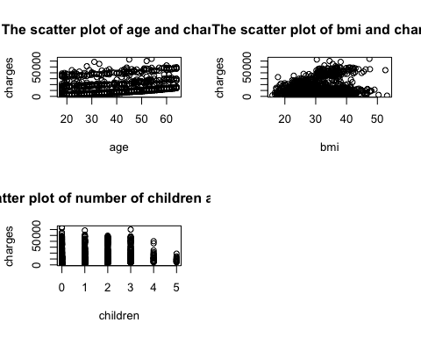

Question 3: Consider the gapminder dataset (available by either loading into the R session or reading in the .csv file available in Brightspace).

1. Create a variable called Europe_1957 which contains all of the rows of the gapminder data set corresponding to the continent Europe in the year 1957 You may subset the data in any way that you please.
2. Plot the distribution of the life expectancy in European countries in 1957. You do not need any titles for your plot.
3. Describe the shape of the distribution (symmetry, skewness, etc.).
4. What is the best measure of the centre of the distribution? Compute this value.
5. What is the best measure of the spread of the distribution? Compute the value(s).
6. Suppose we are interested in a statistic that takes the minimum life expectancy value + the maximum life expectancy value and then divides that sum by 2. We will call this statistic “midpoint”. Compute the observed value of the midpoint statistic for the sample of European life expectancies in 1957.
7. Bootstrap 10000 sample midpoints of European life expectancies in 1957. Save the bootstrapped vector as boot_midpoint.

** Note ** If you are unable to bootstrap this particular statistic, then bootstrap the median instead in order to be able to answer the remainder of the question.

1. Plot the distribution of the bootstrapped midpoints. You do not need any titles for your plot.
2. Describe the shape of the distribution. Does it appear normally distributed?

library(dplyr,ggplot2)

##   
## Attaching package: 'dplyr'

## The following objects are masked from 'package:stats':  
##   
## filter, lag

## The following objects are masked from 'package:base':  
##   
## intersect, setdiff, setequal, union

gapminderr<- read.csv("/Users/itagakikouki/stat123/gapminder.csv")  
  
# Answer (a) below:   
Europe_1957 = gapminderr%>%filter(continent == "Europe", year == 1957)  
Europe_1957

## X country continent year lifeExp pop gdpPercap  
## 1 14 Albania Europe 1957 59.280 1476505 1942.284  
## 2 74 Austria Europe 1957 67.480 6965860 8842.598  
## 3 110 Belgium Europe 1957 69.240 8989111 9714.961  
## 4 146 Bosnia and Herzegovina Europe 1957 58.450 3076000 1353.989  
## 5 182 Bulgaria Europe 1957 66.610 7651254 3008.671  
## 6 374 Croatia Europe 1957 64.770 3991242 4338.232  
## 7 398 Czech Republic Europe 1957 69.030 9513758 8256.344  
## 8 410 Denmark Europe 1957 71.810 4487831 11099.659  
## 9 518 Finland Europe 1957 67.490 4324000 7545.415  
## 10 530 France Europe 1957 68.930 44310863 8662.835  
## 11 566 Germany Europe 1957 69.100 71019069 10187.827  
## 12 590 Greece Europe 1957 67.860 8096218 4916.300  
## 13 674 Hungary Europe 1957 66.410 9839000 6040.180  
## 14 686 Iceland Europe 1957 73.470 165110 9244.001  
## 15 746 Ireland Europe 1957 68.900 2878220 5599.078  
## 16 770 Italy Europe 1957 67.810 49182000 6248.656  
## 17 1010 Montenegro Europe 1957 61.448 442829 3682.260  
## 18 1082 Netherlands Europe 1957 72.990 11026383 11276.193  
## 19 1142 Norway Europe 1957 73.440 3491938 11653.973  
## 20 1226 Poland Europe 1957 65.770 28235346 4734.253  
## 21 1238 Portugal Europe 1957 61.510 8817650 3774.572  
## 22 1274 Romania Europe 1957 64.100 17829327 3943.370  
## 23 1334 Serbia Europe 1957 61.685 7271135 4981.091  
## 24 1370 Slovak Republic Europe 1957 67.450 3844277 6093.263  
## 25 1382 Slovenia Europe 1957 67.850 1533070 5862.277  
## 26 1418 Spain Europe 1957 66.660 29841614 4564.802  
## 27 1466 Sweden Europe 1957 72.490 7363802 9911.878  
## 28 1478 Switzerland Europe 1957 70.560 5126000 17909.490  
## 29 1574 Turkey Europe 1957 48.079 25670939 2218.754  
## 30 1598 United Kingdom Europe 1957 70.420 51430000 11283.178

# Answer (b) below:  
hist(Europe_1957$lifeExp,prob = TRUE)  
lines(density(Europe_1957$lifeExp),col = "red")

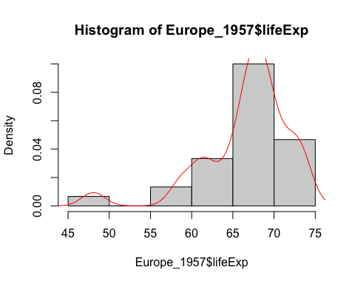

# Answer (c) below:  
  
#The distribution is left-skewed  
  
  
  
  
# Answer (d) below:  
#Since the distribution is not symmentric and there might be a outlier around  
#45 to 50, we should use median to describe centre of the distribution.  
median(Europe_1957$lifeExp)

## [1] 67.65

# Answer (e) below:  
#Since the distribution might not be normally distributed, I should use quantile function  
#to describe the spread of the distribution  
quantile(Europe_1957$lifeExp)

## 0% 25% 50% 75% 100%   
## 48.079 65.020 67.650 69.205 73.470

# Answer (f) below:  
midpoint<-function(x){  
 (min(x)+max(x))/2  
}  
  
round(midpoint(Europe_1957$lifeExp),2)

## [1] 60.77

# Answer (g) below:z  
n = length(Europe_1957$lifeExp)  
boot_midpoint = numeric()  
for(i in 1:10000){  
 temp_sample= sample(Europe_1957$lifeExp,n,replace = TRUE)  
 boot_midpoint[i] = median(temp_sample)  
}  
  
  
  
  
# Answer (h) below:   
hist(boot_midpoint)

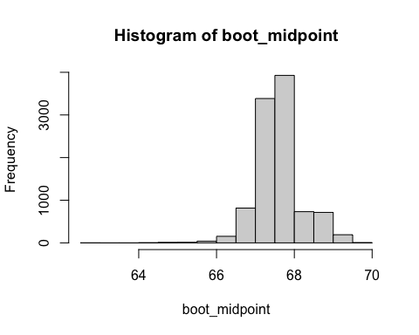

# Answer (i) below:  
#The distribution looks a little bit left skewed, so I do not think I can say  
#this is perfectly normally distributed.

Question 4: The built-in Titanic data set is a 4-dimensional array that contains the following information:

• Dimension 1: Class of the passenger (1 = 1st, 2 = 2nd, 3 = 3rd, 4 = Crew member) • Dimension 2: Sex of the passenger (1 = male, 2 = female) • Dimension 3: Age of the passenger (1 = child, 2 = adult) • Dimension 4: Survival of the passenger (1 = died, 2 = survived)

1. Create (and print out) a table which contains the adult passengers (of all classes and genders) who survived.
2. Create (and print out) a vector called survived which contains all adult passengers (of all classes and genders) who survived.
3. Create a barplot displaying the survived vector. Make sure to include a main title and to label your x-axis. Also, make sure that each bar is a different colour.
4. Create (and print out) a vector called died which contains the adult passengers who did not survive.
5. Create (and print out) a vector called percent.Survived which contains the percentage of adult passengers who survived in each class, Using the sum(survived) in part (b).
6. Create a pie chart that displays the percent.Survived data. Be sure to include a main title for your pie chart.
7. Estimate the proportion of the female passengers (of all classes and ages) who survived using the table created in part (a).
8. Determine a 90% confidence interval for the proportion estimated in part (g) (round to 3 decimal places)
9. Compute the margin of error.

head(Titanic)

## , , Age = Child, Survived = No  
##   
## Sex  
## Class Male Female  
## 1st 0 0  
## 2nd 0 0  
## 3rd 35 17  
## Crew 0 0  
##   
## , , Age = Adult, Survived = No  
##   
## Sex  
## Class Male Female  
## 1st 118 4  
## 2nd 154 13  
## 3rd 387 89  
## Crew 670 3  
##   
## , , Age = Child, Survived = Yes  
##   
## Sex  
## Class Male Female  
## 1st 5 1  
## 2nd 11 13  
## 3rd 13 14  
## Crew 0 0  
##   
## , , Age = Adult, Survived = Yes  
##   
## Sex  
## Class Male Female  
## 1st 57 140  
## 2nd 14 80  
## 3rd 75 76  
## Crew 192 20

# Answer (a) below:   
adult_survived<-table(Titanic[,,"Adult","Yes"])  
adult_survived

##   
## 14 20 57 75 76 80 140 192   
## 1 1 1 1 1 1 1 1

# Answer (b) below:  
survived<-Titanic[,,"Adult","Yes"]  
  
  
  
  
# Answer (c) below:  
barplot(survived,main = "the number of adults who survived",xlab = "The   
 gender",ylab = "The number of people"  
 ,col = rainbow(length(survived)),beside = TRUE)

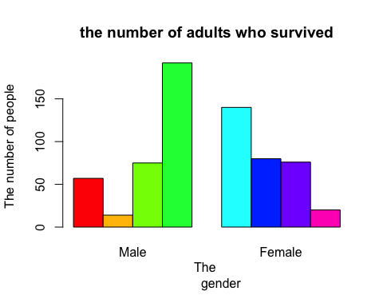

# Answer (d) below:  
died<-Titanic[,,"Adult","No"]  
died

## Sex  
## Class Male Female  
## 1st 118 4  
## 2nd 154 13  
## 3rd 387 89  
## Crew 670 3

# Answer (e) below:  
  
  
#I use for loop to put the proportion of survived adults out of all passengers  
#who dead or survived and to show it in each class, i created a list.  
percent.Survived<-numeric()  
for(i in 1:4){  
 percent.Survived[i]<-round(sum(survived[i,])/sum(Titanic)*100,2)  
   
}  
classes<-c("1st", "2nd","3rd","Crew")  
percent.Survived

## [1] 8.95 4.27 6.86 9.63

for(i in 1:4){  
cat("The percentage of survived adults in", classes[i], "is", percent.Survived[i])  
}

## The percentage of survived adults in 1st is 8.95The percentage of survived adults in 2nd is 4.27The percentage of survived adults in 3rd is 6.86The percentage of survived adults in Crew is 9.63

# Answer (f) below:  
  
  
  
pie(percent.Survived,main = "The pie chart of adults who survived in each class",  
 labels = paste(classes,percent.Survived,"%"))

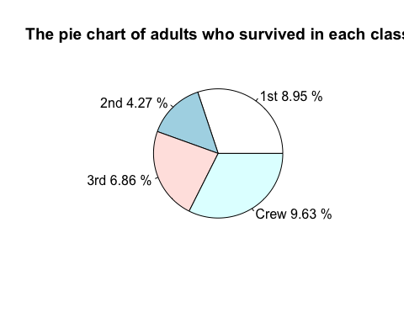

# Answer (g) below:  
female_survived<-Titanic[,"Female",,"Yes"]/sum(Titanic)  
  
  
  
  
# Answer (h) below:  
n = length(female_survived)  
p = mean(female_survived)  
p

## [1] 0.01953657

sd = sqrt(p*(1-p)/n)  
sd

## [1] 0.04893222

#Since this is the sample size is small I will use quantile function  
q = quantile(p,0.95)  
q

## 95%   
## 0.01953657

upper = round(p + q*sd,3)  
lower = round(p -q*sd,3)  
cat(paste("The 90% confidence interval is ",lower, ",", upper))

## The 90% confidence interval is 0.019 , 0.02

# Answer (i) below:  
sd = sqrt(p*(1-p)/n)  
sd

## [1] 0.04893222

#Since this is the sample size is small I will use quantile function  
  
q = quantile(p,0.95)  
q

## 95%   
## 0.01953657

#The margin of the error is   
moe<-q*sd