hw2_stat123

Koki Itagaki

2023-02-13

#1. The built-in UCBAdmissions data set is a 3-dimensional array that contains #the following information: #• Dimension 1: Admit Admitted, Rejected #• Dimension 2: Gender Male, Female #• Dimension 3: Dept A, B, C, D, E, F #Note: You can find the UCBAdmissions data set using data(). #If you wanted to access the data, you could type in UCBAdmissions[1,1,2] to get #this value. If you wanted to create a table with the number of rejected #students in department A, you could type UCBAdmissions [2, ,1].

#(a) Create (and print out) a table that contains all students in department D  
UCB<-data(UCBAdmissions)  
#Department D is a 4th of the dimention 3. So I just use hard brancket to   
#get all data which students are in the department D  
d_data<-UCBAdmissions[, ,4]  
d_data

## Gender  
## Admit Male Female  
## Admitted 138 131  
## Rejected 279 244

rowSums(UCBAdmissions)

## Admitted Rejected   
## 1755 2771

#(b) Create (and print out) a vector called department.D that contains the   
#admitted and rejected students.  
department.D<-UCBAdmissions [, ,4]  
department.D

## Gender  
## Admit Male Female  
## Admitted 138 131  
## Rejected 279 244

#Hint: You may need to use rowSums() on your answer from part (a).  
  
#(c) Create a bar plot displaying the admitted and rejected students in   
#Department D. Make sure to include a main title and label your x-axis. Also,   
#make sure that each bar is a different color.  
  
barplot(department.D,main = "The students in the department D",xlab = "The   
number ofd students",legend = c("Admitted males", "Rejected males",   
"Admitted females","Rejected females"), col = rainbow(4),  
sub = "Written by Koki Itagaki",beside = TRUE)

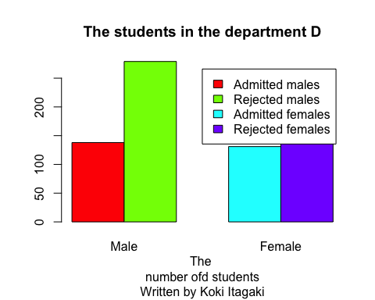

#(d) Create (and print out) a vector called admitted.females which contains  
#the admitted females in Department D.  
#The number of females is the first row and the secound column.  
admitted.females<-UCBAdmissions [1,2 ,4]  
  
admitted.females

## [1] 131

#(e) Create (and print out) a vector called pct.admitted.females which contains  
#the percentage of admitted females in department D.  
  
  
pct.admitted.females = round((admitted.females/sum(department.D))*100,  
 digits = 2)  
print(paste(pct.admitted.females,"%"))

## [1] "16.54 %"

#(f) Create a pie chart that displays the pct.admitted.females data.   
#Be sure to include a main title for your pie chart.  
  
pct.departmentD = round((department.D/sum(department.D))*100,  
 digits = 2)  
pct.departmentD

## Gender  
## Admit Male Female  
## Admitted 17.42 16.54  
## Rejected 35.23 30.81

element_d<- paste(c("Admitted males", "Rejected females", "Admitted females",  
 "Rejected males"),pct.departmentD, "%")  
pie(pct.departmentD,labels = element_d ,main = "Pie chart for the department D")

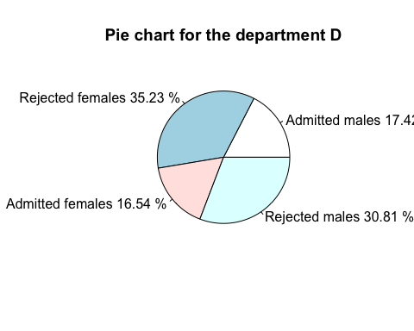

#(g) What does the pie chart imply about the number of admitted females #in department D? The pie chart implies that the number of admitted females are the least number compared to the other categories. Also,we could say there is a trend of that more males get admitted compared to females by approximately 1%. Moreover, most of the people who applied got rejected. In total, only about 30% of people get admmited.

#2. The following question deals with the data set #Government_expenditure_per_student.csv, which you #will need to download from the assignment page.

#(a) Create (but do not print) a vector called expenditure containing the  
#last column of the dataset named Value.  
Value<-read.csv("/Users/itagakikouki/stat123/Government_expenditure_per_student.csv")  
expenditure<-Value[,ncol(Value)]  
  
  
#(b) Create a histogram displaying the distribution of this variable.  
#Be sure to have both a main title and a title on your x-axis.  
hist(expenditure, main ="The goverments expenditure per student",   
 xlab = "The amount of expenditure",sub = "Written by Koki Itagaki")

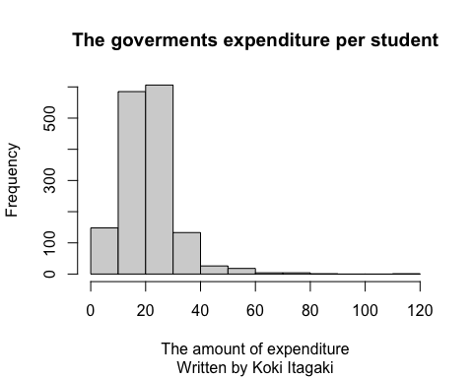

#(c) Describe the shape of the distribution (symmetric, left-skewed,   
# right-skewed).  
print("From the histgram above, we can see that the data loooks symmentric.  
However, there are a few extra data on the left side of the peak point.  
It is possibly right-skewed, but I would say this is symmentric.")

## [1] "From the histgram above, we can see that the data loooks symmentric.\nHowever, there are a few extra data on the left side of the peak point.\nIt is possibly right-skewed, but I would say this is symmentric."

#(d) Compute the appropriate center value and the corresponding measures   
#of variability.  
  
#For the center value, I will find the median.  
#I just use the function called median  
#To find the mesures of variability, I also get standard deviation by using  
#sd function  
median(expenditure)

## [1] 20.30278

sd(expenditure)

## [1] 9.98177

#(e) Remove decimals from the vector named expenditure by using round() and  
#create a stem plot  
re_expenditure<-round(expenditure,0)  
stem(re_expenditure)

##   
## The decimal point is 1 digit(s) to the right of the |  
##   
## 0 | 00000000000001333444444444555555555555555556666666666666666677777777+50  
## 1 | 00000000000000000000000000000000000000000000000000111111111111111111+501  
## 2 | 00000000000000000000000000000000000000000000000000000000000000000111+537  
## 3 | 00000000000000000000000011111111111111111111111122222222222222222222+62  
## 4 | 0001111122223333444445667778  
## 5 | 011122233344445688  
## 6 | 1558  
## 7 | 0123  
## 8 | 9  
## 9 |   
## 10 |   
## 11 | 6

#(c) Describe the shape of the distribution (symmetric, left-skewed, # right-skewed). From the histgram above, we can see that the data loooks symmentric. However, there are a few extra data on the left side of the peak point. It is possibly right-skewed, but I would say this is symmentric.