Lab4_stat123

Koki Itagaki

2023-02-07

#Quesition 1 #Take a look at the following table. The number of various crops cultivated in #a village is given in the following table.

#a) Create a data frame named "crops.df" and then calculate the percentage of   
#crops.  
crops.df<-data.frame(Items = c("Wheat","Pulses","Jowar","Groundnuts","Vegitables")  
 ,crops = c(140,110,30,60,20))  
crops.df

## Items crops  
## 1 Wheat 140  
## 2 Pulses 110  
## 3 Jowar 30  
## 4 Groundnuts 60  
## 5 Vegitables 20

percent<- round(crops.df$crops/sum(crops.df$crops)*100,2)  
percent

## [1] 38.89 30.56 8.33 16.67 5.56

#b) Produce a pie chart showing the items and the percentage of crops with 2   
#decimals and change the color of the pie chart. (Using the paste() function)   
#crops  
segment<- paste(crops.df$Items,percent,"%")  
pie(crops.df$crops, labels = segment, col = rainbow(length(crops.df$crops)),  
 main = "The pie chart for crops")

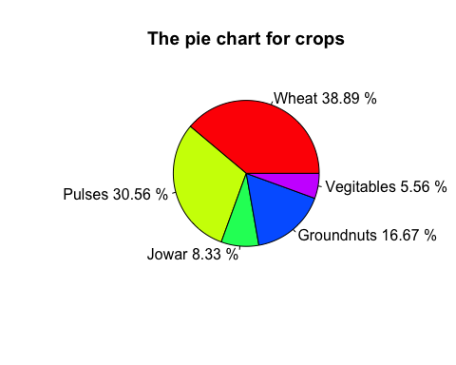

#Question2 Download the data set Superstores.csv and save it #to whatever directory you are using for this course.

#a) Read the file and take a look at the dataset to familiarize yourself   
#with its contents. Then create a sub-dataset that contains all data and   
#columns with restrictions for the Region. The Region can be Central or East.  
superstore<- read.csv("/Users/itagakikouki/stat123/Superstores.csv",  
 header = TRUE)  
  
dim(superstore)

## [1] 128 21

head(superstore)

## Row.ID Order.ID Order.Date Ship.Date Ship.Mode Customer.ID  
## 1 1 CA-2016-152156 11/8/2016 11/11/2016 Second Class CG-12520  
## 2 2 CA-2016-152156 11/8/2016 11/11/2016 Second Class CG-12520  
## 3 3 CA-2016-138688 6/12/2016 6/16/2016 Second Class DV-13045  
## 4 4 US-2015-108966 10/11/2015 10/18/2015 Standard Class SO-20335  
## 5 5 US-2015-108966 10/11/2015 10/18/2015 Standard Class SO-20335  
## 6 6 CA-2014-115812 6/9/2014 6/14/2014 Standard Class BH-11710  
## Customer.Name Segment Country City State  
## 1 Claire Gute Consumer United States Henderson Kentucky  
## 2 Claire Gute Consumer United States Henderson Kentucky  
## 3 Darrin Van Huff Corporate United States Los Angeles California  
## 4 Sean O'Donnell Consumer United States Fort Lauderdale Florida  
## 5 Sean O'Donnell Consumer United States Fort Lauderdale Florida  
## 6 Brosina Hoffman Consumer United States Los Angeles California  
## Postal.Code Region Product.ID Category Sub.Category  
## 1 42420 South FUR-BO-10001798 Furniture Bookcases  
## 2 42420 South FUR-CH-10000454 Furniture Chairs  
## 3 90036 West OFF-LA-10000240 Office Supplies Labels  
## 4 33311 South FUR-TA-10000577 Furniture Tables  
## 5 33311 South OFF-ST-10000760 Office Supplies Storage  
## 6 90032 West FUR-FU-10001487 Furniture Furnishings  
## Product.Name Sales  
## 1 Bush Somerset Collection Bookcase 261.9600  
## 2 Hon Deluxe Fabric Upholstered Stacking Chairs, Rounded Back 731.9400  
## 3 Self-Adhesive Address Labels for Typewriters by Universal 14.6200  
## 4 Bretford CR4500 Series Slim Rectangular Table 957.5775  
## 5 Eldon Fold 'N Roll Cart System 22.3680  
## 6 Eldon Expressions Wood and Plastic Desk Accessories, Cherry Wood 48.8600  
## Quantity Discount Profit  
## 1 2 0.00 41.9136  
## 2 3 0.00 219.5820  
## 3 2 0.00 6.8714  
## 4 5 0.45 -383.0310  
## 5 2 0.20 2.5164  
## 6 4 0.00 14.1694

sample<-superstore[superstore$Region == c("Central","East"),]  
  
  
  
#b) Produce a horizontal bar plot to compare the quantity and category.   
#You should set the bars beside each other. Set the colour of the bars to be   
#the rainbow as you saw in Chapter 10’s lecture and consider a title bar   
#as “Comparing the quantity and category of products,” the x-axis  
#as “Quantity vs Category,” and the y-axis as “Frequency.”  
value <- table(sample$Category,sample$Quantity)  
value

##   
## 1 2 3 4 5  
## Furniture 1 1 5 0 5  
## Office Supplies 1 3 3 6 8  
## Technology 1 2 2 1 1

barplot(value, main = "Comparing the quantity and category of products",xlab =  
"Quantity vs Category", ylab = "Frequency", col = rainbow(2),   
legend= c("Category","Quantity"), beside = TRUE, horiz = TRUE)

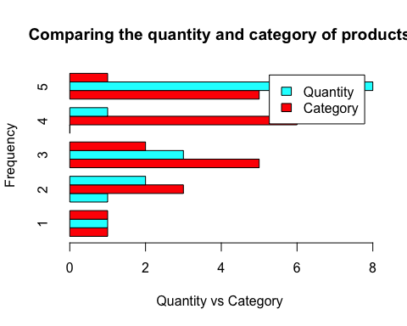

#Question3. Use the Superstores.csv. It contains the profits in the last column.

#a) Produce a line plot with the x-axis as “Index,” the y-axis as “Profit,”   
#and the title as “Profits among superstores.” The x-axis value should be   
#between 0 and 100  
plot(superstore$Profit, type = "l",xlab = "Index", ylab = "Profit",  
 xlim = c(0,100),col = "darkblue", main = "Profits among superstores.")

