Lab6_stat123

Koki Itagaki

2023-03-01

#1. Generate a dataset of student grades, with columns for the student’s name, their midterm score, and their final exam score as below. #name = c(“Alice”, “Bob”, “Charlie”, “David”, “Emily”, “Frank”, “Grace”, #“Henry”, “Isabel”, “John”,“Karen”, “Liam”, “Megan”, “Nate”, “Olivia”), #midterm = c(80, 70, 91, 85, 55, 80, 95, 50, 65, 75, 80, 85, 90, 75, 80), #final = c(85, 80, 70, 90, 55, 85, 90, 75, 85, 70, 80, 80, 70, 60, 75)

#(a) Take this dataset as input and returns a vector of the final grades for   
#each student. (weighted avetrage of the midterm is(0.4)and final score is 0.6)  
data<-data.frame(name = c("Alice", "Bob", "Charlie", "David", "Emily",   
"Frank", "Grace","Henry", "Isabel", "John","Karen", "Liam", "Megan", "Nate",  
"Olivia"),  
midterm = c(80, 70, 91, 85, 55, 80, 95, 50, 65, 75, 80, 85, 90, 75, 80),  
final = c(85, 80, 70, 90, 55, 85, 90, 75, 85, 70, 80, 80, 70, 60, 75))  
data

## name midterm final  
## 1 Alice 80 85  
## 2 Bob 70 80  
## 3 Charlie 91 70  
## 4 David 85 90  
## 5 Emily 55 55  
## 6 Frank 80 85  
## 7 Grace 95 90  
## 8 Henry 50 75  
## 9 Isabel 65 85  
## 10 John 75 70  
## 11 Karen 80 80  
## 12 Liam 85 80  
## 13 Megan 90 70  
## 14 Nate 75 60  
## 15 Olivia 80 75

#To get final grades  
grades<-data$midterm*0.4 + 0.6*data$final  
  
#(b) Use if statements to assign a letter grade (A, B, C, D, or F) to the   
#student named "Charlie. " (weighted average of the midterm is (o.4) and   
#final scores is (0.6)), with the following criteria:  
#A: grade >= 90  
#B: grade >= 80 and grade < 90  
#C: grade >= 70 and grade < 80  
#D: grade >= 60 and grade < 70  
#F: grade < 60  
  
letter_grades <- character(1)  
letter_grades

## [1] ""

if(grades[3]>= 90){  
   
}else if(grades[3]>= 90){  
 letter_grades<- "A"  
}else if(grades[3]>= 80){  
 letter_grades<- "B"  
}else if(grades[3]>= 70){  
 letter_grades<- "C"  
}else if(grades[3]>= 60){  
 letter_grades<- "D"  
}else{  
 letter_grades<- "F"  
   
}  
print(letter_grades)

## [1] "C"

#Bonus  
#create vecttor first  
letter_grade<-character(length(grades))  
letter_grade<-ifelse(grades >= 90, "A",  
 ifelse(grades >= 80, "B",  
 ifelse(grades >= 70, "C",  
 ifelse(grades >= 60, "D","F"))))  
letter_grade

## [1] "B" "C" "C" "B" "F" "B" "A" "D" "C" "C" "B" "B" "C" "D" "C"

#Add new column   
data$grade <-letter_grade   
data

## name midterm final grade  
## 1 Alice 80 85 B  
## 2 Bob 70 80 C  
## 3 Charlie 91 70 C  
## 4 David 85 90 B  
## 5 Emily 55 55 F  
## 6 Frank 80 85 B  
## 7 Grace 95 90 A  
## 8 Henry 50 75 D  
## 9 Isabel 65 85 C  
## 10 John 75 70 C  
## 11 Karen 80 80 B  
## 12 Liam 85 80 B  
## 13 Megan 90 70 C  
## 14 Nate 75 60 D  
## 15 Olivia 80 75 C

#2. You have a variable x that contains a numeric value. You can consider any #numeric value for x.

#(a) Check whether x is positive, negative, or zero.  
x<- -9  
if(x>0){  
 print("x is positive")  
}else if(x<0){  
 print("X is negative")  
}else{  
 print("X is zero")  
}

## [1] "X is negative"

#(b) Considering the numeric value of x, print out x “is positive” or x “is   
#negative” or x “is zero.”

#3. Load the normal_distribution.csv dataset and save it as nd.

nd<-read.csv("/Users/itagakikouki/stat123/lab6/normal_distribution.csv")  
dim(nd)

## [1] 100 1

head(nd)

## normal  
## 1 51.09344  
## 2 56.73150  
## 3 28.81101  
## 4 52.94184  
## 5 28.75654  
## 6 54.35247

nd<-as.numeric(nd$normal)  
#(a) Generate the density curve of the nd using the density() function.  
hist(nd, main = "The dencity curve of the normal distribution", prob = TRUE,  
 col = "lightblue")  
#Density function to plot the dencity of the curve  
lines(density(nd))

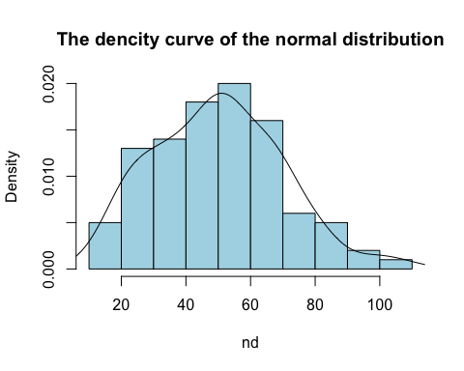

#(b) Find the mean of nd and save it as mu.  
mu<- mean(nd)  
mu

## [1] 49.91465

#(c) find the standard deviation of nd and save it as sig.  
sig<-sd(nd)  
sig

## [1] 19.86311

#(d) Use the function quantile() and the values mu and sig to find the value  
#in nd that is greater than 65% of the values in nd.   
quantile(nd, .65)

## 65%   
## 56.60207