Lec30_feb1_stat123

Koki Itagaki

2023-02-02

#The min() function returns the minimum value of a vector or data frame.  
#The max() function returns the maximum value of a vector or data frame.  
numbers <- c(3,1,2,1,10)  
min(numbers) # 1

## [1] 1

characters <- c("s", "a", "p", "b")  
max(characters) # "a"

## [1] "s"

#==================================================================  
  
grades = c("A", "B", "C", "D", "F")  
grades

## [1] "A" "B" "C" "D" "F"

#or  
  
grades = c(LETTERS[1:4], "F") #letters give small letters  
  
number = c(15,18,8,5,2)  
  
# we can create a pie chart by using pie() function  
  
pie(number, labels = grades, main = "Simple Pie Chart for Stat 123")

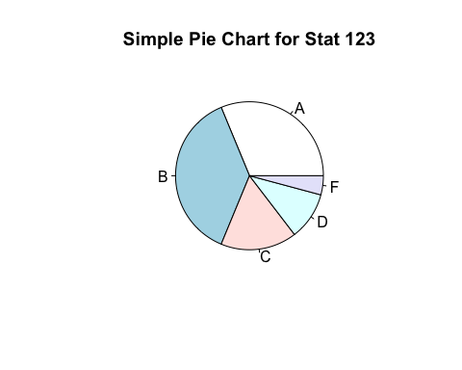

?pie  
  
percents = round((number/sum(number))*100, digits = 2)  
percents

## [1] 31.25 37.50 16.67 10.42 4.17

grades2 = paste(grades, percents, "%")  
grades2

## [1] "A 31.25 %" "B 37.5 %" "C 16.67 %" "D 10.42 %" "F 4.17 %"

pie(number, labels = grades2, main = "Simple Pie Chart for Stat 123")

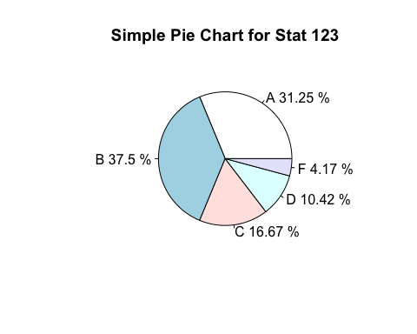

#add col = rainbow(length(grades)) for more vibrant colours  
  
pie(number, labels = grades2, col = rainbow(length(grades)), main = "Simple Pie Chart for Stat 123")

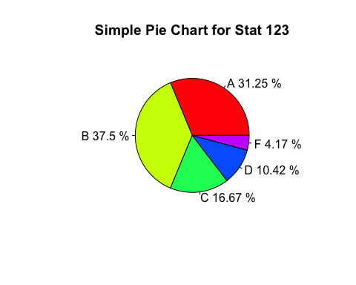

#==================================================================  
  
?mtcars  
  
mtcars

## mpg cyl disp hp drat wt qsec vs am gear carb  
## Mazda RX4 21.0 6 160.0 110 3.90 2.620 16.46 0 1 4 4  
## Mazda RX4 Wag 21.0 6 160.0 110 3.90 2.875 17.02 0 1 4 4  
## Datsun 710 22.8 4 108.0 93 3.85 2.320 18.61 1 1 4 1  
## Hornet 4 Drive 21.4 6 258.0 110 3.08 3.215 19.44 1 0 3 1  
## Hornet Sportabout 18.7 8 360.0 175 3.15 3.440 17.02 0 0 3 2  
## Valiant 18.1 6 225.0 105 2.76 3.460 20.22 1 0 3 1  
## Duster 360 14.3 8 360.0 245 3.21 3.570 15.84 0 0 3 4  
## Merc 240D 24.4 4 146.7 62 3.69 3.190 20.00 1 0 4 2  
## Merc 230 22.8 4 140.8 95 3.92 3.150 22.90 1 0 4 2  
## Merc 280 19.2 6 167.6 123 3.92 3.440 18.30 1 0 4 4  
## Merc 280C 17.8 6 167.6 123 3.92 3.440 18.90 1 0 4 4  
## Merc 450SE 16.4 8 275.8 180 3.07 4.070 17.40 0 0 3 3  
## Merc 450SL 17.3 8 275.8 180 3.07 3.730 17.60 0 0 3 3  
## Merc 450SLC 15.2 8 275.8 180 3.07 3.780 18.00 0 0 3 3  
## Cadillac Fleetwood 10.4 8 472.0 205 2.93 5.250 17.98 0 0 3 4  
## Lincoln Continental 10.4 8 460.0 215 3.00 5.424 17.82 0 0 3 4  
## Chrysler Imperial 14.7 8 440.0 230 3.23 5.345 17.42 0 0 3 4  
## Fiat 128 32.4 4 78.7 66 4.08 2.200 19.47 1 1 4 1  
## Honda Civic 30.4 4 75.7 52 4.93 1.615 18.52 1 1 4 2  
## Toyota Corolla 33.9 4 71.1 65 4.22 1.835 19.90 1 1 4 1  
## Toyota Corona 21.5 4 120.1 97 3.70 2.465 20.01 1 0 3 1  
## Dodge Challenger 15.5 8 318.0 150 2.76 3.520 16.87 0 0 3 2  
## AMC Javelin 15.2 8 304.0 150 3.15 3.435 17.30 0 0 3 2  
## Camaro Z28 13.3 8 350.0 245 3.73 3.840 15.41 0 0 3 4  
## Pontiac Firebird 19.2 8 400.0 175 3.08 3.845 17.05 0 0 3 2  
## Fiat X1-9 27.3 4 79.0 66 4.08 1.935 18.90 1 1 4 1  
## Porsche 914-2 26.0 4 120.3 91 4.43 2.140 16.70 0 1 5 2  
## Lotus Europa 30.4 4 95.1 113 3.77 1.513 16.90 1 1 5 2  
## Ford Pantera L 15.8 8 351.0 264 4.22 3.170 14.50 0 1 5 4  
## Ferrari Dino 19.7 6 145.0 175 3.62 2.770 15.50 0 1 5 6  
## Maserati Bora 15.0 8 301.0 335 3.54 3.570 14.60 0 1 5 8  
## Volvo 142E 21.4 4 121.0 109 4.11 2.780 18.60 1 1 4 2

gearCounts = table(mtcars$gear)  
  
gearCounts

##   
## 3 4 5   
## 15 12 5

barplot(gearCounts, main = "Gear Distribution", xlab = "Number of Gears")

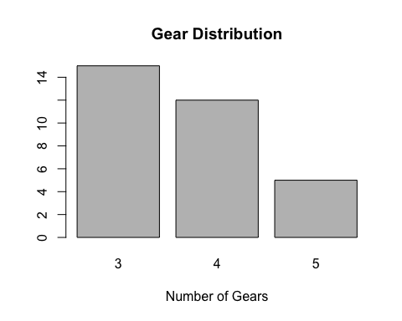

?barplot  
  
autvsman = table(mtcars$am)  
autvsman

##   
## 0 1   
## 19 13

barplot(autvsman, main = "Bar Graph of Auto. vs Man. Cars")

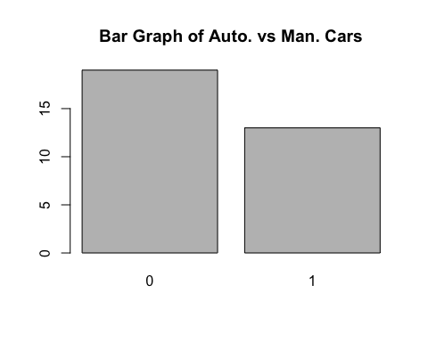

groupCounts = table(mtcars$am, mtcars$gear)  
groupCounts

##   
## 3 4 5  
## 0 15 4 0  
## 1 0 8 5

class(groupCounts)

## [1] "table"

rownames(groupCounts) = c("Automatic", "Manual")  
  
barplot(groupCounts, main = "Distribution of Gears and Transmission", xlab = "Number of Gears", col = c("darkblue", "red"), legend = rownames(groupCounts), beside = TRUE)

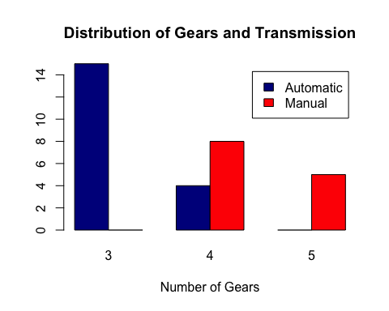

#===========================================================  
?lynx  
  
class(lynx)

## [1] "ts"

plot(lynx, main = "Line Graph for Lynx Data", xlab = "Year", ylab = "Number of Trappings")

